GPR-SLICE Software v7.0

Ground Penetrating Radar Imaging Software

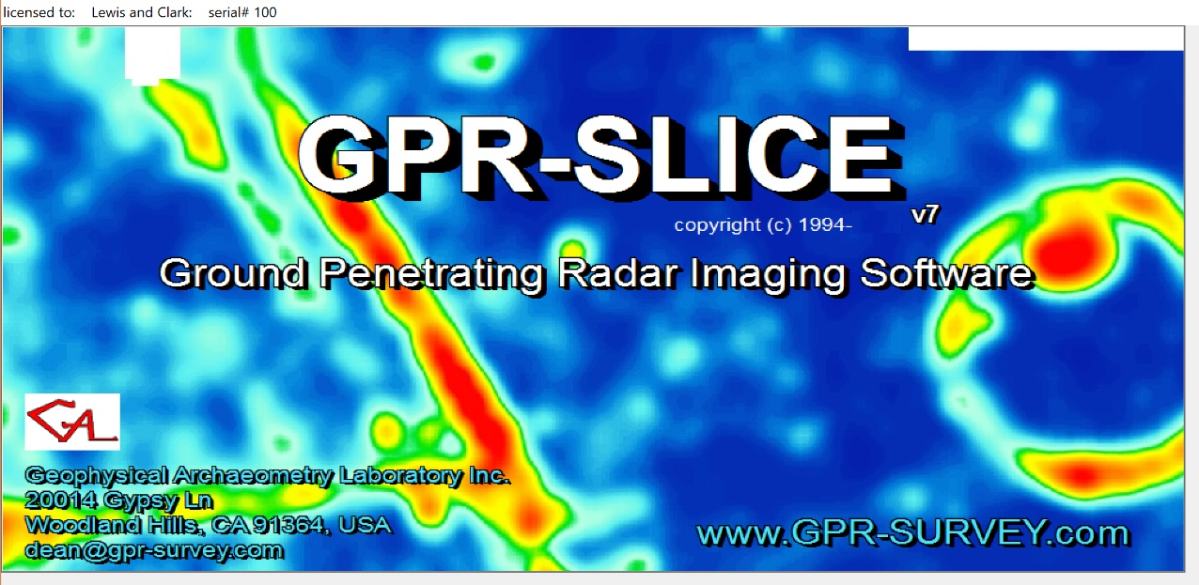

Auto Hyperbola Detection for Bridgedecks

Operation Manual

(Updated June 5, 2019)

Assisted Auto-Hyperbola Detection and Mapping (Bridgedecks)

GPR-SLICE has options to automatically detect hyperbolas and to output these detected hyperbolas for mapping. The bridgedeck module are available via the Hyperbola Search menu and are only accessible for bridgedeck licenses in GPR-SLICE Software. These options (highlighted in red) were developed at the request of companies involved in infrastructure evaluation. Evaluation of bridge decks or sites constructed with rebar or reinforcements can be assisted with GPR surveying. Bridge deterioration can be correlated to amplitude changes and GPR-SLICE provides an easy method for mapping the amplitude changes. Recently, mapping of velocity changes were added to the bridgedeck analysis in April of 2018 and are included in this addendum manual.

The primary options for bridgedeck analysis are to assist the user to auto detect the peak amplitude response of the rebar (Figure 1). and to map the changes in amplitude response across the survey area (Figure 2). A step-by-step procedure for making rebar amplitude maps is provided.

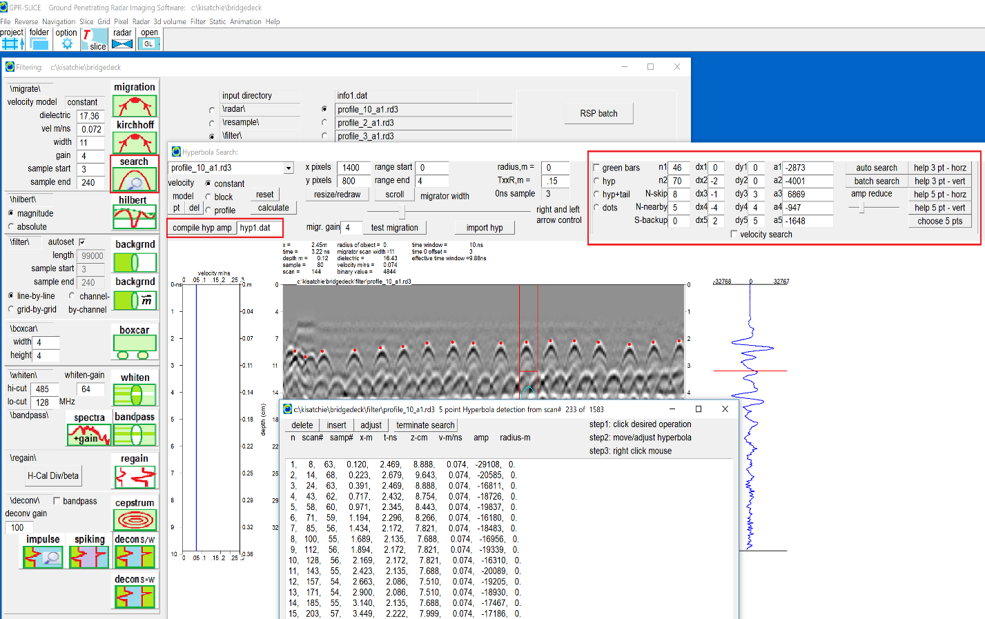
Figure 1. Example of auto-detected peak rebar response across a bridgedeck profile.
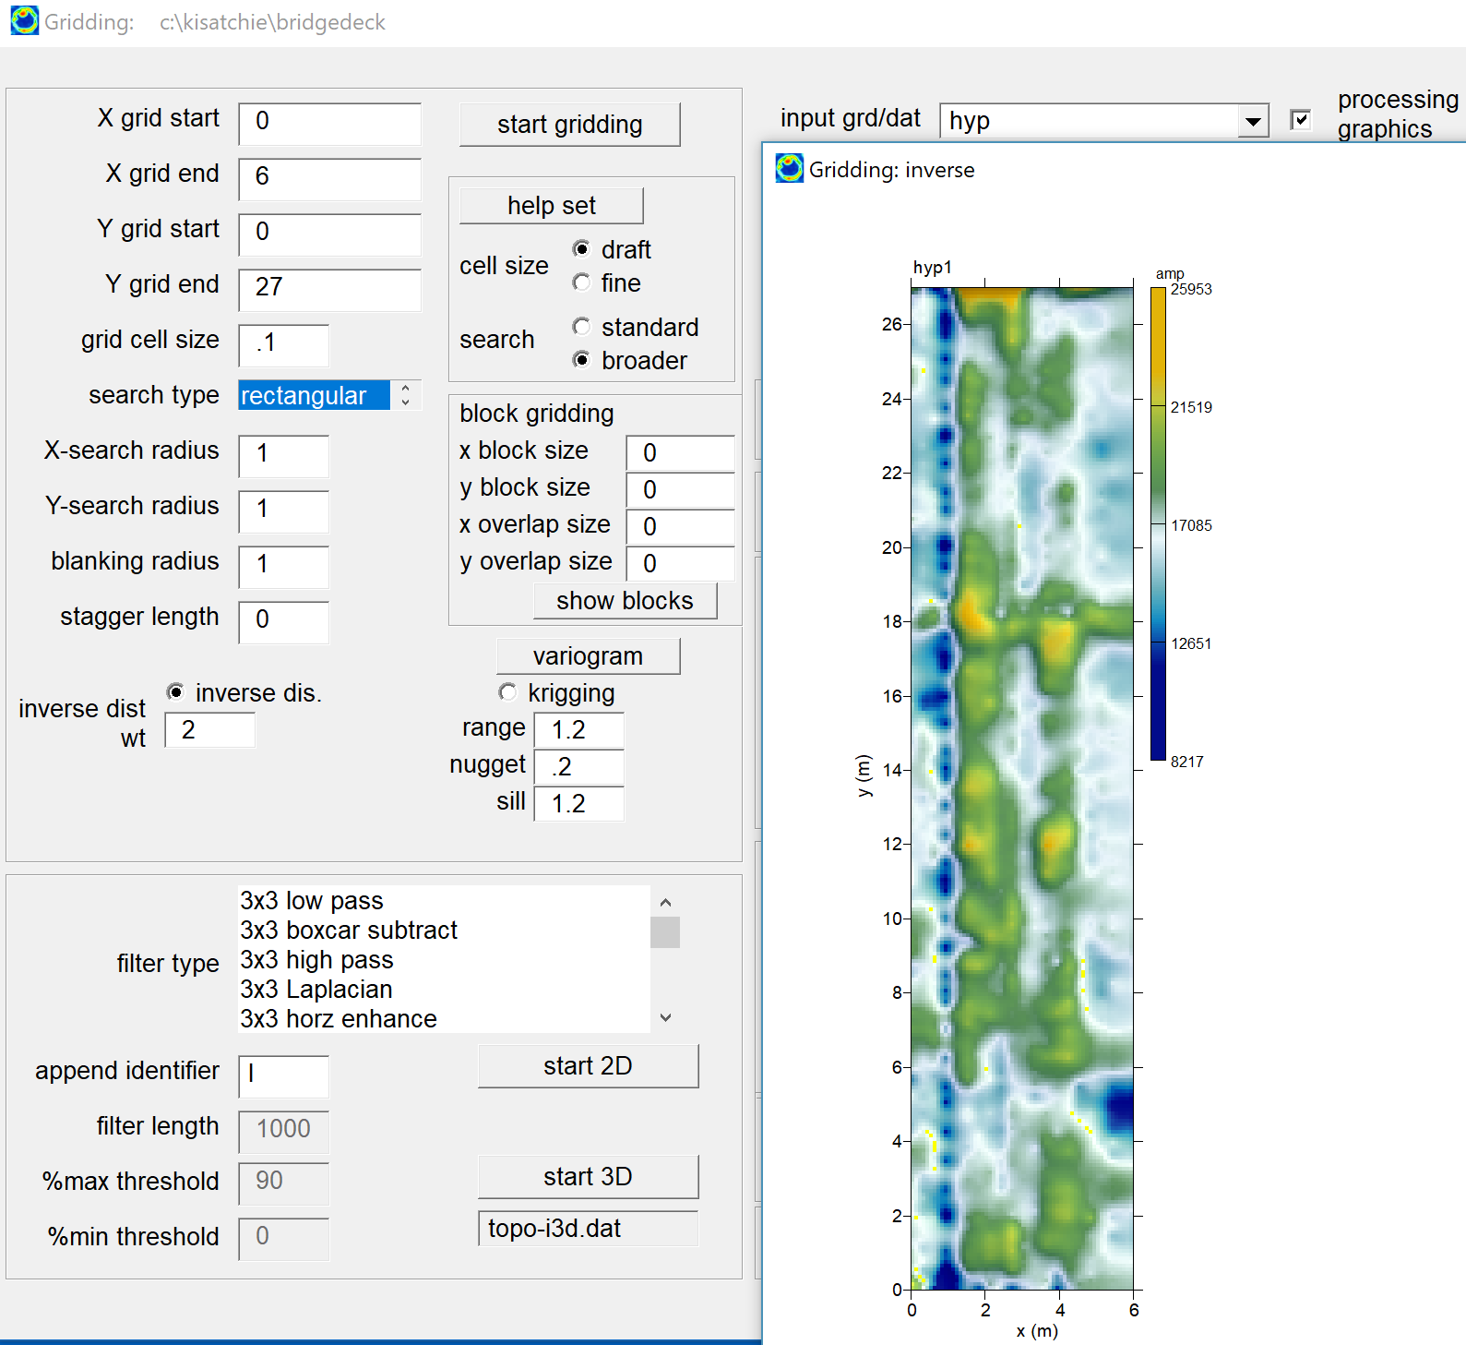
Figure 2. Example of gridded peak rebar response across the survey.

Operations for bridgedeck analysis

- Auto detect hyperbolas
- Compile detected results
- Grid detected results

The auto-detection procedure in GPR-SLICE is to set the amplitude thresholds and normalized locations in either 3 or 5 point location modes. The locations to sample the binary pulse values can be done with 3 primary search methods:

Method 1: 3-point threshold detection - vertical and horizontal directions

Method 2: 5-point threshold detection - vertical or horizontal directions

Method 3: 5 point user chosen points on the hyperbolas (preferred)

The preferred algorithm is method 3 – where the user chooses 5 points at their own desired locations on the hyperbola (Figure 3). (Description for 3/5 points searches is shown in Figure 5a,b ).

Step1- click the Choose 5 points

Step2- move your mouse to a desired hyperbola and pick 5 points. It is best to choose points at the peak + response, peak – response and also on the sloping sides of the hyperbolas. If the hyperbola appears to small you can use either the scroll option settings or adjust the xpixels/ypixels length for display.

Step3 – click the Auto Search button which will then run the search.

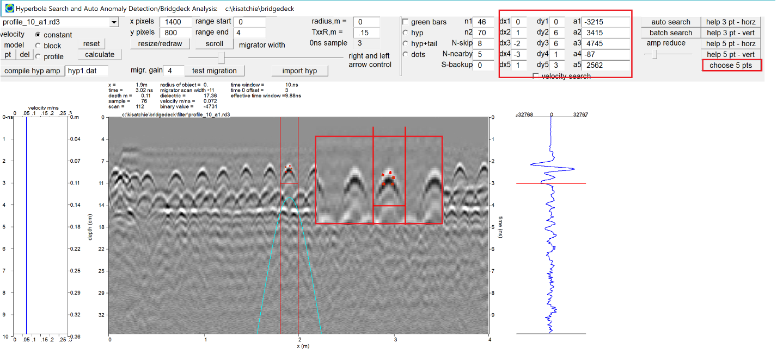
Figure 3. Example of choosing points on the hyperbola.

If very few hyperbola are detected, the user can adjust the amplitude slider bar and lower the amplitudes and more hyperbola should be detected (Figure 4a,b). If the detection is not satisfactory then the user should try choosing a different set of 5 points again and rerunning the auto search till a satisfactory number of points have been detected. Depending on the quality of the radargrams and noises, some profiles may have difficulty in complete auto-detection.

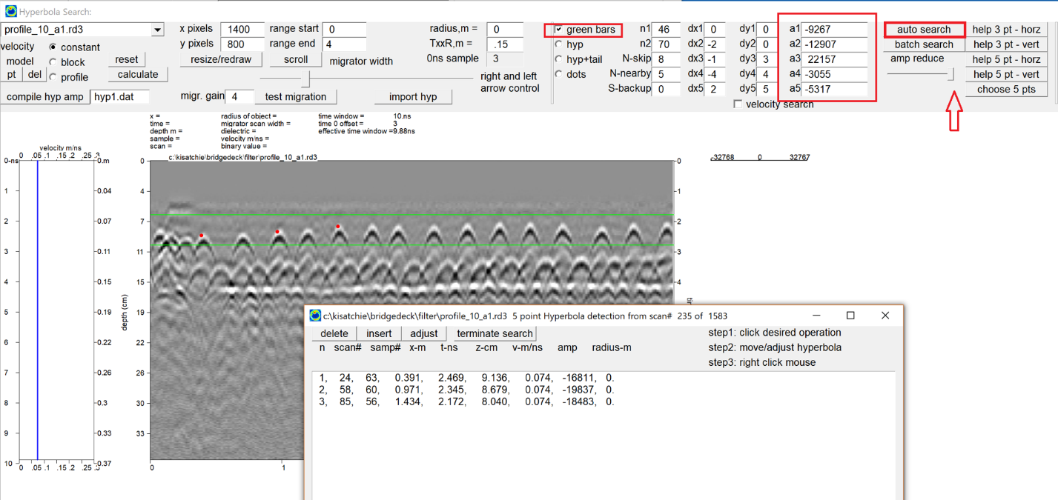

Figure 4a. Example of 5 pt detection.

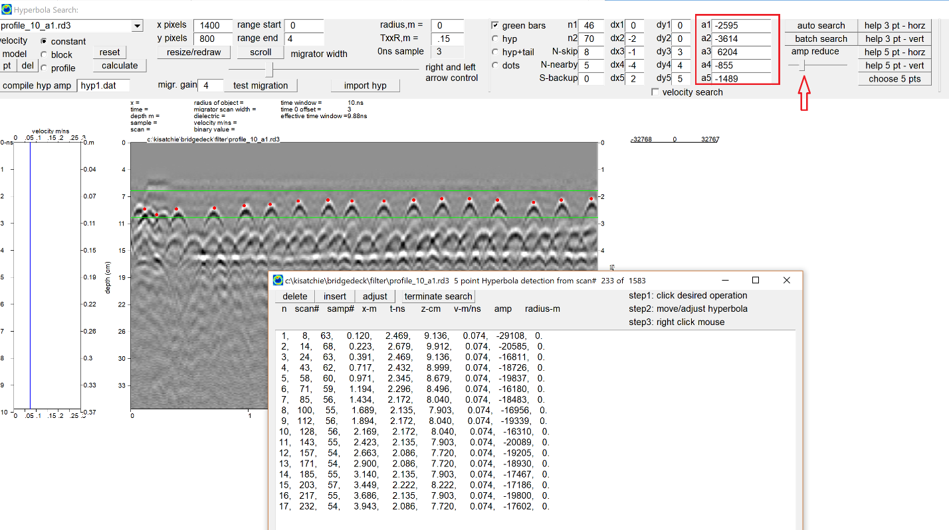
Figure 4b. Example of 5 pt detection with moving the amplitude slider bar to a lower threshold to auto detect more hyperbolas.

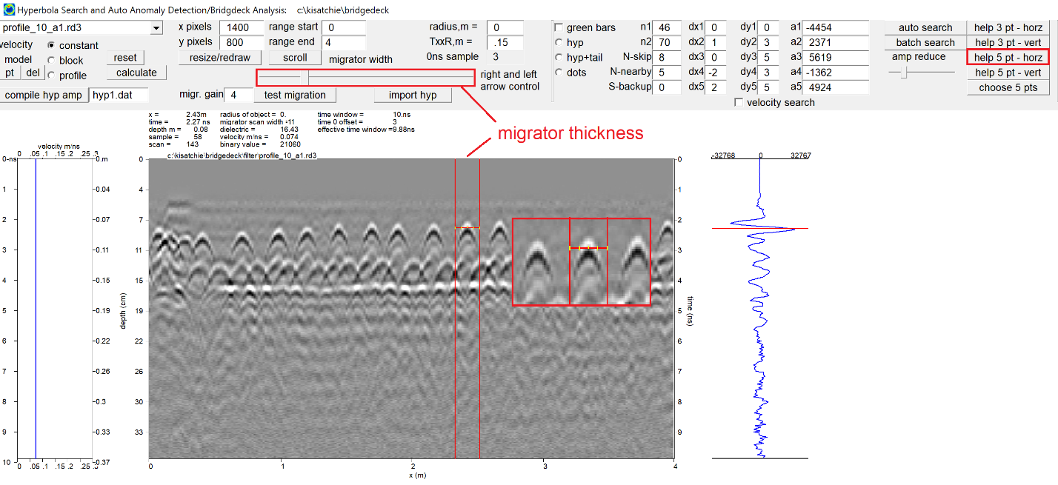
Figure 5a. Example of 5 pt horizontal search setting.

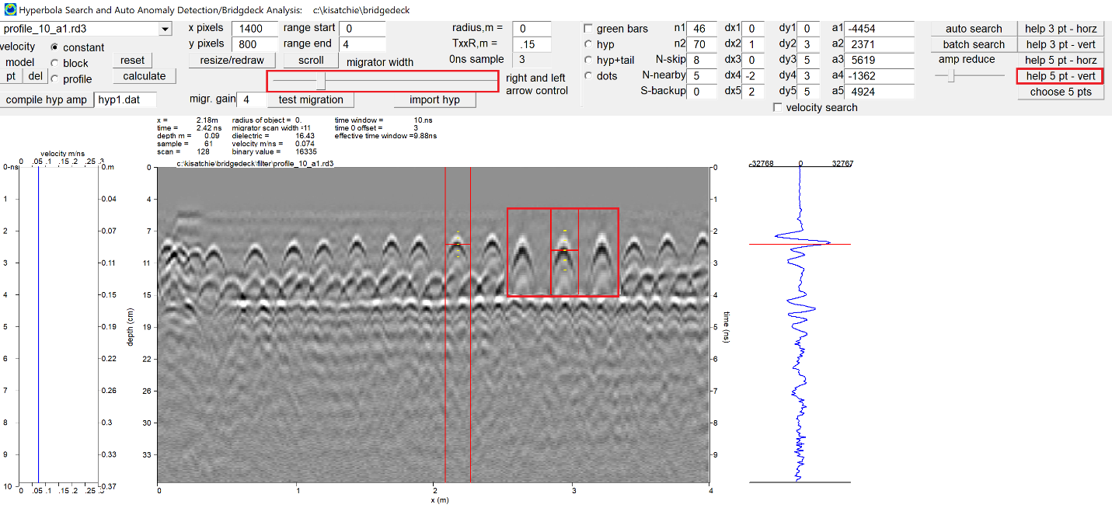
Figure 5b. Example of a 5pt vertical search setting.

5pt horizontal or 5pt vertical search detection parameters can also be set. An example is shown in Figure 5a,b. For these searches the user needs to adjust the migrator slider bar to choose a desired equidistant sampling width for the points. The migrator slider bar controls the width/height of choosing these points. By clicking the mouse, the software will then read the pulse values where the yellow ticks marks exist and place in the a1-a5 slots as well as the dx,dy scan relative locations. (3 pt vertical and horizontal search can also be implemented in the menu and are identical to the 5 point search. On choosing the 3 point the 4th and 5th points will be made identical to point #1 so there are only a total of 3 unique points for auto detection)

The 3 & 5 pt hyperbolas settings were the initial search options in GPR-SLICE Software. Recent implementation of the user choosing the 5 points independently over a hyperbola, it was found that this search method performed superior to the simple vertical or horizontal searches.

The option to manually choose any 5 pts on the hyperbola, actually gives the software the ability to detect any kind of anomalies and not just those related to rebar hyperbola! For these reasons this menu has a broader use then just for bridgedeck analysis and rebar detection - and can be extended to search for specific characteristic pulse amplitudes features across a radargram.

To implement the search algorithm, several additional settings are required:

N1 - The top sample in the scan to begin searching.

N2 - The bottom sample in the scan to end searching.

N Skip - the number of scans to skip in the radargram after detection is made, to begin a new search.

N Nearby - the number of sample points on the digitized pulse or scans to search around the detected point to find the largest peak response on the hyperbola – this value is usually set to a maximum of 5.

N Backup – the number of samples to place the detection above the located binary values set, allowing the user to detect the peak response of the hyperbolas but then reposition the detection at the weaker first arrival amplitudes from the rebar or anomaly to be detected.

The options in the menu allow for using the peak+ or the peak– response of the scan pulse. In addition, cosmetic options to show or not show the hyperbola tails beyond the N-threshold range is available in the menu, along with scrolling options to target just a portion of the radargram are available.
Note: The search algorithm is not perfect. Most sites require some user editing of automatic hyperbola search tabulations. The search algorithm is very sensitive to the threshold settings as well as the number of scans that have to breached with the threshold before getting detected. The user is advised to “play around” with differing combinations of these setting to get the best desired results from automatic detection. This may involve actually adjusting the amplitude thresholds in the slots by hand to reduce/increase them as well as the location of detection on top of the radargram or to use the amplitude slider bar in combination with adjustments.

Editing the Search Results Manually

No automatic detection will work on every dataset and there will false targets recorded on any average rebar detection project. The user has options to manually remove or adjust hyperbola. Shown in Figure 6a is a false hyperbola detected. To remove this, the line of the hyperbola can be set in the dialog and the delete button clicked (Figure 6b) and this will update the list.

The user can also place a desired hyperbola into the list by using the “insert” button (Figure 6c). The steps to insert a hyperbola require the user to 1) click the “insert” button, 2) move to the desired location near the desired undetected hyperbola is, and then 3) right click the mouse to insert a new hyperbola.

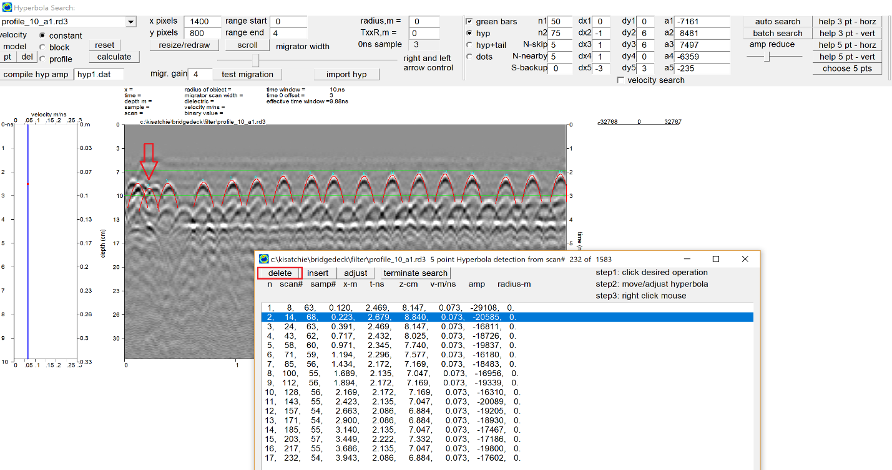
Figure 6a. A false hyperbola detected.

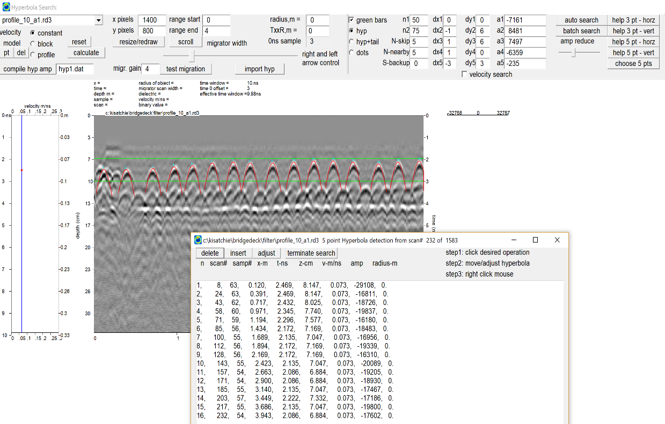
Figure 6b. Manual deletion of a bad hyperbola detection.

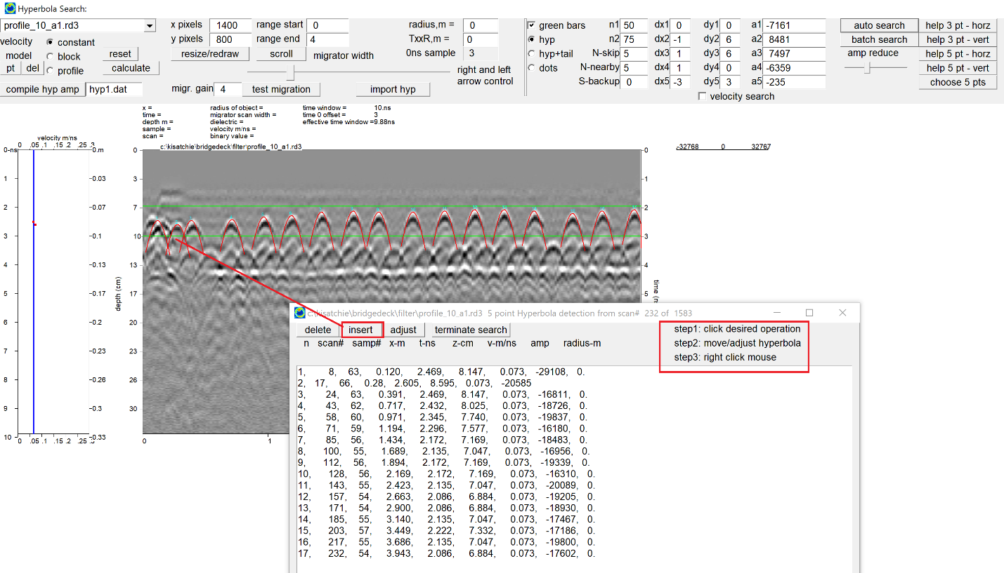
Figure 6c. Inserting a manual chosen hyperbola.

Velocity Mapping

New options were placed into the Bridgedeck module in May of 2018 to map the velocity changes across the site. The velocity mapping works by the user first finding a good search algorithm to discover most of the hyperbola on the radar profile. After that is accomplished, a check box called “velocity search” can be turned on (Figure 7). The hyperbola detection of the same pulse phase is generated. So, if a user choses a peak + or peak- then the hyperbola phase legs from the peak hyperbola response are detected and drawn. The length/width of the detection in terms of scans is determined by the migrator width which is set with the slider bar in the menu. The hyperbola detection shape may look noisy and this can be a result of lack of good hyperbola reflection because of noise. The hyperbola detection shape can also look noisy if the scan density is not sufficient enough. Nonetheless, some of the hyperbola shape detection noise can be ameliorated by regression analysis.

Using a least squares regression analysis from the hyperbola fits, the velocity of the hyperbola can be generated (Figure 7). (The radius calculations can also be made but these are less accurate and although they are provided in the search dialog, these results should be use with a great deal of skepticism). The relative dielectric at the rebar can also be computed from the expression e=c^2/v^2
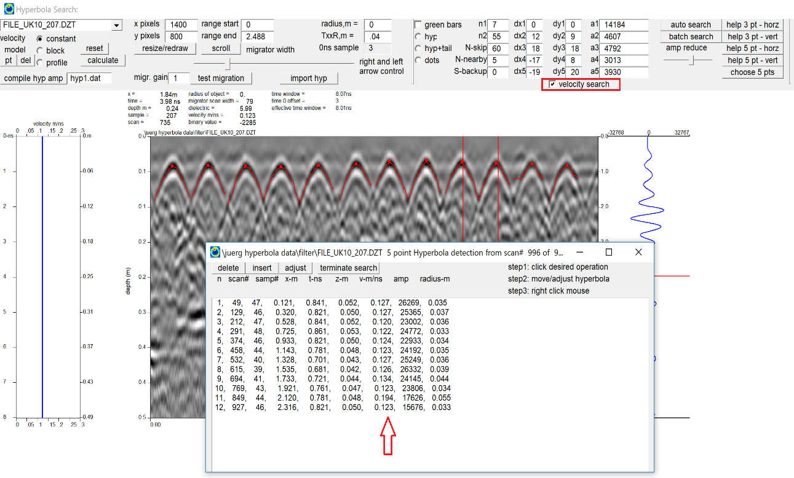
Figure 7. Example of detecting hyperbola shapes from the different phase legs of the hyperbola and using these in a least squares regression analysis to obtain the local velocity.
Compilation of auto hyperbola detection results

The peak amplitude responses of the hyperbola from rebar are important for estimating deterioration of concrete and rebar (for bridge deck). The velocity can also be compiled and provided as an additional data analysis for bridgedecks. To compile the results of the auto-detection the button “Compile Hyp Amp” is clicked. For the first layer of rebar detection the user would use the name hyp1.dat as the identification. A total of 8 different files are outputted:

- Hyp1.dat – x,y,absolute amplitude
- Db-hyp1.dat – x,y,20*log(amp) db
- Norm-hyp1.dat – x,y, amplitude corrected for spherical spreading
- Db-norm-hyp1.dat – x,y, 20*log(normalized amp) db
- Xyz-hyp1.dat – x,y,depth
- Xyzt-hyp1.dat -x,y,depth,time of detected hyperbola
- Dielectric-hyp1.dat – x,y,dielectric (relative)
- Velocity-hyp1.dat – x,y velocity(m/ns)

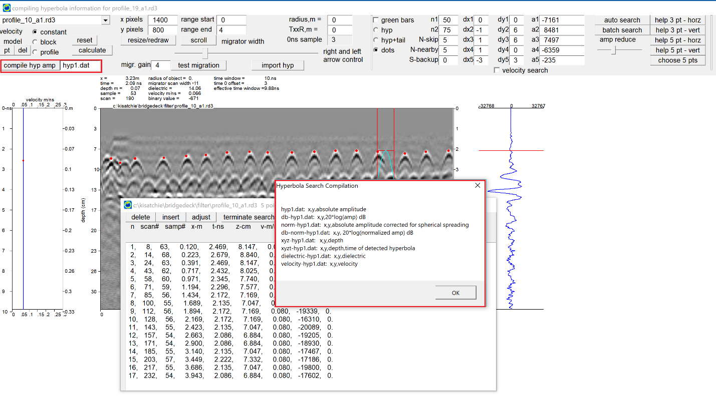
Figure 8. The “compile hyp amp” button location used to export auto-hyperbola and bridgedeck analysis results to a combination of different files. (** only available for bridgedeck licenses **)

In GPR-SLICE Software all the compilation operations are done in batch. Whatever profiles have had their detection run will be compiled to the master export files. It is not necessary to have every profile in the project completed in order to run the compilation. All the files outputted – except for xyzt – hyp1.dat - are 3 column ASCII files which have as the first 2 columns the x and y, and the third column is the amplitude, log(amplitude) in decibels or the velocity of the velocity of the local hyperbola detected. The file xyzt-hyp1.dat is a 4 column file that also contains the time and is available for the user to export to their own preferred software for gridding and displays.

Several files are corrected for spherical spreading and have a normalization correction to account for variable depth of the detected hyperbola. Two files are presented as 20*log(amp) and are in dB decibels. Any of these files can be gridded in the Grid menu in GPR-SLICE (except the export file xyzt-hyp1.dat). Examples for the three most import hyperbola detection exports are shown in for rebar peak amplitude mapping (Figure 9a), dielectric variability (Figure 9b) and for and velocity variability (Figure 9c). The velocity variability map and the dielectric variability maps are filtered on compilation to eliminate any detected velocities from the linear regression analysis that are outside the range of 0.03-.3 m/ns.

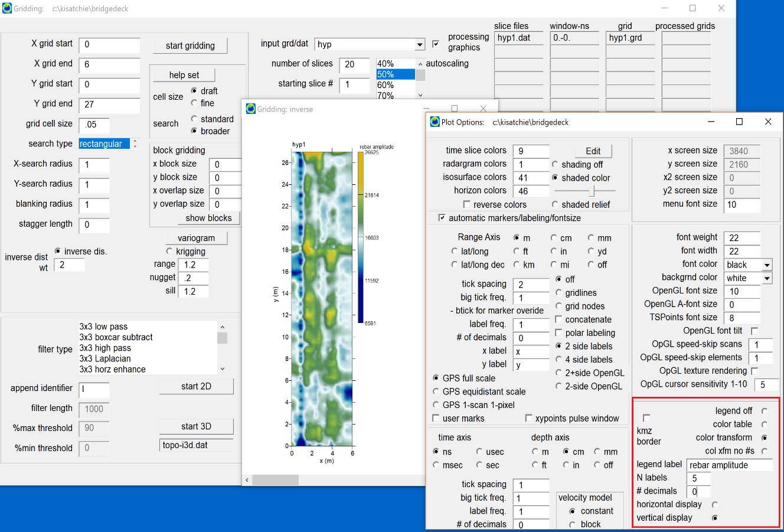
Figure 9a. Peak rebar amplitude map.
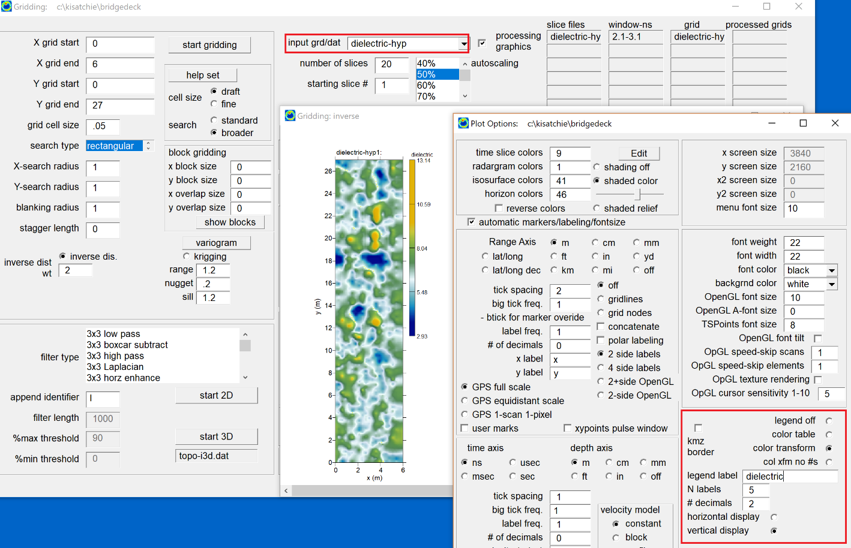
Figure 9b. Dielectric variability map.

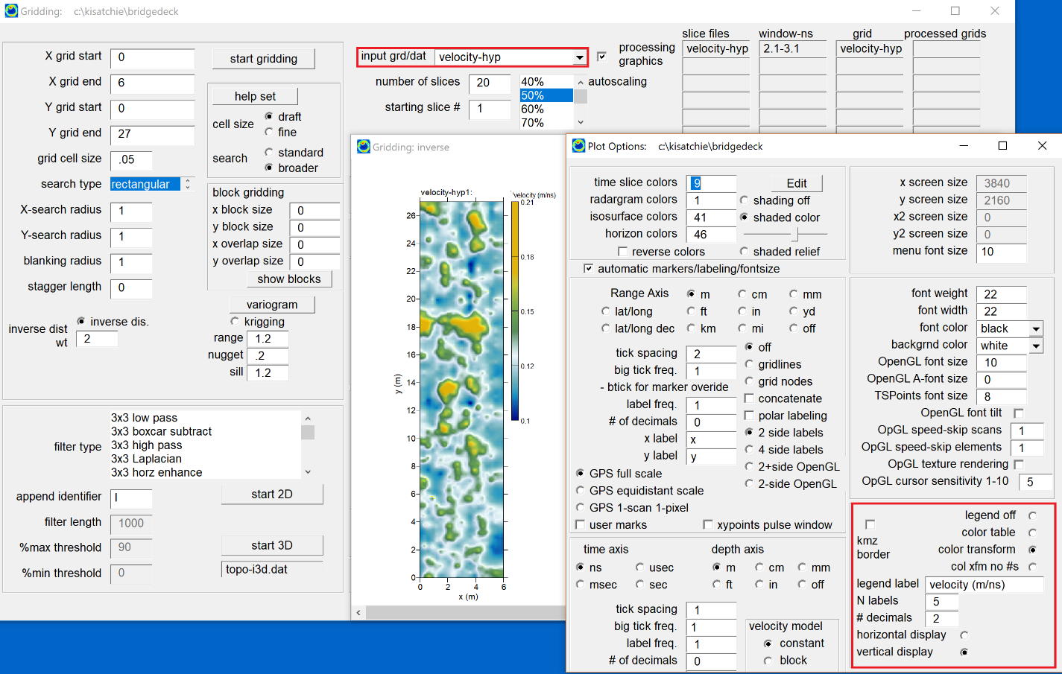
Figure 9c. Velocity variability map.

