GPR-SLICE v7.0
Ground Penetrating Radar Imaging Software

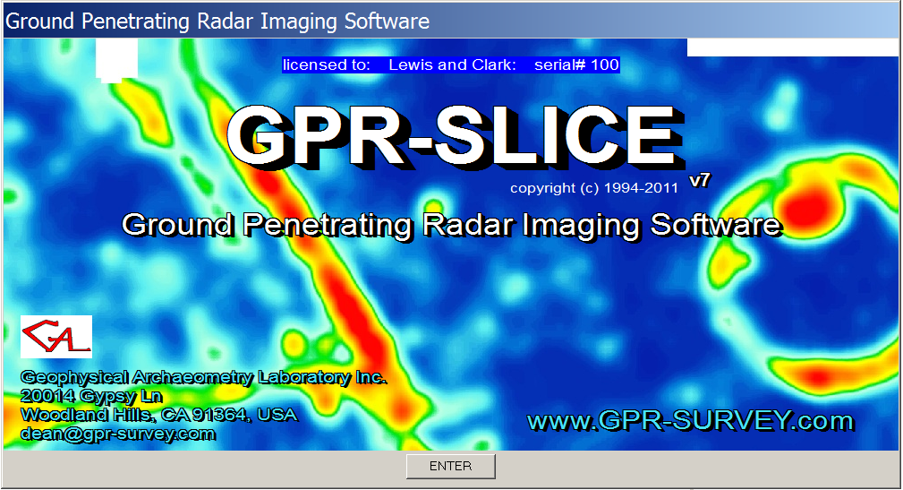
GPR-SLICE Workshop Manual

GPR-SLICE Software
Geophysical Archaeometry Laboratory Inc
20014 Gypsy Ln
Woodland Hills CA 91364
dean@gpr-survey.com
www.GPR-SURVEY.com

GPR-SLICE Workshop Manual
The GPR-SLICE Workshop Manual is designed to teach those fluent in the basic operations of GPR-SLICE v7.0 Ground Penetrating Radar Imaging Software, many advanced features for processing of radar data. The course is expedited using real world examples and specially chosen project folders. The example project folders are for learning the advanced methods and many of these folders were provided by GPR-SLICE users. In this workshop the following topics and examples folders are provided:
1) GPR/GPS surveying with Sensors and Software equipment 3
2) GPR/GPS surveying with GSSI equipment – distance mode 8
3) GPR/GPS surveying with MALA Geoscience equipment 13
4) GPR/GPS Total Station Navigation 18
5a) Image Staggering Correction 21
5b) Image Staggering Correction 2 25
5c) Correcting GPS Latency in Time Slices 28
6) Mosaic Correction 31
7) Topographic Correction 41
8) Topography+Antenna Tilt Correction 50
9) GPR/GPS Elevation Correction 54
10) Horizon Detection and Mapping 59
11) Signal Processing 66
11B) Signal Processing 2 ( + optional GPS issues) 79
12) Overlay Analysis 84
13) Overlay Analysis 2 87
14) XY Surveys 91
15) Importing 2D Geophysical Data 97
16) 0ns Offset Scan-by-Scan Radargram editing and truncation 102
17) Vector Imaging 107
18) Concrete Imaging 2 116
18b) Concrete Imaging – XY decoupled gridding + RSP 119
19) Imaging at Cemeteries 124
20) Imaging at and Historic Cemetery 127
21) ANG surveys with Topography and Vector Extension – complete 3D projection of a 2D radargram over topography. 130
22) Open GL Visualization and Animation Creation 136
23) ANG to Vector with Exact Survey Wheel Information 139
24) Handmarker Navigation 143
25) Georeferencing Local Grids 147
26) Striation Noise Removal 150
27) 2D FFT Grid Filtering 152
28) FK Radargram Filtering 155

1) GPR/GPS surveying with Sensors and Software equipment

Project folder: \kisatchie\ss-gps\ (data courtesy of the Indiana Geological Survey)

Purpose: To introduce how Sensors and Software GPS surveys are integrated into GPR-SLICE software and to show all the steps from using raw GPS tracks to creating time slice datasets.

Basic Information: With every Sensors and Software GPR/GPS survey, a GPS log file with the extension *.gps is created for every radargram. This log file which must reside in the \raw\ folder of a project contains the trace # (in GPR-SLICE referred to as the scan #) followed by a NMEA string.

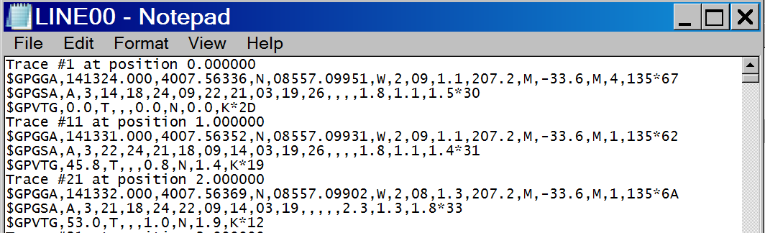

Figure 1 Example of Sensor and Software GPS log files

In this example radargram, every 10 traces and its corresponding NMEA strings are given. There are various NMEA strings available, however, GPR-SLICE uses the GPGGA one for navigation operations. To convert this file to GPR-SLICE format, various quick utility buttons are available in the Edit Info File menu. For this /ss-gps/ example, the user will click on the SS to UTM button in the Edit Info File menu (see next screen shot).

The SS to UTM button will convert the entire *.gps log file for each radargram and generate a *.dt1.gps file which is a 20 column format and is

eastings, northings, elevation, “time”, scan #, gps quality, n satellite, hdop, vector-x, vector-y, vector-z, +9 0s for future growth

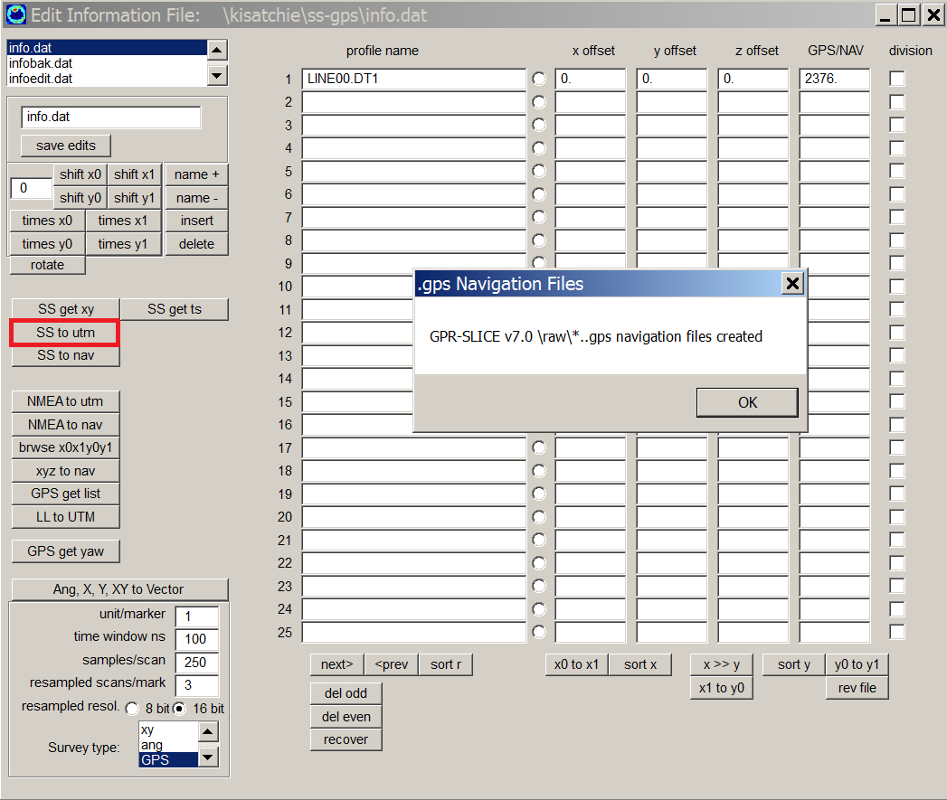

Figure 2 The SS to UTM followed by the GPS Get List operation generates the necessary *.dt1.gps file for further GPR-SLICE processing.

The \ss-gps\ example is a single continuous GPR/GPS survey in which only one radargram was collected over a site at the Indiana Purdue University Strawtown Archaeological site. GPR-SLICE reads the GPGGA NMEA string and converts the latitude and longitude to UTM. An example of the *.dt1.gps file which is written into the \raw\ folder of the project and the GPS track map is shown in the next figures:

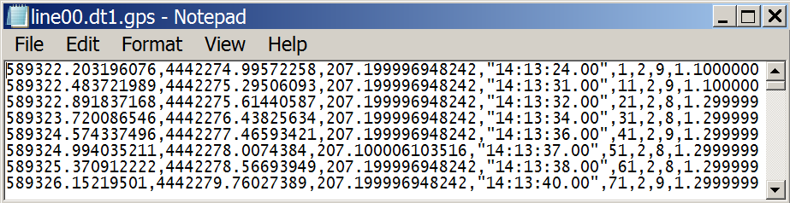
Figure 3 Example of a *.dt1.gps 20 column GPS navigation file.

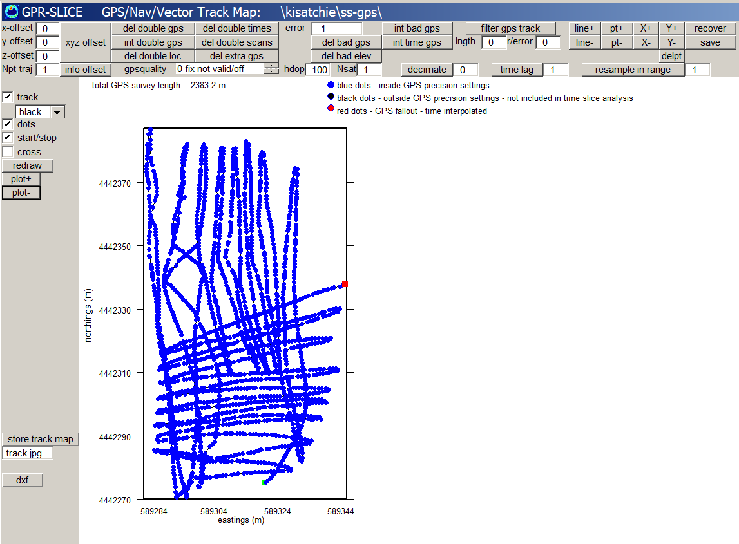
Figure 4 GPS track map

In this example the HDOP and the NSAT in the track menu are artificially set so that all the GPS points appear as blue; black dots would indicate navigation precision outside the desired precision and these data do not get included when time slice data are compiled.

To continue GPR-SLICE processing with this dataset, one continues to the Navigation menu, then uses the option GPS Trace # navigation option (see next screen shot). The GPS Trace # operation, will read the *.dt1.gps files and extract the 5th column scan # as the location where navigation markers are located and where navigation exists:
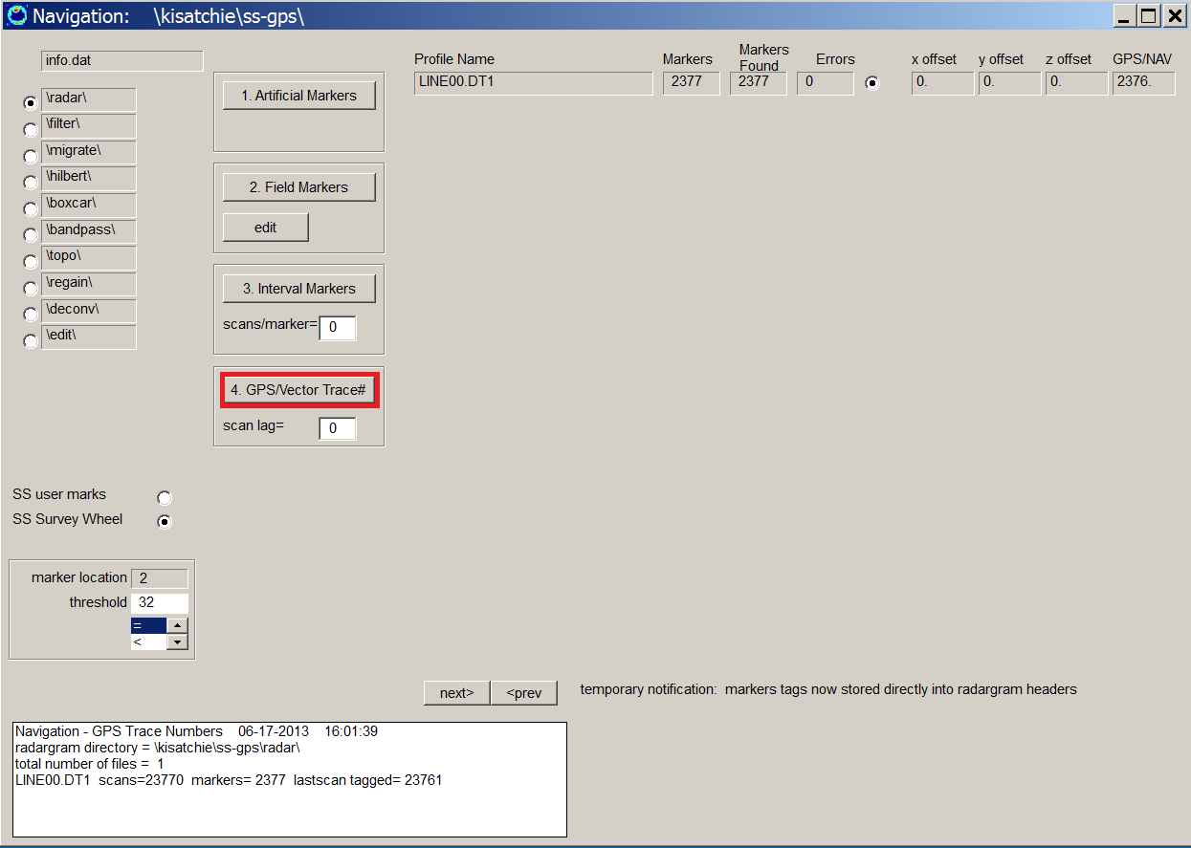

Figure 5 Clicking the GPS Trace # will generate the correct marker files which tag the scans numbers with GPS readings.

After this, the user continues on to do normal slice/resample operations. An example of some 2D GPS time slices for this site:

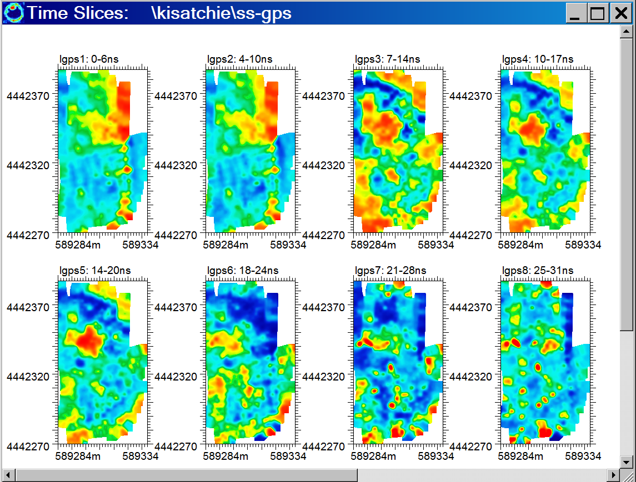

Figure 6 Strawtown site, 2D GPS time slices.

2) GPR/GPS surveying with GSSI equipment – distance mode

Project folder: \kisatchie\gssi-tstamp\ (data courtesy of Mark Villa, Geophysical Survey LLC – not for distribution beyond the training course*)

Purpose: To introduce how GSSI GPR/GPS surveys are integrated into GPR-SLICE v7.0 software and to show all the steps from using raw GPS tracks to creating time slice datasets. In this example time stamps are inserted at constant intervals into the log files by the survey wheel.

Basic Information: With every GSSI GPR/GPS survey, 2 GPS log files, a *.plt file and a *.tmf extension is created for every radargram. The *.tmf file contains timing information when the radargram started and stopped. The *.plt is a GPS log file which contains a whole list of NMEA. The *.plt will normally contain GPS logging information before and after a radargram was recorded. Using the GSSI Tstamp button in the Edit Info File menu, GPR-SLICE will read the *.tmf for the time stamped GPS readings and will extract these scan locations and find the linearly interpolated locations between bordering GPS listings in the PLT file. The process will automatically create the *.dzt.gps files (Figure 1). The key in the GSSI Tstamp solution is that the 5th column of the *.dzt.gps files have the scan #s associated with the time stamped GPS reading (Figure 2). The track for this example is given in Figure 3.

To continue the processing steps to generate time slices for GSSI GPR/GPS surveys it is imperative that the navigation option #4 GPS/Vector Trace # navigation be implemented (Figure 4).
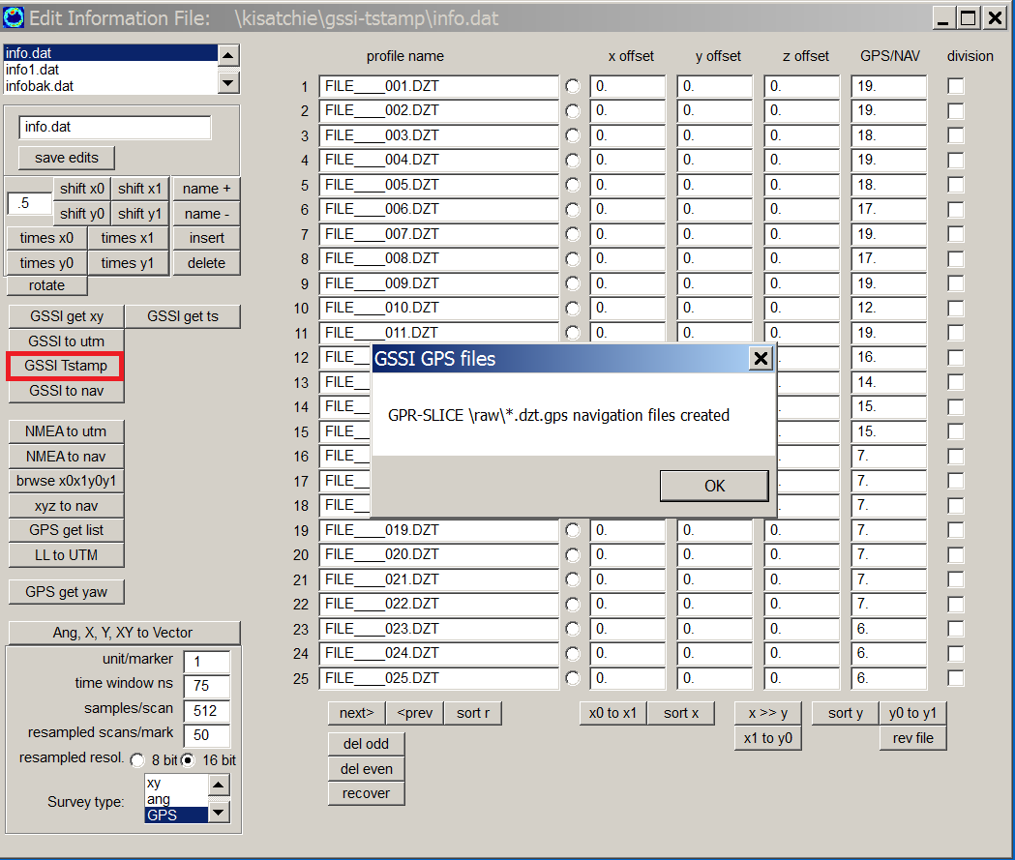

Figure 1 Location of the GSSI Tstamp to extract and convert the necessary information from the *tmp and *.plt files to generate the *.dzt.gps files.

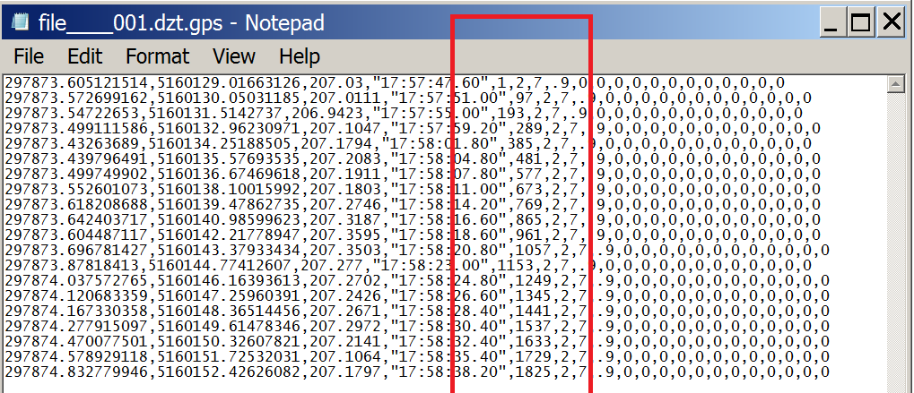
Figure 2 Example of the *.dzt.gps file generatee from the clicking the GSSI Tstamp button. Note, that the 5th column has the scan #’s where GPS tags time stamps are logged at constant intervals every 96 scans.

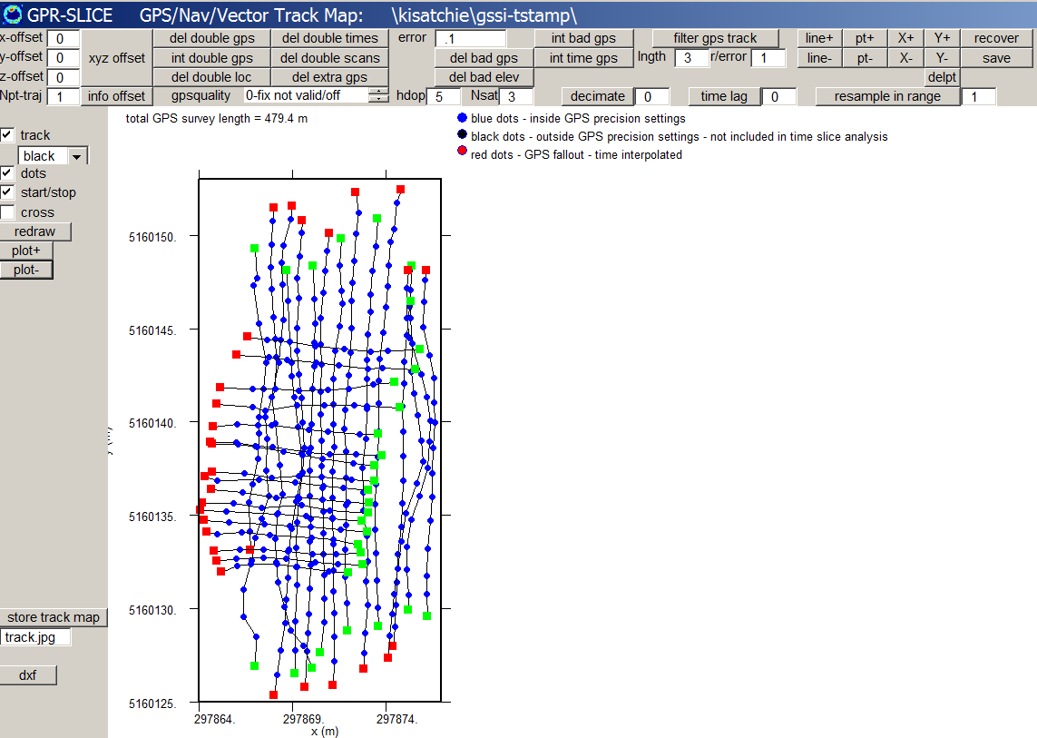

Figure 3 The GPS track for the GSSI-Tstamp navigation solution.
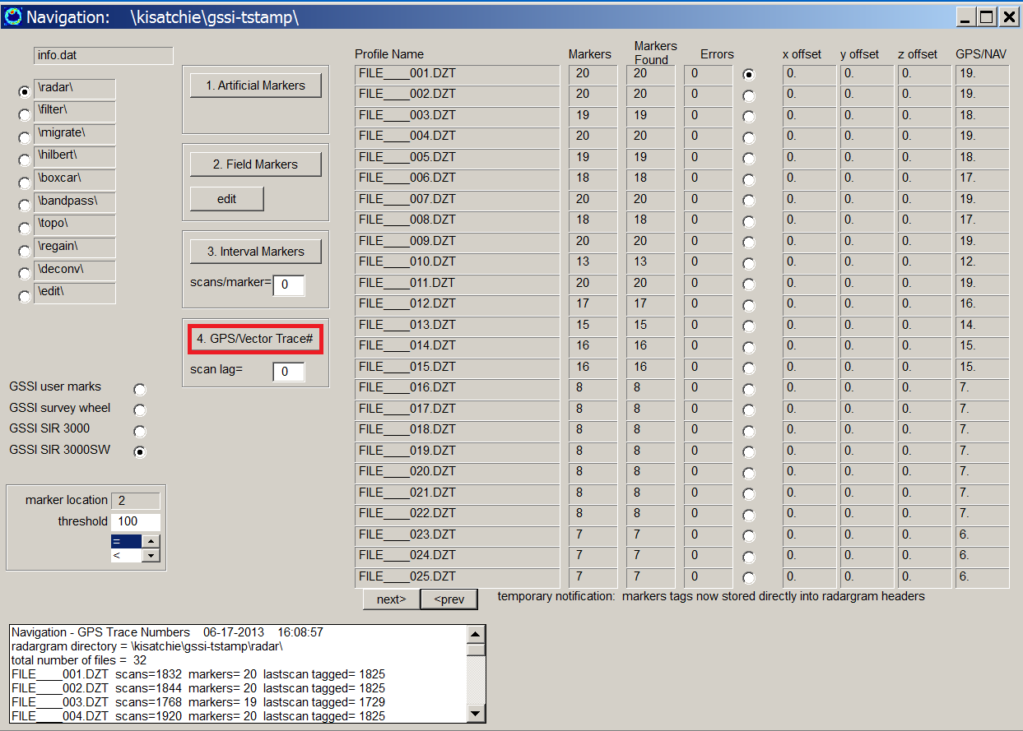

Figure 4 For GSSI GPR/GPS surveys, the GPS/Vecotr Trace # navigation must be used.

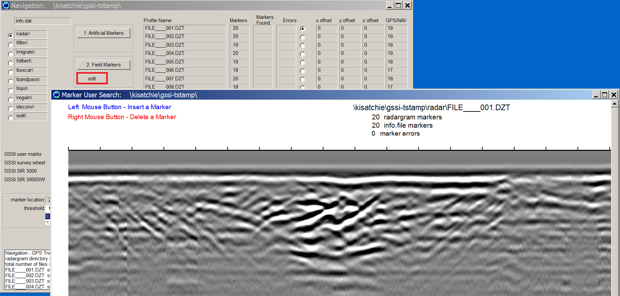
Figure 5. An example diagnostic shows the GPS tags that correspond to constant intervals markers created with the survey wheel.

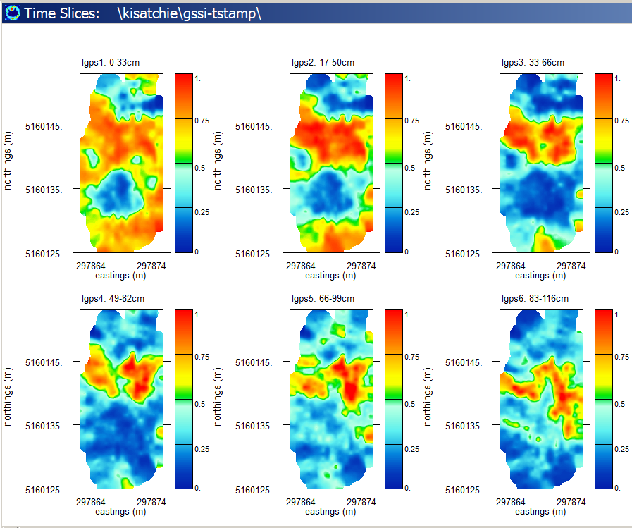

Figure 6. Example of time slices made using time stamped GPS with the GSSI equipment.

3) GPR/GPS surveying with MALA Geoscience equipment

Project folder: \kisatchie\mala-gps\ (data courtesy of the Allan Gontz, University of Massachusetts)

Purpose: To introduce how MALA Geoscience GPR/GPS surveys are integrated into GPR-SLICE v7.0 software and to show the essential steps from using raw GPS tracks to creating time slice datasets. Also to show the options for doing basic filtering of GPS tracks.

Basic Information: With every MALA GPR/GPS survey, a *.cor GPS log files is created for every radargram. An example of a *.cor file which resides in the \raw\ folder is shown in Figure 1. The *.cor file contains the scan # in the first column along with the date, time, latitude, longitude, elevation and other information. Clicking the Mala to UTM button in the Edit Info File menu will generate a *.rd3.gps files containing the converted 20 column standard format file in UTM used for GPR-SLICE processing (Figure 1). Artificial settings for the GPS quality, HDOP and the Number of Satellites can be made to insure all the points are included in the analysis.

The raw GPS track map (Figure 2 – top diagram) shows some round off in ground locations, and this may be a result of the accuracy or the number of latitude and longitude decimals outputted in this early generation raw gps log *.cor file from Mala. There are options to filter the gps log file. In the Track menu, one can see several points that are wayward and are in error. Using the Del Bad GPS point button, one can continue to decrease the error till some bad points are discovered. If there are any errors discovered a message box will come up and say this, and the GPS track menu will also get updated. Using an error of .00005 several of the errant points are discovered and removed (Figure 2 – bottom diagram). (Reducing the acceptable error below this will begin to remove some good points). Where to stop the error process may be left up to the user to determine the acceptable track errors for imaging. After bad points are removed, one can continue to filter the track by using a moving filter (Figure 2 - bottom).

Because MALA GPR/GPS *.rd3.gps files have the scan number in the 5th column, the GPS Trace # navigation option should be used to continue the slicing process (Figure 3). A screen shot of the gridding menu used to generate MALA GPR/GPS 2D time slices of is shown in Figure 4.
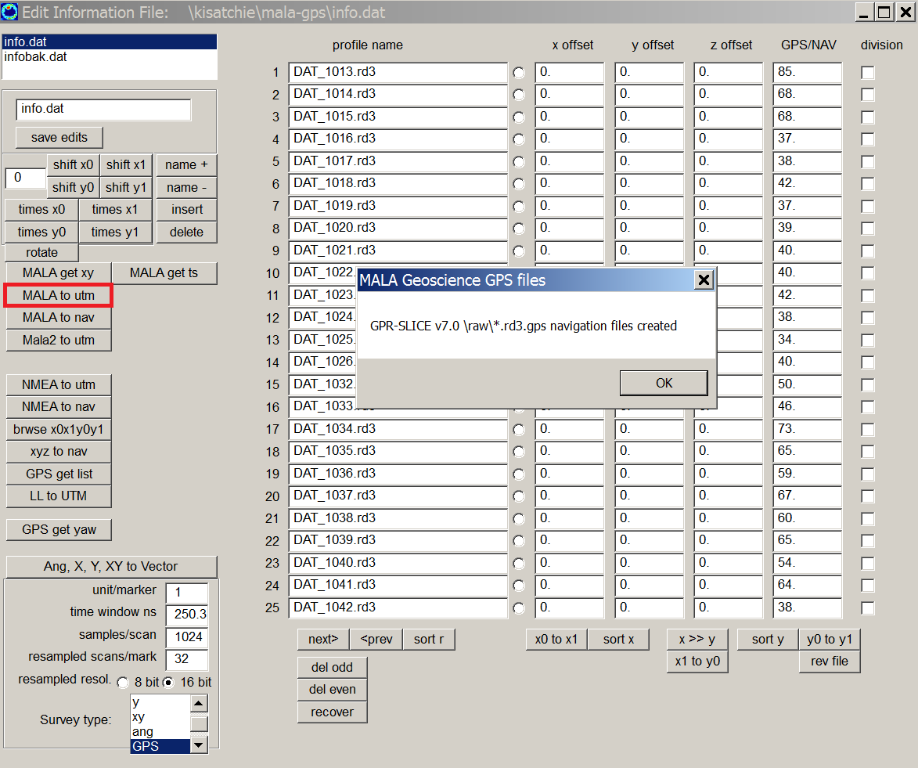
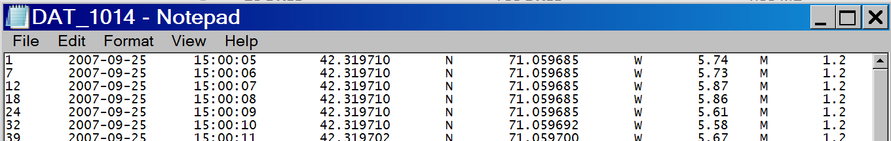
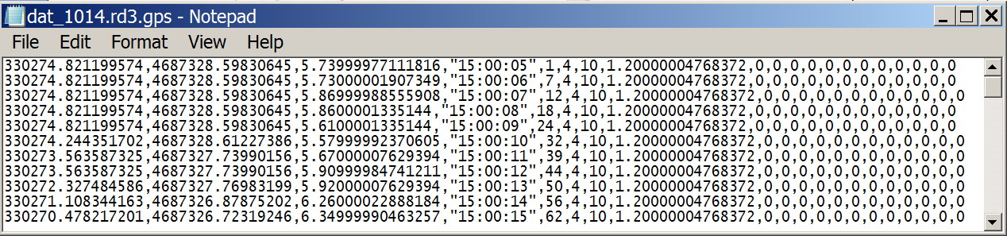
Figure 1. Example of the Mala to UTM button to convert *.cor navigation files in the Edit Info File menu to the standard 20 column GPR-SLICE *.rd3.gps files.

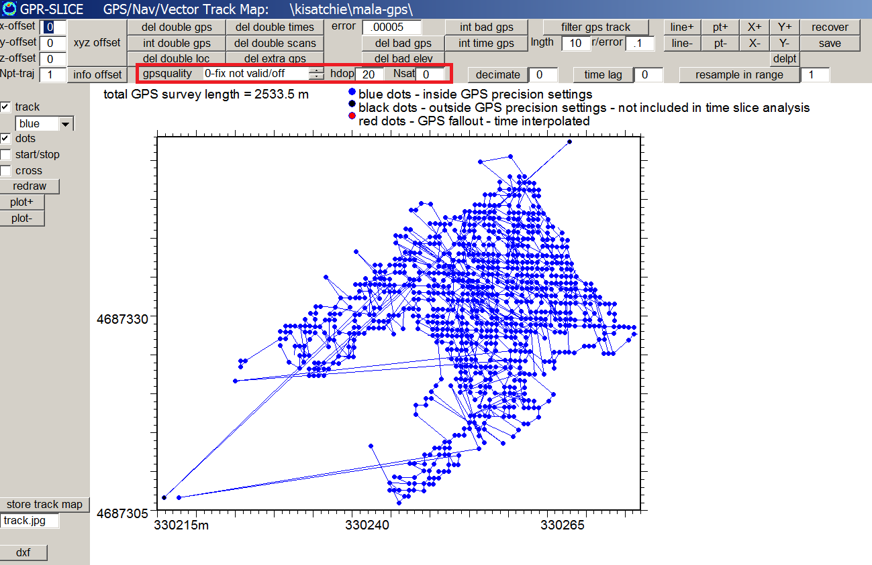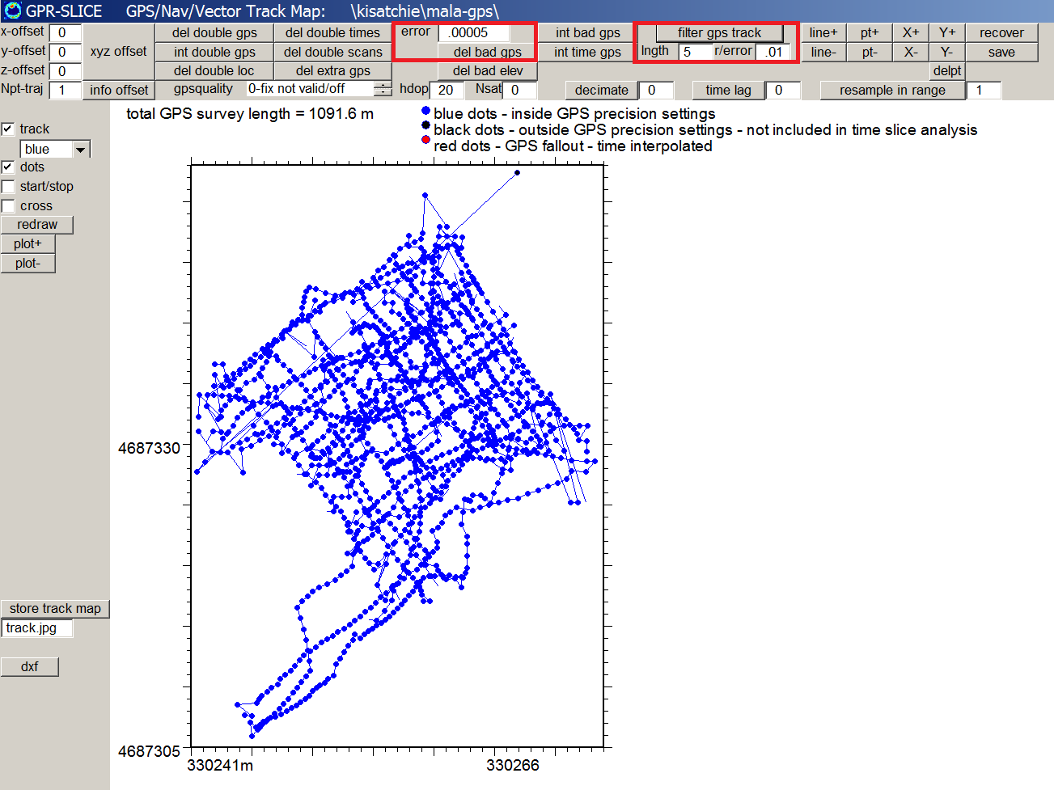

Figure 2. Raw GPS track map (top diagram) and one that is filtered using the Del Bad GPS with an error from the average of .00005 and a moving Filter with a length of 5 and an r/error of .01 (bottom diagram).

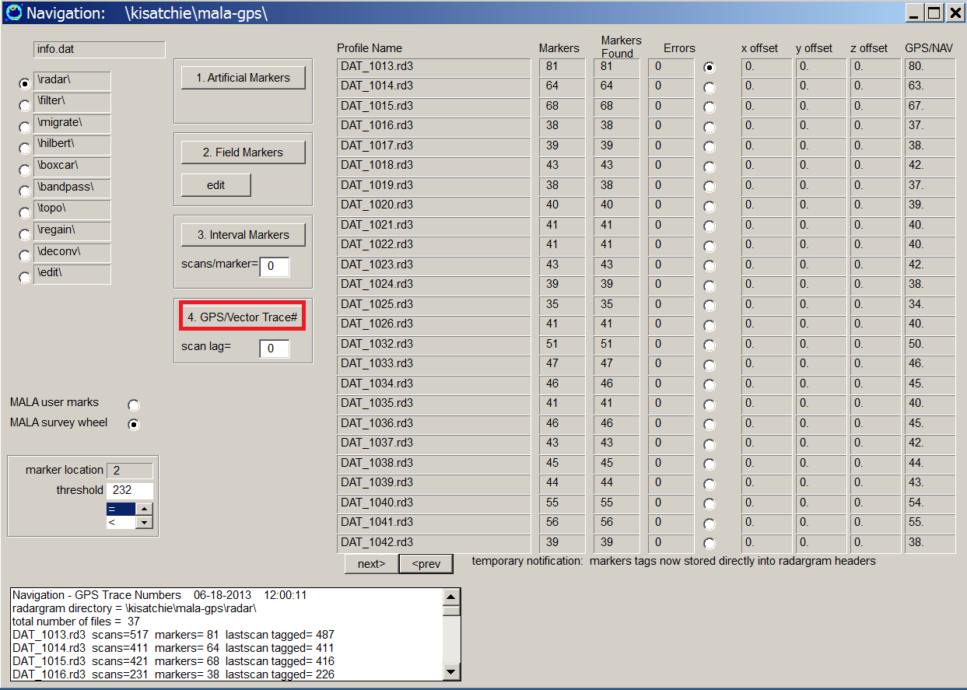

Figure 3. MALA GPR/GPS navigation is applied using the GPS Trace# option in the Navigation menu.

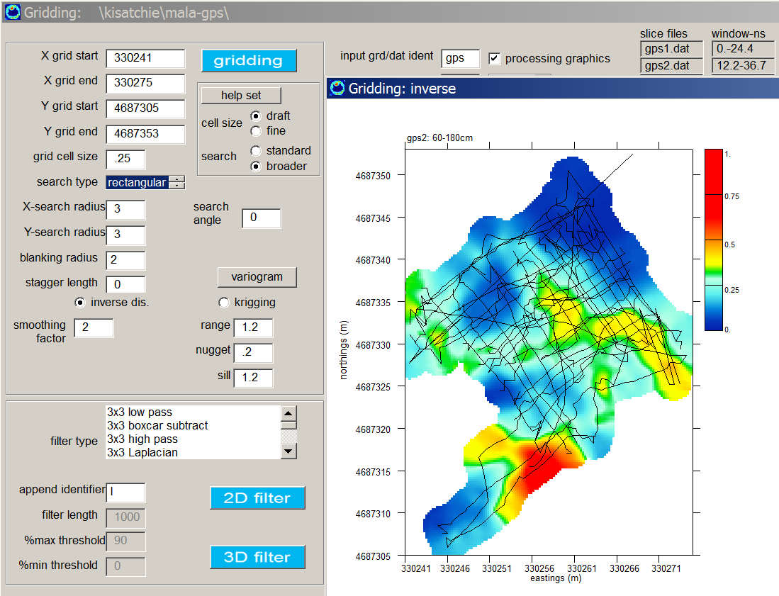

Figure 4. Example of the gridding menu use to generate GPs time slices for project \kisatchie\mala-gps.

4) GPR/GPS Total Station Navigation

Project folder: \kisatchie\ss-nav\ (data courtesy Brian Herridge/Erik Kitt 3DGeophysics.com)

Purpose: To introduce how Sensors and Software total station surveys are integrated into GPR-SLICE software and to show all the steps from using raw total station tracks to creating time slice datasets.

Basic Information: Total station navigated GPR surveys are possible with GPR-SLICE v7.0. Total station surveys are identified in the Create Info File menu with the * to Nav buttons where the * would be the different manufactures name. In general, for all the total station projects the log files are usually identical to the GPS log files except the lat/long/elevations are replaced with X,Y and Z. The total station log files have similar navigation operations to convert the log file to the standard GPR-SLICE 20 column navigation files except that UTM conversions are not done – the X, Y and Z are written directly into the *.*.gps files.

An example Sensors and Software total station project is shown but noted that other manufactures processing have identical operations. For Sensors and Software total station GPR survey, a GPS log file with the extension *.gps is created for every radargram. This *.gps file looks identical to the *.gps files generated for real GPS navigation – only that the local x, y and z coordinates of the survey replace the latitude, longitude and elevation slots in the NMEA string (Figure 1). Clicking the SS to Nav button in the Edit Info File menu (Figure 2) will generate the same 20 column standard GPR-SLICE *.dt1.gps file with: total station x, total station y, total station elevation, “time”, scan #, etc. (Figure 1). The total station GPR tracks for this project are shown in Figure 2. The navigation GPS/vector trace# navigation operation is applied for the total station data since scan numbers for each know navigation position from the total station measurement has been recorded. Example time slices are shown in Figure 3.

Note: Other manufacturers will have similar operational buttons in the Edit Info File menu such as GSSI to NAV, Mala to Nav…etc. for total station operations.

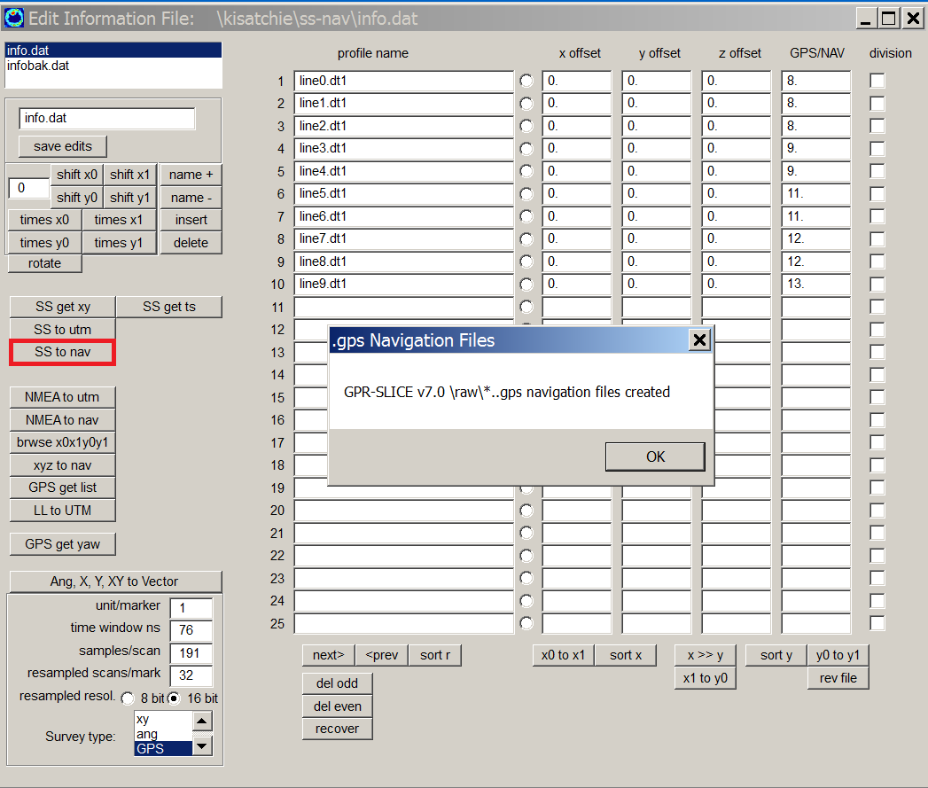
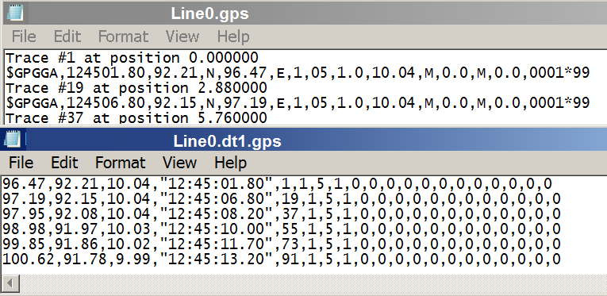
Figure 2 Generating *.dt1.gps files from total station Sensors and Software GPR surveys is accomplished by clicking the SS to Nav button that will convert the *.gps log files to the standard 20 column navigation format in GPR-SLICE.
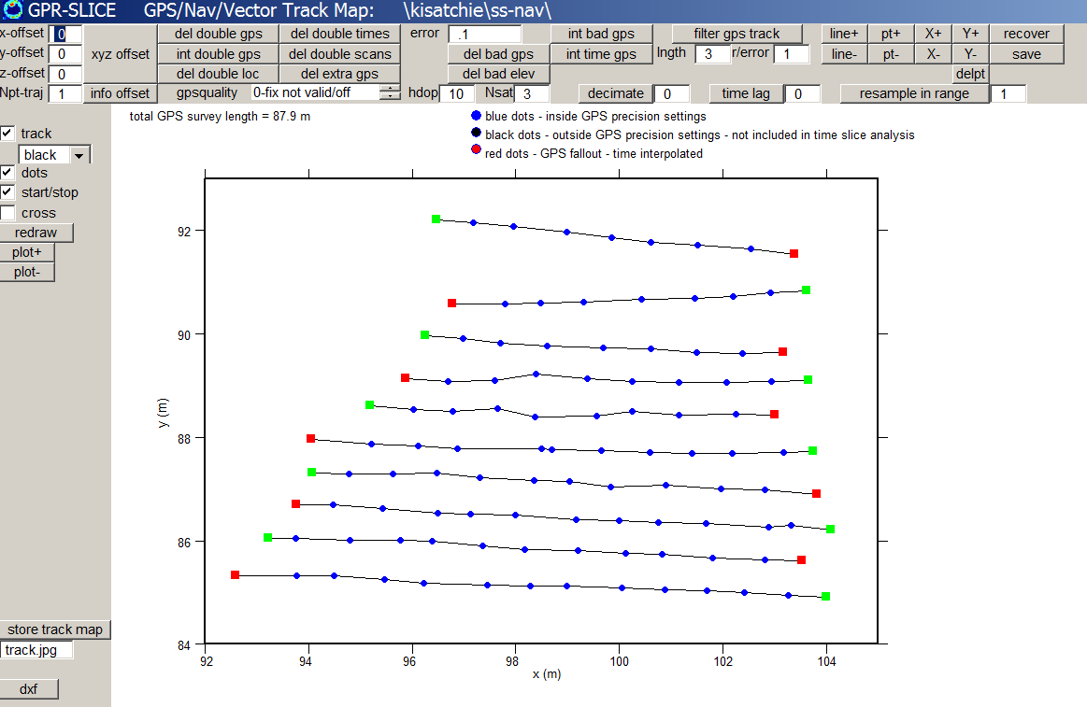

Figure 2. Total station GPR tracks for project \kisatchie\ss-nav\.

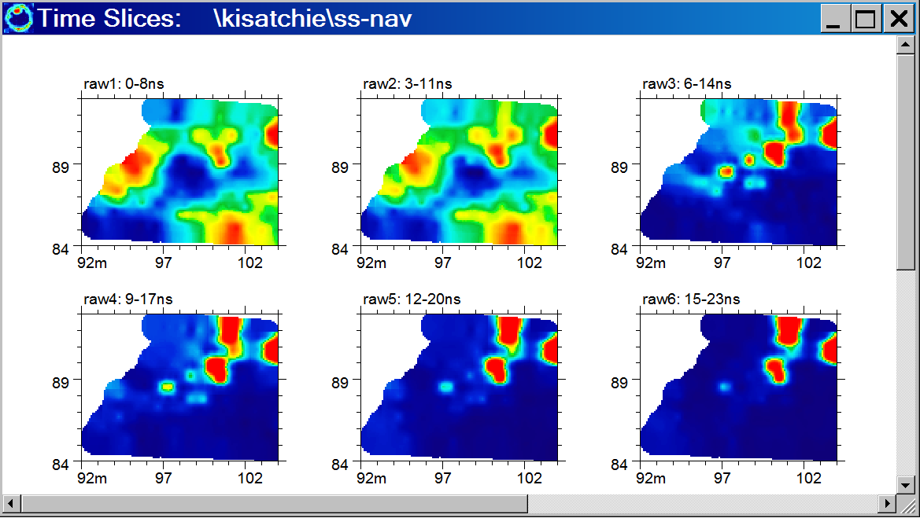

Figure 3. Example of GPR time slices generated from total station GPR tracks for project \kisatchie\ss-nav\.

5a) Image Staggering Correction

Project folder: \kisatchie\staggering\

Purpose: To have the users identify staggering noises in their images and to identify the steps needed to correct for these problems.

Basic Information: Staggering noises with GPR surveys normally result from small location errors in reflections recorded on zig-zag surveys. The errors can be present in hand markers, survey wheel surveys, and even in GPR/GPS surveys. The basic staggering correction process begins first with identifying these errors. Shown Figure 1 is are raw time slices (from the Chillicothe Site in Ohio as part of the National Park Service in Archaeological Prospection from 2005). The image shows some zig-zag staggering noise fairly clearly (across this Indian wall enclosure). To remove the staggering noise, the files that were collected in the reverse direction need to be active in the Reverse menu (Figure 2). If there were no lines checked on, then the staggering correction/stagger length will not have any effect. Likewise, if the incorrect lines are checked on the staggering correction will be incorrectly applied. If this file needs to be adjusted you can check the boxes on and off in the menu then use the Save Edits button – without running the reverse operation – to save the info*.rev file.

With all the elements in place, the staggering correction is implemented by placing an estimated staggering length in the Grid Menu, and re-running the gridding calculation (Figure 3). For this example, a stagger length of 0.8 (m) was estimated and found to give the best results for correcting for the staggering. A comparison before and after is shown in Figure 4.

Note: Differential staggering can also be applied to a dataset. Differential staggering is when staggering is not constant across a site. Differential staggering can be implemented by using a customized reverse file menu and then applying this in gridding operation. For an example on this seeing this the GPR-SLICE Newsletters, please look at the August 2007 newsletter.

Important Note: If the correct reverse information file is not active in the Reverse menu, the software will abruptly terminate if staggering is being implemented in the Grid menu. The correct reverse file must first be active in Reverse menu for staggering operations to work.
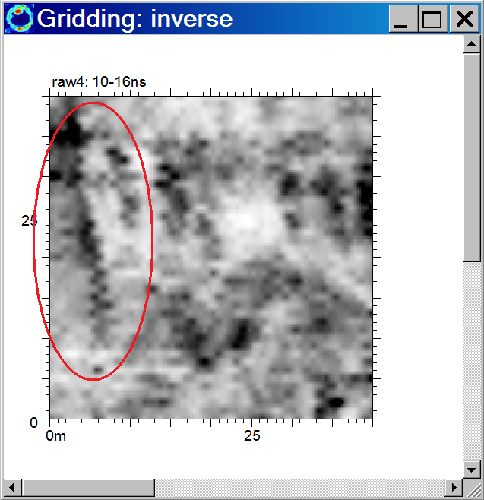

Figure 1. Example of staggering noise in a raw time slice.
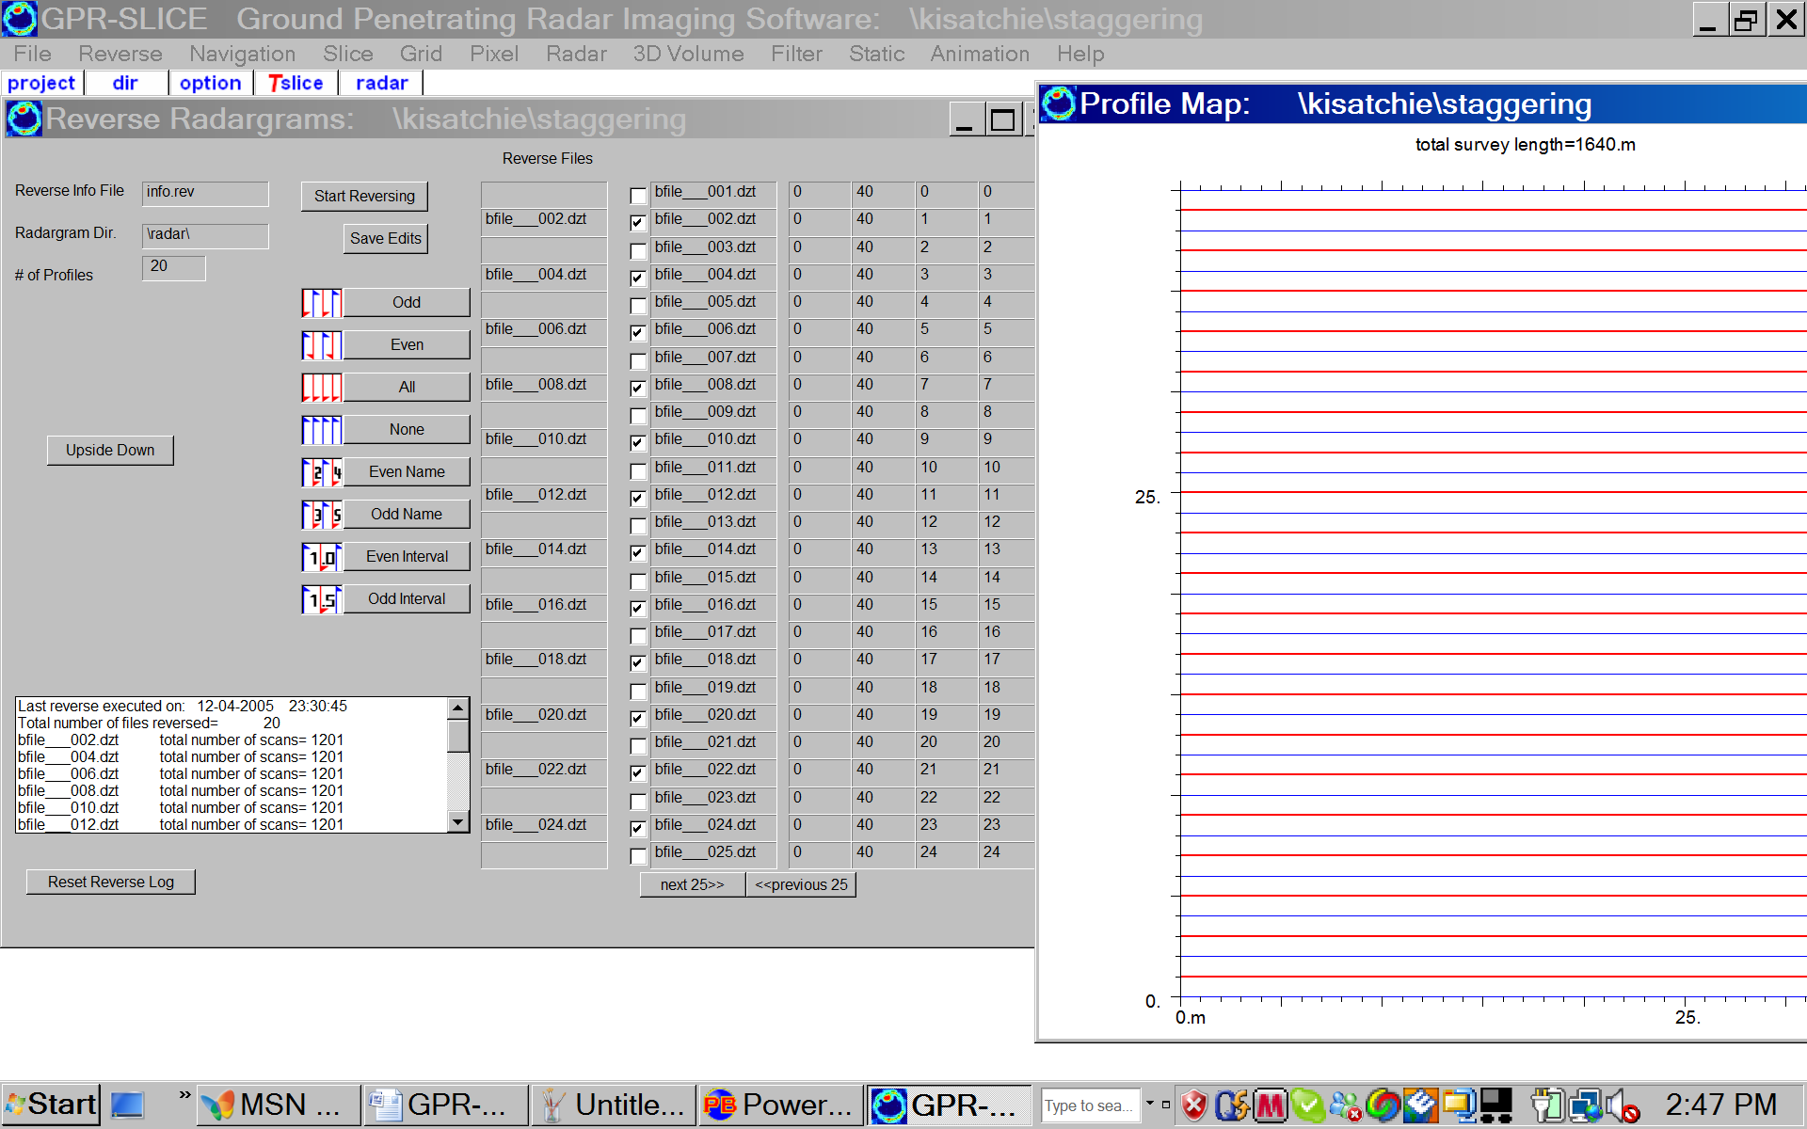

Figure 2. The active information file showing the reversed lines checked on, are the lines that are used for staggering correction.

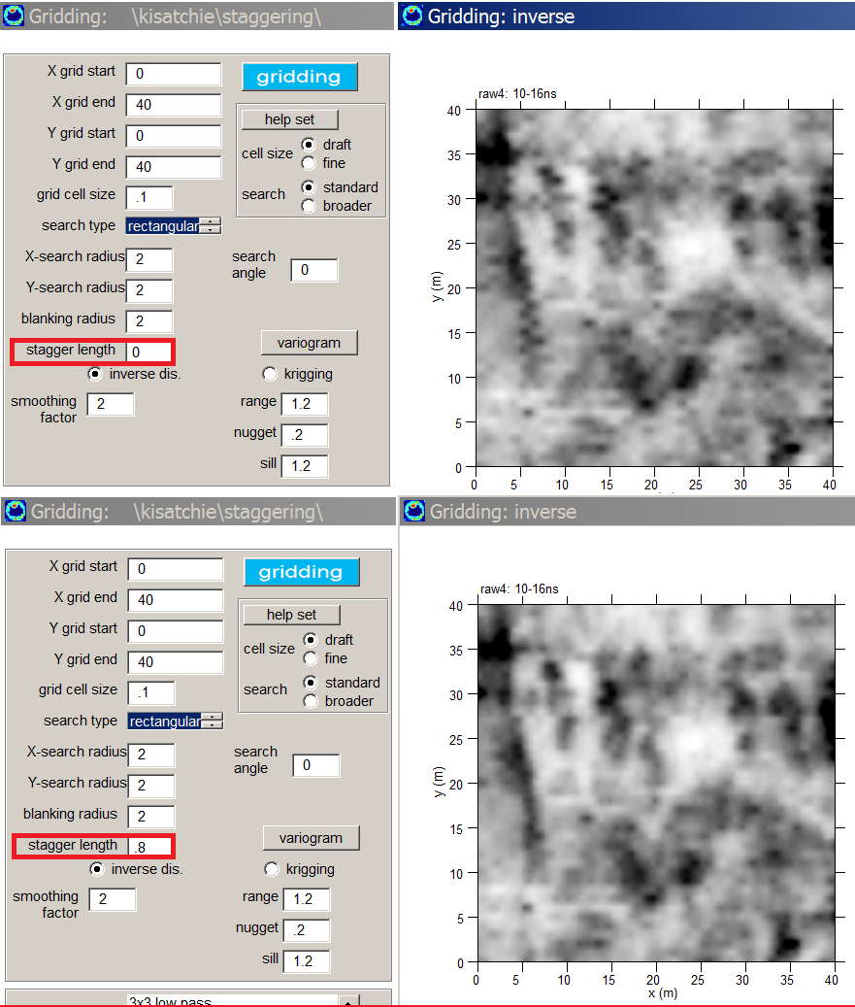

Figure 3. A time slice with staggering noise (top diagram) is shown with a staggering corrected time slice (bottom diagram) for operations in the Grid menu. The correction is implemented by inserting a stagger length of 0.8 m for this dataset.

5b) Image Staggering Correction 2

Project folder: \kisatchie\staggering-2\

Purpose: To introduce to users the different options for correcting for staggering and to recognize staggering in less obvious datasets.

Basic Information: Staggering corrections can often be less obvious in the time slice dataset. An example is shown below for the first 3 time slices from a site (Figure 1) where both raw and background filtered time slices were made. Because of the line streaks seen in the raw slices, the background filtered time slices are also made, although this filter does not completely fix the line noises.

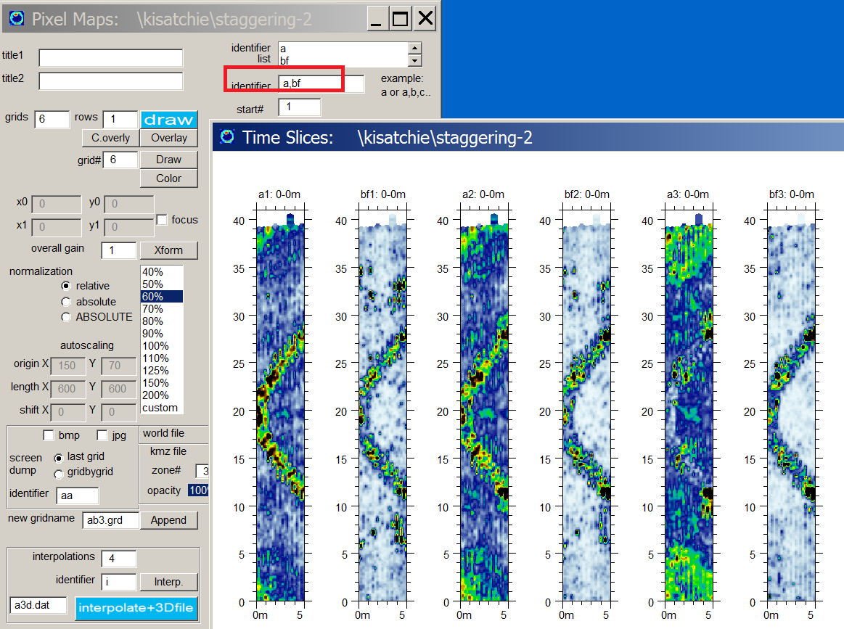

Figure 1. Example of raw and background filtered time slices shown side-by-side. (Data courtesy of University of South Florida, Dr. Sarah Kruse).

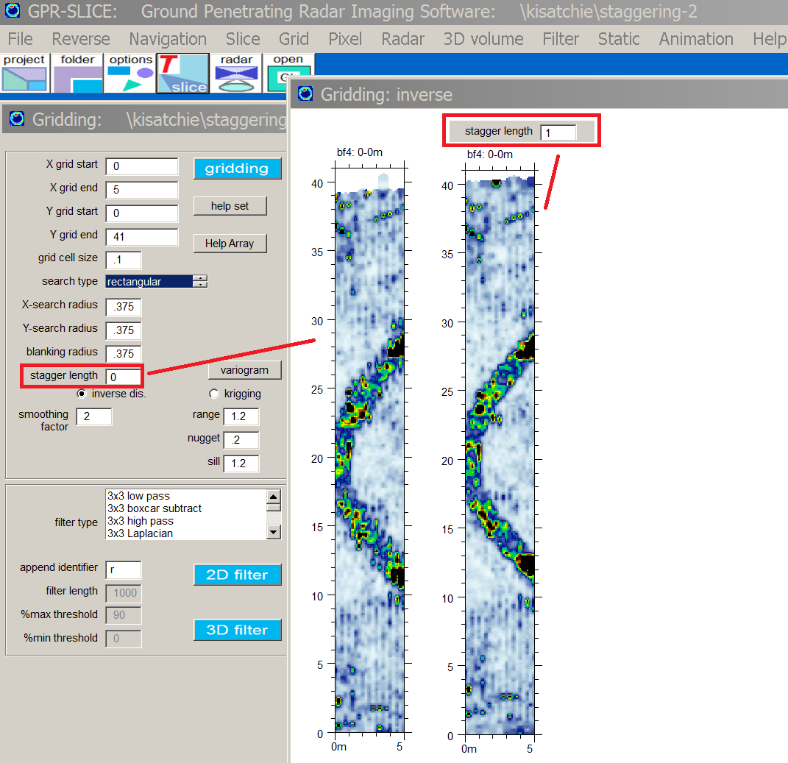
Figure 2. Comparison of raw and staggered corrected time slice made from background filtered radargrams.

The background filtered time slices are “corrected” for staggering using a value of 1 meter. An example of the staggering correction on one of the background filtered time slices is shown with a comparision of the original without staggering applied (Figure 2)

Using a simple 5x5 low pass grid smoother, the effects of minor striping in the time slicesst can also be reduced.
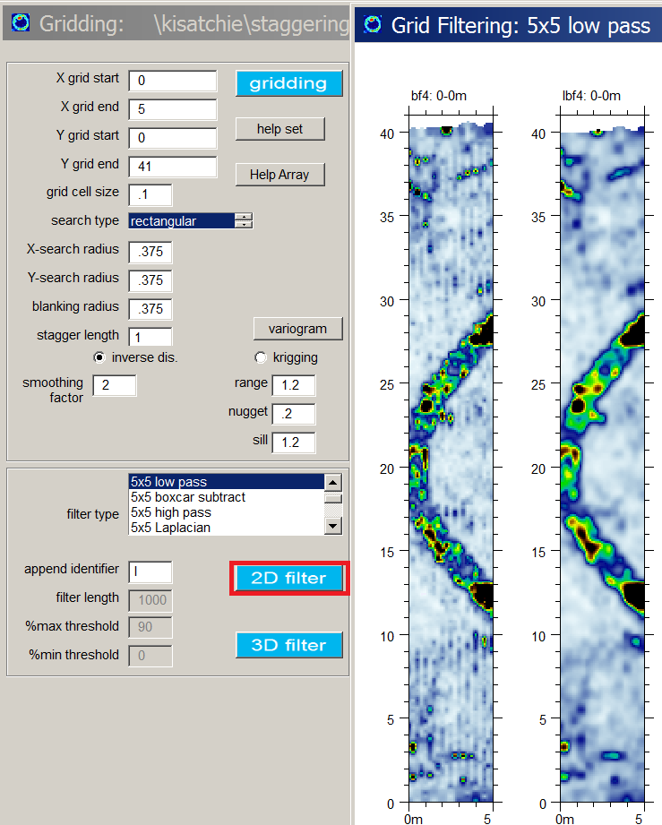

Figure 3. A 5x5 low pass filter is applied to the staggering corrected time slice.

5c) Correcting GPS Latency in Time Slices

Project folder: \kisatchie\GSSI SIR 4000 GPS Latency\

Purpose: To introduc the different options in GPR-SLICE for removing staggering/latency in time slice imagery.

Basic Information: Regular XY surveys can have staggering noises as seen in the 2D time slices, but so can GPS surveys as well. GPS staggering can be seen in time slices made with zig-zag GPS surveys (Figure 1). The staggering can be caused by 3 different kinds of navigation issues:

- incorrect XY offset being applied to the GPS track between the antenna and the GPS receiver
- GPS sync between the radar scan and the GPS log file can be off by some phase/time which is referred to as GPS latency
- A constant scan lag between the recorded radar scan and the tagged GPS listing

GPR-SLICE can handle any of these methods for correcting the navigation using the GPS Track menu. Which correction exists for one’s data however, the user will need to empirically determined what is causing the lack of syncing between the GPS and the tagged radar scans and make the appropriate fix.

The example data for an SIR 4000, the correction needed to fix this data was found to best be accomplished via GPS latency corrections in GPR-SLICE. A GPS latency correction of 0.75s is applied to the GPS track and saved in the menu (Figure 2). After the track is adjusted, the Navigation menu must be rerun and the slice/xyz operations run as well to compile corrected time slices.

Using the comma delimited identifier option in the Pixel Map menu, the corrected and uncorrected time slices can be shown side-by-side (Figure 3).

Note: It should be mentioned that to test if one’s systems has GPS latency, that zig-zag surveys needs to be made across linear features to identify this problem. If the saw-toothed pattern across known linear reflectors is seen, then staggering can be diagnosed. Without a zig-zag survey all the reflections form parallel lines will be shifted by equal amounts in the same direction and the staggering will not make itself apparent!
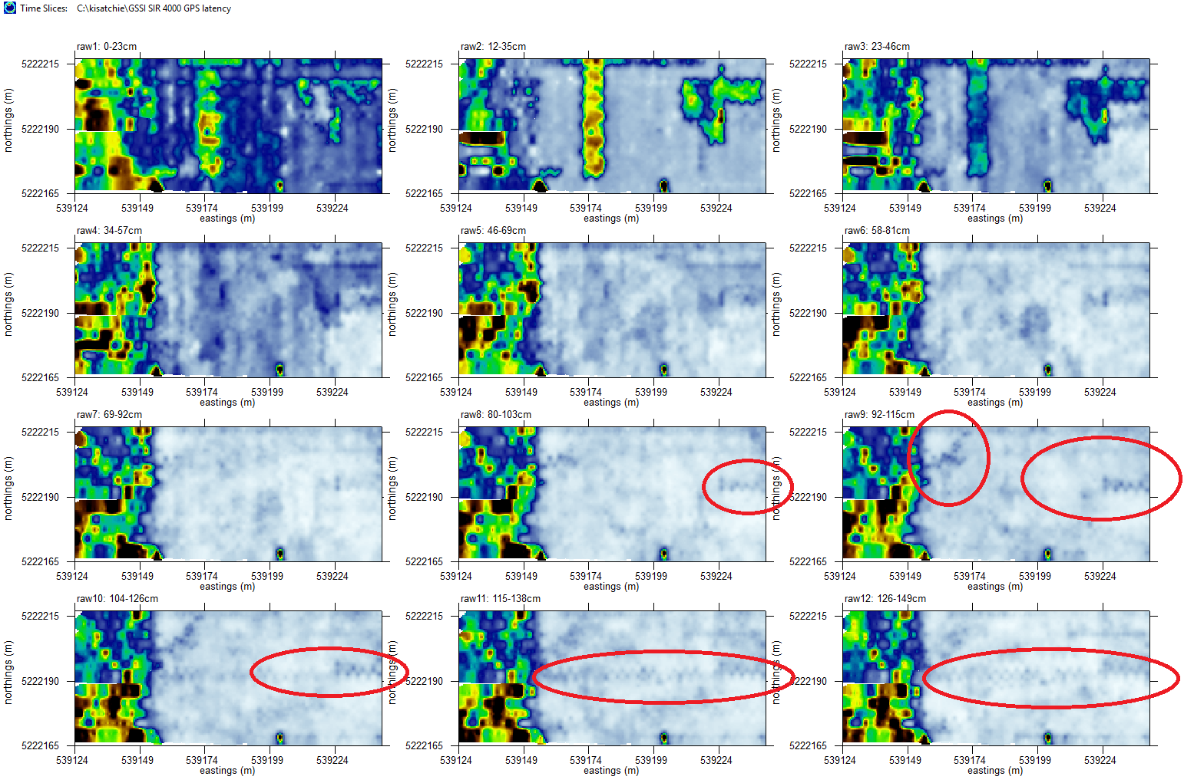
Figure 1. An example dataset showing how GPS staggering might look on time slices were zig-zag GPS surveys are being made.

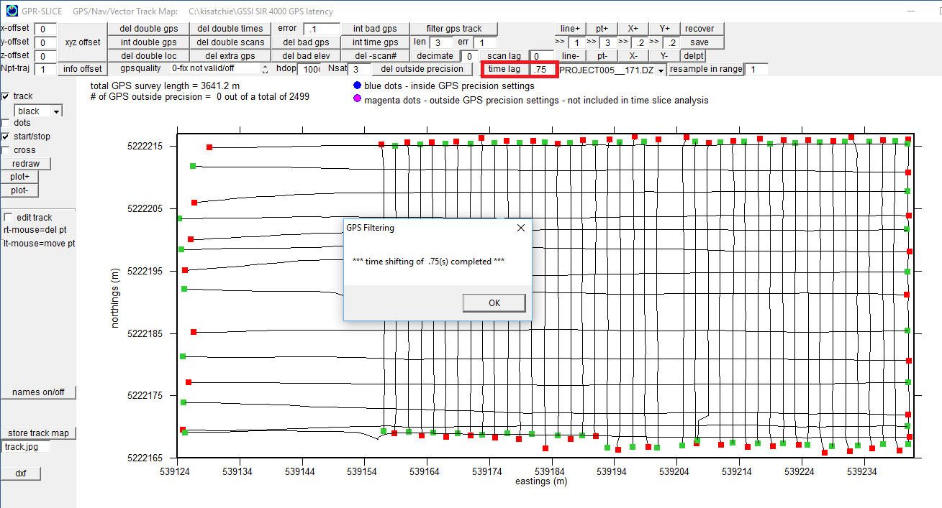
Figure 2. Location in the GPS track menu to make adjustments for GPS latency. In this example a latency of 0.75s is used to adjust the GPS navigation tracks to account for observed staggering in the time slices.

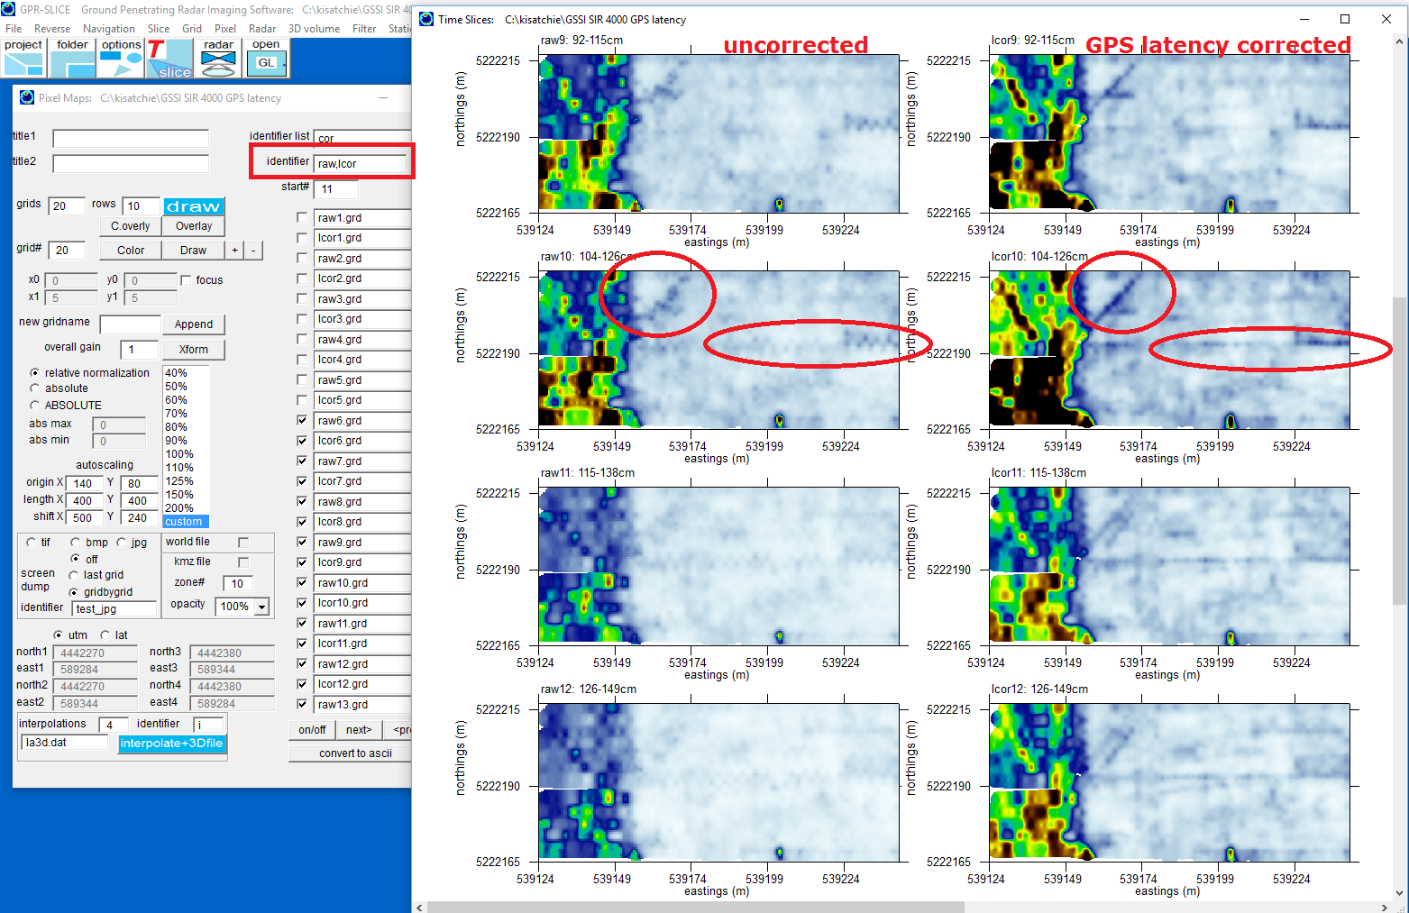
Figure 3. Comparison of corrected and GPS latency corrected time slices.

6) Mosaic Correction

Project folder: \kisatchie\mosaic\

Purpose: To introduce to users the different options for removing mosaic noises from multi-grid surveys.

Basic Information: Many multi-grid surveys show mosaic noises between different blocks of data. These can be caused by varying ground conditions between surveyed sites, equipment changes, or even user induced mosaic noises caused by dissimilar control unit settings or differences in field acquisition. Whatever the causes are, these noises distract from viewing continuous anomalies across large areas. An example of noises for the top 4 time slice at the Kumuibaru Site in Okinawa Japan is shown in Figure 1. To remove these noises, 4 different methods are examined:

1) 0 mean grid
2) 0 mean line
3) Transform matching
4) Mouse block capture and gain adjustment + a new option to Re-grid

To examine these different mosaic correction options, 4 different time slice xyz data have been generated for the Kumuibaru site in Okinawa Japan. 0mg*.dat files represent 0 mean grid time slices. To use 0 mean grid options, user must set the division in the Edit Info File menu where different blocks of data with differing gain are observed (Figure 2). The divisions must be set for the first file, and for the beginning radargram for each block with different gain. In this example only 2 areas with different gain are observed. The mosaic noise begins at y=19.5m as shown in Figure 1. Two divisions for file40 and file79 are set and saved in the Edit Info File menu (Figure 2). With these settings the 0 mean grid XYZ time slice creation can be generated (Figure 3). At the same time we can also generate the 0 mean line XYZ time slices using the identity 0ml (for example) to test this calculation.

0 mean grid is a simple analysis that will calculate the average reflection value in the time slice between the different divisions on the site that are defined, and will subtract this value from every data in that specified division. 0 mean line will do the same sort of calculation, but here the average reflection value from each individually profiled line across the site is subtracted from each individual line. Examples of gridding from the top time slices for 0 mean grid and 0 mean line is shown in Figure 4. Note, this data also has staggering noise. A value of 0.9 staggering length for correcting this problem is also used in the final gridding results.

A 3rd method to remove mosaic noises I call transform matching. This is a touch more involved but can often give far superior results than 0 mean grid and 0 mean line calculations. In this method, a separate time slice grid is made for each site using different information files. The A grids and the B grids, or however number of areas that have mosaic noises are individually calculated. The next step is to display these 2 grids in the Pixel Map menu, adjust the transforms till a match between the areas is made (Figure 5), and then append the grids to a common grid using the Append button in the Pixel Map menu (6). For transform matching, using the Auto Gain All button in the Transform menu for matching works fairly well in balancing the colors between the maps. Small scale adjustments can be made by hand if need be using the auto gained settings as a start.

Important Notes: Generating the 0 mean line and 0 mean grid ASCII time slices requires that the exact slice/resample settings be active that created these grid files. If these are not, creating the time slice ASCII files will fail and execution of the software will terminate. Also, the active reverse files for each block must also be present if staggering corrections are going to be made as well – if not the gridding execution will be terminated and you will be bounced out of the software.

Optional Practice: Use the beginners project and break the information file into 2 files, info1.dat and info2.dat, each having about half the radargrams. Convert each dataset with (very) different gain curves (for this Sensors and Software equipment). Generate time slices that have artificially induced mosaic noises. Try all the methods.

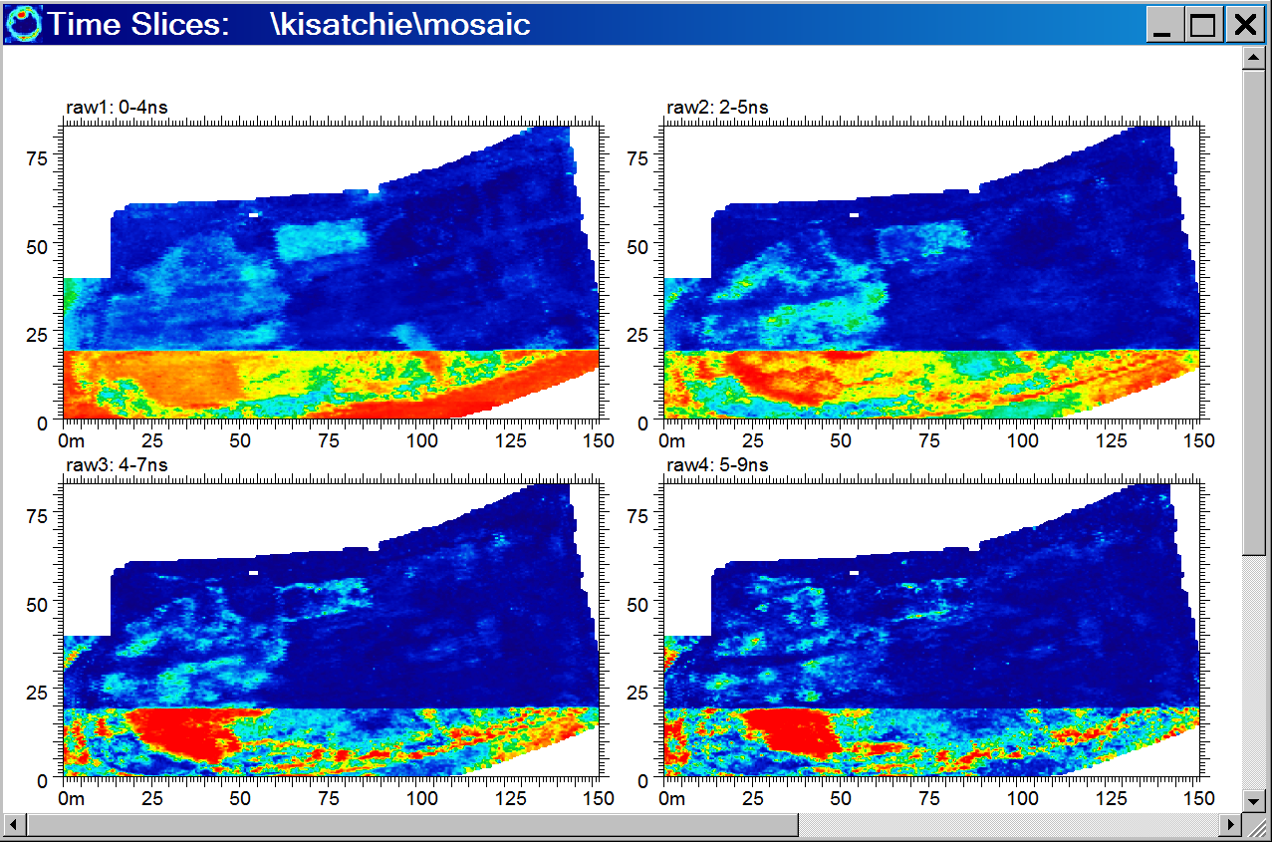

Figure 1 Example of mosaic noises for the project \kisatchie\mosaic\. Not there are also staggering problems as we
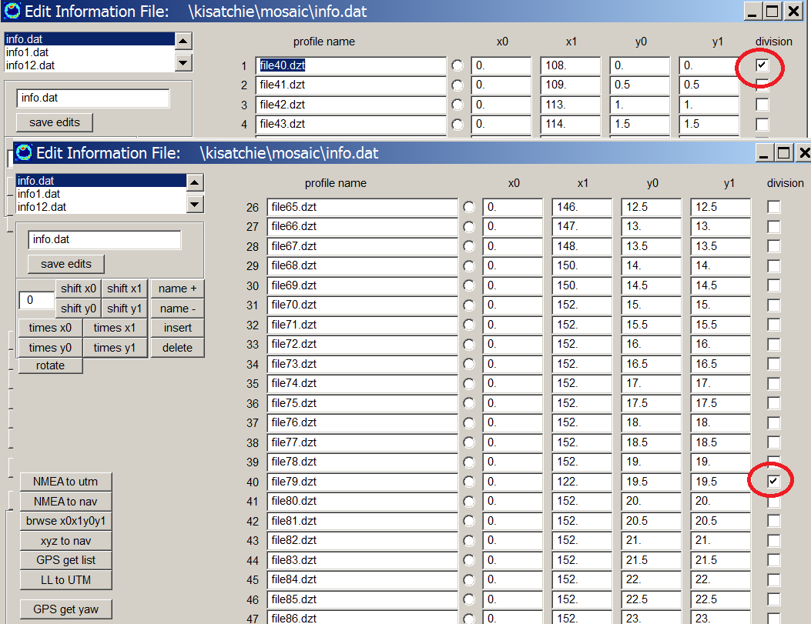

Figure 2 Setting the division locations where different blocks of GPR data, with mosaic noises are defined. Note, the first file in the divisions columns should be clicked on to define the first radargram for the first block. The next checkmark defines the start of the next block of data.

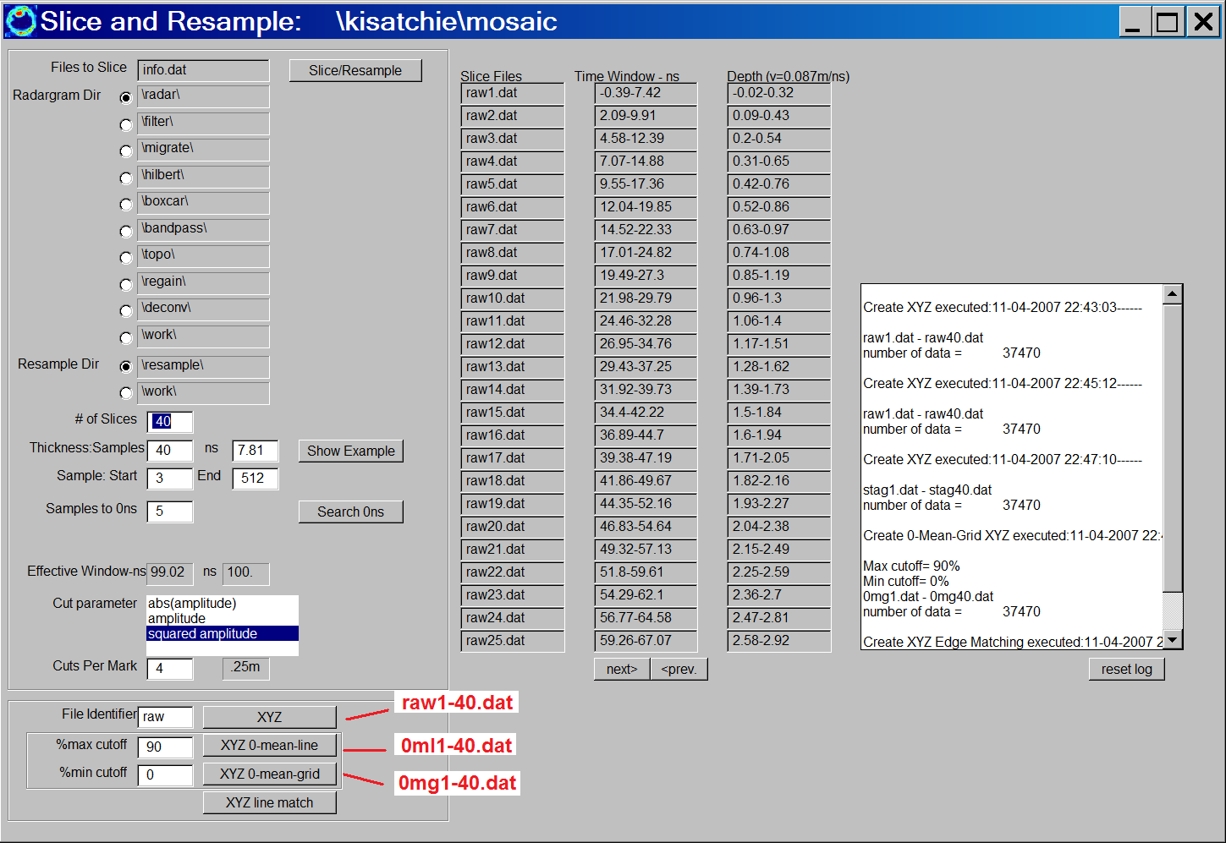

Figure 3 Raw, 0 mean line and 0 mean grid time slices ascii dataset generation.

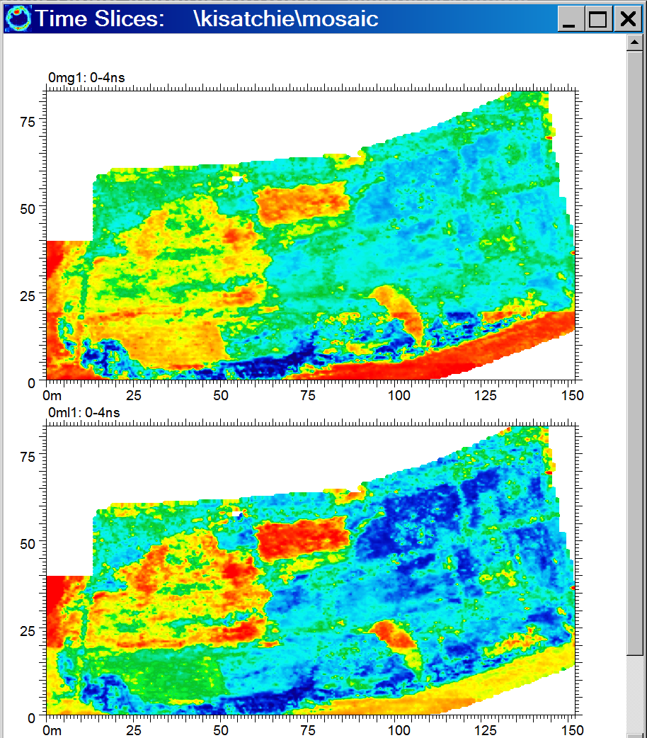

Figure 4 Comparison of 0 mean grid and 0 mean line time slices to remove mosaic noise for project \kisatchie\mosaic.
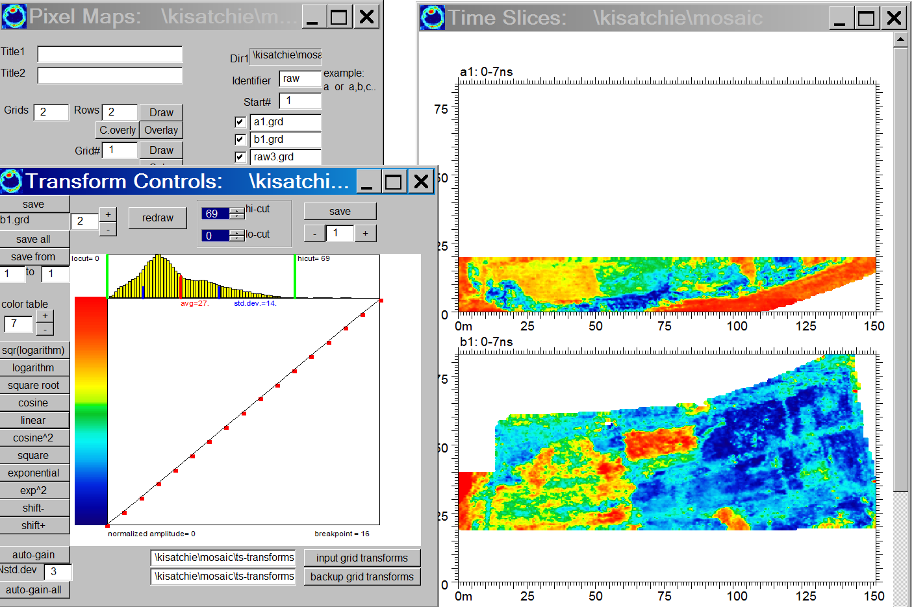

Figure 5 The method of transform matching to correct mosaics involves displaying the different divisions with mosaic noises separately, adjusting the transforms, then appending the areas together using the Append button (Figure 6).

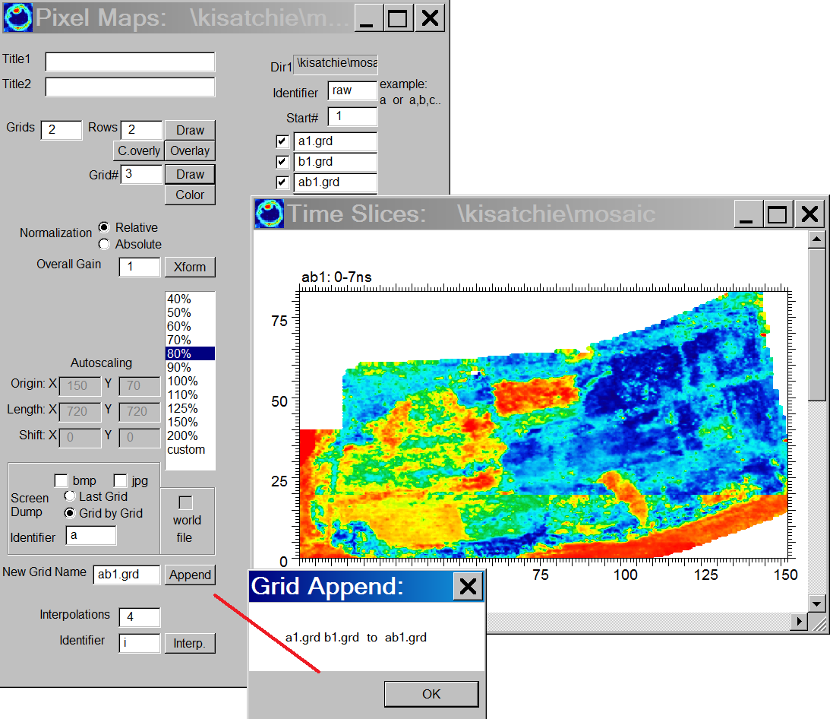

Figure 6 Appending the areas that had transform matching to remove mosaics is accomplished by clicking the Append button. Note: the New Grid Name needs to have the *.grd extension included.

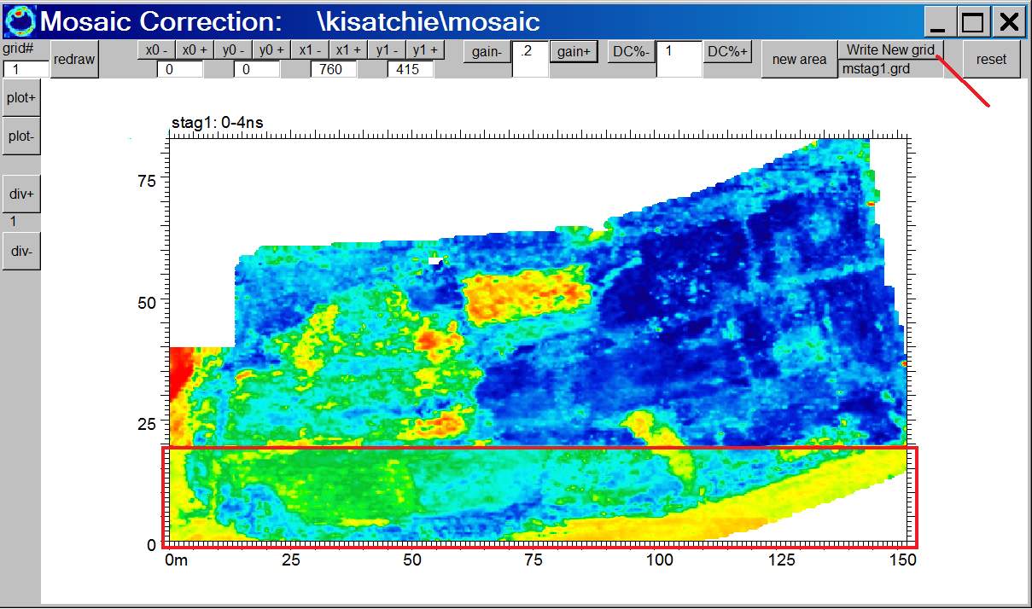

Figure 7 Another method for mosaic correction is the Mosaic Correction menu. In this method the mouse is used to capture areas with mosaic noise, and then apply a gain or a dc shift of the data to balance the colors.

A 4th method to remove mosaic noises is available in the Mosaic Correction menu (Figure 8). In this menu one can capture various individual areas which have mosaic noise, apply a gain or a DC shift to the area to try and balance the colors between the different areas. Once a reasonable match is made, the user can then click the Write Grid button which make a mosaic corrected grid with the “m” identifier appended to the grid name. To smooth out the rough edges it is always best to begin the process with raw-unsmoothed grids, and then apply a 3x3 or a 5x5 lo pass filter to the grid in the Grid menu.

A new option in GPR-SLICE v7.0 was added to re-grid the original *.dat file using the gaining settings used in the Mosaic Block Capture. The Re-grid option is also available in the Mosaic Corrections menu. This new operation requires that all the settings in the Grid menu to be identical to the grid that is active in the Mosaic Correction menu.

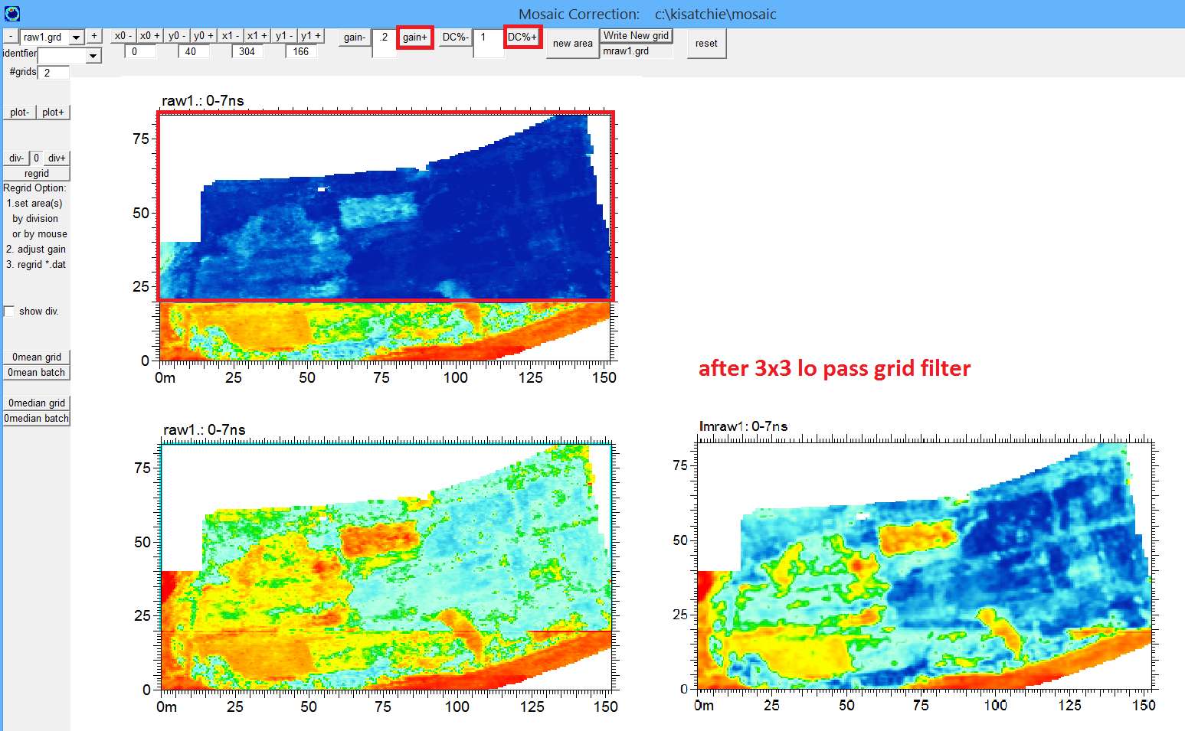
Figure 8. Mosaic Correction menu for capturing rectangular regions and manually adjusting gains to match areas with mosaic noises is available on the Pixel pulldown menu.

7) Topographic Correction

Project folder: \kisatchie\mala-topo\

Purpose: To introduce how automatic topographic corrections are implemented into a GPR dataset.

Basic Information: There are 3 different ways to implement topographic corrections in a GPR dataset in GPR-SLICE:

- Correct radargrams for topography, writing new binary files, then generating depth slices and 3D volumes from topography corrected radargrams. Tilting of the radargrams over topography can be accounted for (yaw is not).

- Correcting radargrams/3D volumes graphically without actually reading in topography corrected datasets, by using Open GL topo warping options. Topo warping in Open GL is done real time for radargrams and 3D volume elements including horizons and isosurfaces. Tilt and yaw of the radargrams is not included.

- Vector imaging formats have an advanced topography warping options that will read a topography grid file, and generate vector normals – allowing the user to graphically display 2D radargrams in 3D space that account for the yaw and tilt of the antenna that are calculated from the topography model.

Before any corrections method is implemented, topographic information over a site is needed to correct GPR radargram for topography. GPR-SLICE needs to import a file called topography.dat located in the main project folder. An example of an importable topography.dat file is shown below:

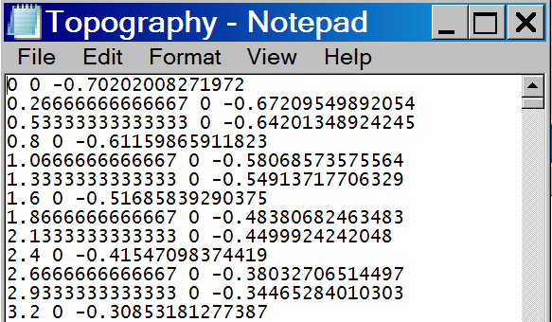

Figure 1 Example of a single space delimited file for topography describing X and Y coordinates, and the 3rd column which is topography/elevation in meters.

The file can have only a single space between x, y, and z or better yet, it is best to have a comma delimited file. There should be no more than one space between x, y and z and there should not be any header line in the file as well. Once this file exists, the user can enter the Static menu and run step 0, which is to set the microwave velocity for the site. This is determined from hyperbola searching or some other means. Next, the user can follow the steps 1-4 in the Static Menu under the heading Import Topography and Batch Correct.

Step 1 is shown in Figure.2. A dialog will come up letting the user know how many elevation points were read in along with the minimum and maximum elevation value. If these values do not agree with what the user knows about the topography, the topography.dat file should be re-checked and edited. The import process generates a file called topo1.dat which is a specially designed file containing the topography of the site – converted to effective radar scan samples – to be used in adjusting the elevations of the radargrams.

Step 2 is for gridding the XYZ topo1.dat file to generate the topo1.grd file (Figure 3). The user should use a large enough search radius to ensure that the entire site is gridded properly and no wholes are left in the topography grid.

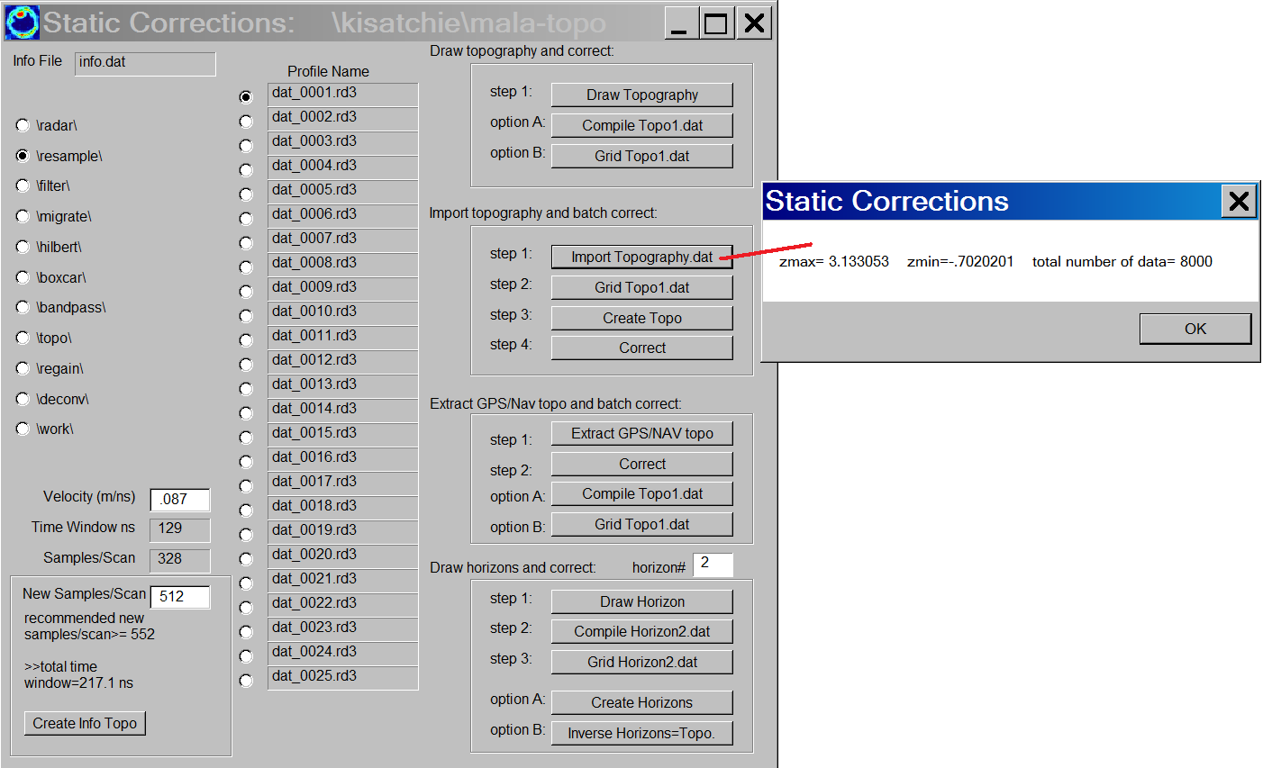

Figure 2 Step 1 in the process to correct a grid dataset for topography is to import the Topography.dat file.

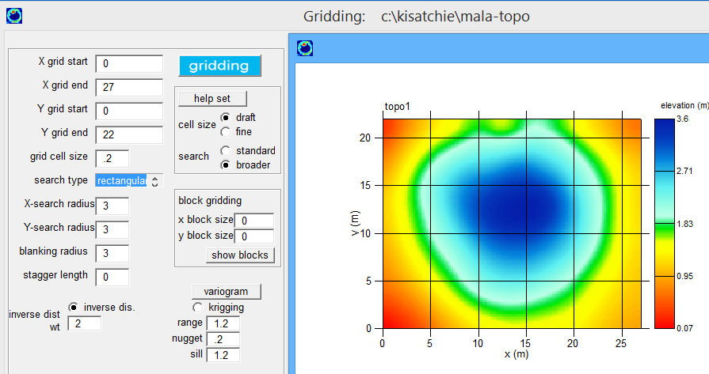

Figure 3 Step 2 in the Static menu is to Grid Topo1.dat.

Once Step 2 is complete, the user can proceed 4 different ways by either

A) Continue with actual radargram corrections (writing binary files) etc. then perform slicing operations

B) Go to volume warping which also includes radargram graphic warping in Open GL,

C) Write warped 3D volumes and show results in Open Gl, or

D) Vector imaging to define radargram yaw and tilt.

Method B and C are the easiest. Method D is an advanced method to be discussed in the Vector Imaging section and will correct radargrams for yaw and tilt based on the topography grid. Let’s go to Method B first (skipping the more traditional operations) with OpenGL volume warping as this will give many of the desired topography results quickly. Assuming the user has made a 3D flat rectangular volume, they can proceed directly to the Static Menu and use the Open GL Topo Volume Warp menu:
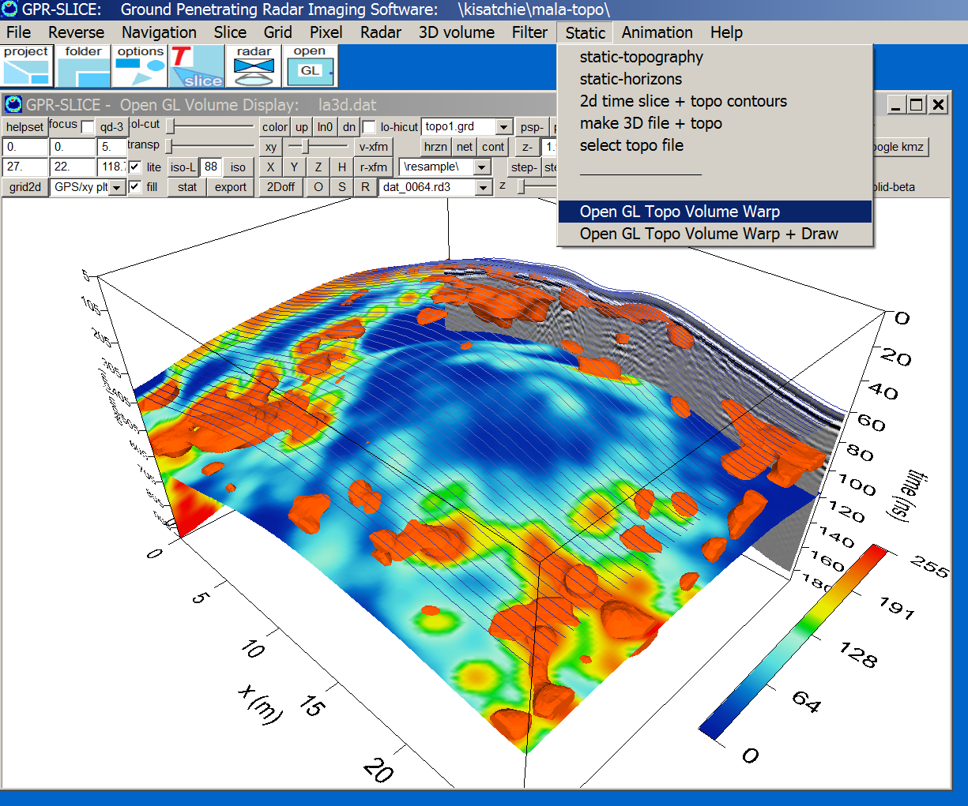

Figure 4 Open GL visualization showing the topography net, a topography+tilt corrected radargram, and several z and x fences from a topography warped 3D volume dataset.

In the Open GL Topo Volume Warp menu the user can display any element to the screen with topography warping. The Z slice are shown with the topography for the grid. To get “level plane” depth slices, we can proceed to step B and generate a topography warped 3D volume – which writes a new data volume – and then enter the traditional Open GL Volume menu to get level plane Z slices in the volume.

To make a topography adjusted 3D volume we enter the Static menu:

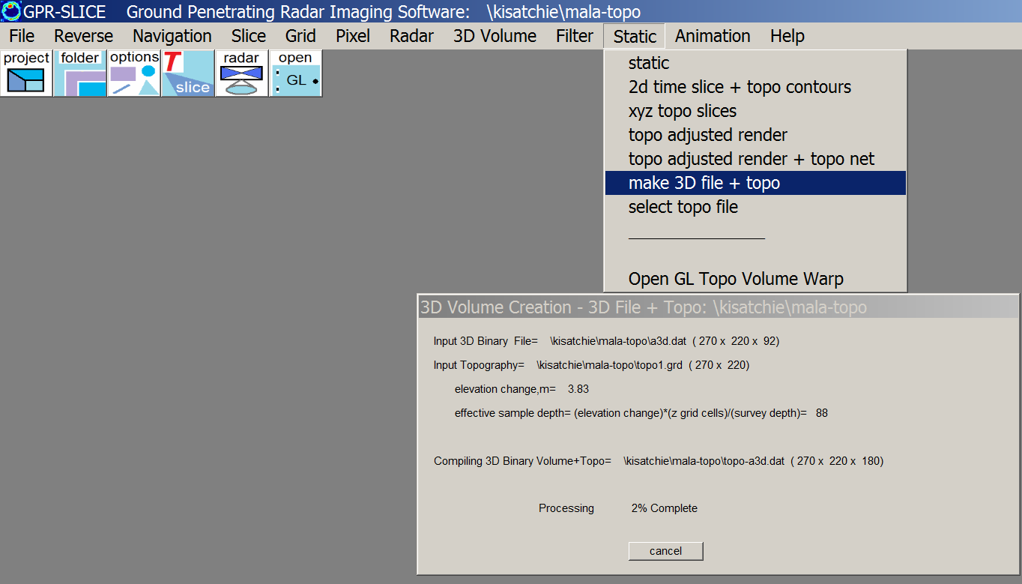

Figure 5 A topography adjusted volume is generated using the active topography grid file and the rectangular – unwarped – data volume.

A new volume which appends the identifier “topo” is automatically generated.

Note: If the surveyed site has significant topography changes, compared to the radargram depth, the size of this volume can be enormous, and Open GL operation may fail because of memory considerations.

Once the volume is generated, the user then goes to the 3D Volume menu and selects the topo+*3D.dat file as the active volume. After which Open GL Volume is available:

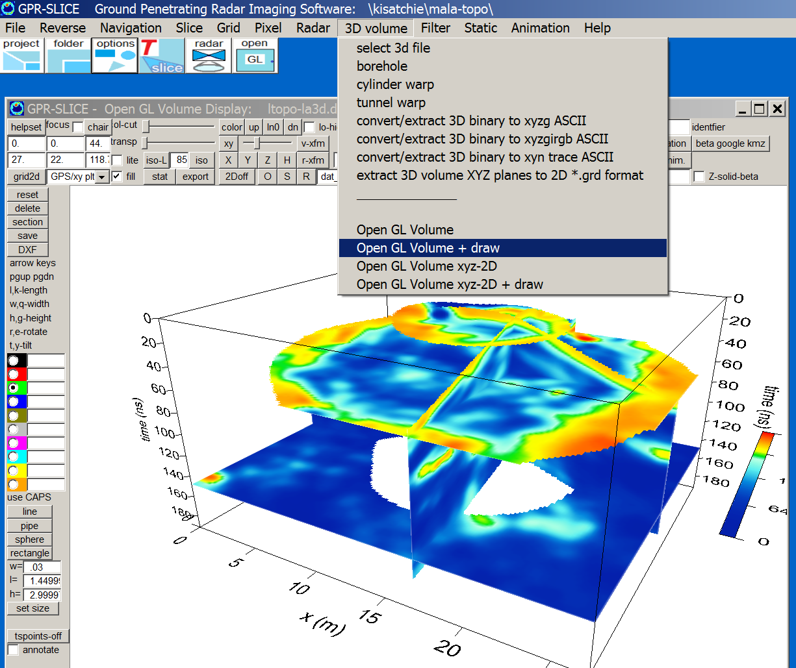

Figure 6 Open GL Volume displays of a topography adjusted volume. With the topography adjusted volume, level plane z slices become available.

The topography adjusted volume should normally have a 3x3x3 or 5x5x5 low pass 3D filter applied to the volume to smooth out the warped volume cells (which is sometimes apparent in simply shifting of volume grid cells up and down to account for the topography in the 3D file).

We now can proceed with some traditional methods of correcting radargrams for topography, writing binary files, and then using these datasets to make depth slice images.

Step 3 in the Static menu, a button called Extract Topo (Figure 2) extracts the topography profiles for each individual radargram in the information file by reading the topo1.grd file.

Step 4 using the Correct button (Figure 2) operation, opens up the topography correction menu (Figure 4). Clicking the Batch Topo Cor button or the Batch Topo+Tilt Cor (discussed in more detail in \kisatchie\tilt\ example in section 8). The process will run in batch till all the radargrams are adjusted for topography. The topography corrected radargrams are written to the \topo\ folder.

Note, for the settings in this example, one can see that the bottom part of the corrected radargram is slightly truncated. The reason for this is that not enough new samples/scan are allotted for the corrected radargrams. GPR-SLICE never reduces the resolution of the recorded radargram. The additional topography changes require the new corrected radargram to have an extended length. GPR-SLICE will let you know what this length is in the bottom left-hand side of the Static menu where the new recommended scan length is written. In this menu shown in Figure 2 a new samples/scan of 552 is recommended (but only 512 was placed in this location which caused the truncation of the bottom part of corrected radargram in Figure 7). Resetting the new samples/scan to 552 and re-running Step 4 is necessary to not get truncated radargrams that are corrected for topography.

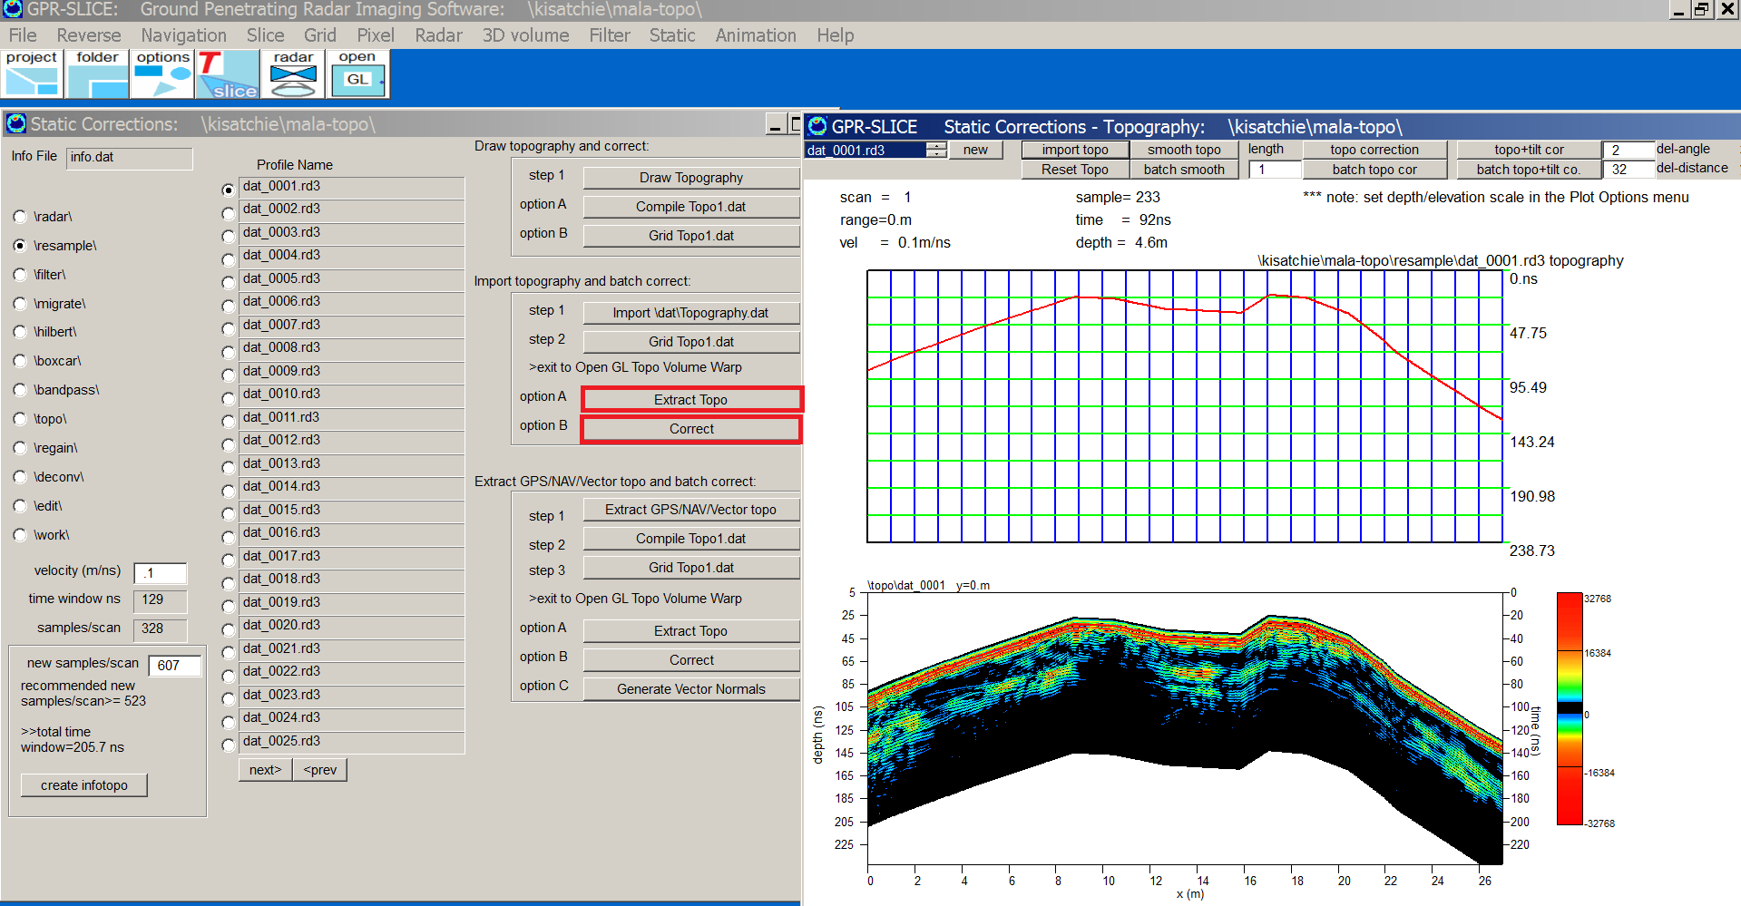

Figure 7. In this example the final step to adjust radargram for topography is implemented using either the Batch Topo Cor or Batch Topo+Tilt Cor operation. Note that the radargram is slightly truncated on the bottom at the starting locations due to an incorrect new samples/scan setting placed in the Static menu.

Once the radargrams are adjusted, a new information file, called infotopo.dat should be generated with the new samples/scan. After that, the user can then proceed as normal to the Navigation menu acting on the \topo\ folder and begin slicing these data. You can compare some of the results with the topography warped images.

8) Topography+Antenna Tilt Correction

(For more advanced procedures that encompass yaw and tilt see the Vector Imaging Section)

Project folder: \kisatchie\tilt\ (data courtesy of Hiromichi Hongo and Higashi Noriaki, Saitobaru Archaeological Museum, Miyazaki, Japan)

Purpose: To introduce how to correct for the tilt of the GPR antenna over sites with abrupt topography and to visualize the effects that velocity has on the tilt adjustment.

Basic Information: The antenna that is used to survey over a site with topography is subject to tilting of the directional beam that is transmitted into the ground. To account for antenna tilt, special options were placed into GPR-SLICE in the Static menu. It is useful to examine what the effects that velocity has on the tilt adjustment for 3 different velocities, 0cm/ns, 6cm/ns and 12 cm/ns. Beginning with 6 cm/ns for setting the velocity in Static, the user then clicks on the Step 4 button – Correct. Because we are using only a single line for this folder, we need to then click the Import button in the Static Corrections menu, and then run the Topo+Tilt Correction process to start the correction (Figure1). It is useful to compare the same results using a much higher velocity of 12cm/ns which is shown in Figure 2. In this example we can see crossovers between radar scans at depth caused by the antenna tilt across the site. The tilting obviously becomes more pronounced as the velocity increases. For a final comparison using a velocity of 0cm/ns, results in no antenna tilt in the corrected radargram (Figure 3). This example would yield the same results as the standard topographic elevation which simply shifts the scans vertically to account for elevation changes.

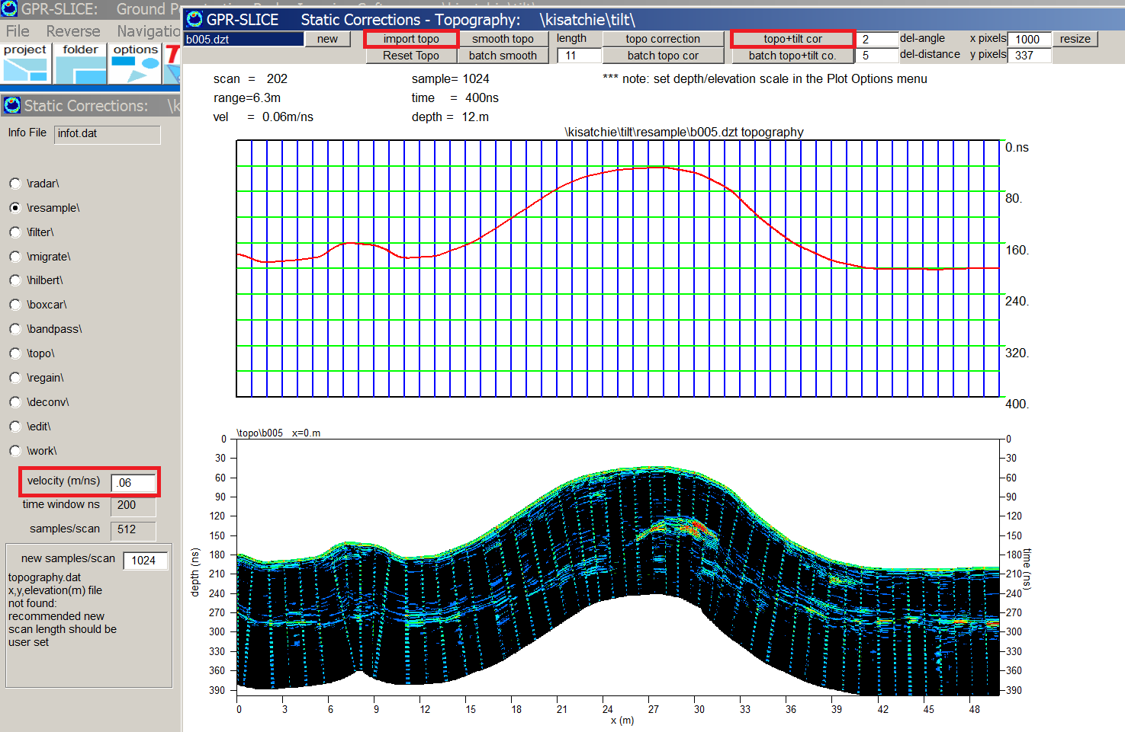

Figure 1. Correcting for antenna tilt is implemented by importing the topography profile then clicking the Topo+Tilt Cor button for a single line. The velocity for this correction was at 6cm/ns. This process can also be run in batch for all the radargrams in the information file.

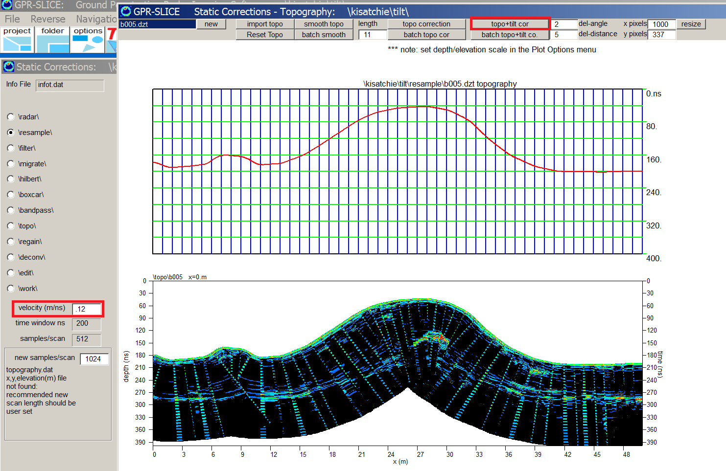
Figure 2. Shown here is a topography+tilt corrected radargram using a velocity of 12cm/ns.

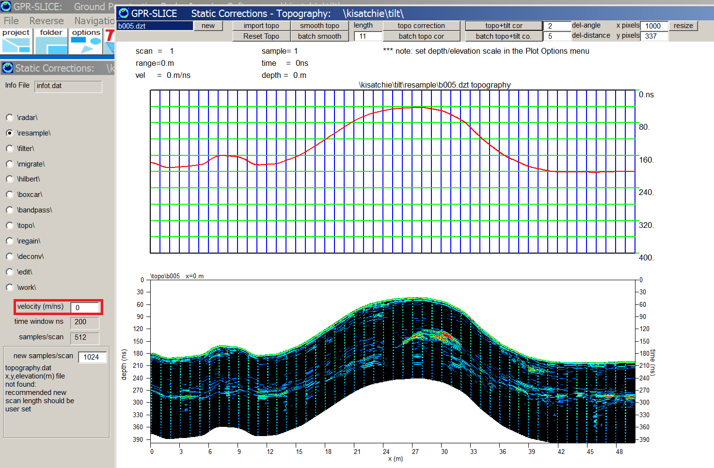

Figure 3. This example is a topography+tilt corrected radargram using a velocity of 0cm/ns. This correction is identical to the regular topography correction which simply shifts the scans vertically to account for the elevation.

9) GPR/GPS Elevation Correction

Project folder: \kisatchie\gps-topo\

Purpose: To introduce how elevation from GPS surveys are integrated in the Static Menu for making topographic corrections to 3D radargrams. Also, to show how to smooth topography profiles prior to making topographic corrections in the case of noisy GPS elevations.

Basic Information: GPS elevation is normally outputted to high degree of accuracy with RTK equipment. GPR-SLICE *.*.gps formats contain the elevation information in its 3rd column. Using the data in this project, the normal operation are run:

1) Use the GSSI to TStamp button to generate the *.dzt.gps files (for other manufacturers the buttons are similarly names) (Figure 1).

2) Proceed to the Navigation menu (using GPS Vector/Trace# Navigation) (Figure 2)

3) Enter the Static menu (Figure 3) and

A. Set the velocity of the site
B. Set the recommended new samples/scan
C. Click the Extract Topo
D. Click the Correct button to open the Static Corrections –
Topograph menu (Figure 4)
D.1 Click the Import button
D.2 Set the smoothing length to 25 and click the Smooth Topo
Button.
D.3 Click the desired Topo Correction button.

To display the topography corrected file, the user must also generate a new infotopo.dat file containing the extended number of new samples/scan needed to correct the radargrams to the \topo\ folder. For this particular example, a new scan range of 4693 is required for the infotopo.dat file and the 3D GPS radargram with topography is shown in Figure 5.

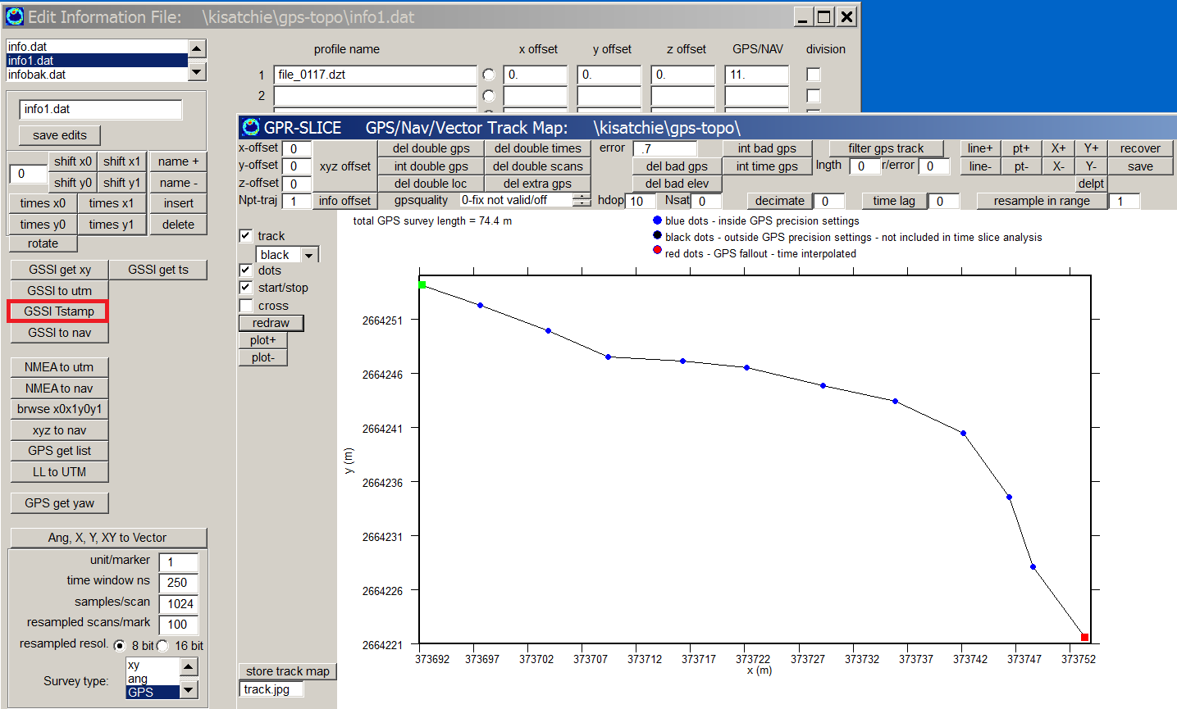
Figure 1. Example GPS track.

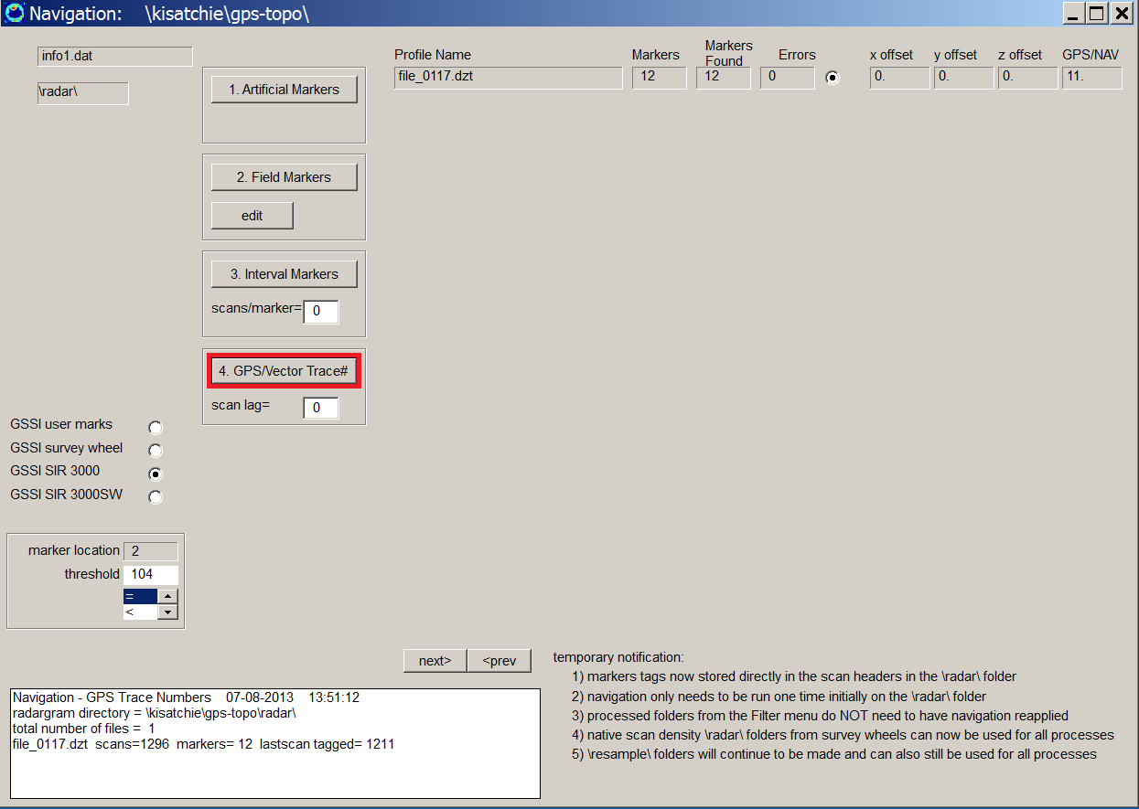
Figure 2. GPS/Vector Trace # navigation is applied to the dataset
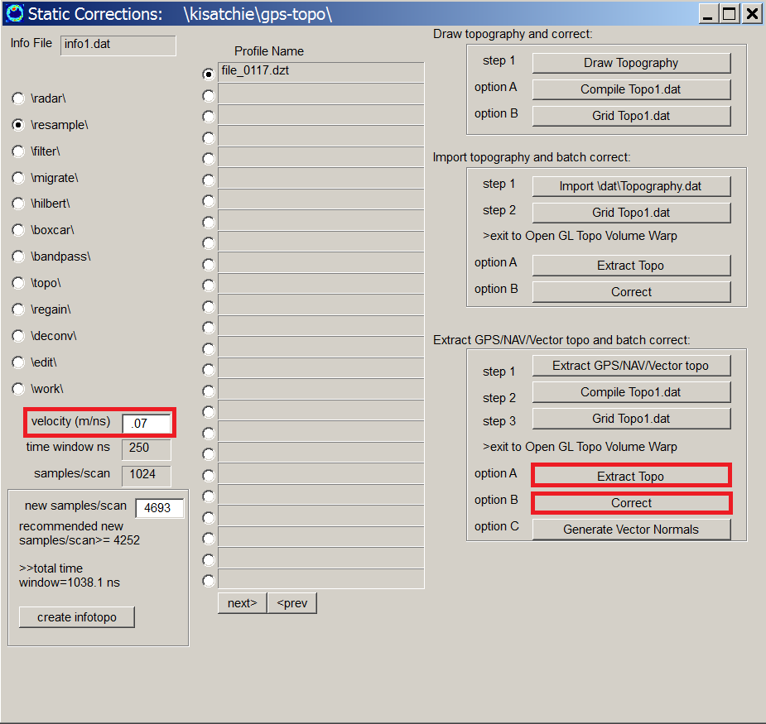
Figure 3. After the navigation is run, the Static Menu is entered where the velocity is set, the Extract Topo, followed by the Correct operations are implemented.

Note: The Extract Topo is similar to the Extract GPS/NAV/Vector Topo button, except that a topography file topo1.dat for area gridding is not generated. If a volume is desired to be topography corrected then this button should be implemented instead of the Extract Topo button.

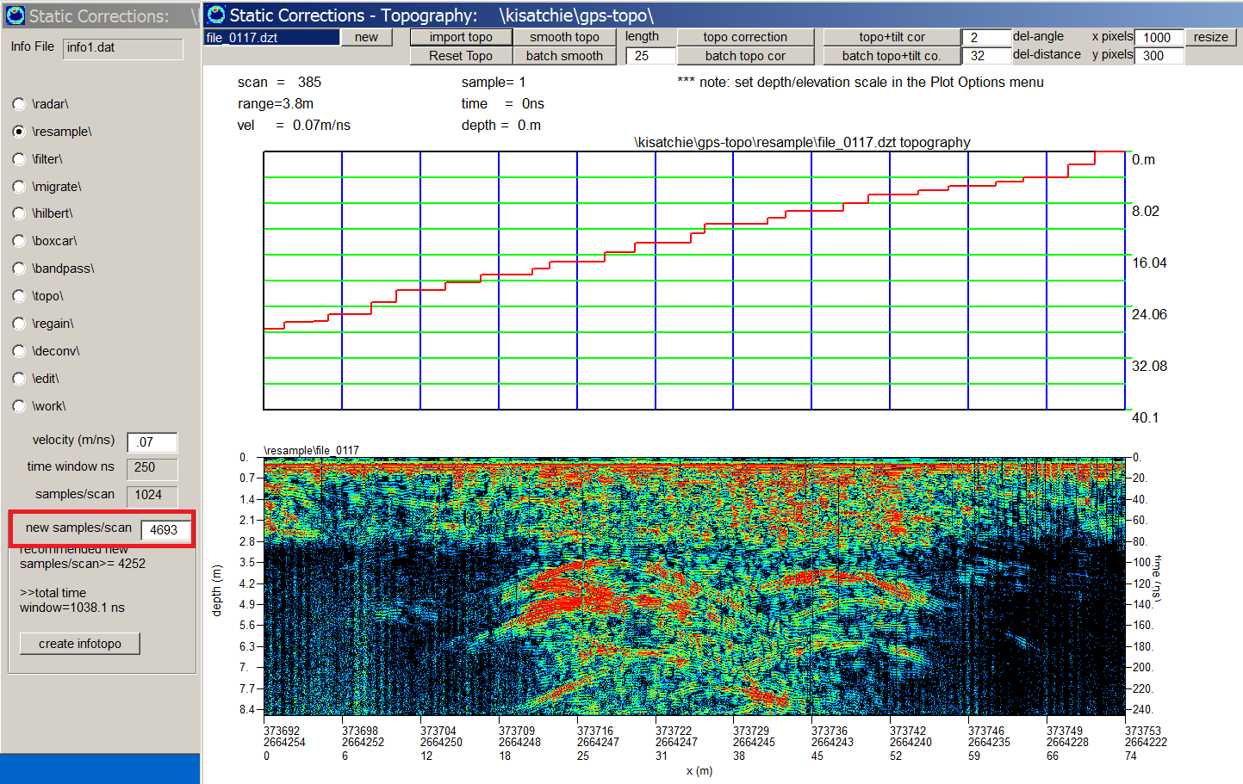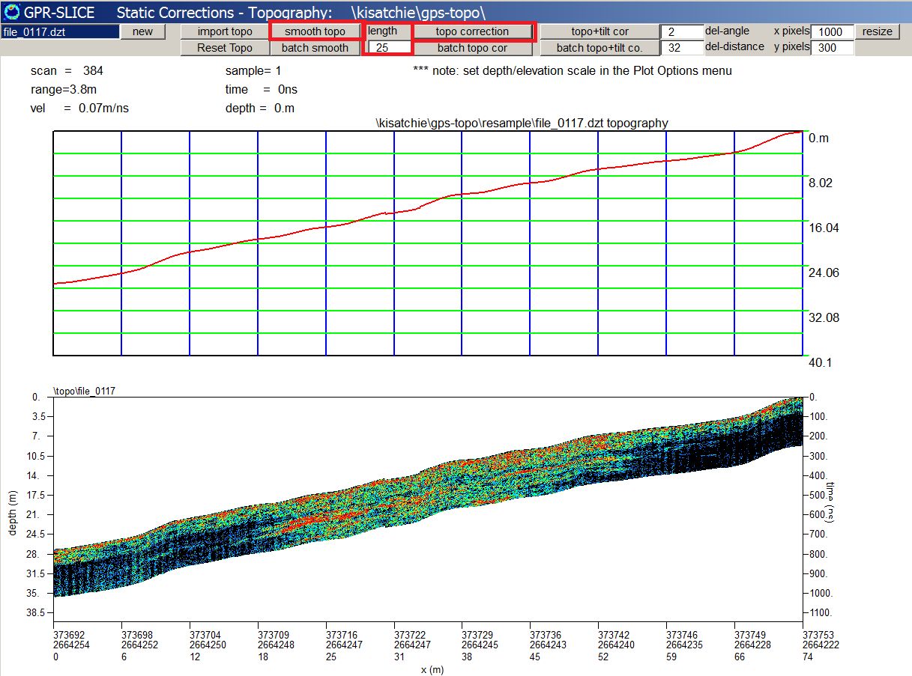
Figure 4. Example of the smoothing topography from a noisy GPS elevation dataset prior to running the Topography correction.

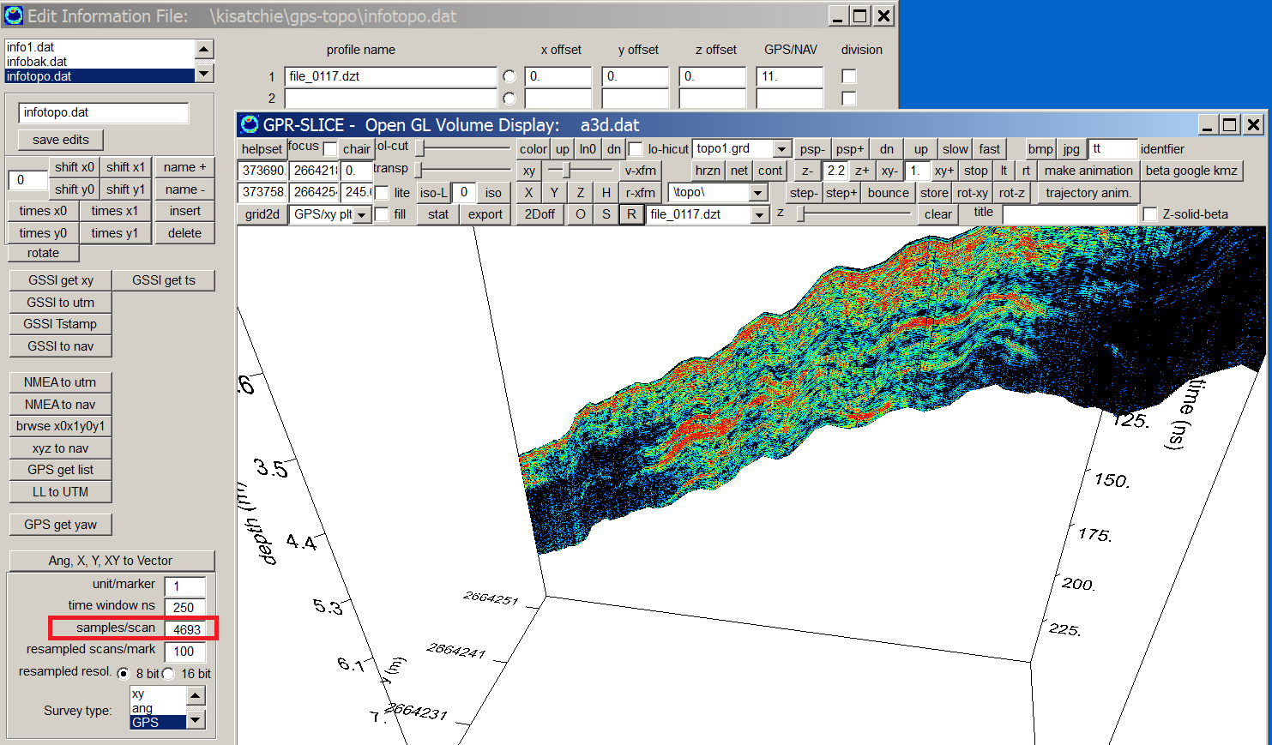
Figure 5. Example of a GPS topographically corrected radargram displayed in the real-time OpenGL Radar menu for project \kisatchie\gps-topo\.

10) Horizon Detection and Mapping

Project folder: \kisatchie\horizon\ (data courtesy of Daniela Hofmann, Wiebe Group, Germany)

Purpose: To introduce how horizon surfaces are detected and mapped, and to show horizon surfaces can be used to make horizon slices.

Basic Information: The basic steps to generate horizon profiles across the radargram dataset are provided for in the Static menu under heading Draw Horizon and Correct heading (Figure 1). The menu allows the user to define up to 8 horizons within the dataset. In this menu there are options to either draw the desired horizon using the mouse, or to use options in the software to automatically detect the horizon (Figure 2). Using the auto-detect options works reasonably well for well defined horizon. For this example, the sample start/end range to apply the horizon detection is set to between 20-100 samples. The desired range can be estimated using the mouse movements and examining the sample range being updated in the graphic. Shown in Figure 2 is an auto detected horizon for one radargram. Continuing to discover the 2nd horizon, we reset the sample start/end to 105-210. The green horizon is detected (Figure 3). There is some noise on the detected horizon profile which we can smooth out. There is an option to apply a small smoothing filter to the auto detection process by clicking the Auto Filter checkbox (Figure 4). If the auto-detected horizon is still very noisy, the user can use the Import/Edit button in the menu then manually adjust the detected horizon using the mouse. The procedures can be continued until up to 5 horizons can be detected (Figure 5). Adjusting the auto detected horizons can also be accomplished using draw/edit functions in the menu (Figure 6).

The horizon corrected radargrams are written to the \topo\ folder using the new samples/scan. The horizon profiles that were detected or drawn across the radargrams are now represented by flat lines across the horizon corrected radargrams. Thus making time slices across the horizon corrected radargrams is essentially applying a non level surface – or generating horizon slices across the complete radargram dataset.

There are several options that can be done with the horizons after they are detected: 1) the horizons can be compiled to a horizon1.dat file, 2) the horizon1.dat file can be gridded to be stored for later purposes in Open GL Volume displays (Step 1 & 2 und the Draw Horizon and Correct heading in Figure 1). Other advanced options available include “re-extracting” the gridded and smoothed horizons as the horizons of choice (Create Horizon button in Figure 1). Also, another advanced option available to the user allows them to assume that the horizons represent a flat layer in the ground. With this assumption the horizons can then be used to create artificial topography profiles using the Inverse Horizons=Topography button Figure 1). Once these are generated, the typical topographic corrections can also be applied.

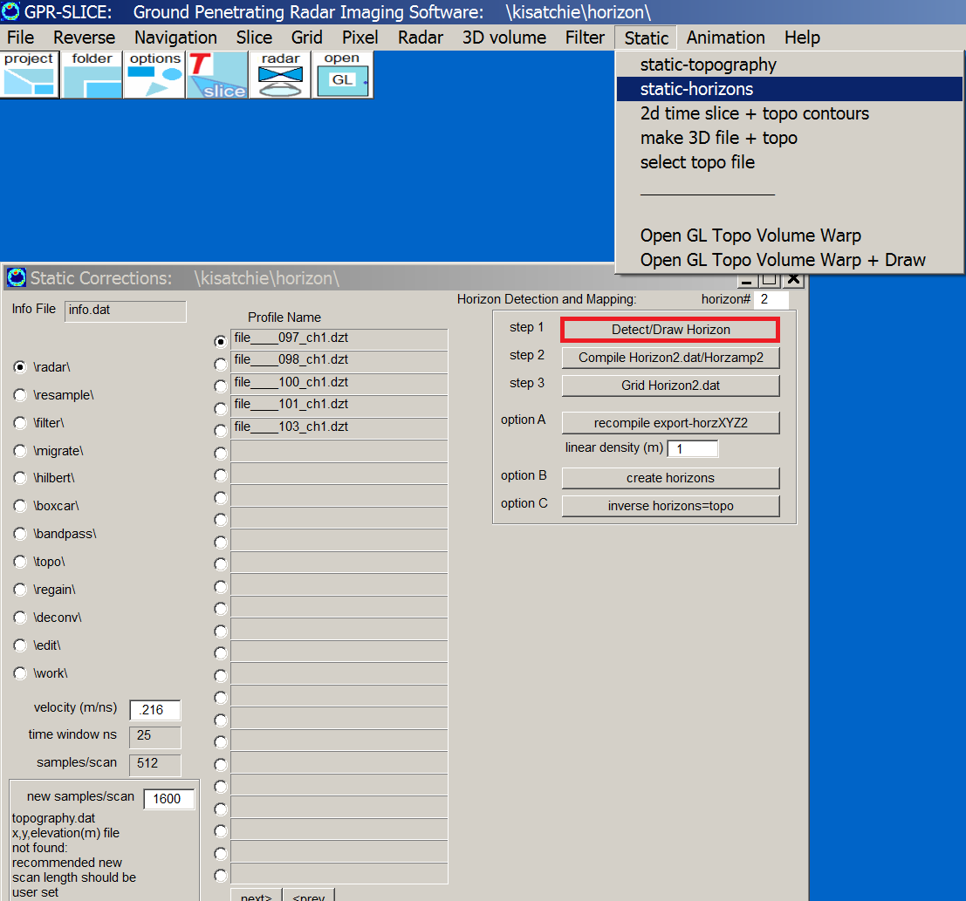

Figure 1. To begin using the horizon operation the user clicks the Draw Horizon button which launches the Horizon Detection and Mapping menu. The velocity should be set prior to entering the menu.
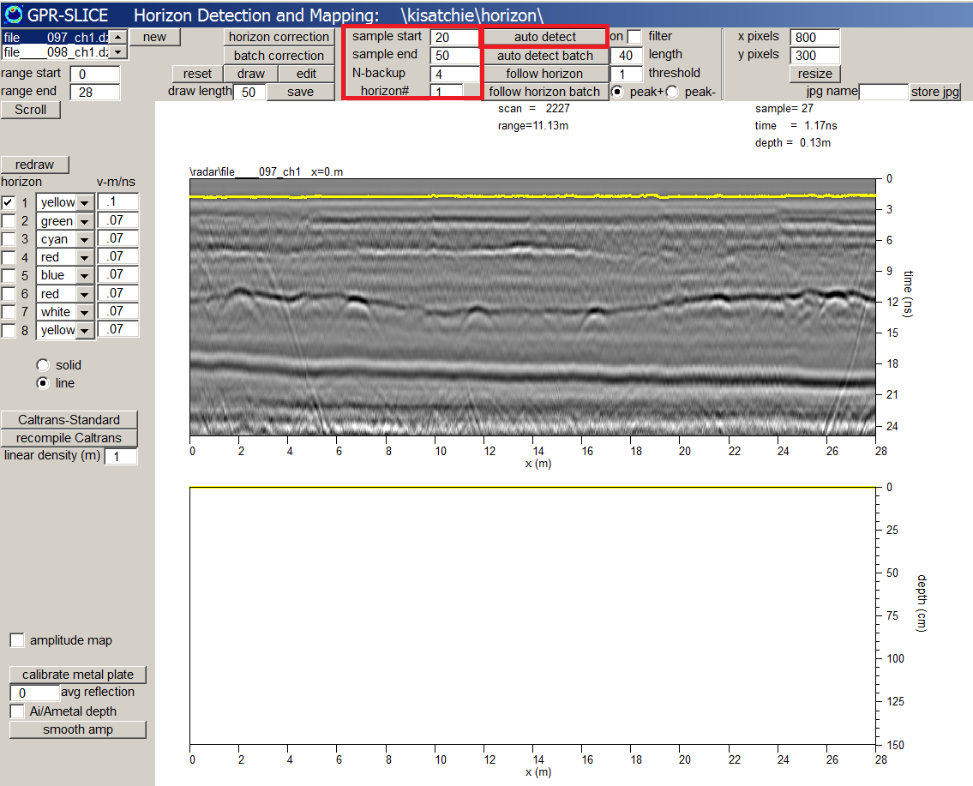

Figure 2. An option to automatically detect horizon profiles over a user set sample range is available. In this example the sample range is from 20-100 samples is used to detect the ground surface reflection (0 ns offset – scan-by-scan). The first horizon is set to1.

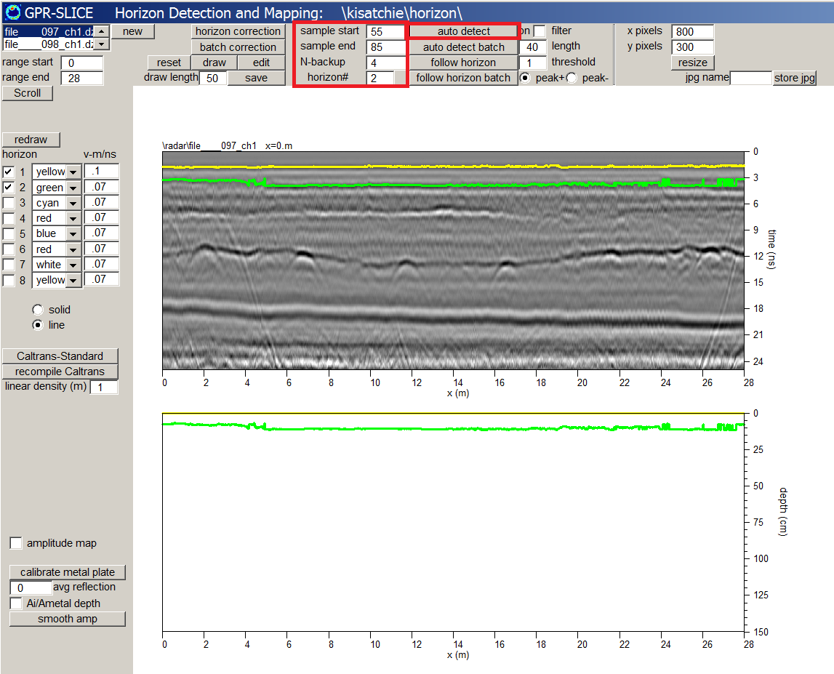

Figure 3. The 2nd horizon is detected by using the sample start/end from 105 to 210 and setting the horizon to #2.

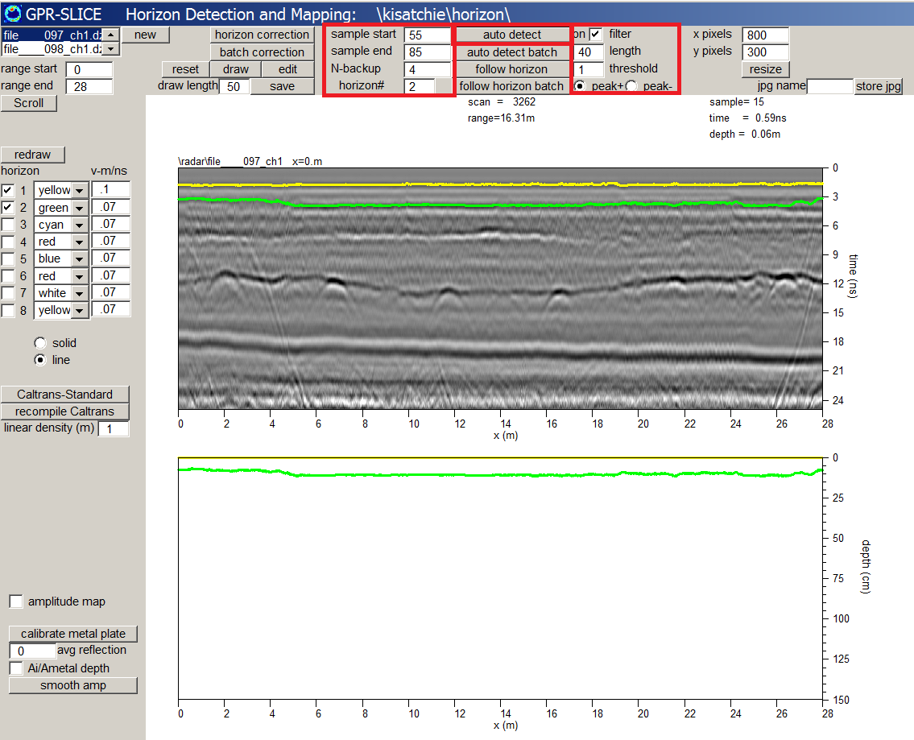

Figure 4. The 2nd horizon is smoother after detecting it with the filter engaged.

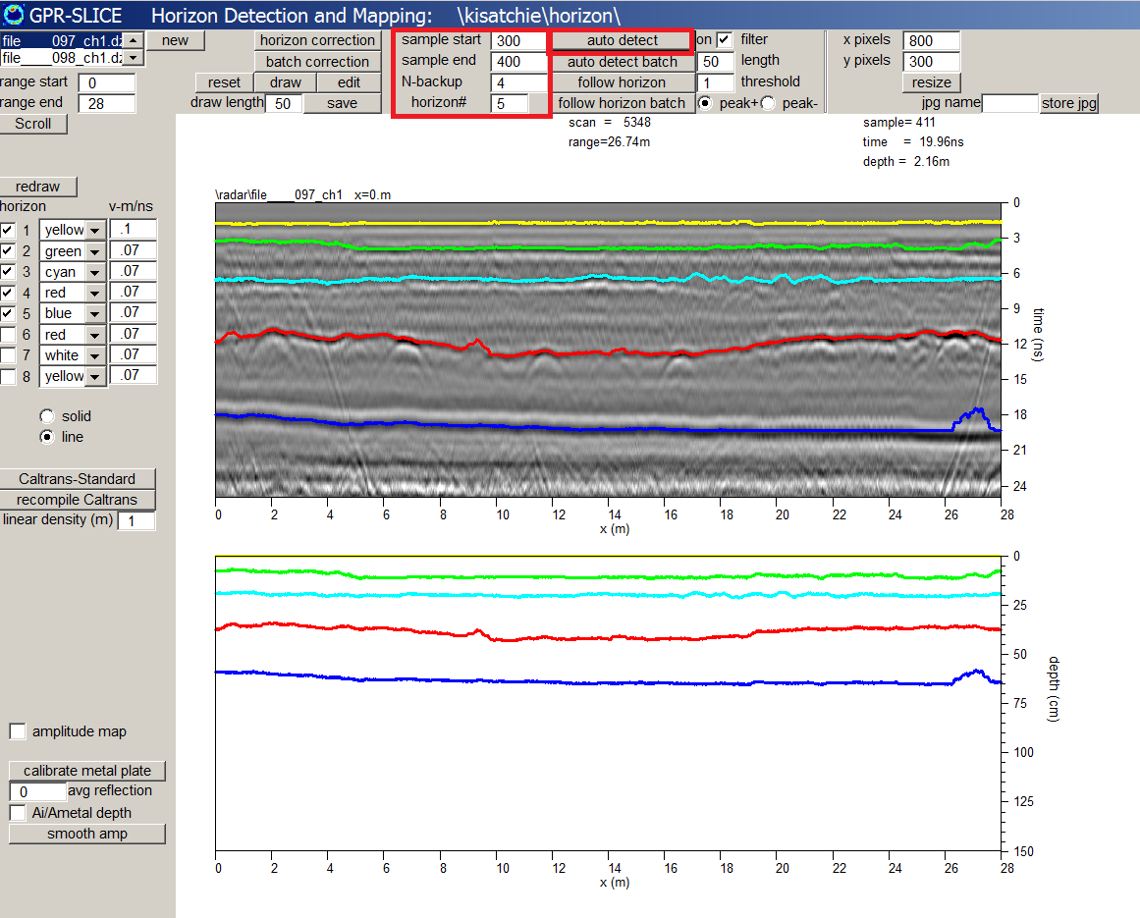

Figure 5. The procedures can be continued till up to 5 horizons can be detected.

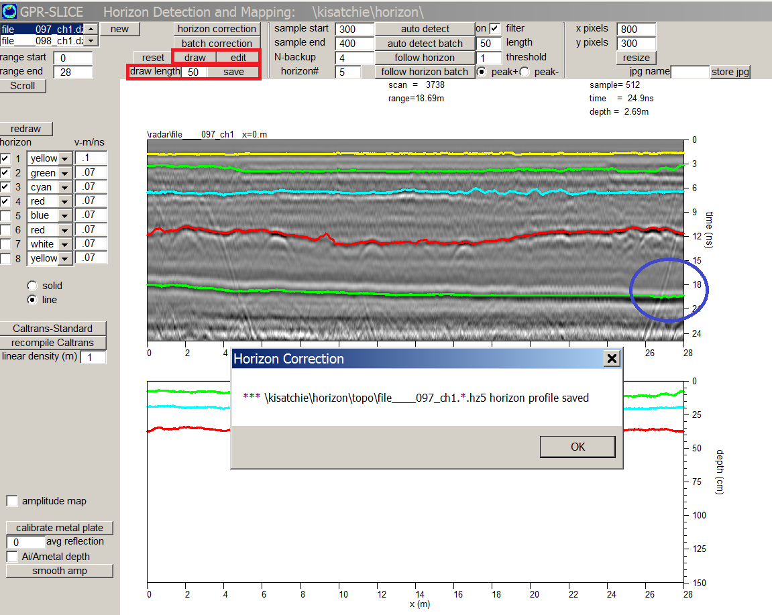
Figure 6. Auto horizon detection can be adjusted with manual drawing and editing.

The Horizon Detection and Mapping menu now has capabilities to assign individual velocities to each layer that is detected. The software also generates a layer depth map which accounts for the all various velocity intervals and properly adjusts each individual horizon.

Optional: GPR-SLICE also has capabilities to make horizon slices – non-level time slices. Horizon Correction operations are first implemented which will make the detected horizon flat in a horizon adjusted radargram. The horizon corrected radargrams which are written to the \topo\ folder, can then be used for time slice operations. Slicing these horizon corrected data with level slicing, is equivalent to making a horizon slice through the uncorrected radargrams.

Note: To adjust the tick labeling on the depth plot, there is a 2nd set of Axis labels added to the Option menu.

11) Signal Processing

Project folder: \kisatchie\processing\ and \kisatchie\treasure\

Purpose: To introduce basic signal processing including, bandpass filtering, background filtering, migration, Hilbert transforms, and smoothing of noisy radargrams.

Basic Information: Signal processes can be applied to the radargram dataset prior to time slice operations. The kinds of signal processes that might need to be implemented can best be visualized after time slices of the raw radargram data. The basic signal processes most often applied to radargrams are briefly discussed:

The 8 basic signal process briefly covered in the workshop are:

- Bandpass filtering
- Spectral whitening
- Box car smoothing
- Background removal
- Migration
- Hilbert transform
- Spectral deconvolution
- FK filtering

Bandpass filtering – is a process to remove low frequency and high frequency noise components in radargram. A good example to see the effects of bandpass filtering is for a radargram collected where some ground noise in the cable was apparent (Figure 1). The bandpass filtering requires that lo pass and hi bandpass frequency cutoffs be set. These are accomplished by using the left/right mouse button. The hi-pass cutoff should be set to a value where the shifting pulse does not have any DC shift from the read line (e.g. no wobble). The low pass setting should probably be set to no more the twice the center frequency, however, if high frequency noise is still apparent, this can be lowered.

The bandpass filtering operation (Figure 2) shows that low frequency DC drift apparent in the raw radargram is completely filtered out in the bandpass filtered radargram.

Spectral Whitening – is a process which makes the amplitudes of all the desired frequencies in a radargram pulse identical. This works by converting the radar pulses to the frequency domain, the complex frequencies are adjusted to unity; and an inverse fast fourier transform is then made. A divisor gain value must be set to properly adjust the gain in the radargram when the filter is run. Making all the frequencies have the same amplitude – or whitening the radargram – can help to provide balancing of the signal as well as remove overly strong reflection. The phase of the pulses is what generates the radargram as opposed to varying frequency amplitudes in a raw radargram. An example of spectral whitening is shown in Figure 3. Spectral whitening is only applied to the lo and hi frequency cutoff. All the frequencies outside the bandpass are set to 0 and removed.

Boxcar Smoothing – is a simple method to smooth out noises in the radargrams. It is precisely as described; a boxcar that averages values determined by the width and height of the box and is applied over the entire radargram (Figure 4). Boxcar smoothing is useful for displaying final radargrams.

Background filtering – is used to remove the constant banding horizontal banding that is recorded in the raw radargrams. The process of background filtering is a simple operation and involves computing the average radar scan over a specified length of the radargram, and then subtracting this average scan from every scan. The filter length is normally set to a value much larger than the number of scans in the radargram (although it can also be used over a locally shorter length). The default length is 99000 scans. An example of background filtering is shown in Figure 5. The background filtering was done on the previously bandpass filtered radargram. The output radargram from background filtering is written to the \filter\ folder. Thus, the radargram that resides in the \filter\ folder now has had 2 filtering processing applied to it – bandpass and background filtering.

Migration – is a process that adds up all the pulse amplitudes along hyperbolas in the radargrams and places the combined amplitude at the apex of the hyperbola. This is done for every point inside the radargram. The net effect is to collapse the reflection hyperbolas caused by the broad directional beams of the antenna into simple point sources. Constructive and destructive interference of the recorded across the radargram will filter the hyperbolas out of the radargrams. Before migration can be used, a nominal velocity of the site must be determined from hyperbola searching. A estimated value of the velocity of .09 cm/ns can be found in the Hyperbola Search menu (Figure 6). It should be noted, that if velocity estimated is from measuring the hyperbola is also a function of the radius of the object. Ideally we want a point source reflector; however, in reality there are no point source reflectors in the ground. If the size of a pipe or object is known, this can be used to insert a radius for the object (Figure 4) to give a better estimate.

GPR-SLICE v7.0 now has variable velocity depth profiles in the Hyperbola Search menu and for migration filtering.. Using the left mouse to discover the hyperbola, the right mouse button is used to save the velocity/dielectric to the given depth. Using the Calculate button for either, constant, block or profile, the velocity model of the site can be generated.

Use radargram number 15 (37rd55.dt1) in the information file as a good example to get a velocity profile from 2 very different hyperbolas. In this example, a block velocity model is appropriate. After the velocity is estimated, the migration is performed (Figure 7).

Hilbert Transform – is a process to compute the envelop of the radar pulse. It is very useful for making very thin time slices where the effects of the phase of the pulse are not wanted. In general, imaging of the pulse phase is not wanted for most archaeological applications. An example of the Hilbert transform applied to bandpass filtered, background filtered, migrated radargrams is shown in Figure 8.

Note: Hilbert transformed radargrams may look a little “grayer” then the original radargram. The reason is that the Hilbert transform does not have any negative values – everything is a positive (envelop) number. On re-display in the Radargram menu, a more appropriate color table can be used which starts the gray scale from the middle of the palette to better illuminate the radargram and show the whole range in Hilbert transform values.

A combined multi-radar display showing all the 6 different processes applied to a radargram can be shown (Figure 10). In this example the custom display settings are use to shift the plots and to size them.
Once all the process are applied to our radargram the next step is to generated time slices. To compute time slices of processed radargrams the user must return to the Marker menu and apply or discover the navigation for the desired filter folder. After navigation, the slice/resample operation are run on the desired filtered folder and processing continues as normal.

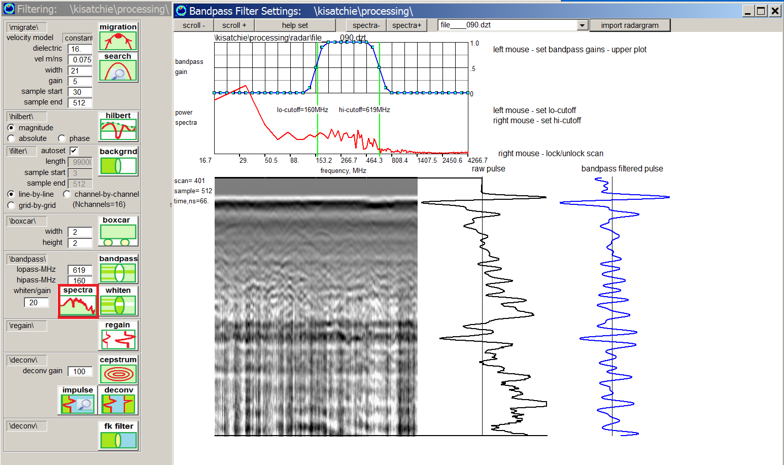
Figure 1. Example of setting the spectra cutoffs for the lo and hi-pass filters.

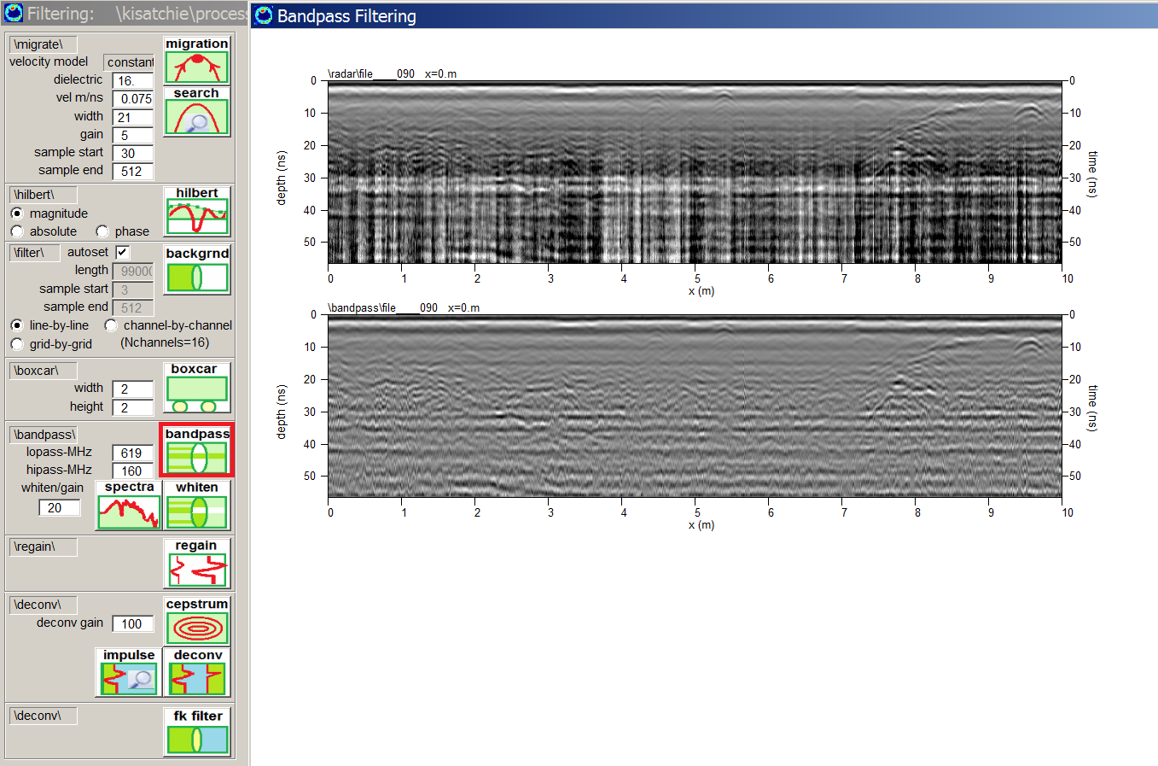
Figure 2. Using the lo pass and hi pass frequency setting for the bandpass cutoff, the bandpass filtering process is run.

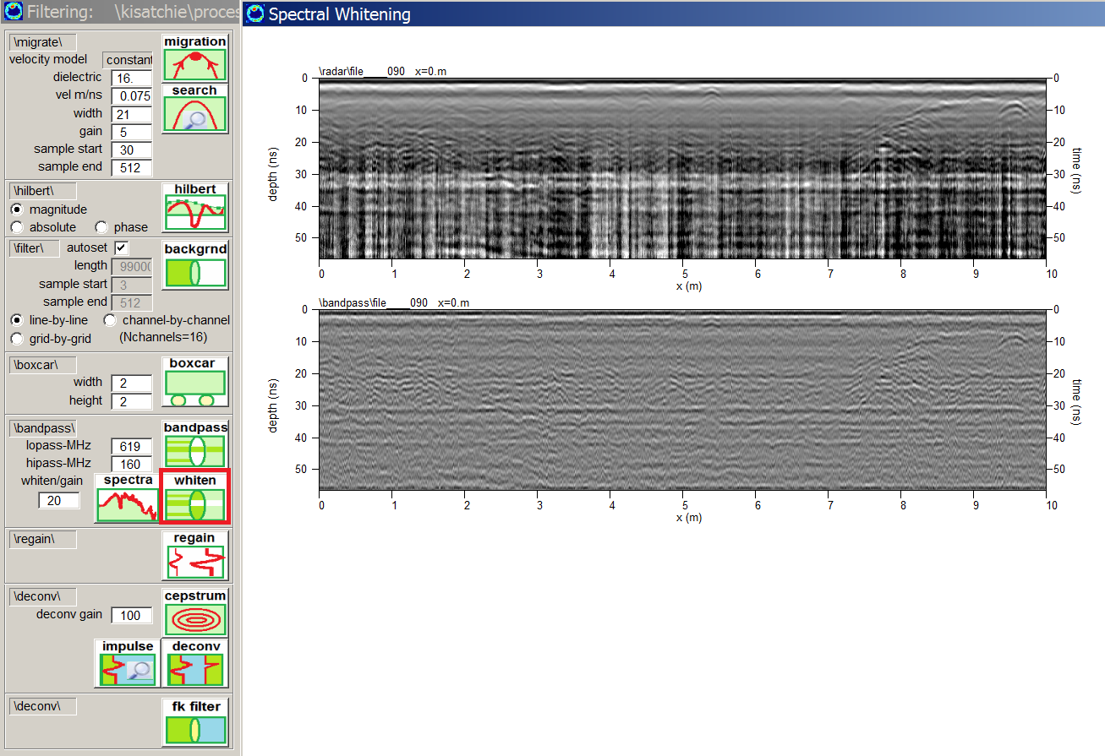
Figure 3. Spectral whitening of a radargram within the bandpass frequencies.
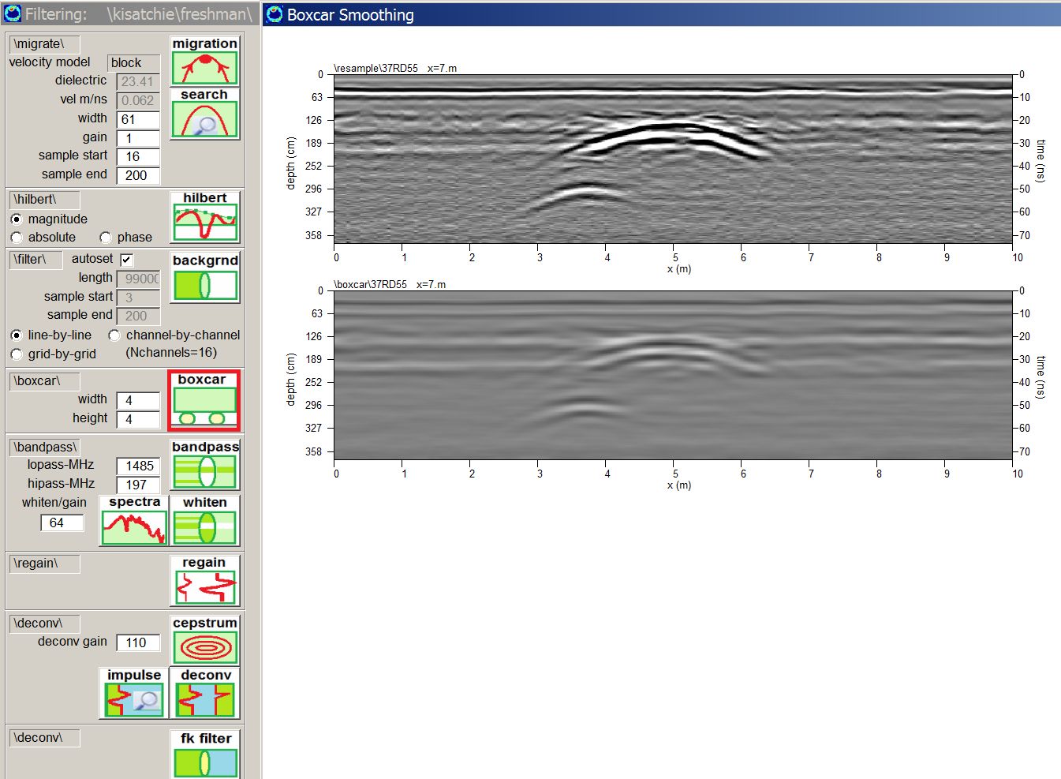

Figure 4. Example of doing a boxcar smoothing operation to eliminate noise.

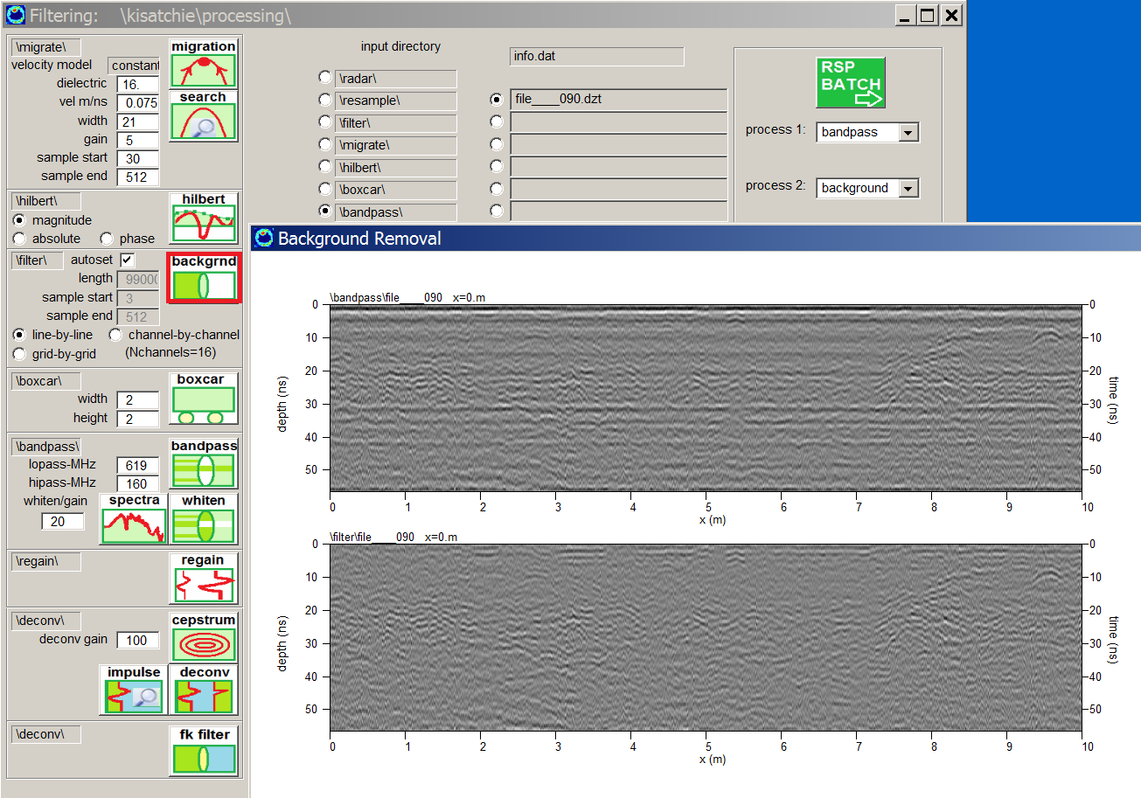

Figure 5. Example of background filtering applied to a radargram (to a radargram from the \boxcar\ folder).

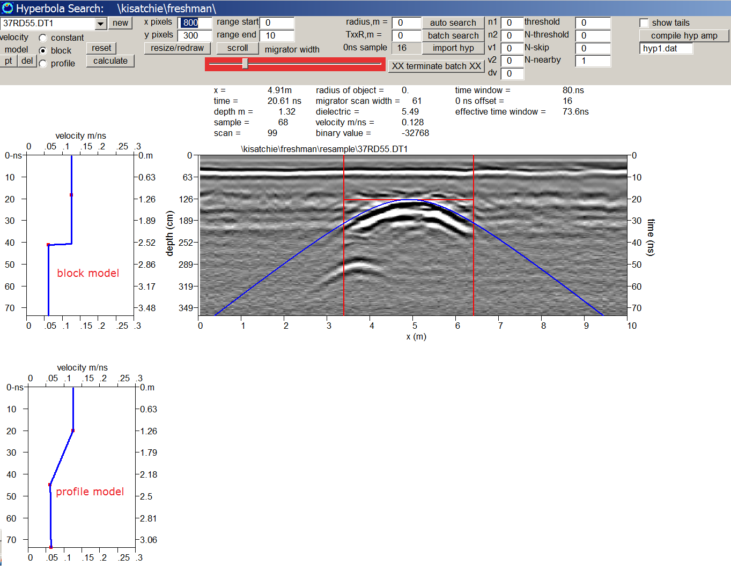

Figure 6. Before migration can be implemented, the microwave velocity of the site must be detected using the Hyperbola Search menu. GPR-SLICE v7.0 is equipped for doing migration from a variable velocity depth profile.

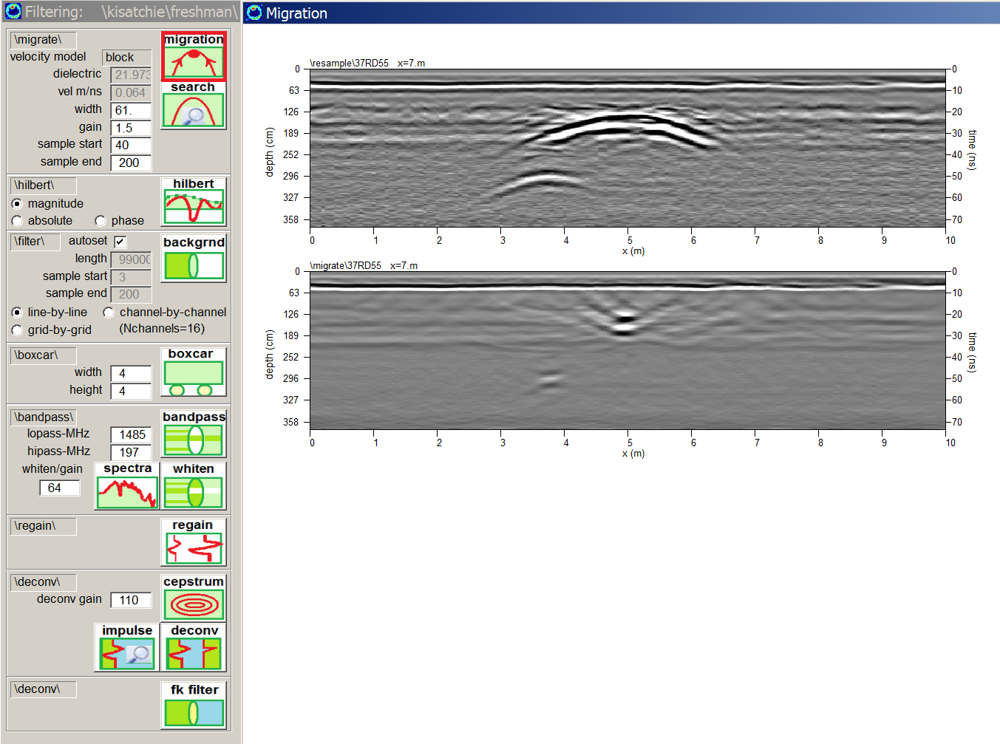

Figure 7. The migration process using the new options for vartiable velocity profiles was applie to a bandpass, background and boxcar filtered radargrams residing in the \boxcar\ folder.

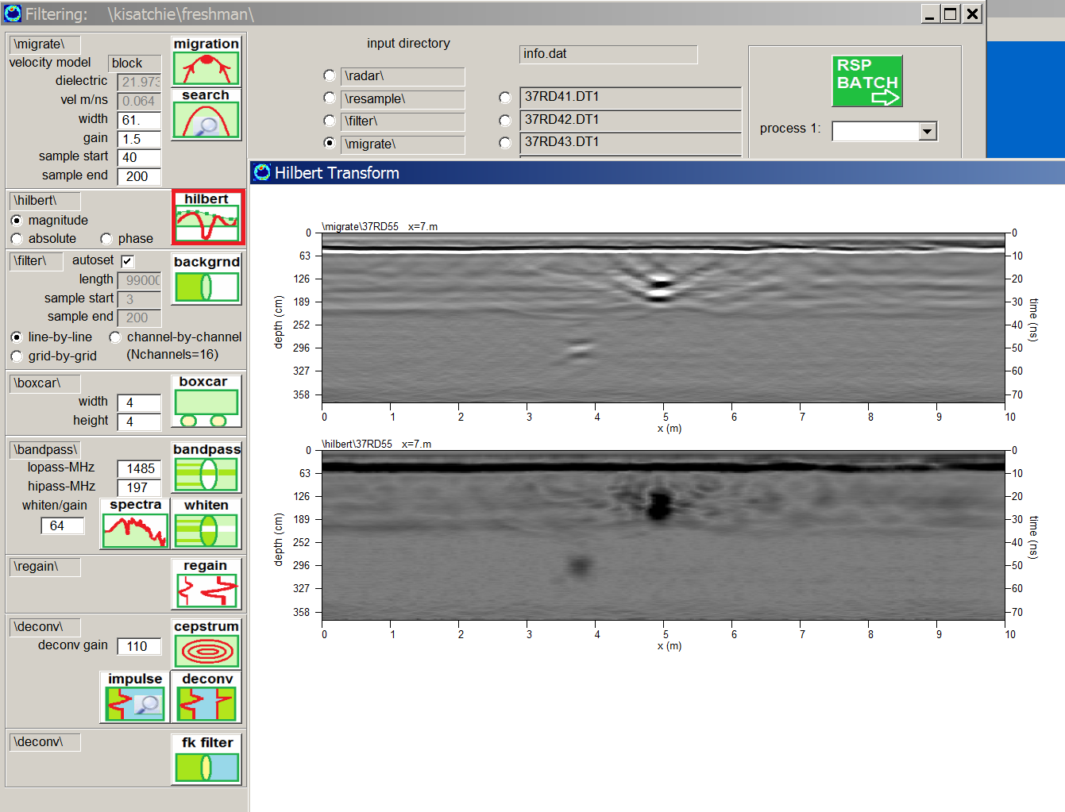

Figure 8. The Hilbert transform was applied to bandpass filtered, background filtered, migrated radargrams residing in the \migrate\ folder of the project.

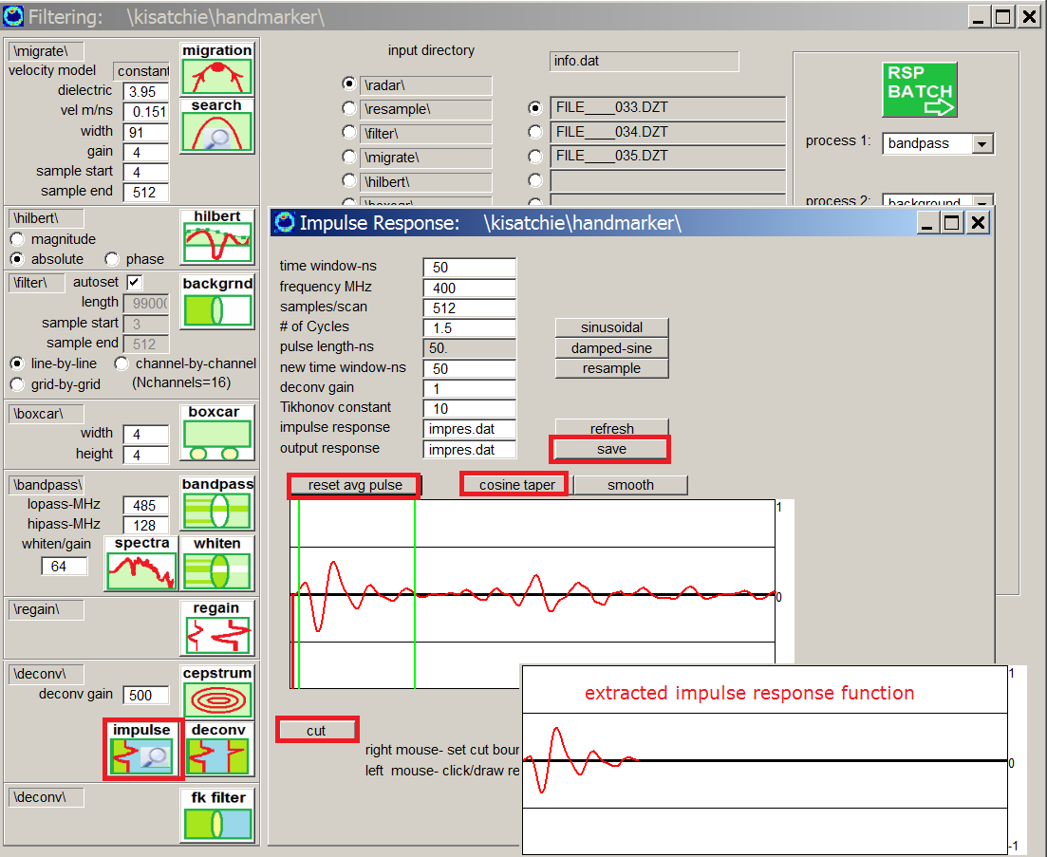
Figure 9. Spectral deconvolution requires setting an impulse response function by taking the average pulse, and then cutting out the desired (estimated) pulse.

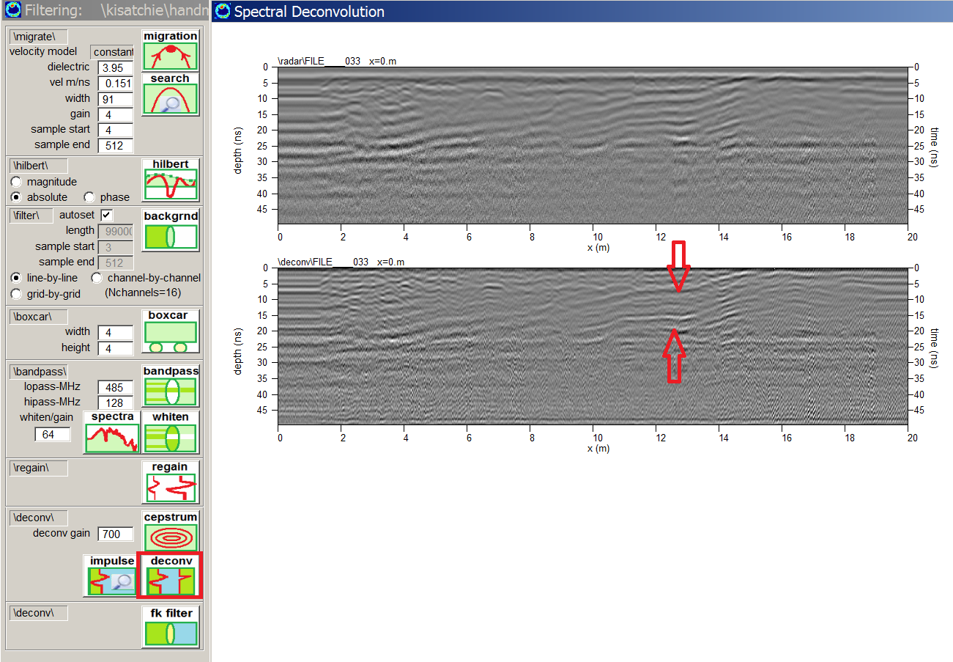
Figure 9. Example of spectral deconvolution filtering. In this example reverberation on a reflector is partially removed in the deconvolved radargram.
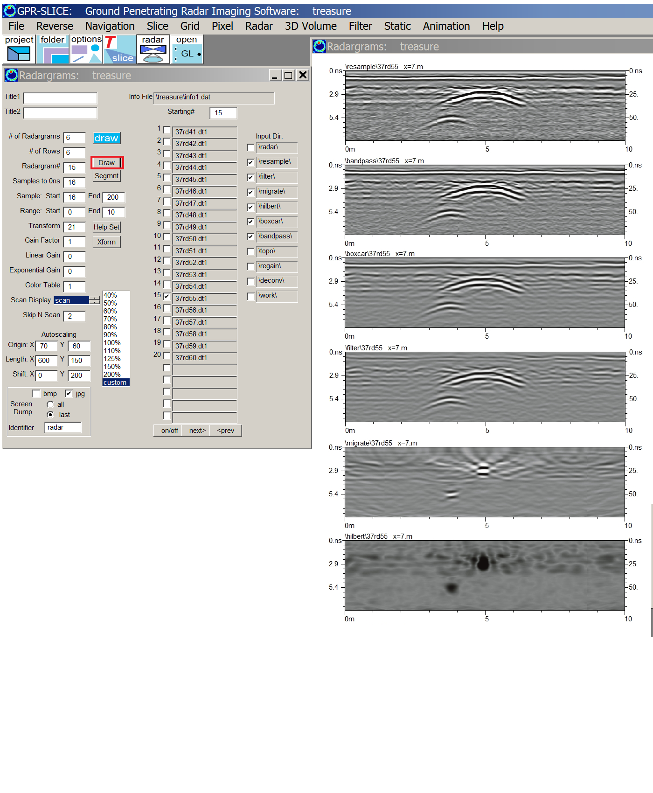

Figure 10. An example of displaying all the processed folders using the 2D Radar menu.

11B) Signal Processing 2 ( + optional GPS issues)

Project folder: \kisatchie\cellphone\

Purpose: To introduce basic signal processing including to remove cell phone noise using bandpass filtering and to also show problems with GPS collection

Basic Information: Often certain unidentified noises appear in radargrams which can be effectively removed by bandpassing. What may look like sporadic noises which are not constant across the radargram, can often be removed by bandpass filtering. Shown in Figure 1 are several radargrams showing such sporadic noises on the bottom range of the data.

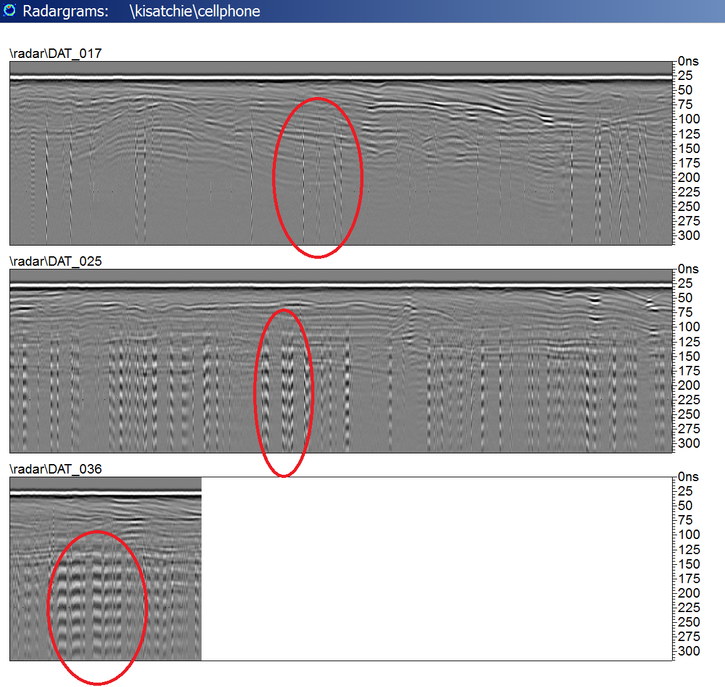
Figure 1. Noises (from cell phones) are identified on these 3 radargrams which have a defined frequency content. (Data courtesy of Joe Boyce, McMaster University).
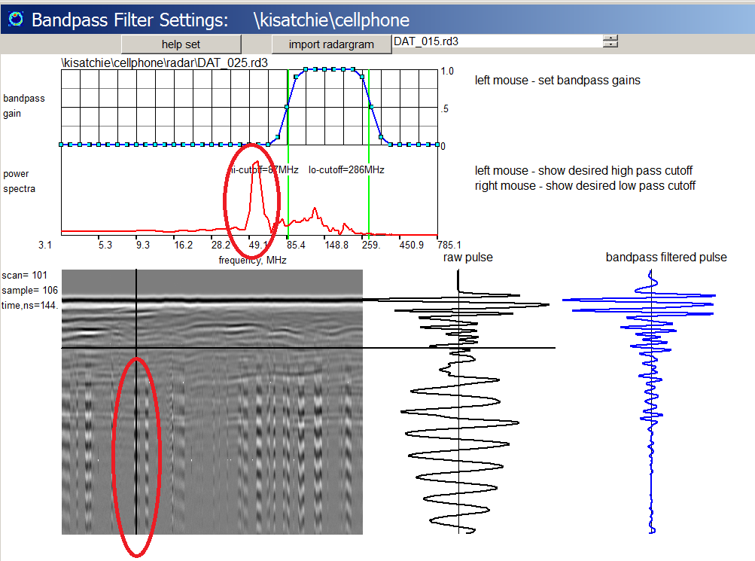

Figure 2. In the Spectra menu, the frequency content of the isolated noise events can be identified. The bandpass cutoffs are set to avoid the unwanted frequencies.

The isolated sporadic noises on the bottom on the radargrams shown are most likely caused interference from cell phones that were used or left on during data collection. The equipment used was a low frequency – unshielded antenna which can receive interference from above ground microwave sources. However, these isolated noises can be effectively removed with bandpass filtering. The frequency content of these isolated noises can be found by using the mouse to lock the crosshairs on these pulses. The one shown in Figure 2 indicates the noise has a large low frequency component as seen in the spectra plot. By setting the hi-cut (and the lo-cut) green bars to exclude frequencies below this value, the bandpass filtered radargram will have these noises removed (Figure 3).

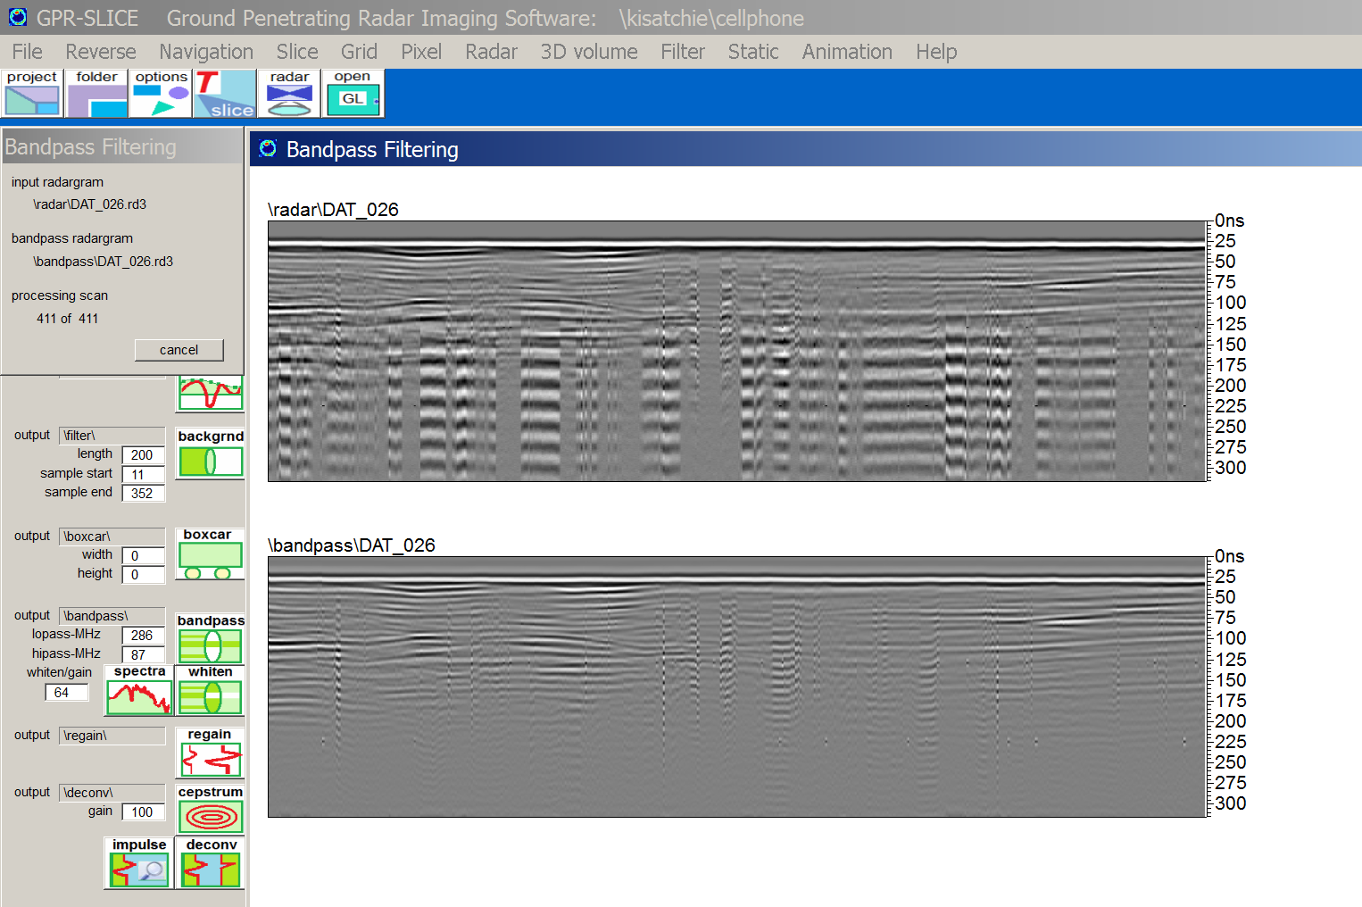

Figure 3. An example of one radargram with cell phone noises removed by bandpass filtering.

*Optional training

There are other GPS issues which can be examined on this dataset. Creating the GPS track map will give a incorrect map. The GPS tracks will have to be corrected by using the Del Bad GPS button and using a proper error length (Figure 4). (The best error length is .01, but other error should be looked at to see what results. If larger error lengths to remove bad points are used, some tracks will be left outside the GPS included data and will appear as empty files.) The interpolating time GPS buttons can also be investigated. Many lines will show that the GPS has multiple sections where more than 10 seconds of GPS fallout occurs. Ultimately, the user decided to forego the use of GPS and to use the UTM GET XY (Figure 5) button which will override the GPS log files and will import at file called utmgetxy.dat which exists in the \raw\ folder. They knew the data was collected along straight line chords on the site so just the start/end points were needed. To import an external navigation file, it should be a 4 column file with simply eastings-start, northings-start, eastings-end, northings-end. These chords are directly imported into the Edit Info File menu.

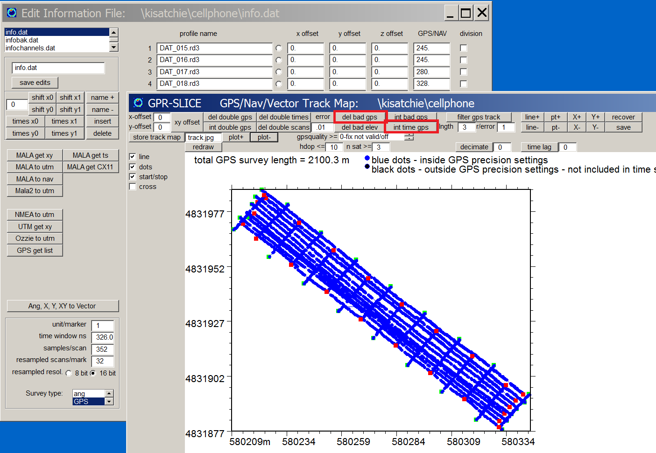
Figure 4. The GPS track map which needs to be corrected with several operations.

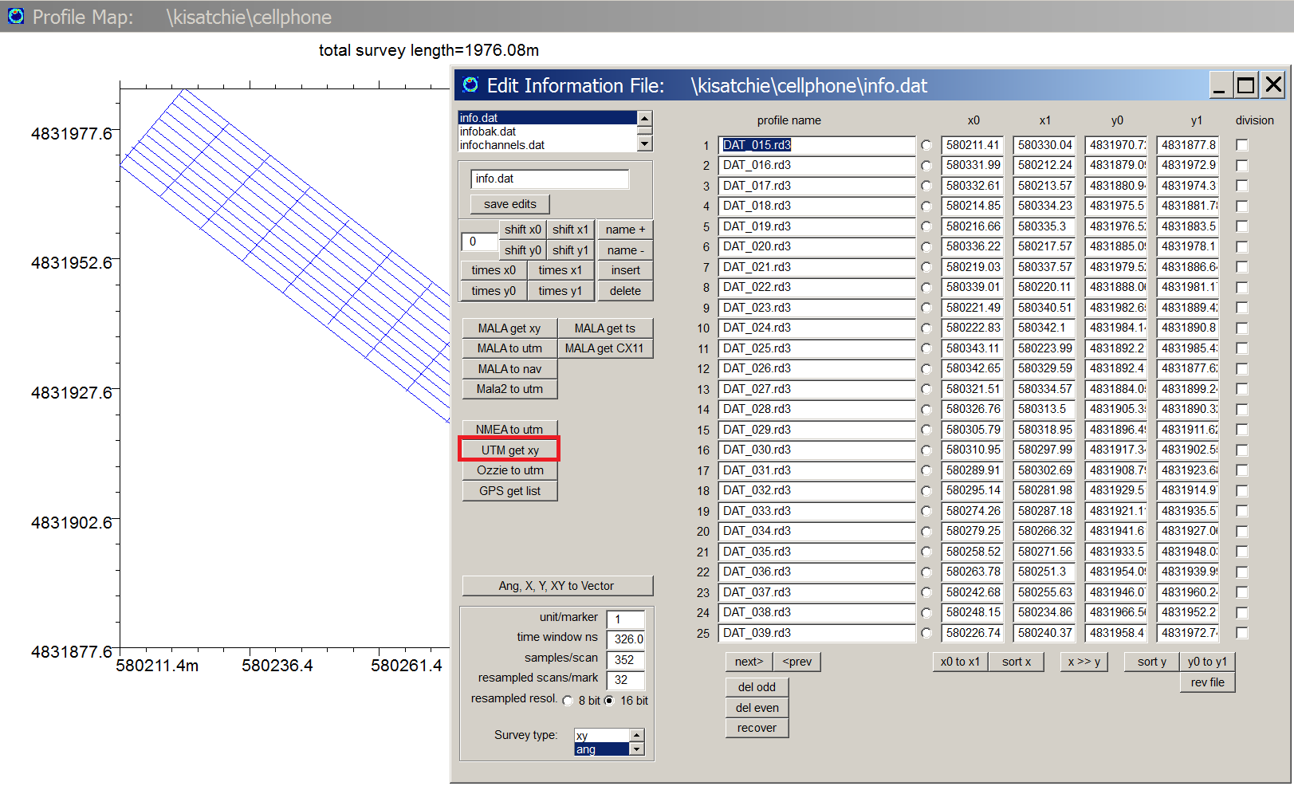
Figure 5. The option to read in an external UTM file with the start/end points is shown.

12) Overlay Analysis

Project folder: \kisatchie\overlay-analysis\

Purpose: To introduce the most useful 2D imaging available that will help to create comprehensive images of all the important reflections and place them on a single map.

Basic Information: Overlay Analysis is a unique process where the relative-strongest-reflectors are collected on an image. The process can be considered to be a binary process where the strongest pixel, from a series of desired time slices, is overlaid on top of one another. The process is different than taking a thick single time slice since in overlay analysis each individual slice level contrast can be controlled as well as its weighting in the final image. Overlay analysis is not sensitive to the arbitrarily applied scan gain curves or recorded gain in the data, since each level is re-gained at the discretion of the user.

An example showing what is actually going on in overlay analysis is described in Figure 1. A series of time slices are drawn to the screen. The first time slice is completely illuminated. The following time slices in the series only show those pixel elements that are stronger than all the previously drawn images. As can be seen, the number for pixels that are illuminated as one goes deeper into the site decreases with depth. However, using the transform menu, any desired level can have colorization applied that can overweight or underweight any of the contributions from that level.

Application of overlay analysis to the Nanaojo Castle site in Ishikawa Prefecture, a complete description of the important reflectors from near the top surface to any desired depth can be generated (Figure 2). Checkboxes in the Pixel Map menu are available to quickly shut off the contributions from any time slice level in the ground. Commonly, as is shown in the diagram, one usually will shut off the time slices from the top to remove the ground surface reflections. However, these can be included or underweighted in colorization before the overlay process is started.
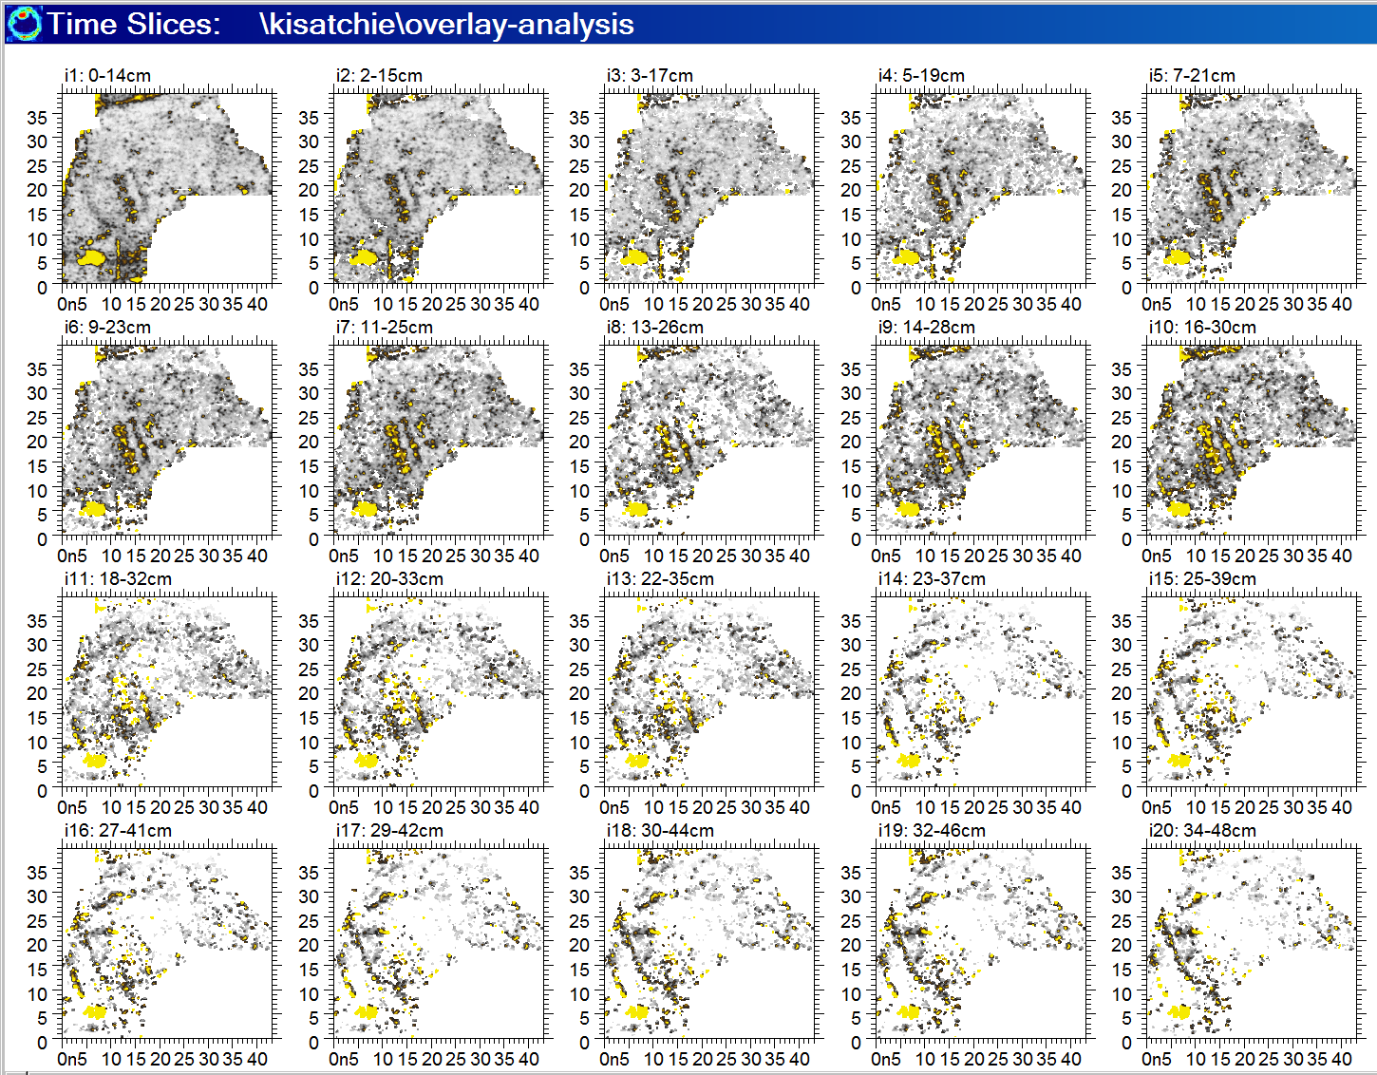

Figure 1. Overlay analysis is implemented by illuminating only those pixels which are stronger than previously drawn pixels up to the desired level.
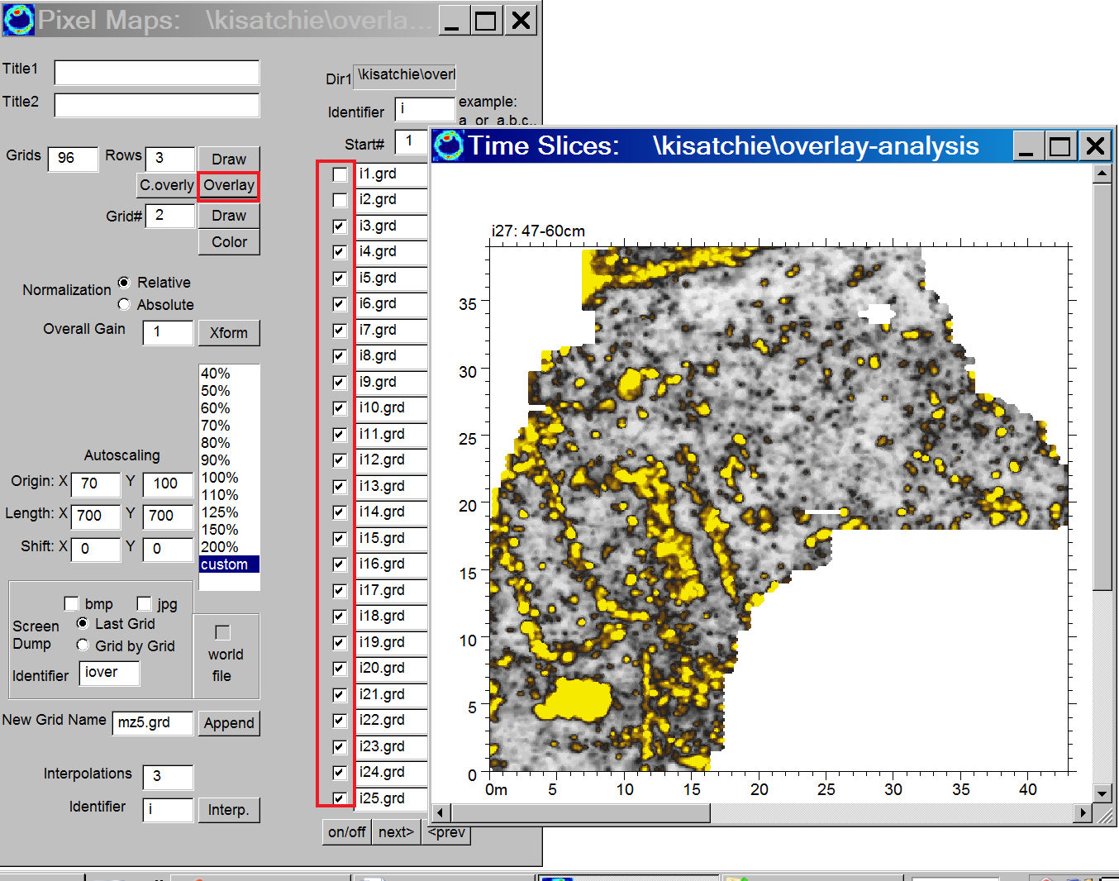

Figure 2. Overlay analysis shows many features which are shown to be continuous anomalies when “connected” via this graphically operation.

13) Overlay Analysis 2

Project folder: \kisatchie\overlay-analysis-2\

Purpose: To continue to introduce the most useful 2D imaging available that will help to create comprehensive images of all the important reflections and place them on a single map – Overlay Analysis…Please do this with your data!!!

Basic Information: Overlay analysis is examined at another site, the Biesterfelt site in Fargo North Dakota to try and locate Indian pit houses and features within these archaeological structures. Overlay analysis is the key to imaging of this site – without it the subsurface answers would be obscured. This projects indicates the need to individually colorized the time slices in order to get the desired result. Shown in Figure 2 9 slices made at the site. A round feature on the first slice is a pithouse feature. Using overlay analysis on the first pass is shown in Figure 2.

The features inside the pithouse are perhaps to over gained to make use of this image. By regaining the lower time slices, from 2-9 (Figure 3), keeping the first time slice gain intact so that the round pithouse can be view, and applying a transform that only exemplifies the stronger reflections, re-colorized time slices can be seen in Figure 3 Using this data to perform overlay analysis on the entire data, more features can be seen. In Figure 4, several strong anomalies perhaps located on perhaps 4 posthole corners can be interpreted in this overlay analysis map in which individual transforms were applied to different part of the time slice dataset.

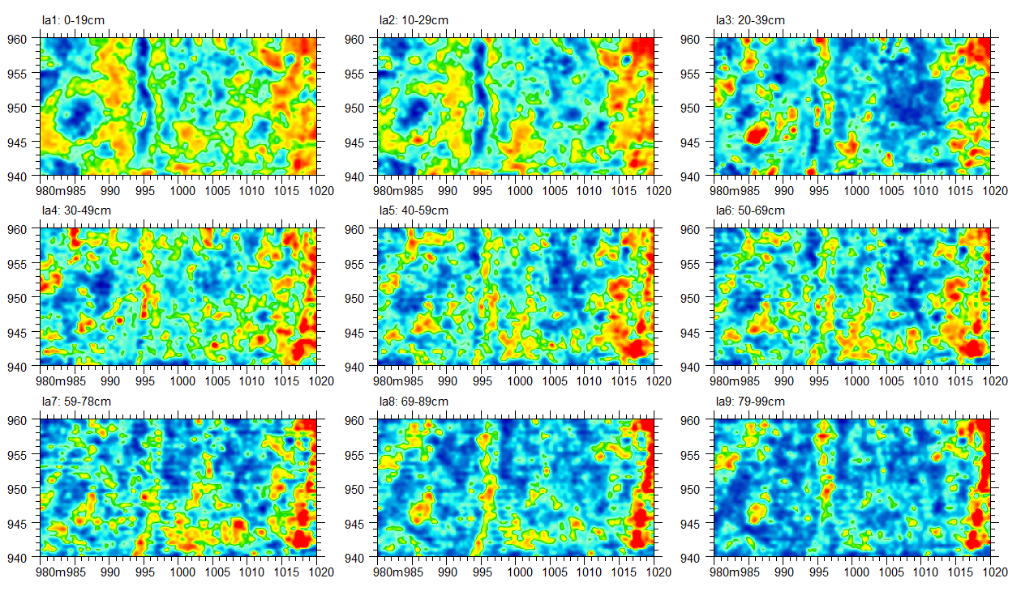

Figure 1. Time slices made for the Biesterfelt site.

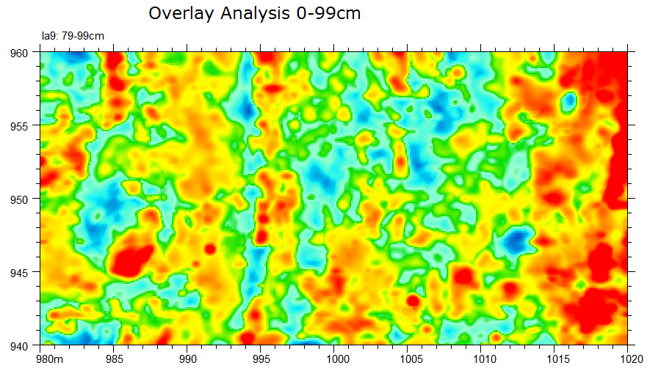

Figure 2. Overlay analysis image. This image perhaps shows to much information inside the pithouse, as the colorizations shows to much strong reflections.
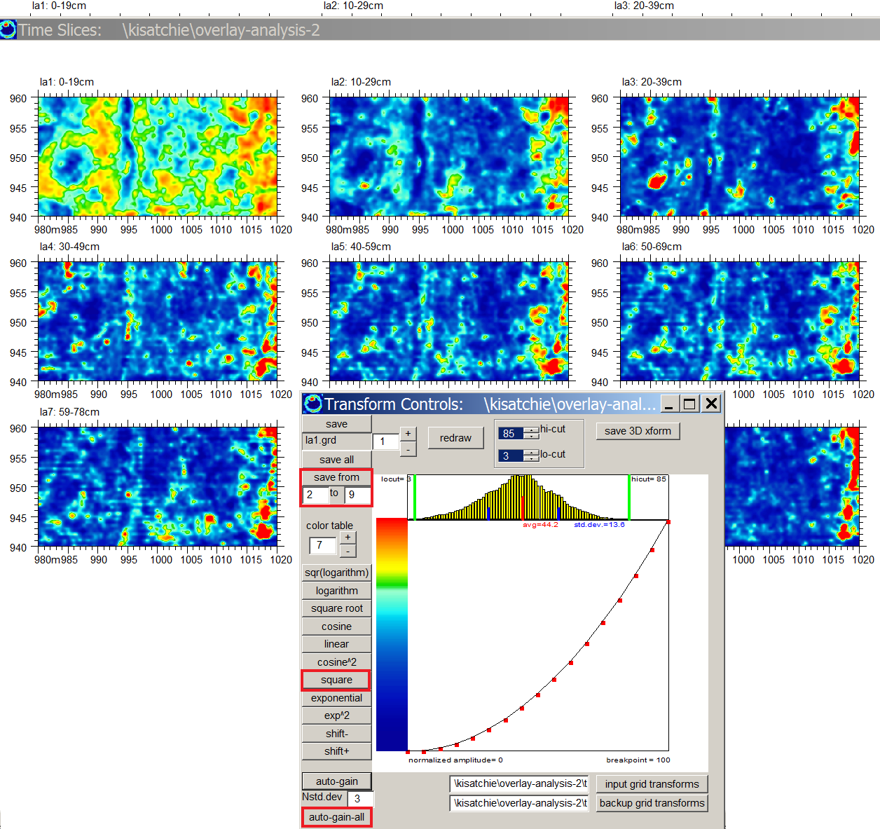

Figure 3. Time slice 2-9 are regained to de-emphasize the lower and mid-range reflectors.
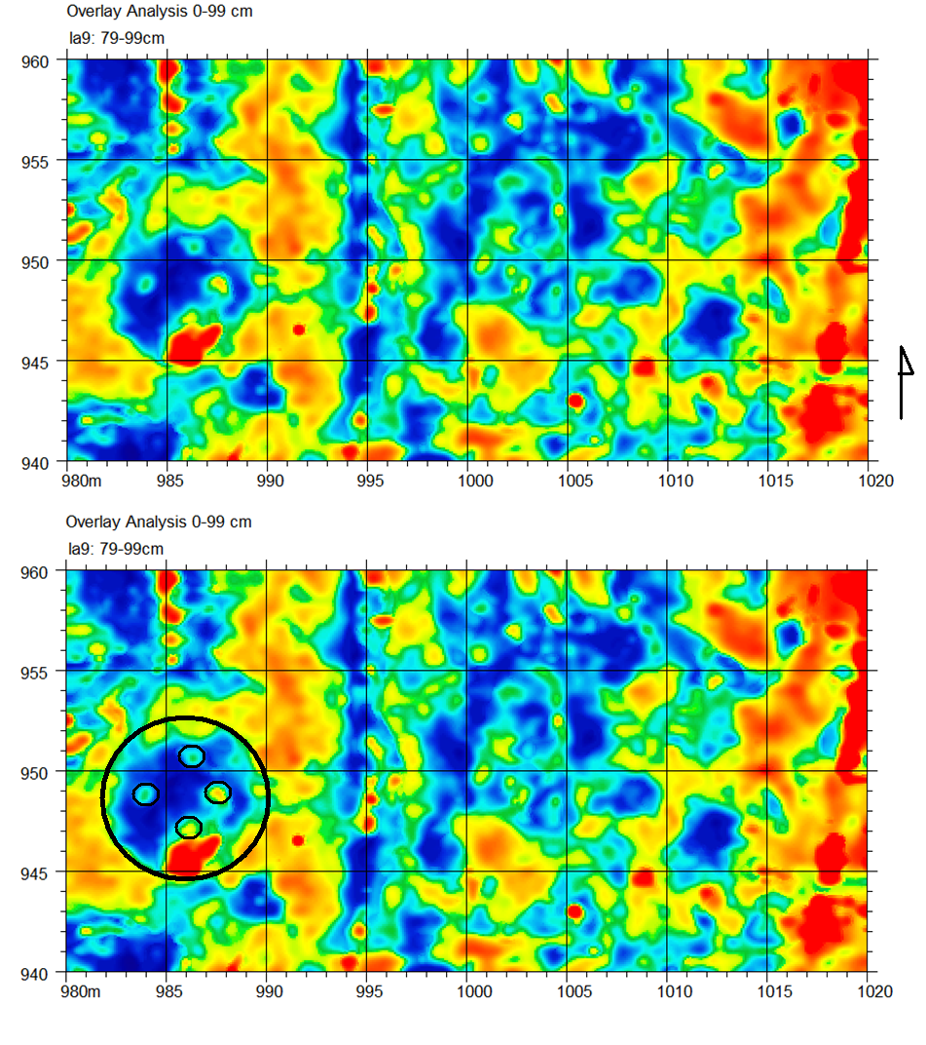
Figure 4. Overlay anlysis is applied after re-colorizing the maps from levels 2-9. The interpretation of 4 possible posthole corner can be identified on a single overlay analysis image.

14) XY Surveys

Project folder: \kisatchie\frederica-xy\

Purpose: To introduce X and Y cross surveys and to discuss special noises in these surveys that can sometimes occur.

Basic Information: There is no final answer on whether single direction surveys are better than half as dense bi-directional surveys. In any event, many users collect data in both x and y to generate time slice maps. Some unique problems in these data can occur if the data collected in the x and y direction were not recorded very close in time or if equipment or environmental changes have altered the overall reflections between x and y surveys. The operations to generate time slices from x and y directions are identical to making time slices from uni-directional surveys. Reviewing the procedures for those that do not commonly do bi-directional surveys is provided.

The first step is to make a comprehensive information file containing the names of all the radargrams collected. This can be easily done by first generating the x line information file, e.g. infox.dat (Figure 1), followed by the y line information e.g. infoy.dat (Figure 1). After these 2 independent information files are generated in the Create Info File menu, the user can then append these together to a comprehensive information file, e.g. infoxy.dat using the Append operation (Figure 1). (Note, individual info files can also be created using the Import option which will read all the radargrams in the \raw\ folder and use the set navigation).

The next step is simply to follow all the main processing operations to generate time slices (e.g. Figure 2). The data for this site are “well behaved” and no measurable gridding noises exist. Often, if the data collected in x and y have slightly different gains, then doing the combined bi-directional time slice calculation will show what we call “checker-boarding noises”. Shown in Figure 3 is checker-boarding noise (artificially synthesized) in the dataset. This was accomplished by using the Regain process in the Filter menu and regaining just the y lines – thus inducing an artificial mosaic between the x and y lines.

To effectively remove this noise the user can generate separate time slices for the x direction and separate time slices for the y direction, and then to use Grid Math in the Grid Menu to generate a additive time slice. The process of decoupling the time slice and then adding the separated grid has the net effect to cancel out the mosaic noise between the time slices. One can also us the weighting factor for one of the grids for grid math to weight one of the grid more heavily or less during the addition process.

In Figure 5 a comparison time slices showing the original XXYY time slices with checker boarding noises, XX for the x line profiles, YY for the y line profiles, and XX+YY time slices for the checker-boarding corrected time slices. It is useful to note that the same gridding parameters were used for all the time slices calculated.

This technique of line separation, individual time slice calculations and then using grid math is very useful to not only remove checker boarding noises, but also shielding line noise caused by difference line-by-line from zig-zag surveys (please see the GPR-SLICE manual for further discussion for removing shielding line noises).

Note: Using a multiplication factor of -1 will essentially map the differences between the x and y time slices grids.

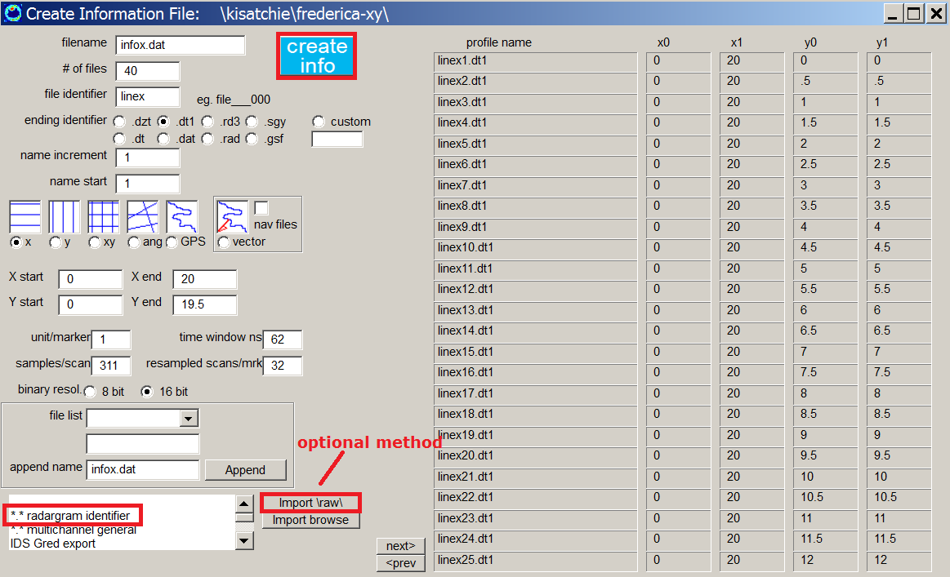
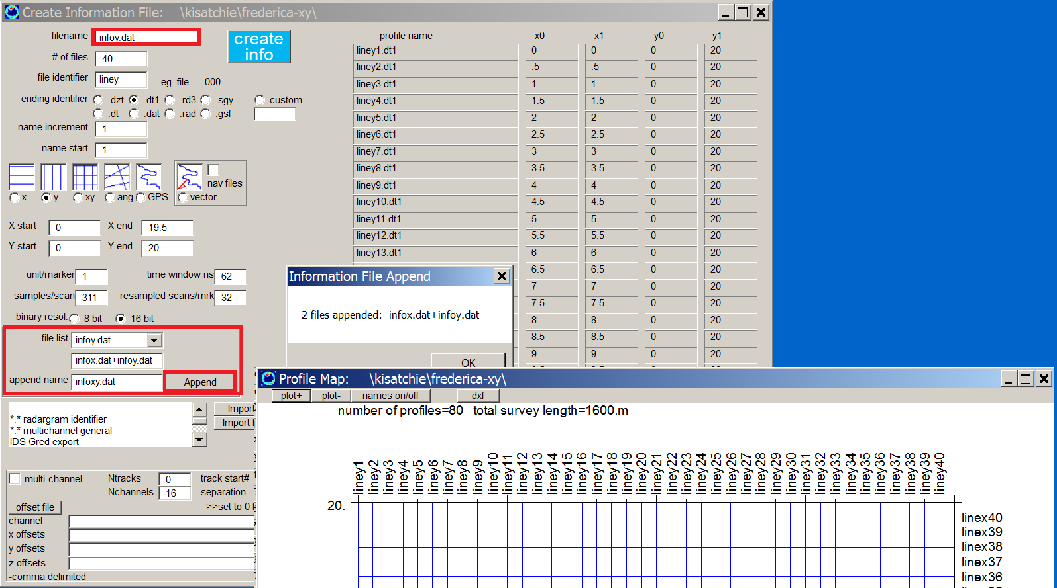

Figure 1. A comprehensive information files containing the names of all the bi-directional radargram names can be created using the Append button. It is easiest to make the x and y line information separately then use the append option.
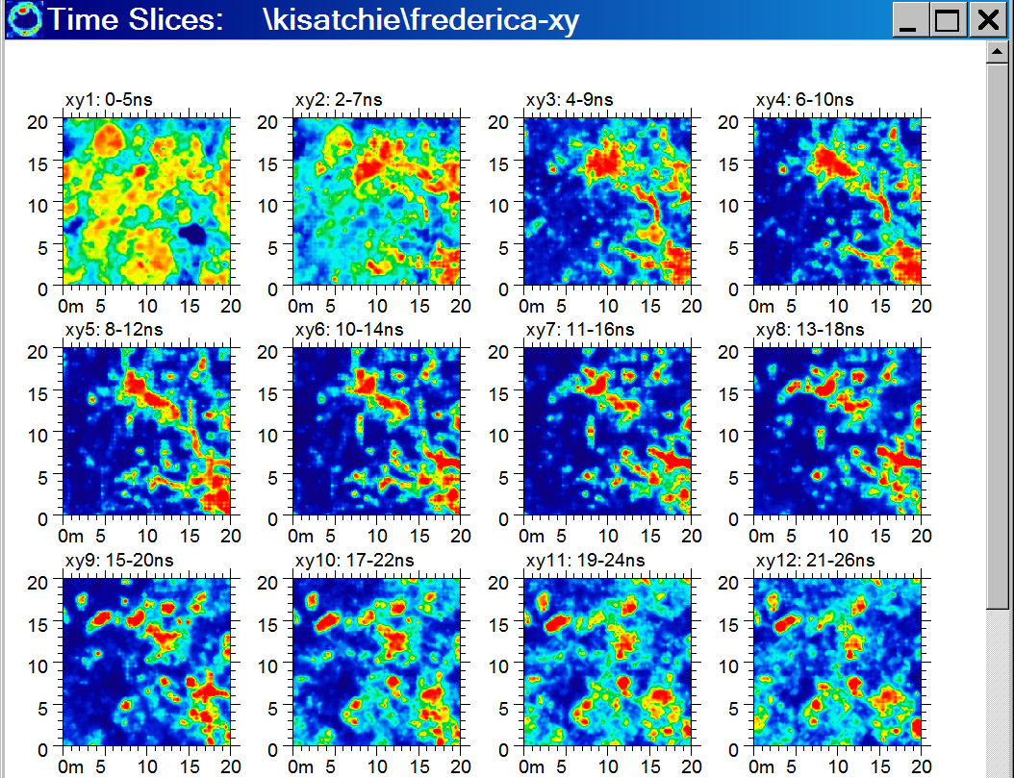

Figure 2. Example of bi-directional time slices generated for the Ft Frederica site using Sensors and Software equipment.

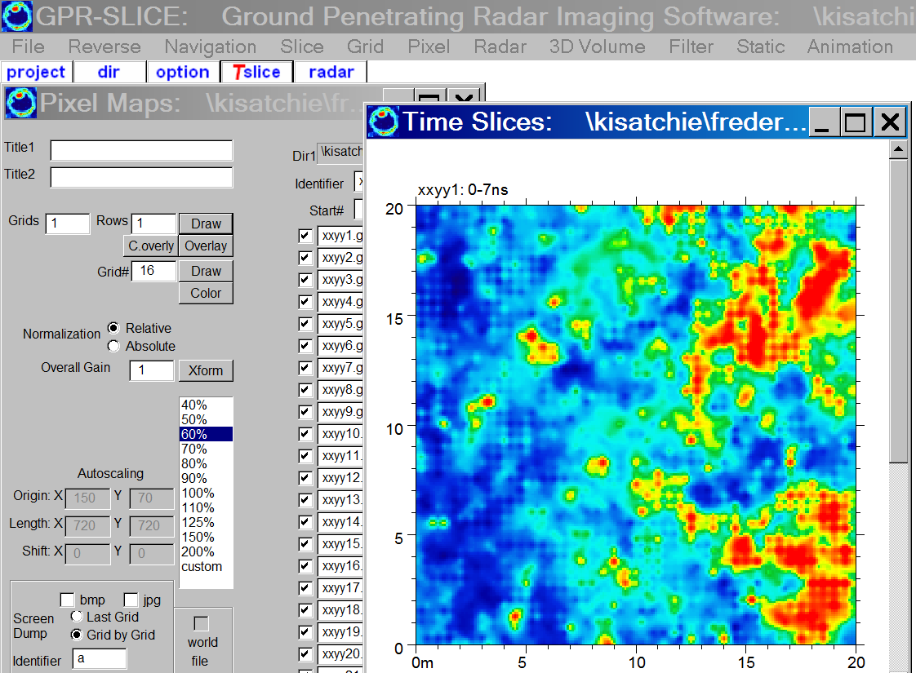
Figure 3. Example of checker-boarding noise caused by gain differences between X and Y profiled lines for a site.

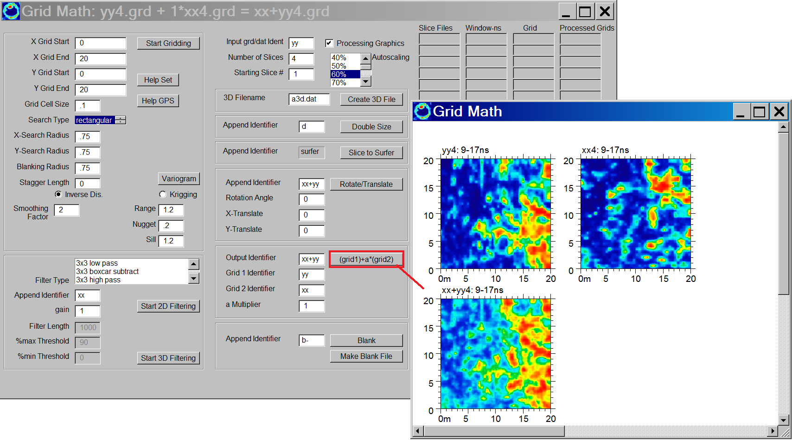

Figure 4. One effective method to remove the check-boarding noise is to compute the x and y line time slice maps separately, and then to use Grid Math to generate a new time slices that add up the separate maps
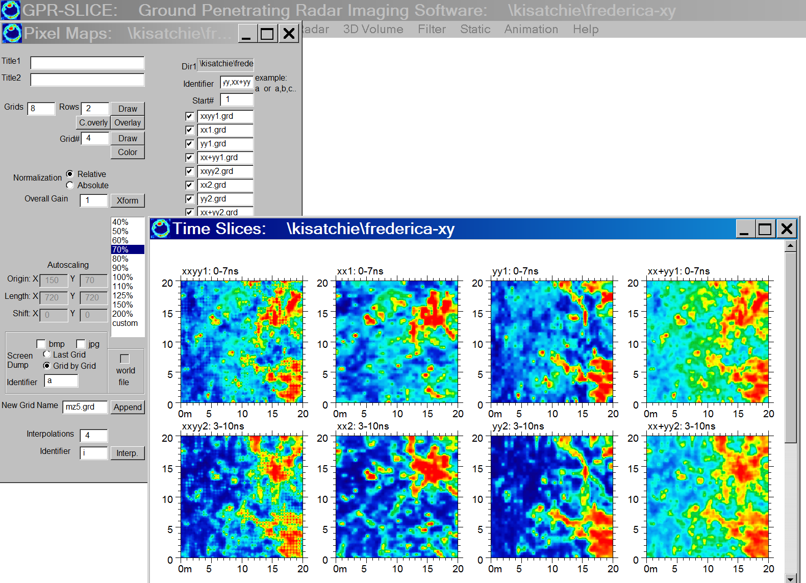

Figure 5. Using the comma delimited identifier option in the Pixel Map menu, it is easy to display all 4 calculated grids. XXYY is the combined grid showing checker-boarding noise, XX are the x line profile, YY are the y line profile time slices, and XX+YY are the time slices computed using Grid Math. Checker-boarding noise is not present in the XX+YY time slices!

15) Importing 2D Geophysical Data

Project folder: \kisatchie\radar+mag+res\

Purpose: To introduce the capabilities in GPR-SLICE to process data other than GPR data using an import option for geophysical data.

Basic Information: GPR-SLICE was specifically designed for GPR data and nothing else. However, many function developed in GPR-SLICE has some overlap with examining typical geophysical data from other equipment. To import data, the user needs to have a comma delimited x, y, data file without any header as shown in Figure 1. After this file is placed into the main project folder, the Import operation is run. It is important that the output data be appended with a numeric definition onto the name of the file (Figure 2). This imported and converted file can then be used in gridding operations in GPR-SLICE using the typical identifier definition with the grid start number (Figure 3). Time slices, magnetic, resistivity or other data can be compared and displayed in the Pixel Map menu (Figure 4). The possibility of using overlay analysis to synthesize comprehensive 2D maps can also be investigated with the Pixel Map menu.

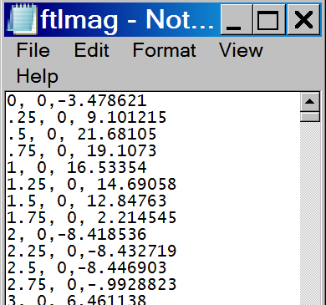

Figure 1. Example of (magnetic) data used for importing to GPR-SLICE.

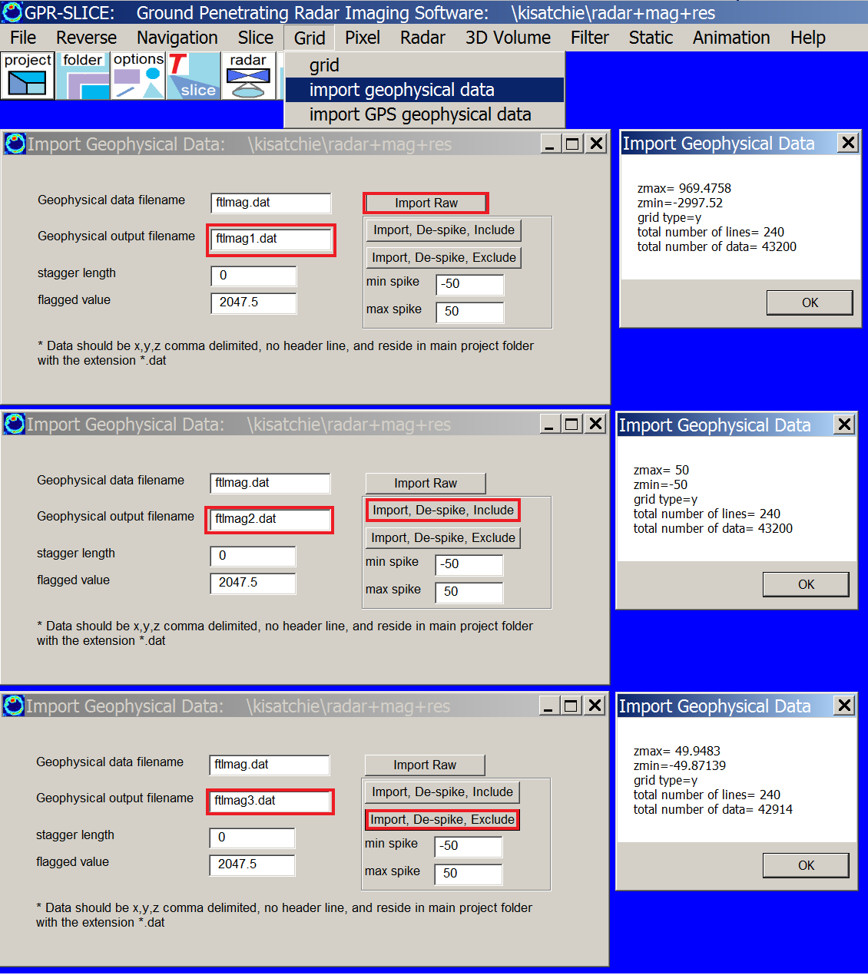

Figure 2. The imported data should have a numeric extension beginning with “1.dat”. In this example, a magnetic survey dataset is imported as raw data (ftlmag1.dat), de-spiked data (ftlmag2.dat), and de-spiked data that excludes data over the spiked values (ftlmag3.d). The data can also be examined with tighter spiking values…e.g. -+30..

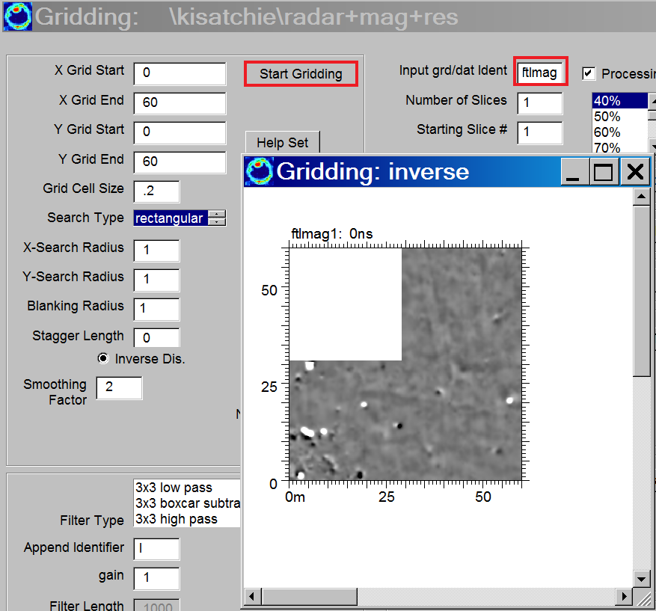

Figure 3. Imported 2D geophysical data of any kind can be gridded in GPR-SLICE.

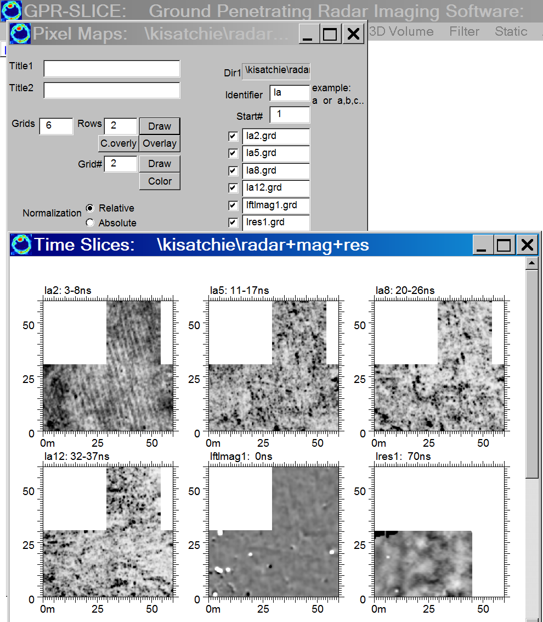

Figure 4. In this example, 4 time slice maps, 1 magnetic map and a partial resistivity map from a site in Ft Lewis, Washington is show.

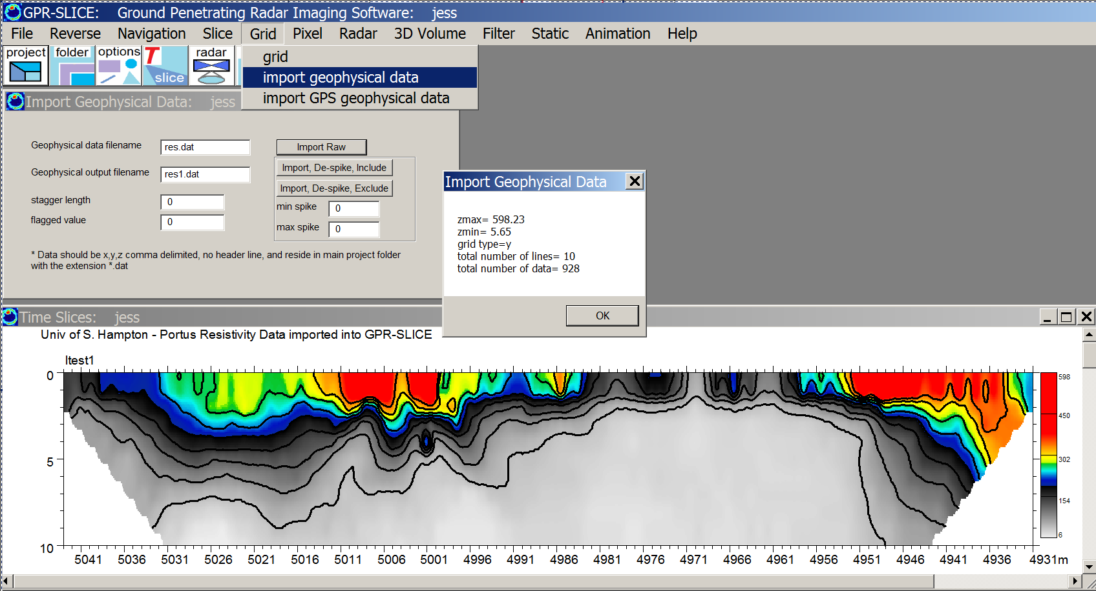

Figure 5. The University of South Hampton provided this dataset of ERT.dat – electrical resistivity tomography, which can also be imported and processed in GPR-SLICE.

16) 0ns Offset Scan-by-Scan Radargram editing and truncation

Project folder: \kisatchie\0ns-offset\

Purpose: To introduce the latest capabilities of GPR-SLICE v7.0 to automatically detect the 0ns offset for each scan on radargram and to automatically fix the 0ns offset across the radargram and all the radargrams in a project.

Basic Information: A new option to detect the sample number for each individual scan where the 0 ns are located has been added to the Radargram Editing menu in V6. With this advanced process, the user can automatically detect the 0 ns scan-by-scan and the software will auto truncate the radargram and generate new radargrams with the 0ns offset shift synced across all the radargrams in the project. This operation will run in batch.

One might ask why would one want to detect the 0ns scan-by-scan and have the software truncate each scan to this local value. Well, there are some datasets, where the 0ns drift occurs dramatically within the radargram profile. This situation can occur with any equipment that undergoes some kind of electronic drift/noise. Till Sonnemann from the University of Sydney has been working in Cambodia, and he recorded typical radargrams as shown in Figure 1:

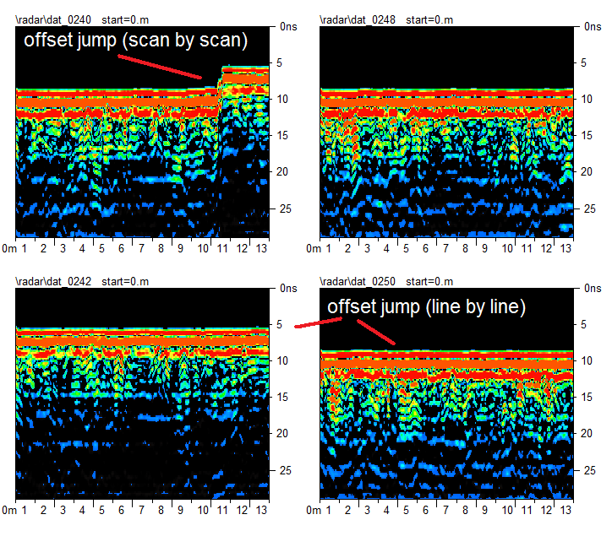
Figure 1. Examples of 0ns offset changes in a dataset.
The 0 ns offset in the top left radargram shifts by about 3 ns suddenly near the 10 meter range. The other radargrams also shows significant changes in the 0ns offset between different lines. Making time slices of 0ns offset uncorrected radargrams will produce inconsistent and noisy time slices which will appear to have mosaic, striping and other problems, in addition to not showing reflections at equal depth across the site.

GPR-SLICE was equipped to handle line-by-line automatic offset detection for our multi-channel users. However, the earlier versions only kept this 0ns offset available for time slice operations, but did not truncate or edit the radargrams to generate a new set of radargrams with a constant offset. Because this offset problem appears in single channel data, the software needs to provide an option for non multi-channel users as well to correct for this problem.

The new process to do this correction is in the Radargram Editing menu called Auto 0ns Scan-by-Scan + Truncate. The process works by looking at a threshold change on the signal prior to the pulse rising. The operation will discover the smallest and the largest 0ns offset across the entire set of radargrams first and over each individual scan. When this is done a message box will appear detailing a description of the minimum and maximum 0ns offset. This information is needed prior to adjusting and truncating a new set of radargrams with a new sample length. For instance in this dataset, the minimum and maximum sample positions detected are the 26th and 43rd sample. When the process of radargram editing/truncation is finished, a new set of radargrams will be written to the \work\ folder containing radargrams which have the 0ns adjustment for each scan, and total scan length of (N sample – 43). A new information file called infoedit.dat will be written. To continue the data processing, the infoedit.dat file should be highlighted in the Edit Info File menu to make it the active information file.

The radargram editing for 0ns offset, requires several important data processing step in order to properly generate time slices. These steps are:

1) Convert the \raw\ data using Batch Gain (not Batch Gain – Wobble) and with NO gain curve- e.g. all the gain points set to 1.

2) After reversing the files if necessary, continue to the Radargram Editing menu and run the scan-by-scan or the line-by-line process to adjust for the 0ns offset and to write a set of 0ns corrected radargrams in the \radar\ folder to the \work\.

3) Highlight the infoedit.dat file in the Edit Info File menu for the new set of radargrams in the \work\ folder that have been adjusted.

4) Return to the Filter menu and run the Regain menu on the \work\ folder to make gained radargrams in the \regain\ folder

5) Run the Spectra menu to set the bandpass frequencies and then run the Bandpass operation.

6) Go to the Navigation menu and select the bandpass folder for running the desired navigation option. Proceed as usual to the Slice\Resample operations to make time slices.

Step 1 is necessary since applying gain prior to correcting for the 0ns offset would result in unequal gaining after truncation. The gaining of the radargram must be done after the 0ns adjustment is made.

Similar operations are done for line-by-line 0ns detection. In this operation, the average 0ns offset across each individual line is first calculated and this is used to make the adjustment.

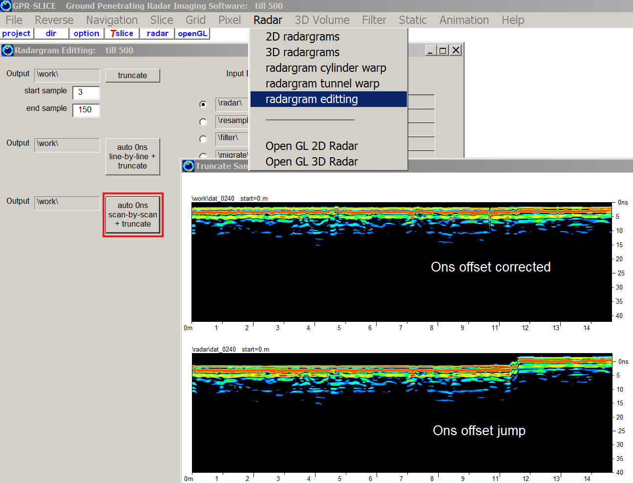

Figure 2. Screen shot of the 0ns offset operations in the Radargram Edit menu.

In the run runtime environment, only the corrected radargrams is actually displayed. Once the operation is completed, the user can then return to the Navigation menu apply navigation to the appropriate folder. An example image showing a comparison of raw, line-by-line, and scan-by-scan 0ns offset corrected time slice is shown in Figure 3 (using the multi-grid time slice display option):

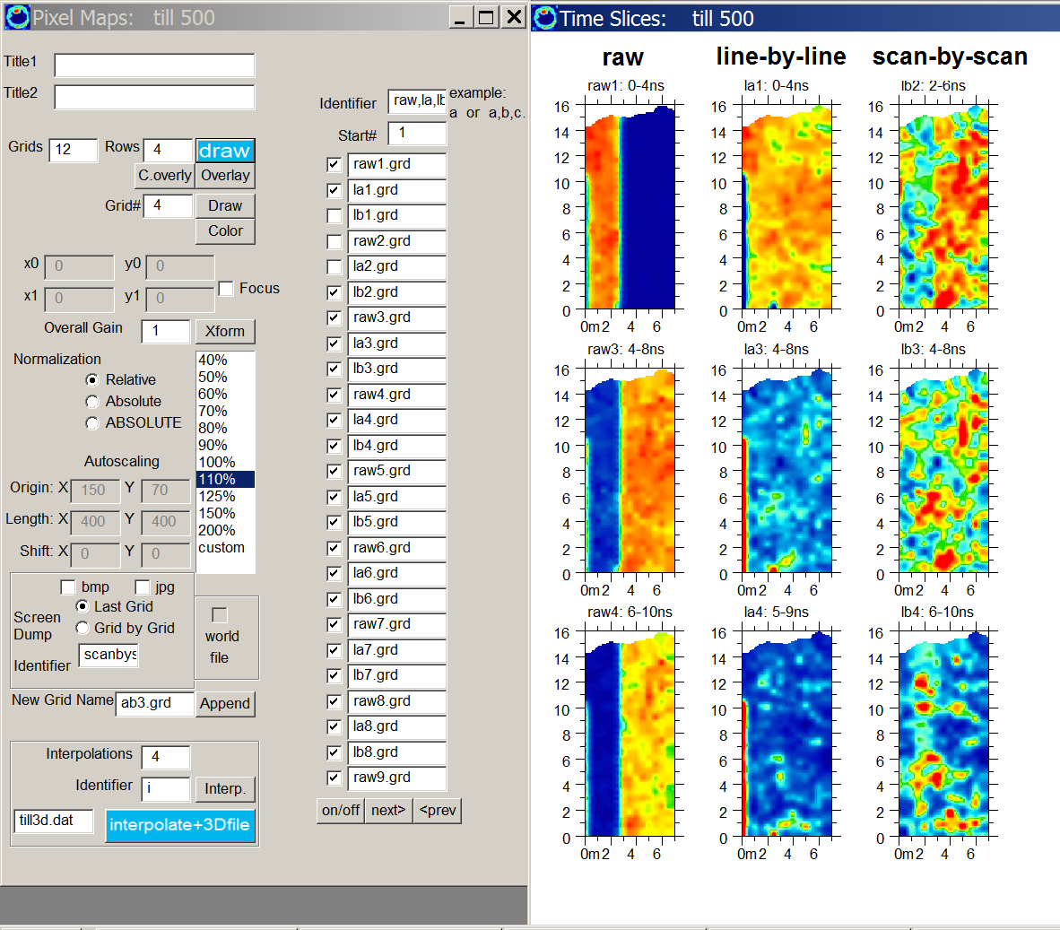

Figure 3. Comparison time slices of raw, line-by-line offset and scan-by-scan offset corrected images.

In the time slice comparison images (Figure 3), the raw data are seen to show significant ‘mosaic’ noises caused by slicing the data with uncorrected offsets. The line-by-line slices look fairly good outside of the first line which has significant changes of the offset in that one individual radargram. The scan-by-scan time slices look the best and show no noises related to 0ns offset drift and changes in the radargram dataset.

17) Vector Imaging

Project folder: \kisatchie\vector\

Purpose: To introduce the latest capabilities of GPR-SLICE v7.0 to display radargrams collected along complicated geometries in 3D space.

Basic Information: The first vector imaging options were released in January of 2009. The vector imaging is comprises a new navigation file format that is enclusive of x, y, xy, ang, GPS or even total station navigation, along with addition information on the orientation, pitch, yaw and tilt of the antenna in 3D space. The new 20 column vector formats, which uses the same extension *.*.gps for the navigation file, allows any orientation. This workshop we will example 3 geometries

- Longitudinal collected along a tunnel
- Radial GPR collection on a tunnel
- Surveying over sites with topography

We will use the beginners project data and place these small lines into the a new folder call \kisatchie\vector\.

Vector - Longitudinal tunnel surveys

The steps to generate longitudinal tunnel navigation are outlined in the Vector Longitudinal Tunnel Warping menu (Figure 1) and are also provided here:

Create Info File menu:
Step 1. Create an X survey info file (Figure 2)
(x0,x1=profile start/end length along the tunnel)
(y0,y1=no need to set these)
Step 2: Click the Vector/Nav File recreate the info file
(stores the x0,x1 lengths to the vector info file)
Vector Longitudinal Tunnel Warp menu:
Step 3: Set the longitudinal angles for each radargram
Step 4: Click Vector Longitudinal Tunnel Survey button
(adjusts the 9-11th columns for antenna orientation in
the *.*.gps files)
Open GL 3D Vector Radar menu:
Step 5: Display the projected longitudinal tunnel radargrams
(Figure 3)
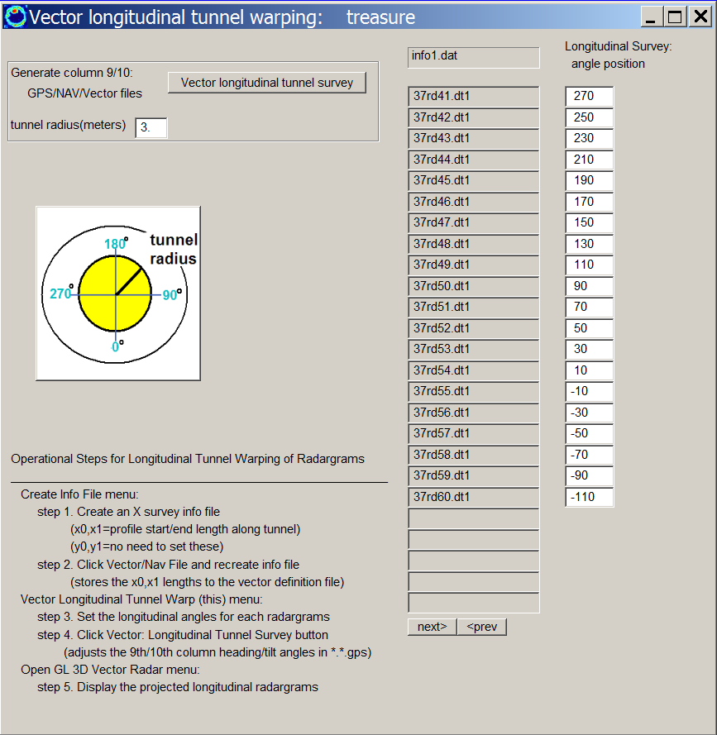

Figure 1. Menu to make generate the vector definitions for radargrams collected along the longitudinal axis of a tunnel.

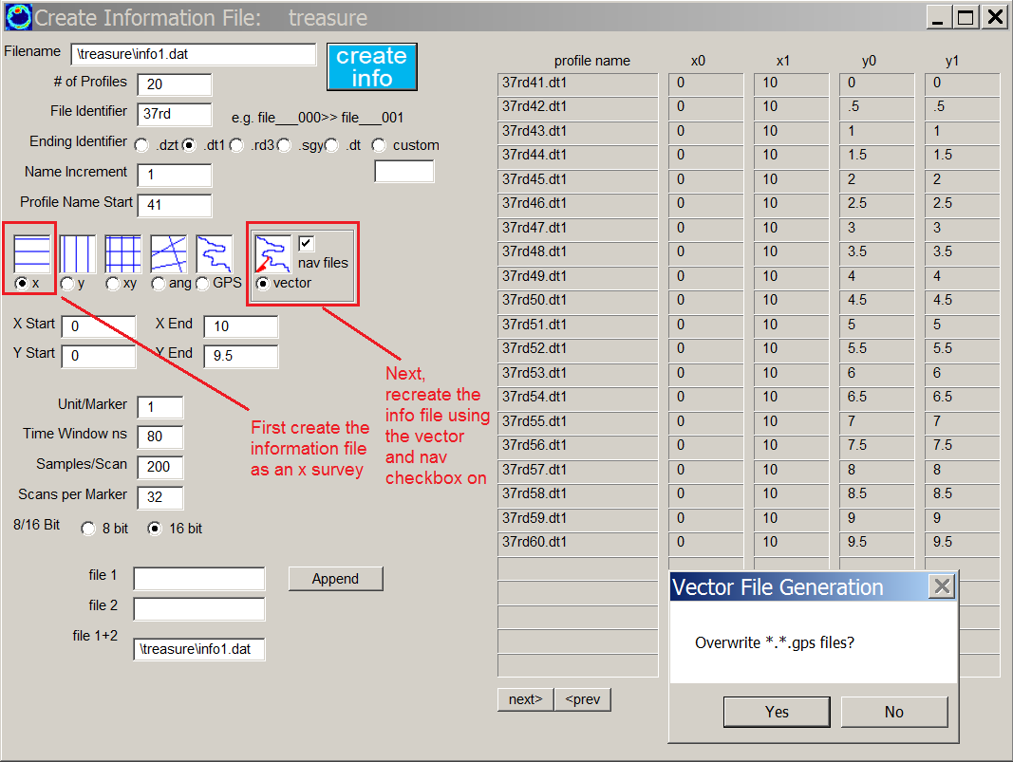

Figure 2. The Create Info File menu is used to generate *.*gps vector files. These files will be adjusted to define the geometry that is associated with the navigation.

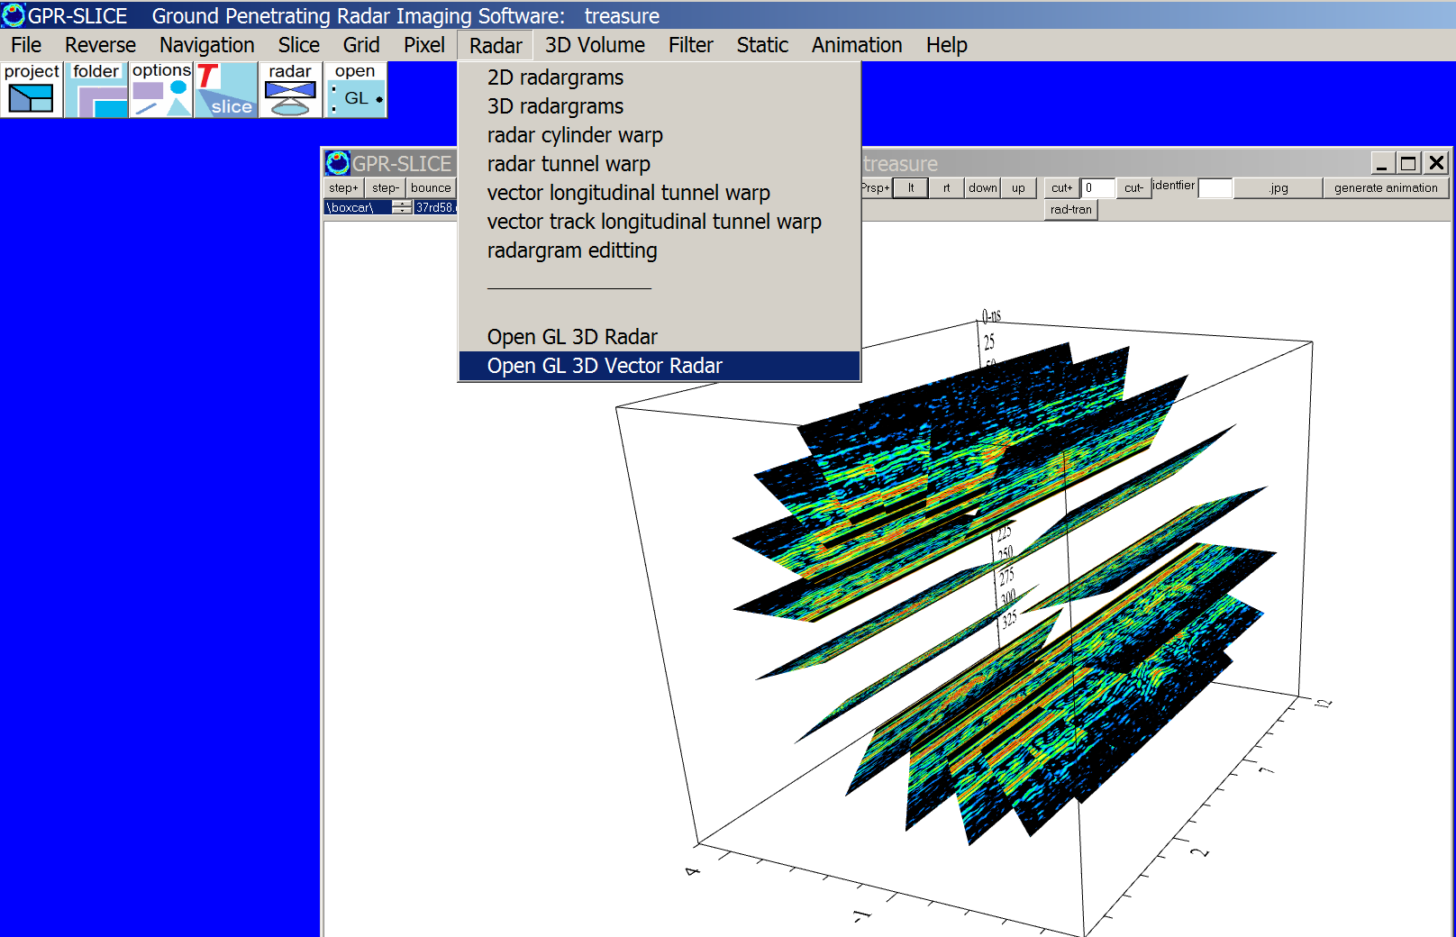

Figure 3. An example of the projected radargrams collected along a tunnel is shown in the following screen shot of the Open GL 3D Vector Radar menu:

Vector – Radial tunnel surveys

Radial warping of radargrams is done in a similar fashion to longitudinal warping. Radial warping requires the initial information file to be a y file (Figure 4). Follow in the Steps in Figure 5 which is also shown in the Vector Radial Tunnel Warping menu. A quick button to replicate the start and end angles of the survey on tunnel are available which will read the first slots. Clicking the Vector radial tunnel survey button will generate the vector files. Radial tunnel radargrams are displayed using the Open GL Vector Radar menu (Figure 6).

The complete steps for radial tunnel warpiing are also provided as follows:

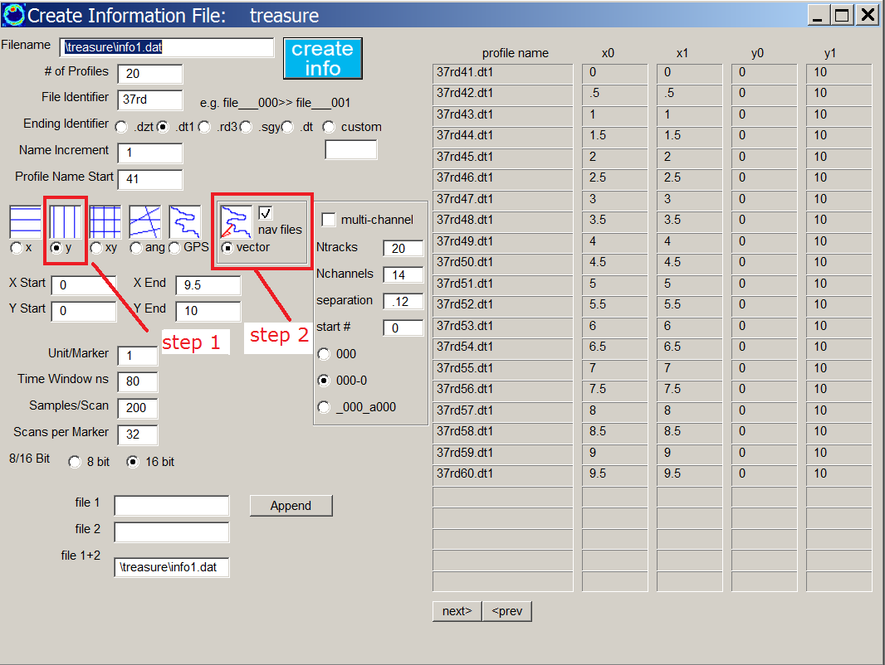

Figure 4. Radial warping requires an initial y information file, after which the vector files can be generated in step 2.

Create Info File menu:
STEP 1. Create an Y survey info file
x0,x1=position along the tunnel with x0=x1 normally
y0,y1= SET artificially long enough for vector definition
increments
STEP 2. Click Vector/Nav File and recreate info file
(stores the y0,y1 lengths to the vector definition file)
Vector Radial Tunnel Warp (this) Menu:
STEP 3. Set the start and end angles for each radargrams
STEP 4. Click Vector: Radial Tunnel Survey button
(sets the vector definitions in columns 9-11 IN the *.*.gps)
OPEN GL 3D Vector Radar menu:
STEP 5. Display the projected radial radargrams
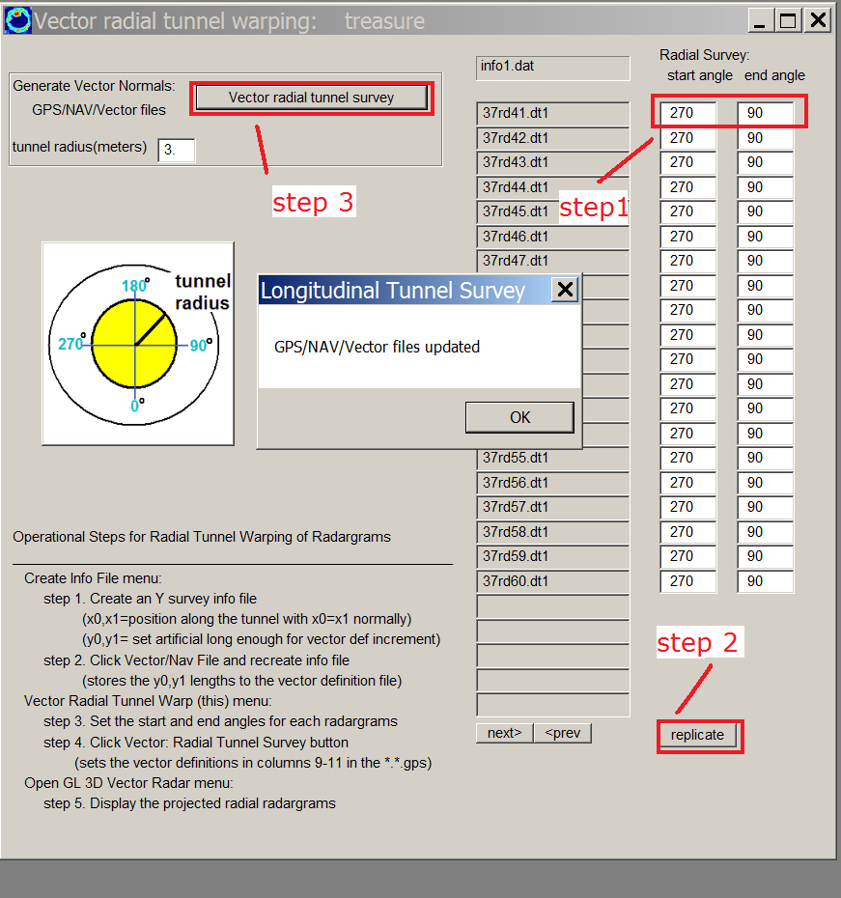

Figure 5. A Radial tunnel surveys have vector files generated from a start/end angle. The initial information file needs to be y information file.

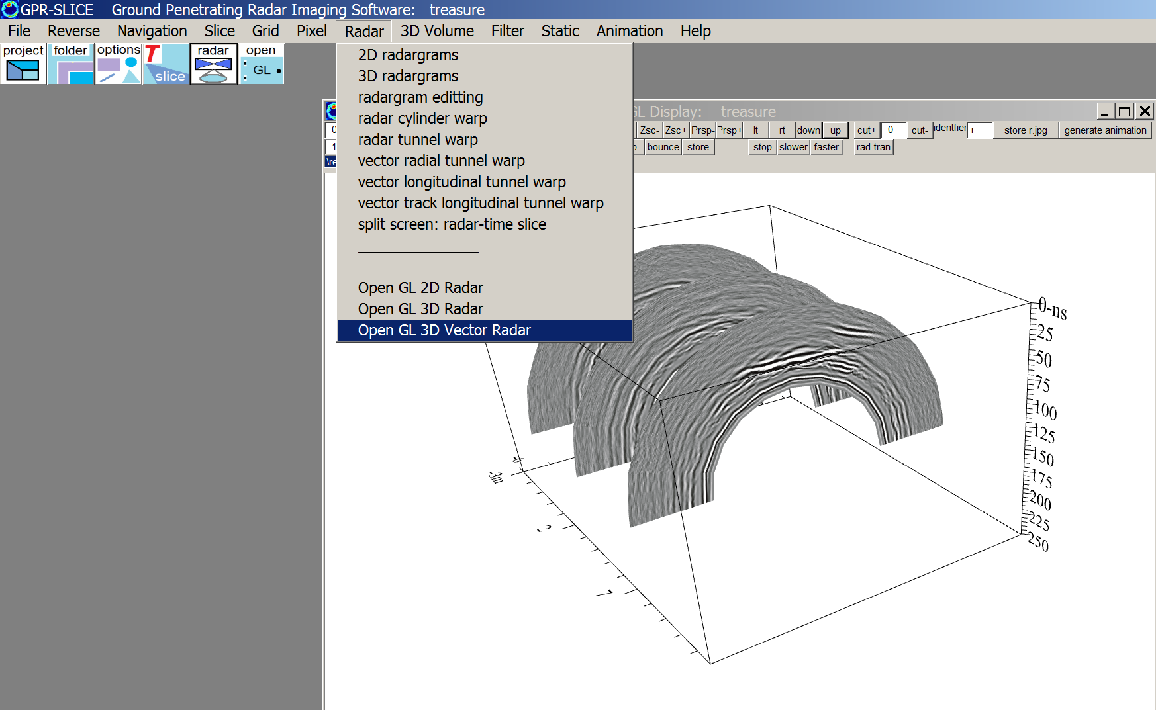

Figure 6. Using Open GL 3D Vector Radar menu, the radial tunnel warped radargrams can be displayed.

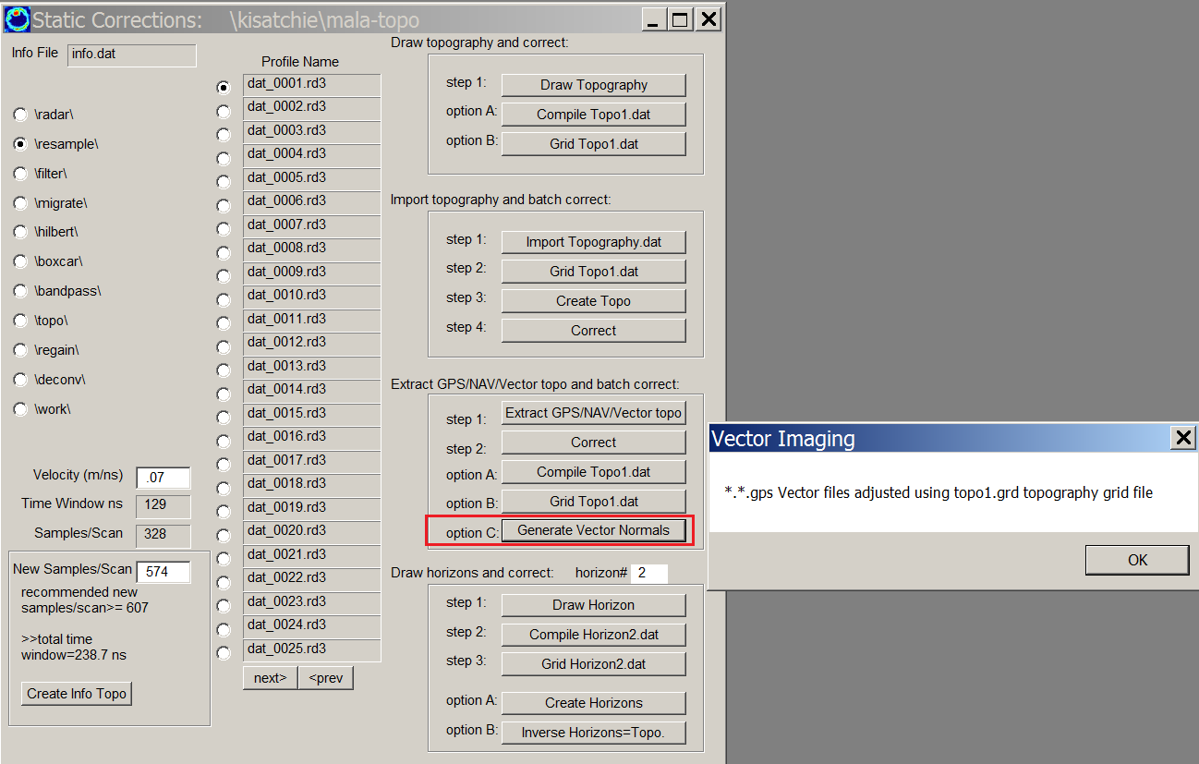

Figure 7. Returning to the \kisatchie\mala-topo\ folder we can generate the vector files following the topo1.grd file for the project. A redefinition of the information file, to a vector file, is required in the Create Info File menu.

Vector - Surveys over sites with Topography

GPR-SLICE v7.0 has an option to calculate the surface normals automatically across a topography grid file and place these vector components into columns 9-11 in the *.*.gps files. The button called Generate Vector Normals, will read the active topography grid file and compute the surface normal to the topography. The surface normal is in the direction that the GPR scan will be projected into the ground. The surface normal is computed looking at 2 vectors on the topography grid file, e.g. looking at 3 points on the topography file and generating 2 vectors of elevation differences between two of the points, leaving one point as the origin of the vectors. The cross product between the two vectors provides the surface normal to the vector.

Currently in GPR-SLICE v7.0, a distance of 5 grid cells is examined in order to give a local surface normal without too much rapid change that would occur in looking at adjacent grid cells and topography. This provides for a touch of smoothing in generating the vector columns. In the future, options for adjusting this value by the user and/or vector smoothing will be provided.

An example of what can be done now with these automatic vector imaging options, is that a 2D radargram collected over a site with topography, gets projected as a 3D radargram when the orientation (pitch, roll and yaw) of the antenna is included. Shown in Figure 8 are example 3D radargrams collected over a site with topography. One needs to rotate the volume real time to see how the tilt and yaw are mapped into 3D space. Currently vector radargrams can only be displayed using the Open GL Vector Radar menu.

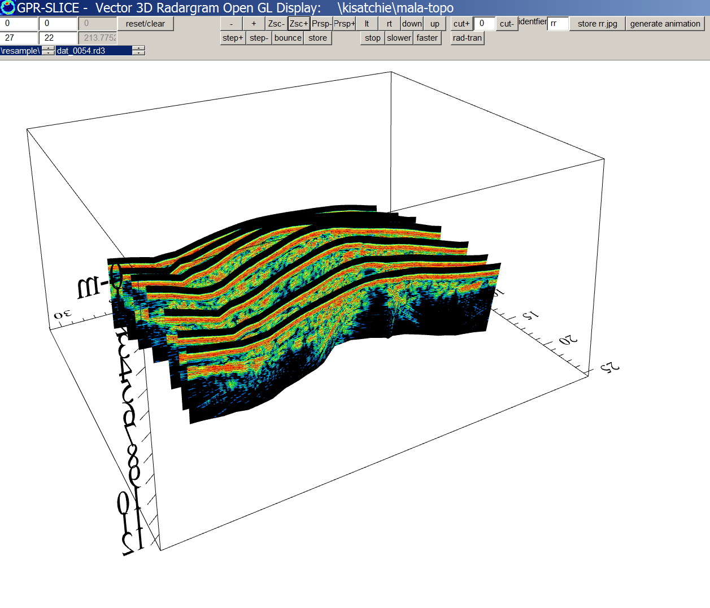

Figure 8. Example of automatic vector imaging over a site with topography.

18) Concrete Imaging 2

Project folder: \kisatchie\concrete2\

Purpose: To demonstrate 1) grid “decoupling” 2) grid “directional overweighting” to enhance linear feature parallel or perpendicular to x an y directions and to show 3) grid math operations.

Basic Information: An example dataset of a concrete with rebar located in both x and y directions is provided. The data are processed with x lines and y lines separately using infox.dat and infoy.dat files and gridded “decoupled” time slices are made. However, in order to enhance linear features that may be transverse to each profile direction, overweighting in transverse profile direction is made.

Shown in Figure 1 are the gridding settings used for the X lines and in 18.b2 are the gridding settings used for the Y lines. Note that using a rectangular search radius (length) of x=1 and y=7 for the X profile data will enhance or “bleed” anomalies transverse to the line in the y direction.
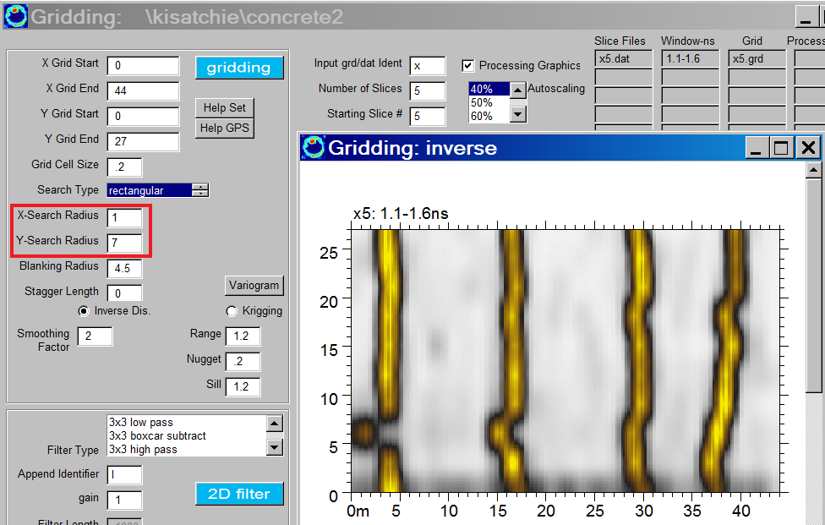

Figure 1 Grid settings used for making time slices of just the X line data. (Data courtesy of Ron Crowson).
Likewise, using an x=7 and y=1 search radius for the Y line data (in Figure 2) the anomalies transverse to the Y lines – in the X direction are enhanced.

It is interesting to note that these time slices are shown at the same depth and as one might predict the X lines show very well the transverse anomalies, and vice versa for the Y lines – which show very well the anomalies perpendicular to the native profile direction. Some remnants of the parallel directions are seen but are very faint.

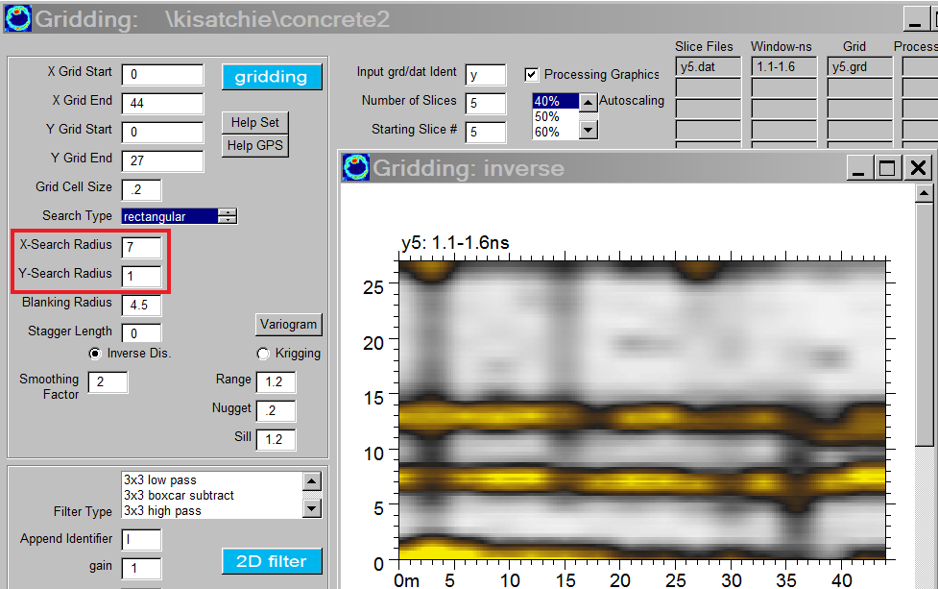

Figure 2 Grid settings used for making time slices of just the Y line data.

The next step is to use Grid Math and add the two decoupled grid sets together as shown in t he Figure 3:

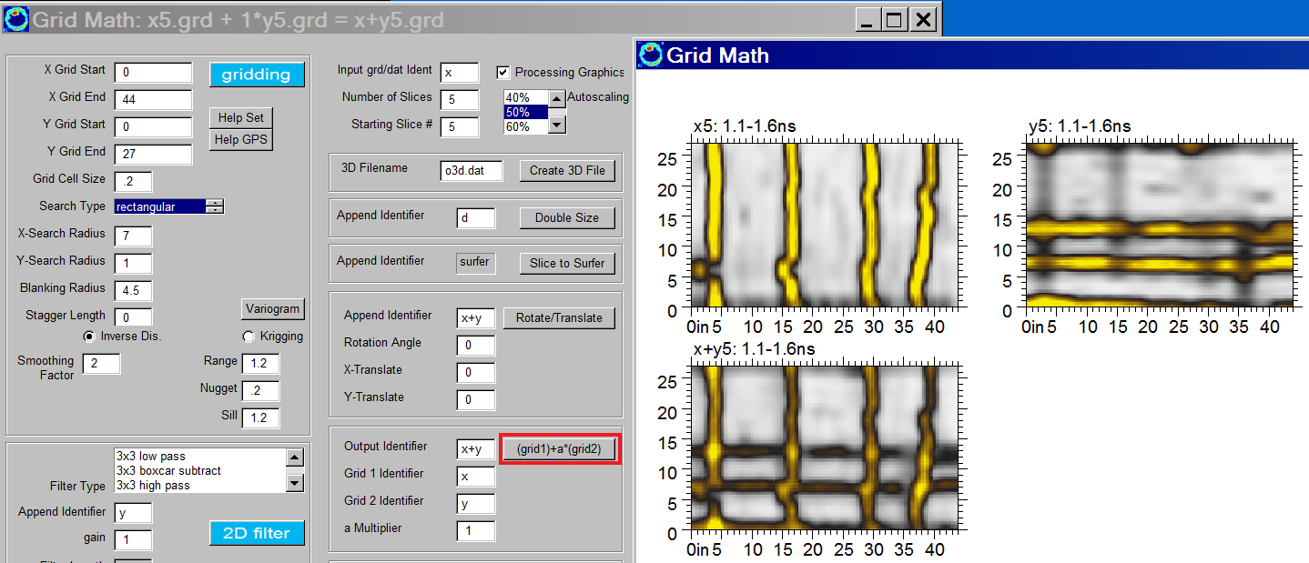

Figure 3 Grid math operation to add time slices made from X and Y lines to generate X+Y time slices.

The final 2D results of applying grid math to the entire dataset are shown in Figure 3. One additional small “adjustment” is made to the data. The very top 2 time slices generated from migrated/Hilbert Transformed data show artifacts from these signal processes. For this reason, the option to use just the original top two time slices from unprocessed radargrams – called the raw1 and raw2.grd files can be inserted into the Pixel Map menu by hand if desired.

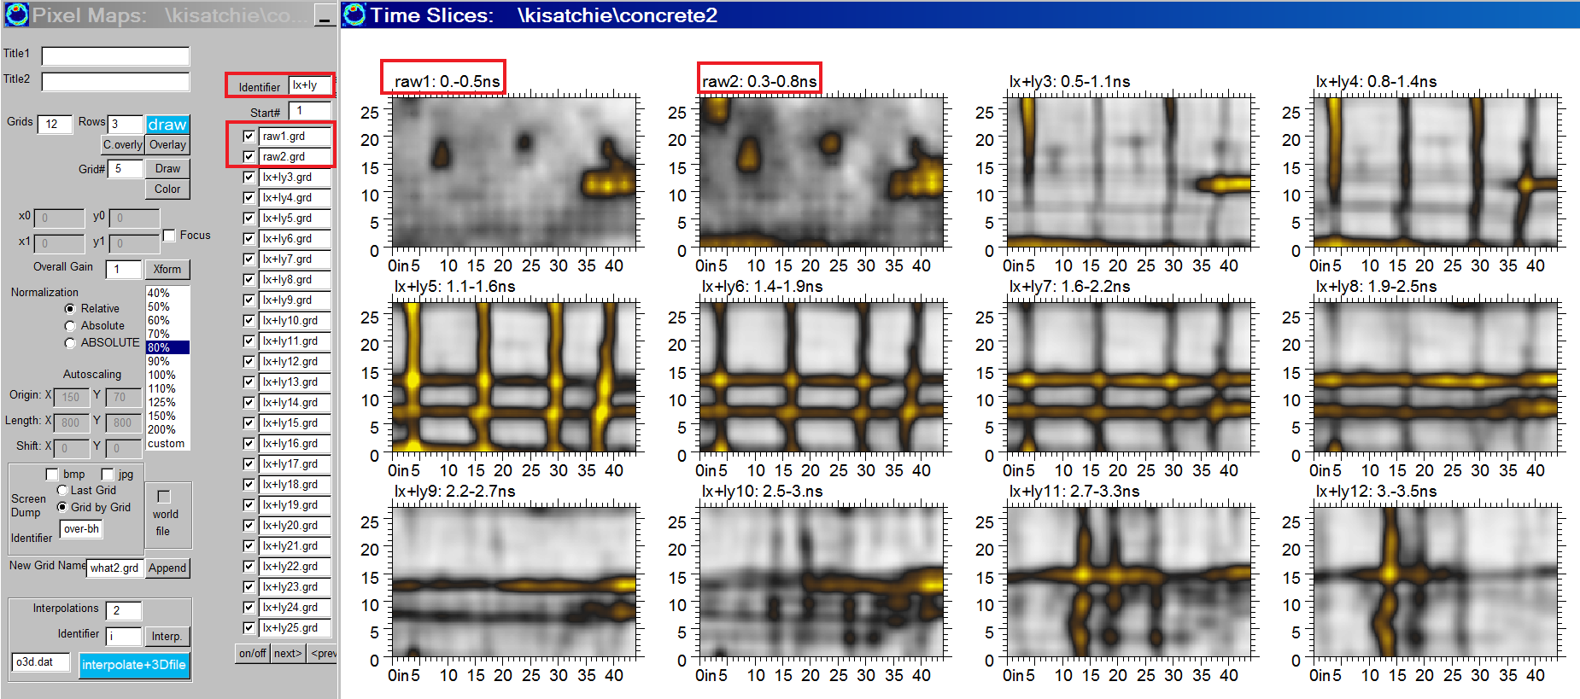

Figure 3 Example of the settings to show a combination of raw and processed time slices in the Pixel Map menu. 3D Volumes generated from this combination or any combination can be done in the menu!.

18b) Concrete Imaging – XY decoupled gridding + RSP

Project folder: \kisatchie\concrete\

Purpose: To introduce some of the signal operation and image processing operations to get the clearest images from fine scale xy surveys on concrete using BlueBox Batch operation call XY decoupled gridding + RSP (radargram signal processing).

Basic Information: An example dataset of a post tension cable with rebar is provided as a practice folder. The user will need to generate a cross XY information file by appending an infox.dat and an infoy.dat file in the Create Info File menu and should get the following Grid Plot:

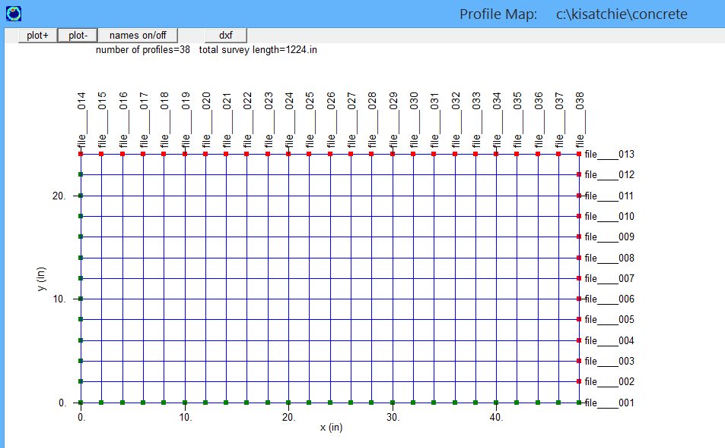

After generating the infoxy.dat file, this project can be processed completely on automatic using the the BlueBox Batch XY decoupled gridding + RSP (Figure 1). The settings for several other critical menus: the Filter menu and and the Slice/Resample menu are given in Figure 2 and 3.

A) The BlueBox Batch run for this operation, one must set the elliptical gridding setting for X and Y line radargrams. For the X line radargrams a value of .4 (in) in the X direction and 4 in in the Y direction are used; vice versa for the Y line radargram values of 4 and .4 are used respectively. These settings are for elliptical gridding operations. (Figure 1)

b)After these settings are made in the BlueBox Batch menu, the slice/resample menu can have the number of slices, thickness and number of cuts per mark set to a value to generate more bins between markers (in this case a value of 5 is used, Figure 2)

c) The Filter menu should be set so that process 1 is defined as Kirchoff Migration and process 2 is Hilbert transform (Figure 3)

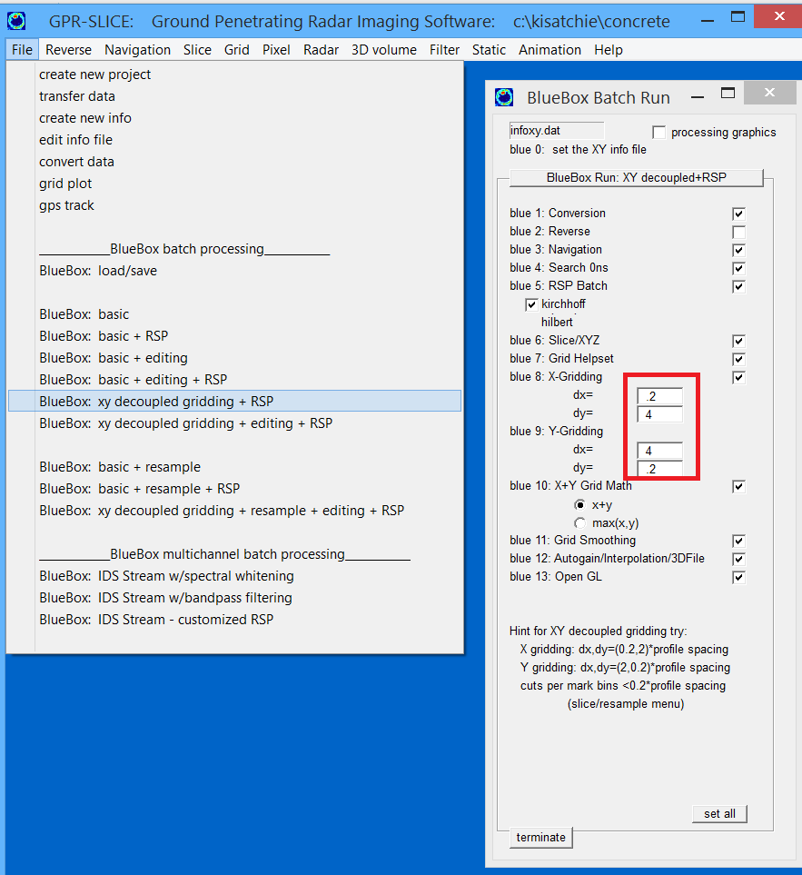
Figure 1. BlueBox Batch Run XY decoupled gridding + RSP with setting defined for elliptical gridding operations.
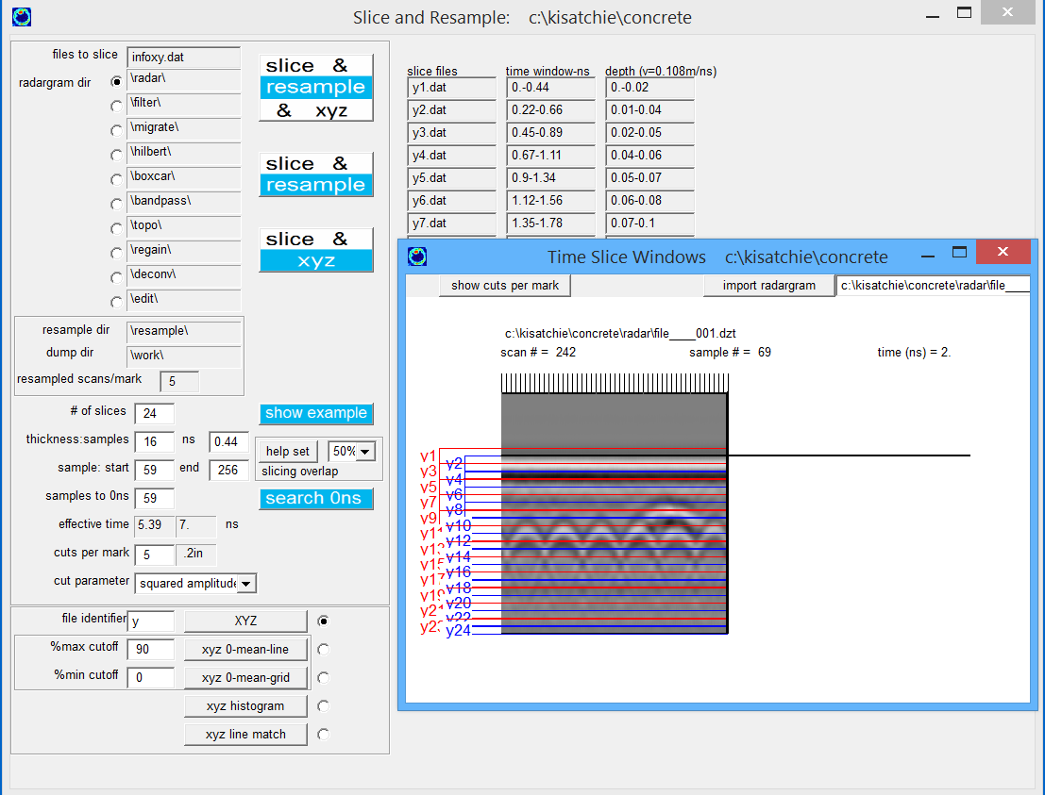
Figure 2. The number of slices, thickness, and the cuts per mark are set to a value that generates bins smaller than 0.2 times the profile spacing.
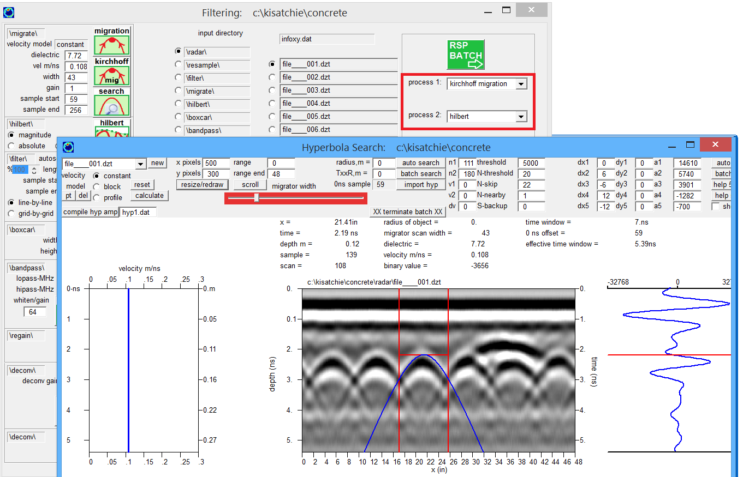
Figure 3. RSP settings are made with process 1 set to Kirchoff Migration and process 2 to Hilbert transform.

Once these settings are made, the BlueBox Batch operation can be started. Time slices of migrated/Hilbert transformed radargrams are shown in the Figure 4 along with multi-radargram displays in the Radar 2D menu.

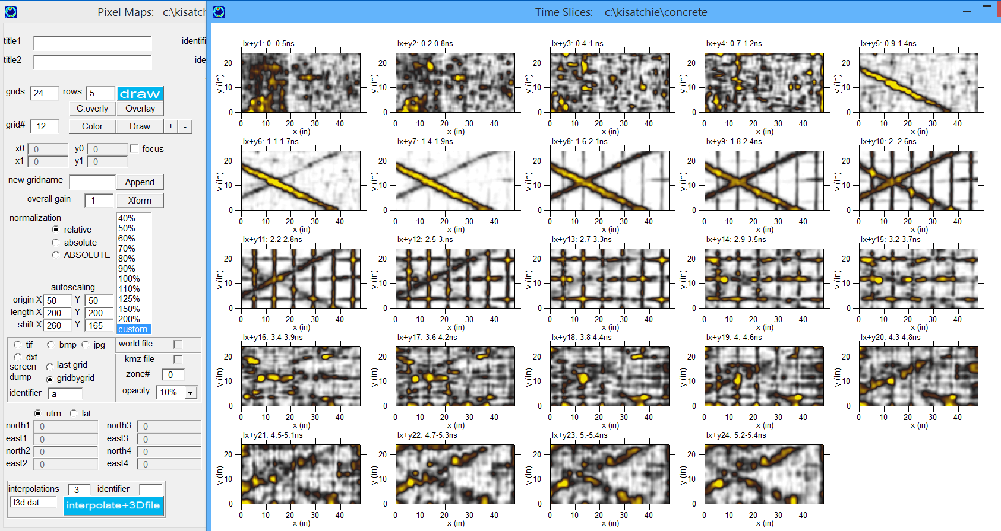
Figure 4 Times slices made from decoupled X and Y time slices with grid math and RSP.

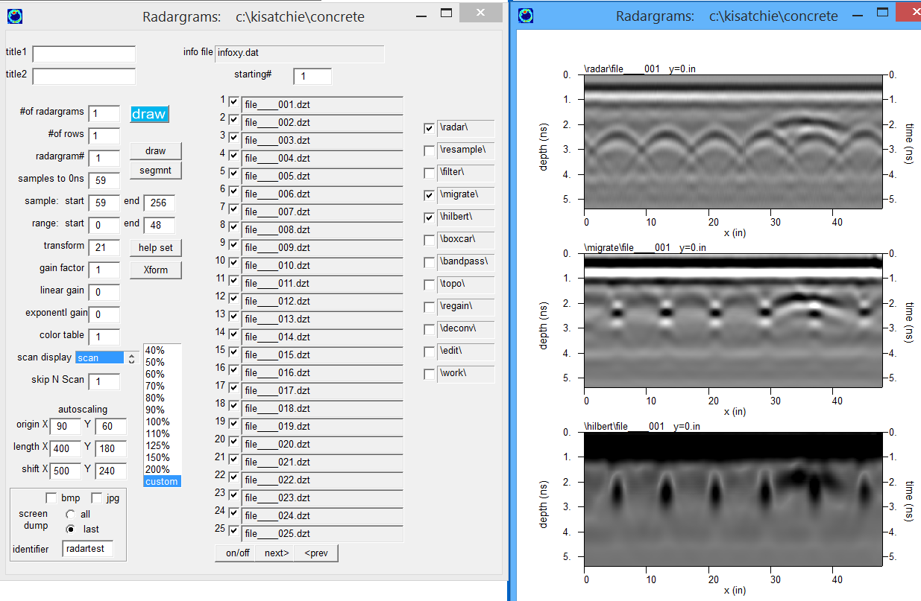
Figure 5. Multi-radargram display showing different RSP processes.

19) Imaging at Cemeteries

Project folder: \kisatchie\cemetery\

Purpose: To key in users into the kinds of anomalies to look for at cemeteries.

Basics: Looking for unmarked graves at cemeteries is becoming one of the largest area of research with GPR. The things to look at in GPR in cemeteries are to try and discover burial pit and/or burial remains. Burial remains are often not discovered because of deterioration, however,, back filled trenches are still often the remnant structure that can be detected with GPR. An simulation example of a typical burial using GPRSIM v3.0 Ground Penetrating Radar Simulation Software is shown in Figure 1. The top of the burial pit, because it is backfilled with soil that has been “homogenized”, no reflections are recorded near the ground surface on the top of the pit. If the burial is intact at depth, stronger reflections will appear within the burial pit. Another important feature that can often be seen in radargrams, and less so in time slices, are diffraction legs recorded off the top edges of the pit. These can be seen in the simulation and in real data (Figure 1).

Generating time slices for the Seminole cemetery in Florida, (Courtesy of the Seminole Tribe of Florida and Kent Schneider), we can see several features that are indicative of unmarked graves (Figure 2, 19.3). In the top most slice weak reflections located in several rows probably indicates detection of backfilled trenches from the unmarked graves. Deeper in the time slice dataset, some reflections in the same area are appear as stronger reflections. This may indicate that some shallow burial remains might exist. It is useful to try and compare locations of the topmost slice with the deeper slice to see what burials might have co-located weak and then deeper strong reflections. Explore the use of overlay analysis on only 2 images, e.g. #1 and #4 to see which locations have overall weak- top surface rectangular reflections, followed by strong rectangular reflections at depth.

Note: Because of the sensitive nature of this particular site, we ask users not to disseminate these data or images.
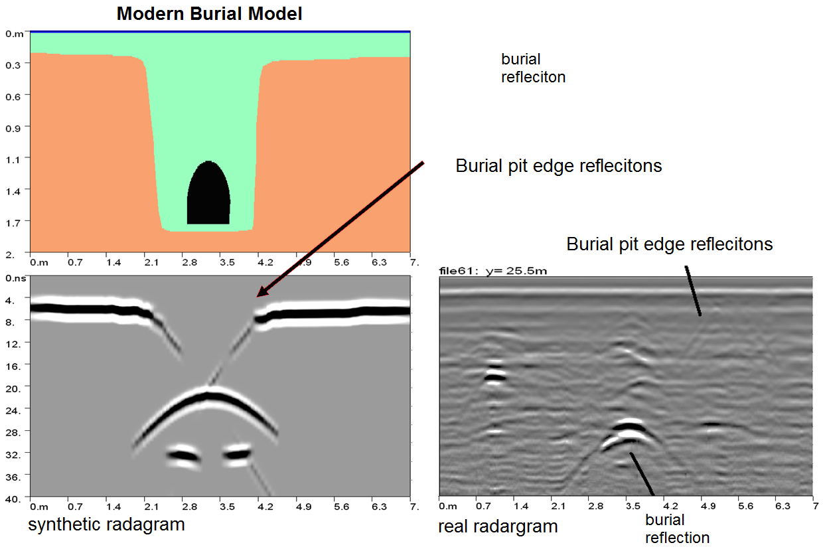

Figure 1. GPRSIM simulation of a burial compared with a real radargram collected at the Jena Choctaw Cemetery, Louisiana.

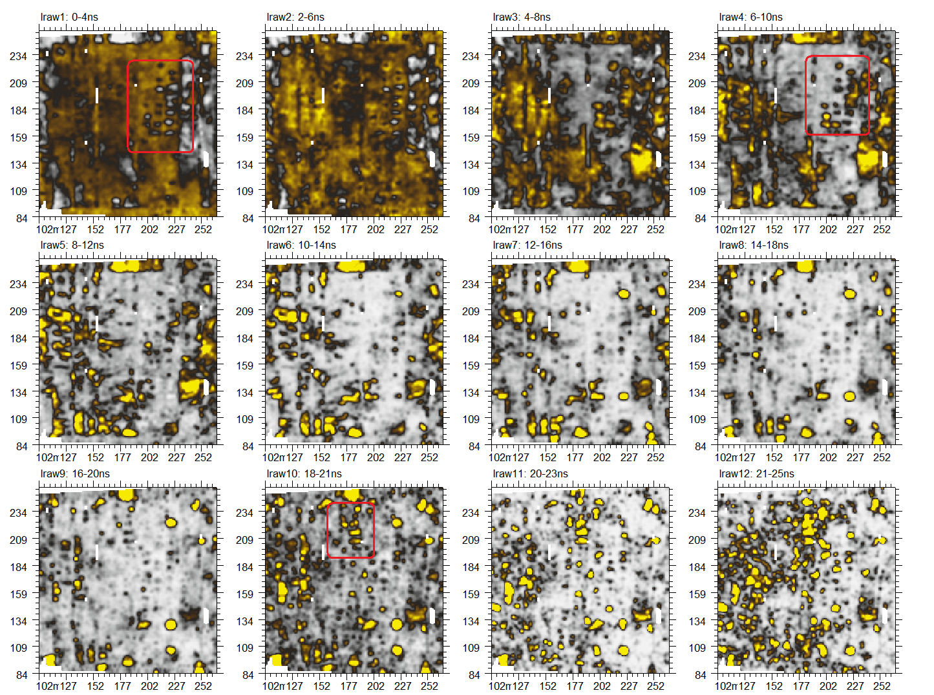
Figure 1 Time slices from a Seminole cemetery, Florida.

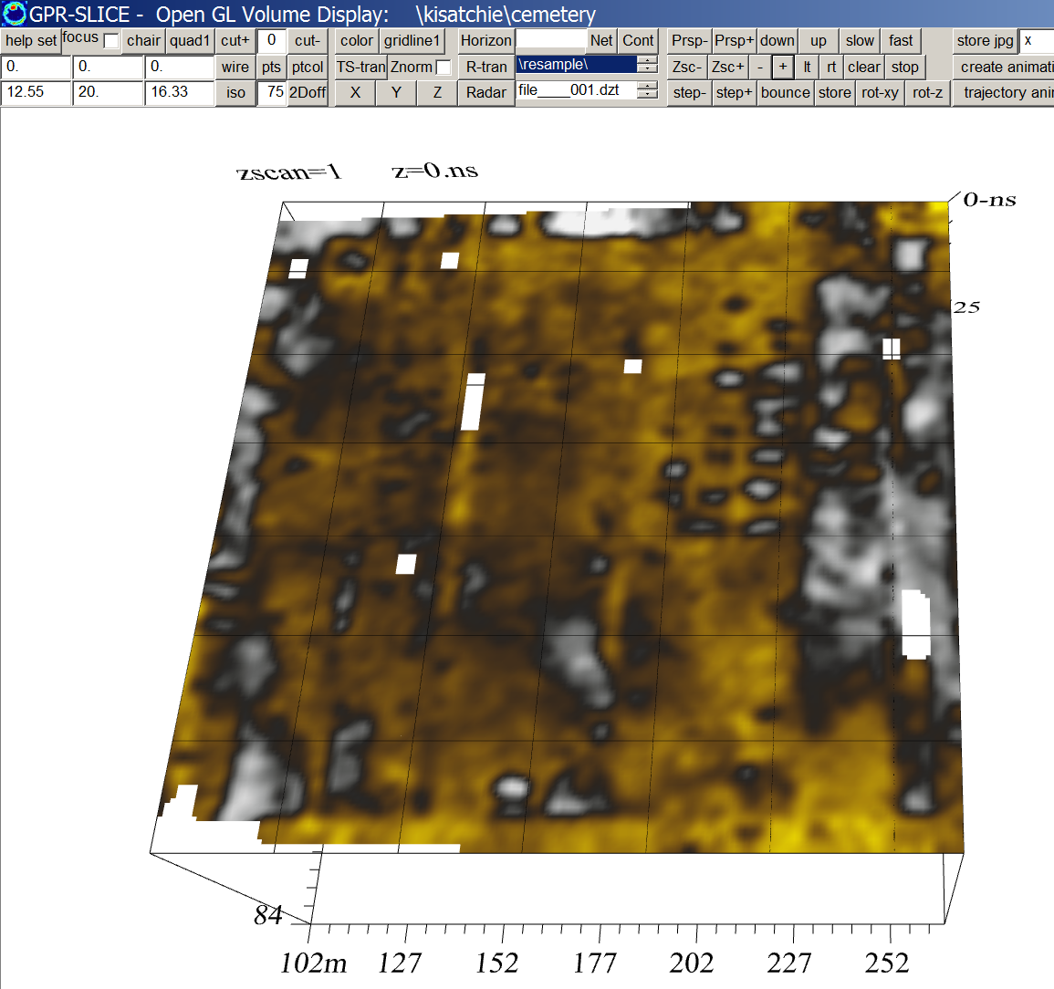
Figure 2 3D Time slice from the top surface at the Seminole cemetery, Florida.

20) Imaging at and Historic Cemetery

Project folder: \kisatchie\cemetery-marquez\

Purpose: To key in users into the kinds of anomalies to look for at historic cemeteries with random burial locations and to train the user in use of field marker navigation and in overlaying external information onto time slices using the Open GL Volume Draw menu.

Basics: Some historic cemeteries do not have regularly oriented burials. Regularly spaced burial bits in column and rows makes it much easier to identify these features in GPR images. Often, random locations are the norm in many smaller cemetery sites. One such site is the Pascual Marquez Family Cemetery in Santa Monica Canyon (Figure 1, http://www.gpr-survey.com/gprslice2.html ). This site is a family cemetery that was part of the first Mexican Land Grant that was awarded to the Marquez and Reyes families in 1839.

The site was surveyed with a SIR 3000 GPR system supporting a 400 MHz. Navigation was done using tapes and hand marker navigation. Several lines have navigation errors which can be edited using the Edit option in the Navigation menu for Field Marker navigation (Figure 2). The Navigation menu identifies lines with the number of header markers not corresponding with the number of markers found from the information file.

After correcting navigation problems and time slicing, the most useful display is an overlay time slice is used to corroborate anomalies with the location of burials measured from an early photograph. Relatives’ recollections of the cemetery from the 1930s, 40s and 50s, before the crosses were removed, also aided in deciphering the GPR results

Three sniffing dogs which can identify burials were also brought to the site. The locations where these dogs indicated burials are compared with an overlay time slice in Open GL Volume Draw. To get the overlay time slices into Open GL 3D requires importing the single overlay-analysis1.grd file which is by default generated whenever an overlay display is run and generating a very narrow 3D file from this. Shown in Figure 3 is a comparison of the dog hits with overlay map. Several areas where suspected (weak) reflections at the tops of burial pits correspond with the dog locations.
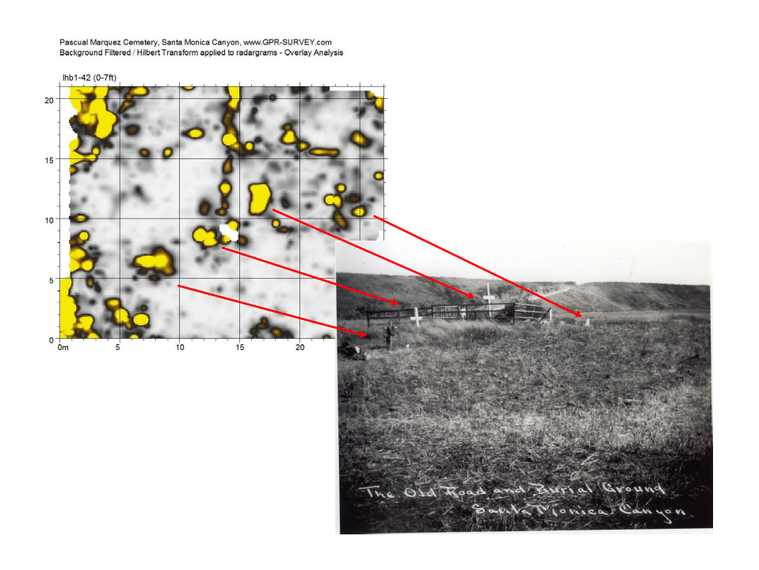
Figure 1 Interpretation of an overlay time slice with an old photography from the early 1900s from the Pascual Marquez Family Cemetery.

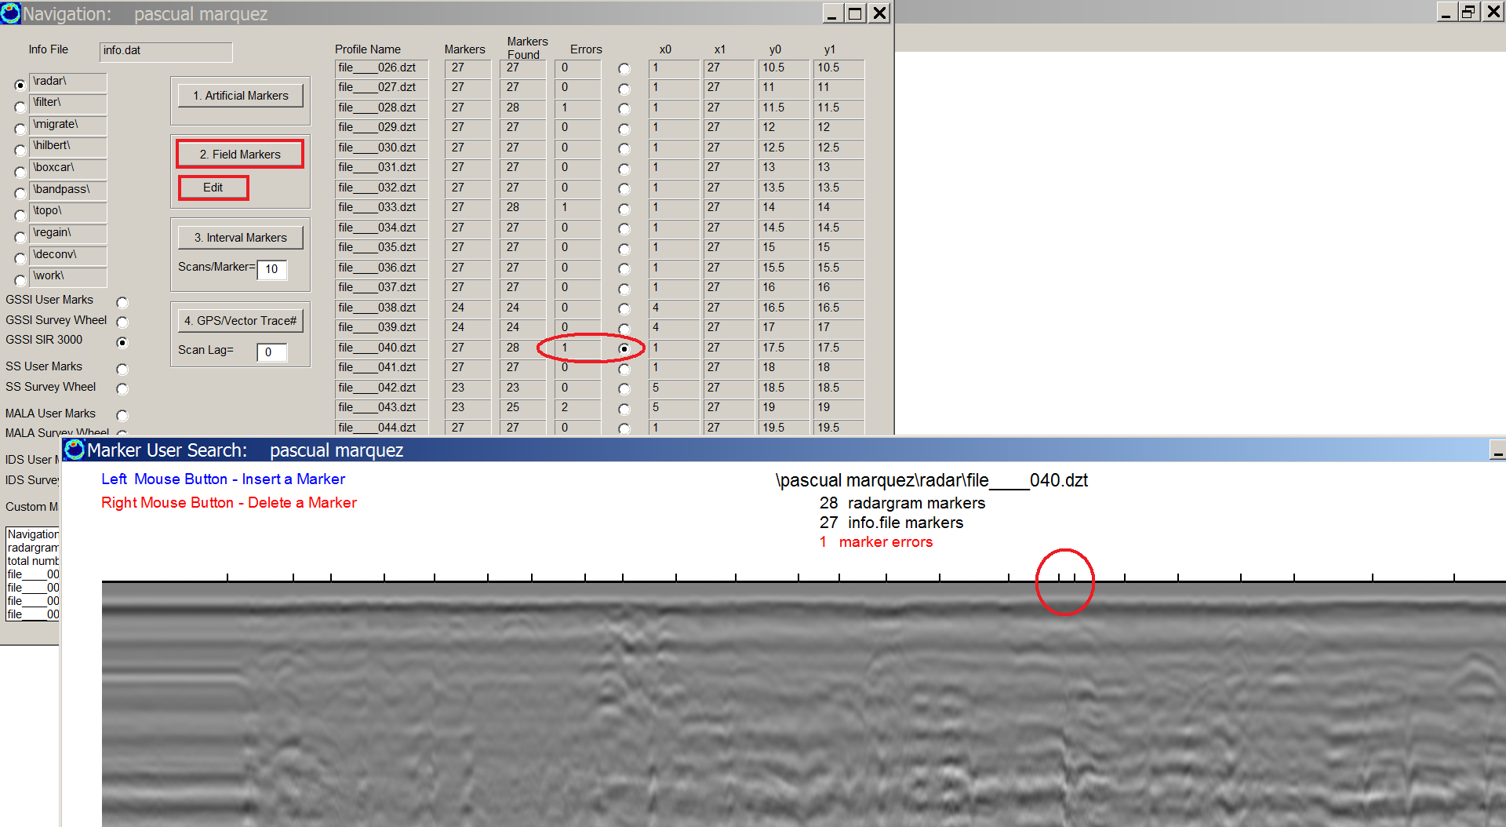

Figure 1 Several radargrams from the Pascual Marquez site have marker errors that can be edited in the Navigation Edit menu for Field Markers.
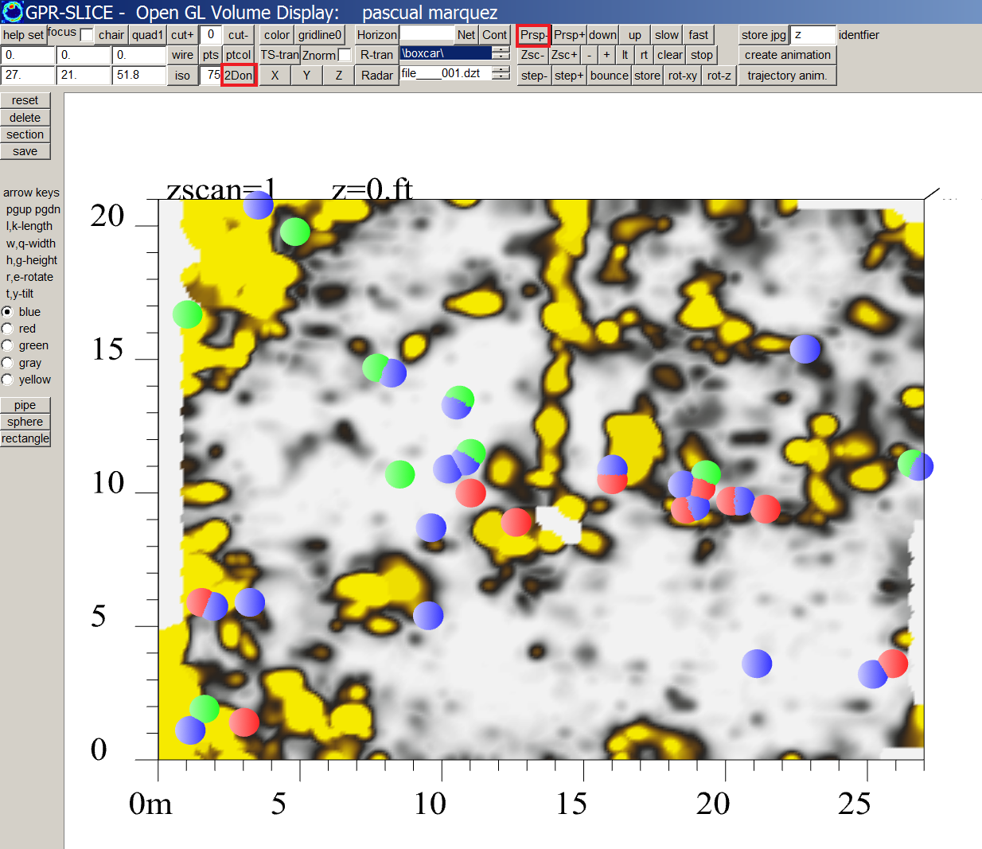

Figure 3 Overlay time slice with color coded circles where each of 3 sniffing dogs indicated locations for possible burials. If the top time slice is used you one may need to click the Perspective – button to bring the equal depth objects into view.

21) ANG surveys with Topography and Vector Extension – complete 3D projection of a 2D radargram over topography.

Project folder: \kisatchie\ang-topo-vector\ (data courtesy of Erich Fischer, University of Florida)

Purpose: To introduce how 2D radargrams are projected into real 3D space using the GPR-SLICE Vector Imaging which account for the scan vector. Also, to show how to generate the vectors automatically from known topography.

Basic Information:

ANG surveys are a special survey subset in GPR-SLICE which encompass straight line surveys which can be located in any angle in 2D. ANG actually contains, X, Y and XY surveys in its definition. The ANG definition is needed for these surveys as a flag for accurate binning during time slicing. To process and display an ANG survey with topo the steps are to

1) First create resampled or any processed radargrams one would like to work with from a Ang survey (Figure 1)

2) Convert the Ang survey to a vector survey using the quick button in the Edit Info File menu. (Figure 2).

3) Import the topography in the Static menu and grid it, making sure to generate topography grid that fully encompasses the radargram profiles. For this example a search radius of 2,2 and blanking radius of 2 will work sufficiently, lower values will have problems. (Figure 3)

4) Generate vector normals in the Static Menu to update the 9,10,11 columns of the vector files with the vector information from the topography grid map (Figure 4)

The projected radargrams can be shown in Open GL Vector Radar (Fig 21.5) and/or with the topography net on top (Figure 6). Note, the radargrams have tilt, yaw and pitch!! (The regular topography radargram the Open GL Topo Volume Warp menu, even though a volume is not present is available (Fig 21.6). This menu will not account for the scan projection in 3D space, but it does allows for displays of the topography on top of the radargrams with complete projection only in 2D planes).

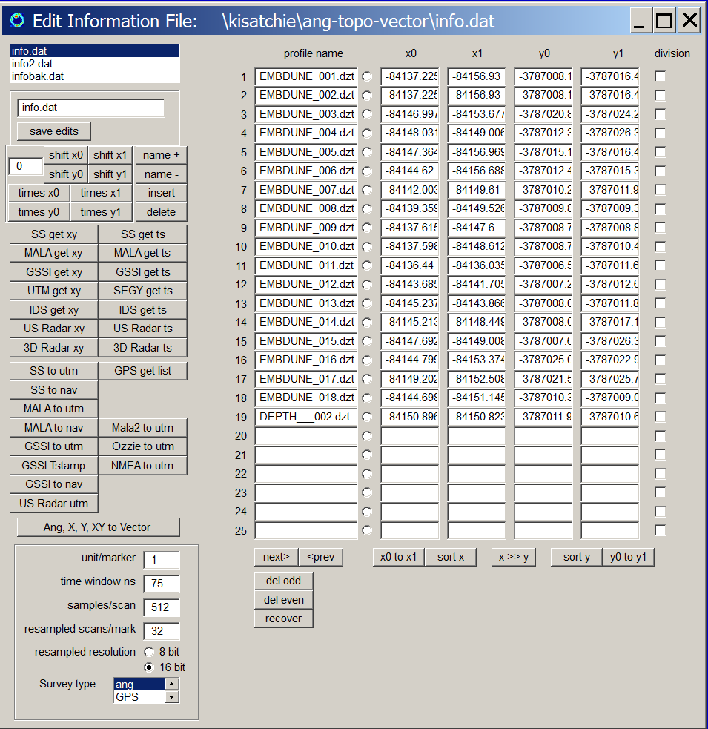

Figure 1. First generate an Ang information file with (straight line) chords. Also, it is important to make a backup copy of the information file in case you make some mistakes.
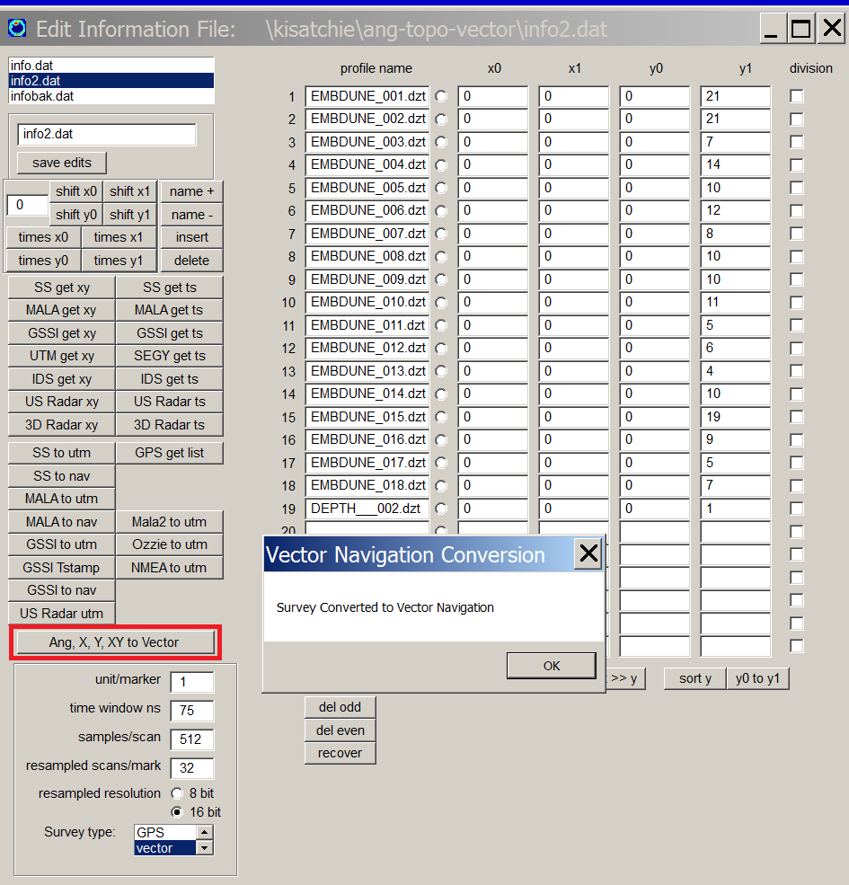

Figure 2 Convert the Ang survey to Vector using the Ang, X, Y, XY to Vector button in the Edit Info File menu.

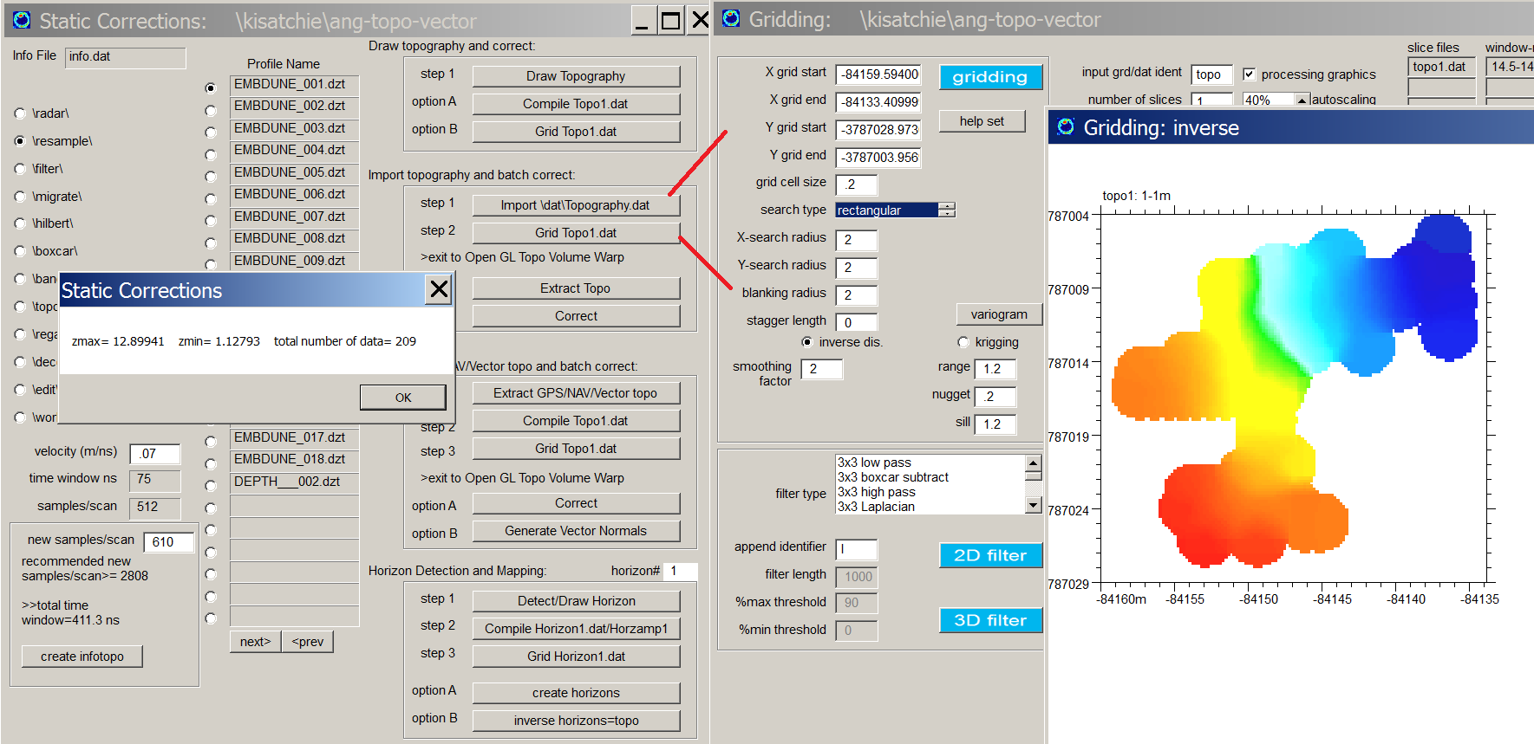Figure 3. Use the Import Topography.dat option to generate the topography topo1.grd file.

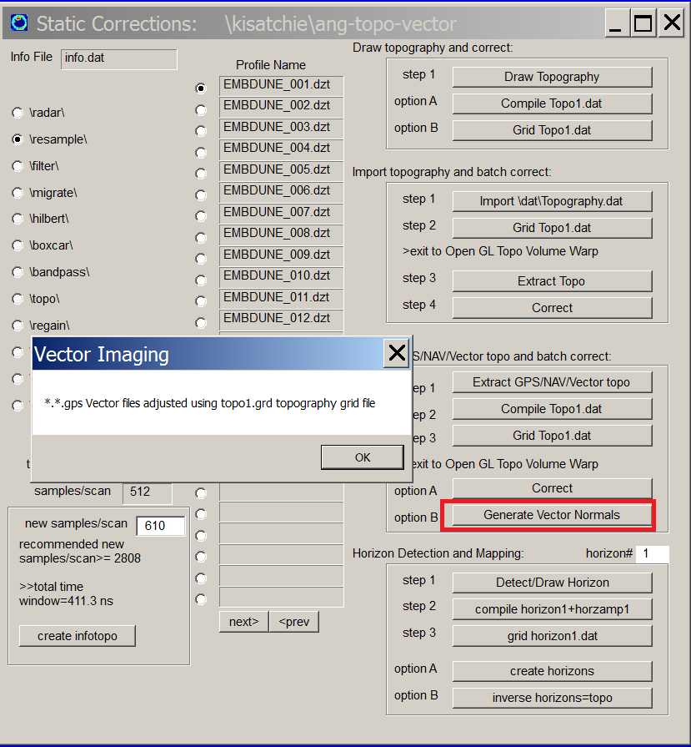

Figure 4. Generate the vector normals from the gridded topography and update the *.*.gps vector navigation files, filling in columns 9,10, 11 with the vector of the scan.

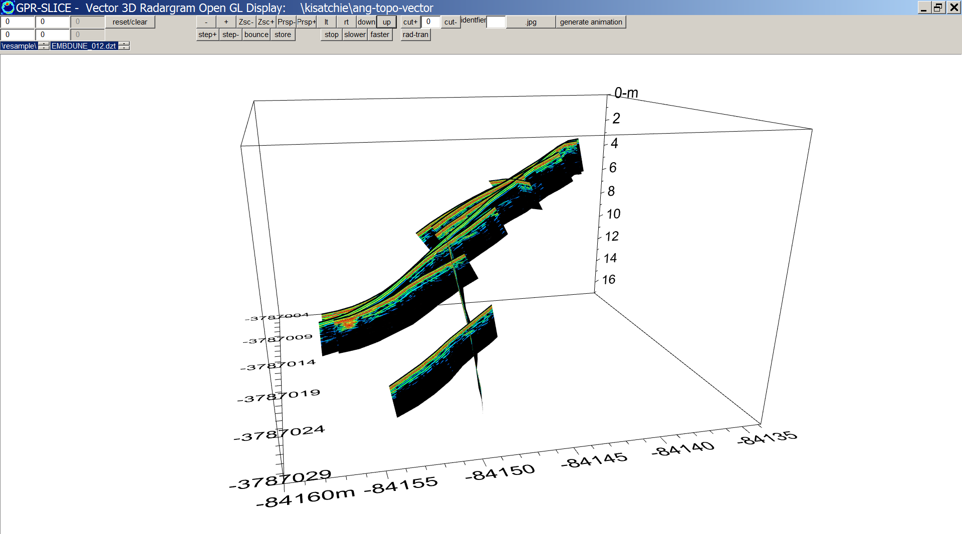
Figure 5 Open GL Vector Radar display of radargrams collected over a sand dune.

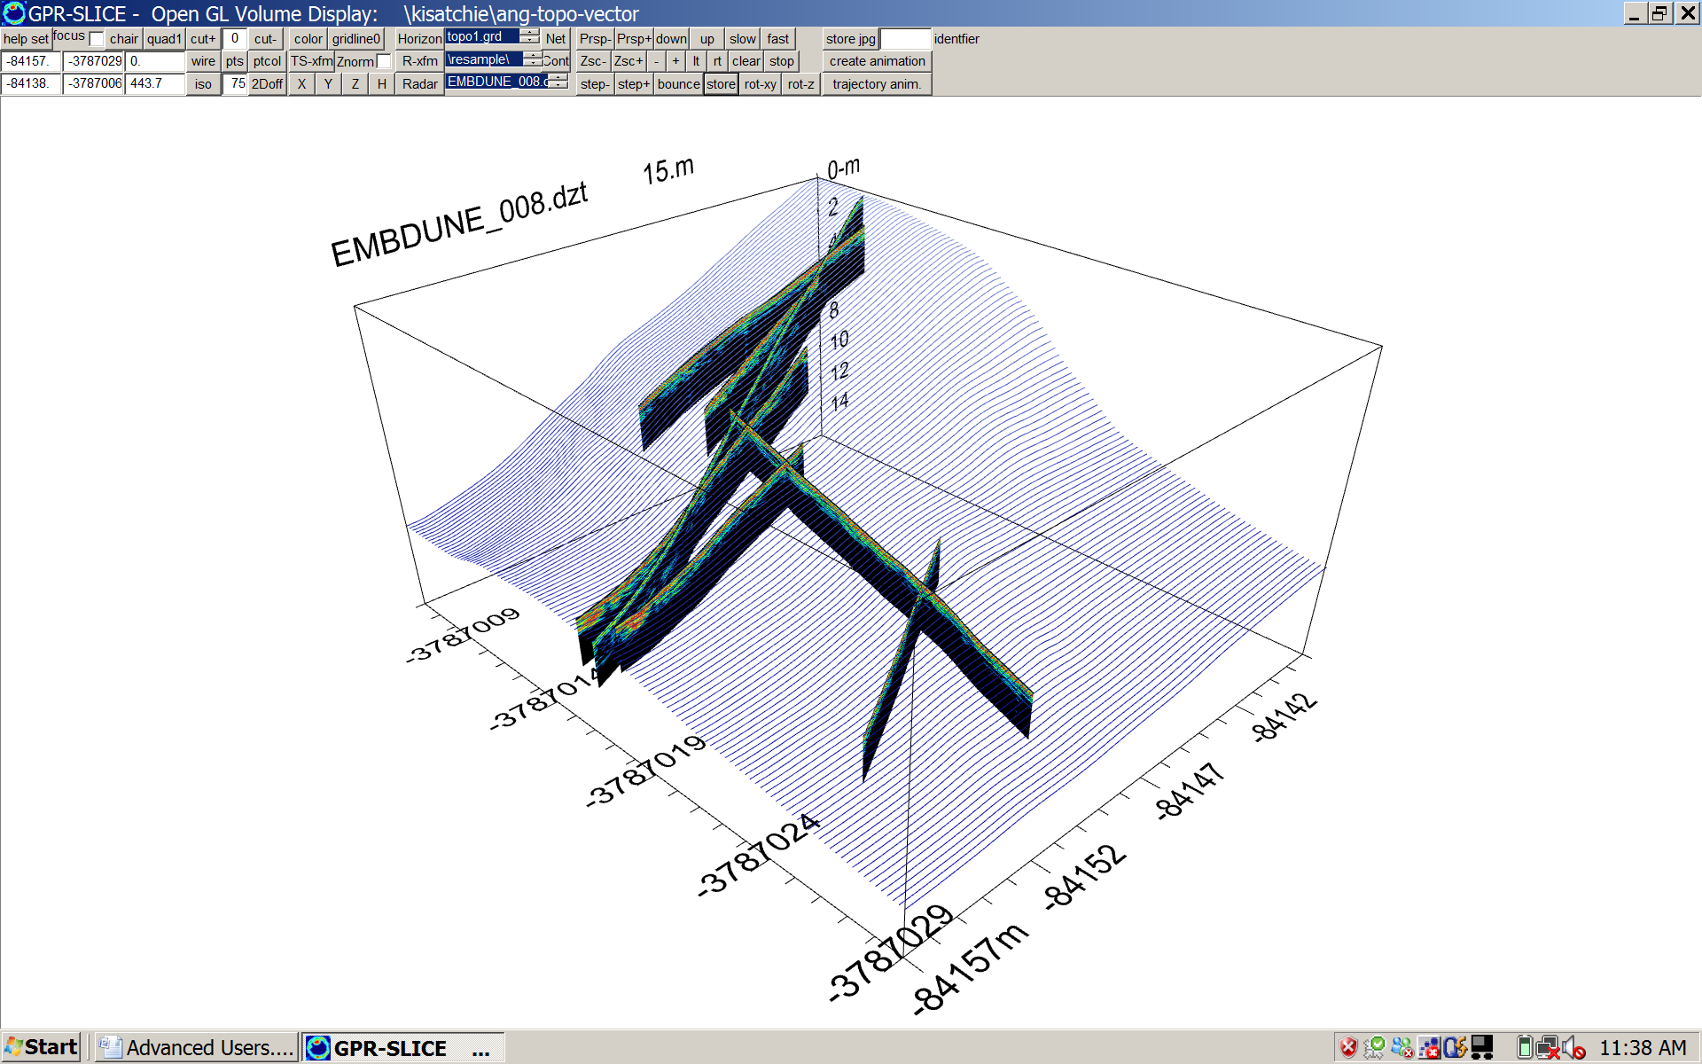
Figure 6 Topo Volume Warp display of the radargrams in the Static menu with the topography draped on the topography corrected radargrams.

22) Open GL Visualization and Animation Creation

Project folder: \kisatchie\ all folders and your own

Purpose: To introduce the latest capabilities of Open GL visualization and the capabilities of this very powerful graphic for display and interpretation of ground penetrating radar data.

Basic Information: In January of 2006 our first Open GL module for GPR-SLICE was introduced. Since this time, we have expanded our Open GL capabilities for radargrams, GPS radargrams, 2D surface mapping, and a newly released Open GL Volume routine that can mix and match many kinds of elements within the same graphic screen. OpenGL allows the user to rotate, tilt, and fly into the GPR-SLICE volume all in real time graphics.

Shown Figure 1 is one kind of a display that can be accomplished with the new OpenGL Volume menu. In this example the 3D volume z slices are displayed and any individual level is stored. Radargrams can be added by clicking the Radar button. Any number of radargram can be stored to the screen using the Store button. Another example in Figure 2 shows several additional elements that can be stored to the screen including 3D time slice fences, radargrams, and the detected horizon surface for project \kisatchie\horizon. Example of isosurfaces for concrete imaging is shown Figure 3.

To generate any animation, the user can click the Generate Animation button. This will cause the last element to increment through all the slices, or files and to store jpgs for each frame drawn to the screen. The software will then prompt the user to ask if they want to update this to the Animation List menu for later viewing or animation export.

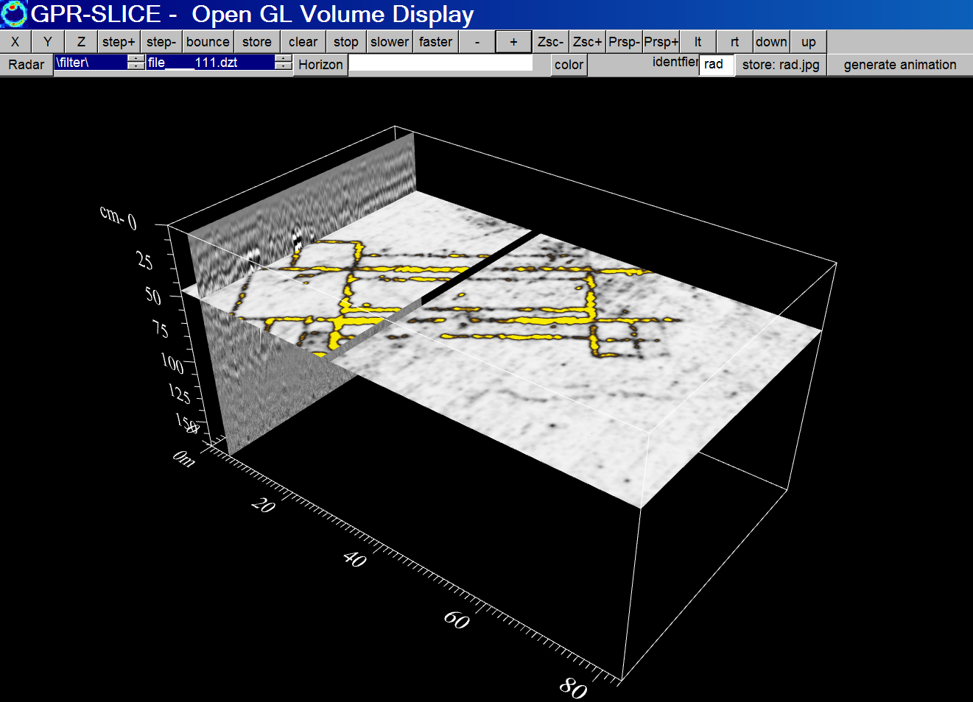

Figure 1 Example of a 3D volume display mixed with a radargram.

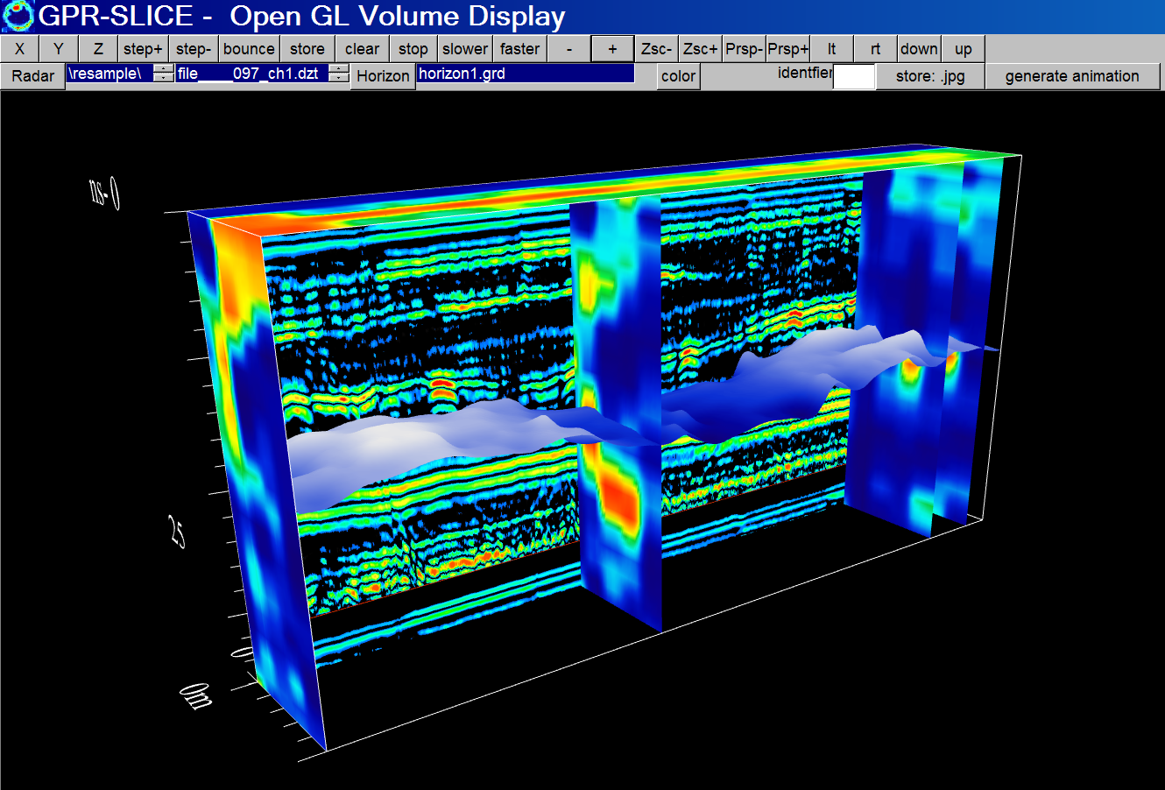

Figure 2 In this example, 4 different elements are stored within the OpenGL graphic including radargrams, y slices, z slices, and a horizon surface that was detected.
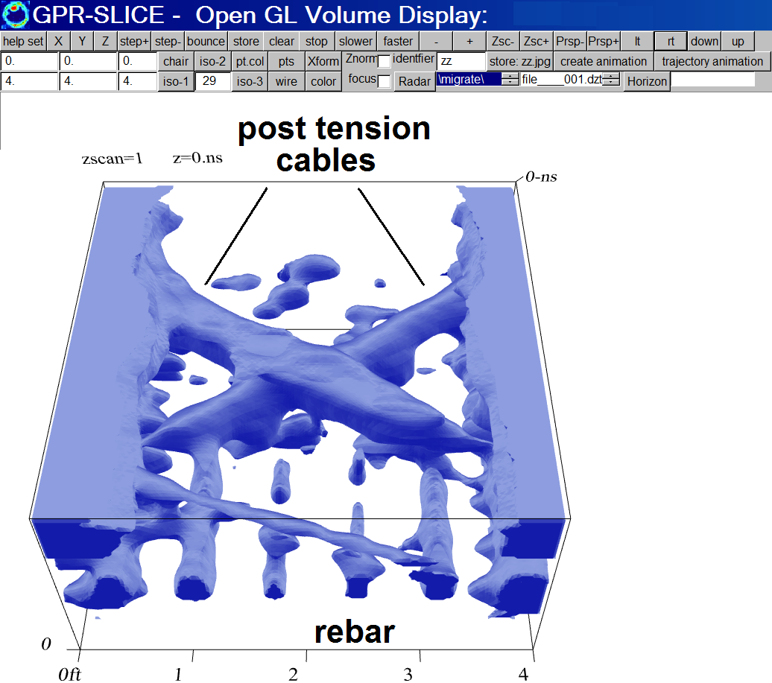

Figure 3 Example of an isosurface render from a survey of an engineering site with post tension cables and rebar (\kisatchie\concrete project). An isosurface showing 29% strongest reflecting surface is shown.

23) ANG to Vector with Exact Survey Wheel Information

Project folder: \kisatchie\angtovector

Purpose: To introduce using the exact survey wheel lengths stored in the radargram header files as an option for navigation and to demonstrate the conversion of this navigation to generalized vector navigation surveys.

Basic Information: GPR-SLICE can have a variety of methods to import navigation. Often, many users rely on the recorded lengths of the survey wheel as their primary navigation measurement. Various manufacturers’ buttons are available in the Edit Info File menu to extract the exact survey wheel information (Figure 1). The lengths can be rounded off to the nearest integral distance unit or preserved with the native decimal lengths. If the exact lengths are used with no rounding, these surveys must be redefined as an ANG survey. ANG definitions need to be used for surveys with fractional line lengths, e.g. line lengths that use fractional-decimal units or for surveys in which the lines are not parallel to the x or y axis of the site and are “angled” lines.

An example of using the exact survey wheel lengths is provided for a dataset collected with a US Radar equipment (using the older ERA Technology format). The button US Radar XY is clicked and the survey wheel lengths are chosen not to be rounded – the exact lengths recorded according the survey wheel are being used. From here the conversion is made (Figure 2) and typical processing is done.

However, if the full functionality in GPR-SLICE is desired, for instance to use optional functions like Radar – Time Slice split screen functions as well as proper reporting information operations like XYpoints or TSpoints, then all ANG surveys should be converted to generalized Vector navigation surveys.

Shown in Figure 3 are the operations to convert to Vector surveys. A single button called ANG, X, Y, XY to Vector is clicked which will

1) generate the *.*.gps 20 column vector navigation files for each radargram

2) re-populate the active info.dat file where the number of navigation points (or listings in the *.*.gps files) is stored in the Y1 column of the information file. Note, the x0, x1, y0 columns are zeroed out just as in GPS or Vector surveys.

In converting to Vector navigations, the Grid plot the must be shown using the GPS plot in the file pulldown menu. (Figure 4). An example of the radargrams displays for the converted ANG to Vector survey shows that the distance labels have 3 markings: X, Y and Total Range from the beginning of the radargram. (This is identical to GPS label reporting but with X being eastings, Y being northings, and the Total Range).
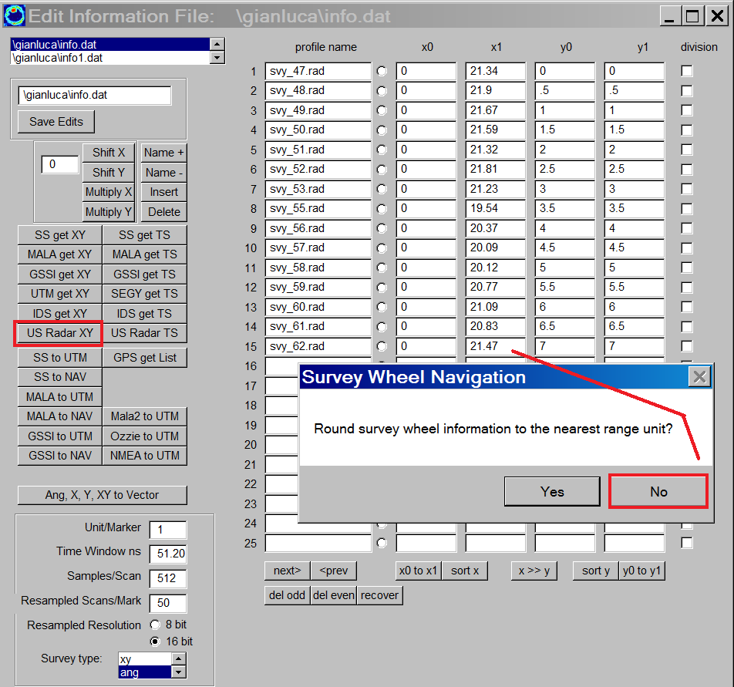

Figure 1. Example of using the exact survey wheel measurements (for a US Radar GPR survey). (Data courtesy of Gianluca Catanzarit, University of Complutense, Madrid, Spain).

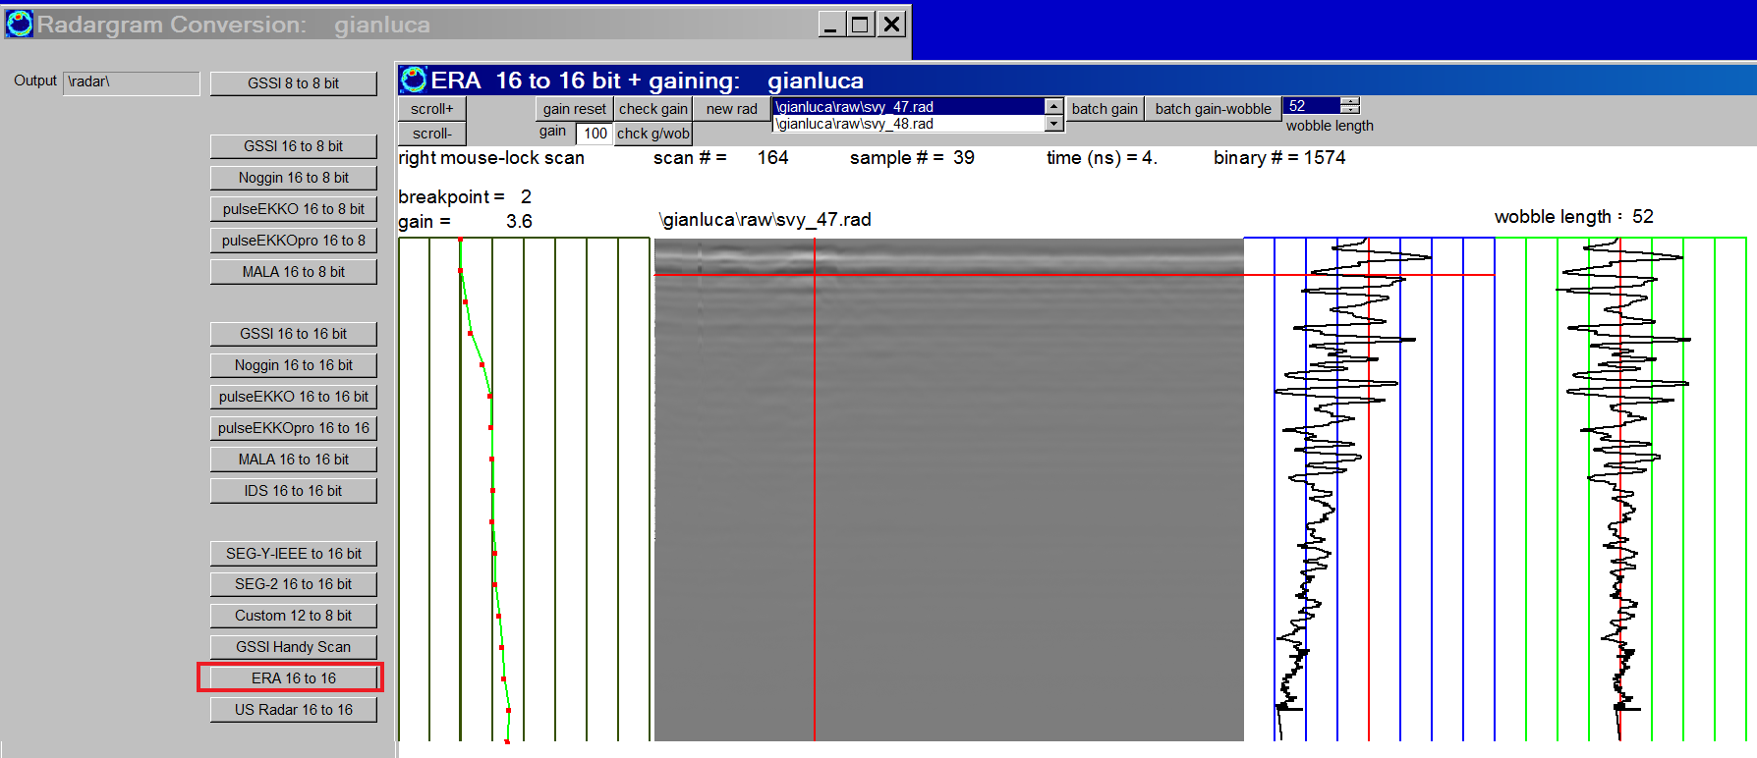

Figure 2. Example of the conversion menu for US Radar (using the older ERA Technology formats).

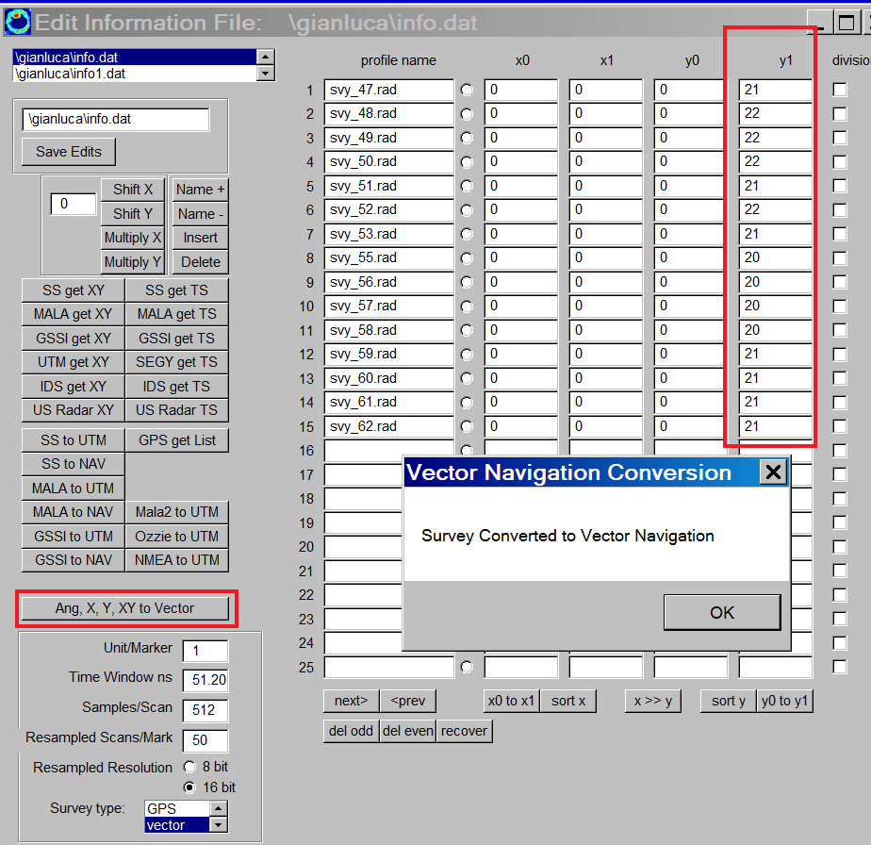

Figure 3. Conversion of ANG (or X or Y or XY) surveys to generalized Vector navigation surveys is done with a single one click button in the Edit Info File menu.

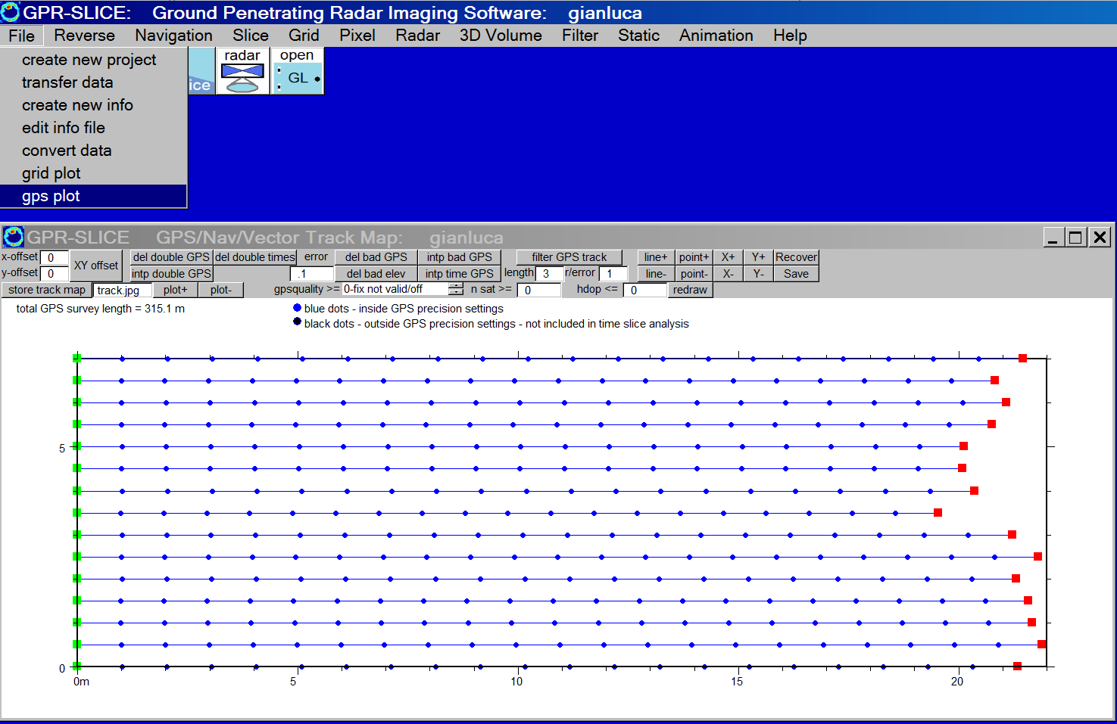
Figure 4. After conversion to a generalized Vector navigation survey format, the survey plot is shown using the GPS plot button. The start and stop points are represented by green and red dots; the blue dots represents points where navigation exists. (Note, all the points should be shown in blue color – if they are shown in black, then XYZ time slice compilation will only have the blue dots compiled)).

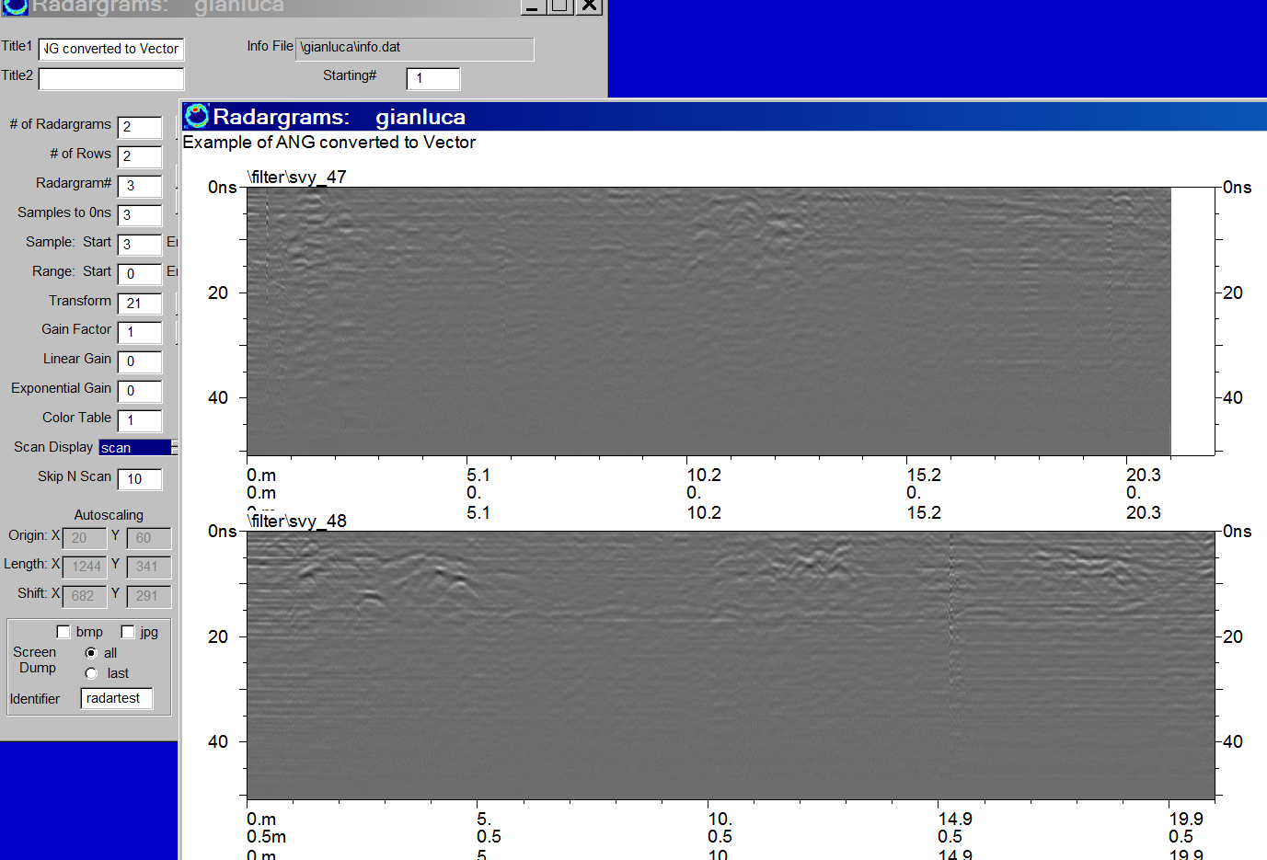

Figure 5. An example of radargram displays for generalized Vector navigation where the X, Y and the integrated range of a radargram is shown. To see the fractional lengths, the # of decimals in the Options menu should be set to 1 for the range axis.

24) Handmarker Navigation

Project folder: \kisatchie\handmarker

Purpose: To introduce handmarker navigation and how this is operated on in GPR-SLICE Software as well as to see how navigation errors are tested and corrected.

Basic Information: GPR-SLICE can have a variety of methods to import navigation. Often, many users must use handmarker navigation for a survey particularly in areas where survey wheels cannot be effectively used such as on very bumpy ground. GPR surveyors will lay out tape and place a markers in the data as the antenna passes predefined distances next to the tape, such as 1 meter etc.

The profile information for a handmarker survey is made the same way it is for a survey wheel survey, where the start and end points are placed into the information file (e.g. Figure 1). After the data are converted, the next step is to check that the number of markers inserted by the surveyor agrees with the information file (Figure 2). In this example, 2 profiles are found to have marker errors by running the Field Marker navigation option in the Navigation Menu. Profile file____033.dzt has 1 marker error and profile file____039.dzt has 2 marker errors. A menu for inserting or deleting field markers is launched by clicking the Edit button below the Field Marker operation button (Figure 3). The left mouse is used to insert a marker at any given location on the radargrams; a right mouse click on a marker is used to remove any inserted marker.

After the radargrams are edited, the user must re-run the Field Marker operation to make sure all the profiles have 0 navigation errors and also to redefined the *.mrk files used for slice/resample and time slice creation.

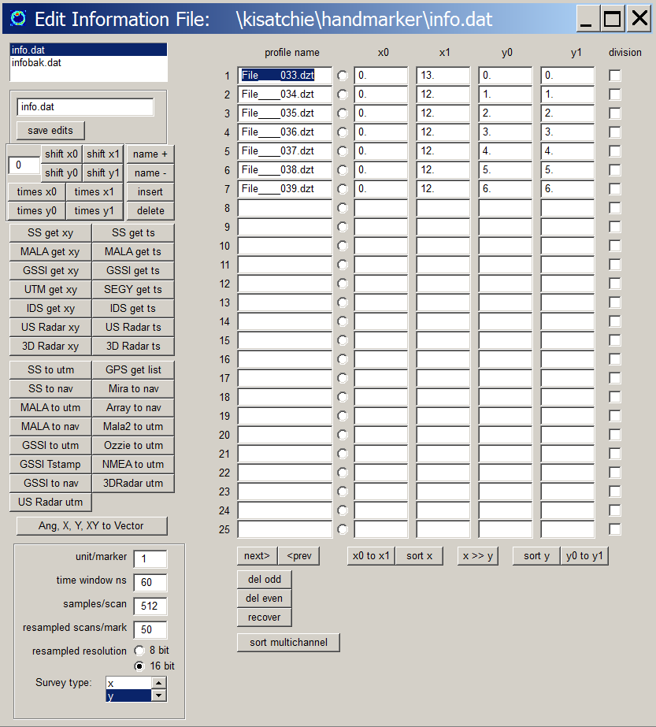

Figure 1. An example of an information made from a survey done with user markers inserted in the profiles for navigation.

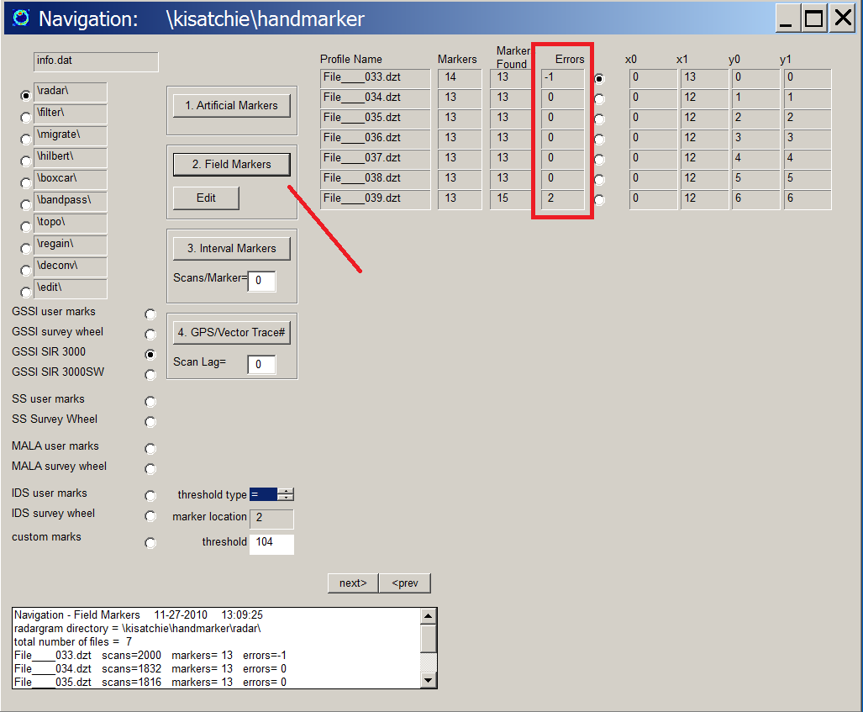

Figure 2. The Field Marker navigation option is run to discover the number of errors in the navigation. In this example, 2 profiles have a different number of markers then defined by the profile information file.

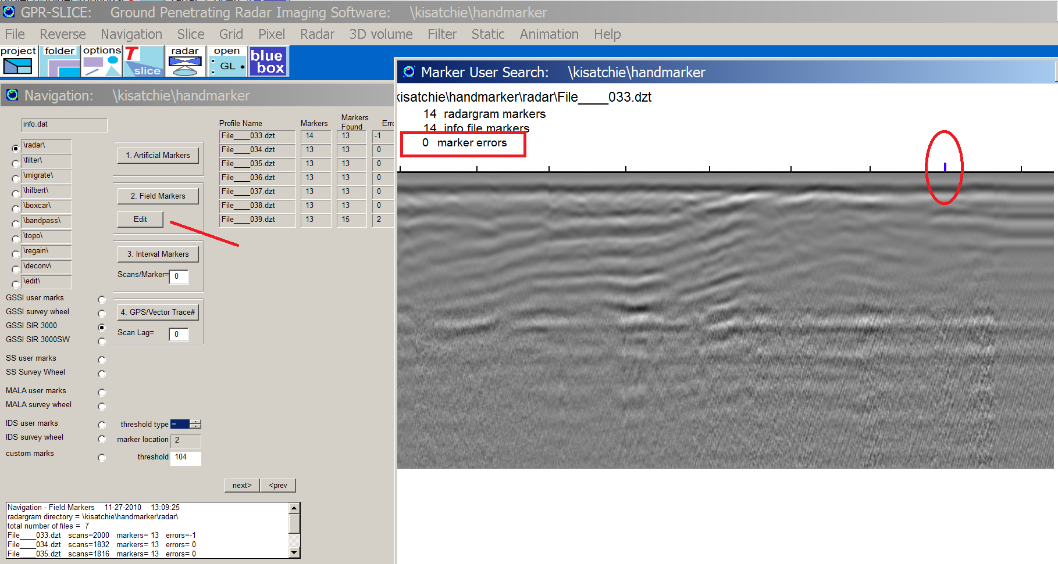

Figure 3. For user inserted markers, the Field Marker navigation option is run. In this example 2 profiles are determined to have marker errors.

25) Georeferencing Local Grids

Project folder: \kisatchie\georeference local grids\

Purpose: To introduce the operations for putting local grids into georeferenced grids.

Basic Information: GPR-SLICE has options to create GIS world files as well as Google Earth image files. GIS world files have and associated *.jgw or *.bmw file for any image file. Google Earth *.kmz georeferenced image files are an archive file containing a *.kml file and the image file that is written in png format. GPR-SLICE is able to make the necessary world files as well as the archive Google Earth files all within the Pixel Map menu. However, before these files can be generated, the time slice grids that are collected in a local coordinate need to be translated to the georeferenced coordinates. This is done in the Grid menu.

Shown in Figure 1 is the rotate/translate menu operations in the Grid menu to move the local grid made with a 0,0 southwest corner, into a georeferenced grid. The UTM coordinate of the southwest corner is used to move the grid into its new georeferenced position. The append identifier (in this case an “r”) is placed on the rotated/translated georeferenced gridset. (For simple translation without rotation, the Fix Data Origin radio button is clicked on).

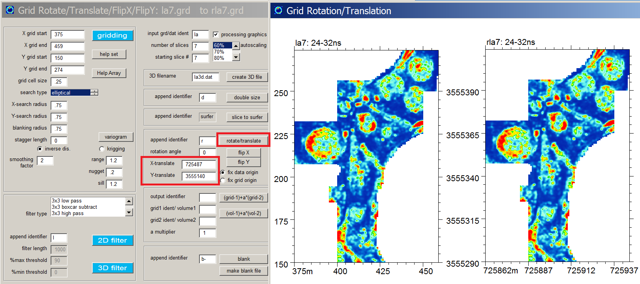

Figure 1. The Rotate/Translate button in the Grid Menu is used to translate local grids into georeferenced grids.
After the georeferenced grid is made the next step is to simply display the grid in the Pixel Map menu with the BMP and KMZ checkboxes clicked on (Figure 2) for Google Earth maps. The georeferenced images can be drawn in batch or one-by-one using either the blue Draw button or the single grid# Draw button

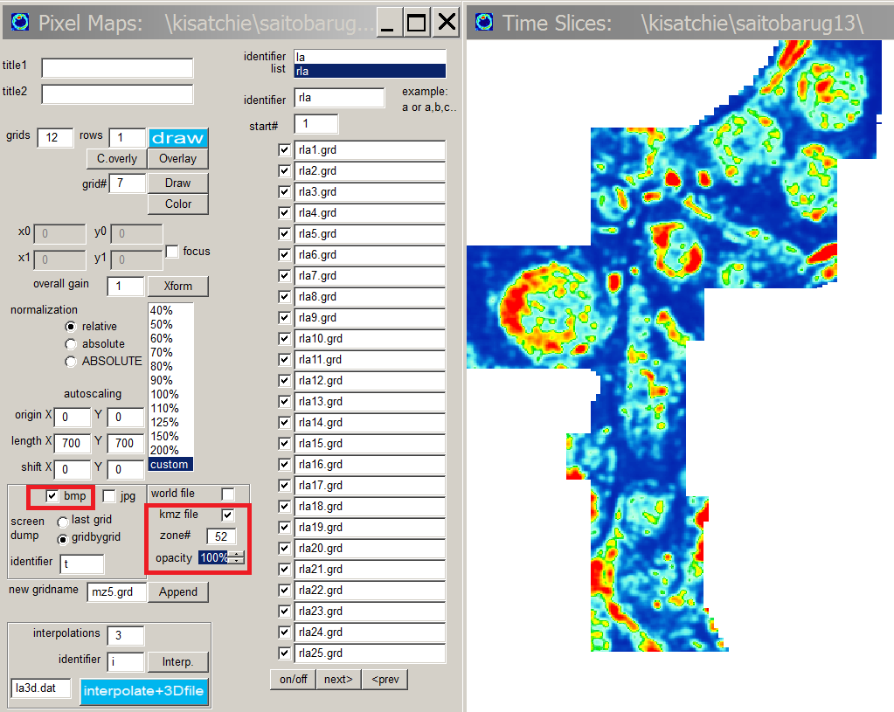

Figure 2. Example showing the settings to make Google Earth *.kmz image files.

The *.kmz file (or the *.jgw or *bmw for World File output) are written to the \jpg\ folder in the project. Opening the *.kmz file with Google Earth will open the image in there (Figure 3).
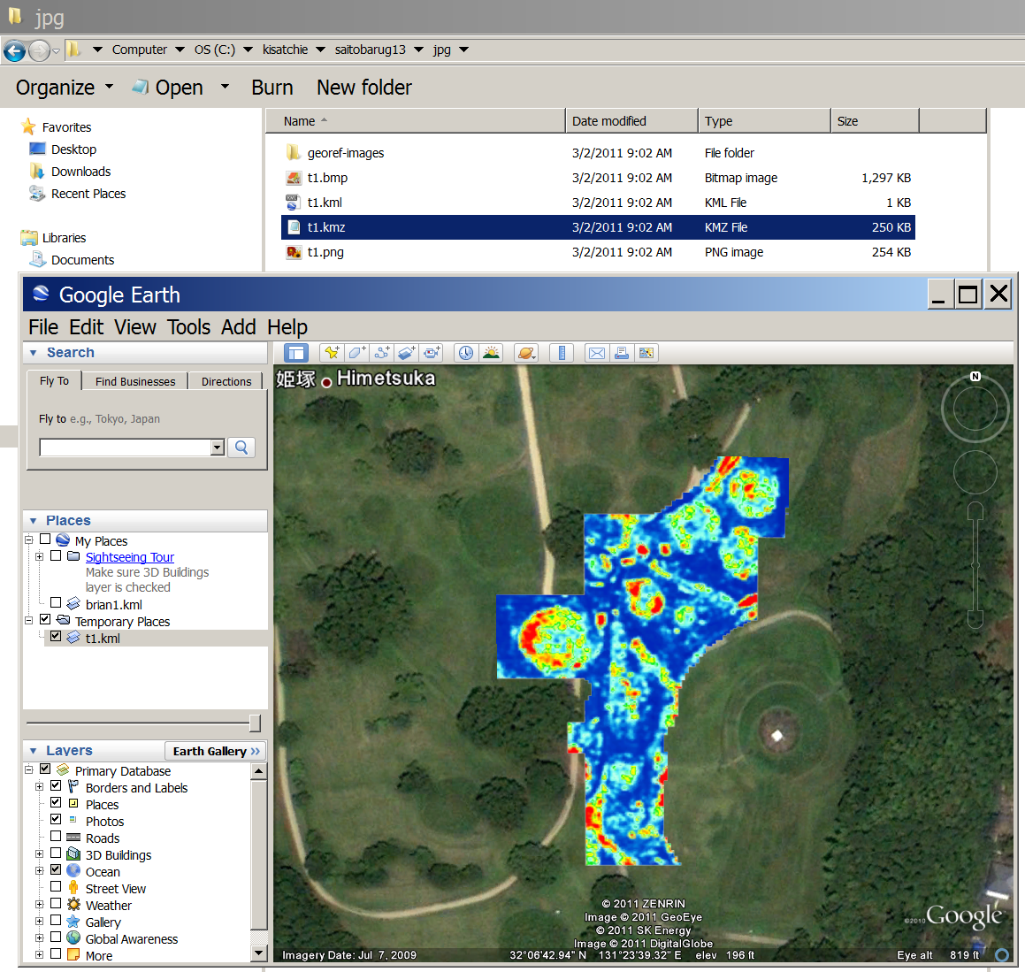

Figure 3. Example of a Google Earth map made in GPR-SLICE software. The data is of a portion of the Saitobaru Kofun Burial Mound Park in Miyazaki, Japan. (Data courtesy of Higashi Noriaki and Hongo Hiromichi, Saitobaru Archaeological Museum).

26) Striation Noise Removal

Project folder: \kisatchie\striation noise removal\

Purpose: To introduce the operations available in the Grid menu to filter grids to remove line noises.

Basic Information: GPR-SLICE has filtering options in the Grid menu to remove a variety of noise from the time slice images. These filters can sometimes alleviate the need to do signal processing on the radargrams prior to making time slices. An example of a image processing to remove line noise seen on a time slice image is shown in Figure 1. In the time slice a1 line noises can be seen in the image. Using a vertical filter in the Grid menu, these noises can be reduced. The vertical filter will compute the average along vertical grid lines and remove the average reflection (similar to 0 mean grid filter in XYZ compilation). The filter in the Grid menu however, has several settings that the user can adjust: filter length and %max/%min threshold. The filter length tells how many grid cells to compute the average value of the filter. The moving average value in this example is set to 1000, which goes beyond the entire length of the number of grid cells – such that the average is just a single average.

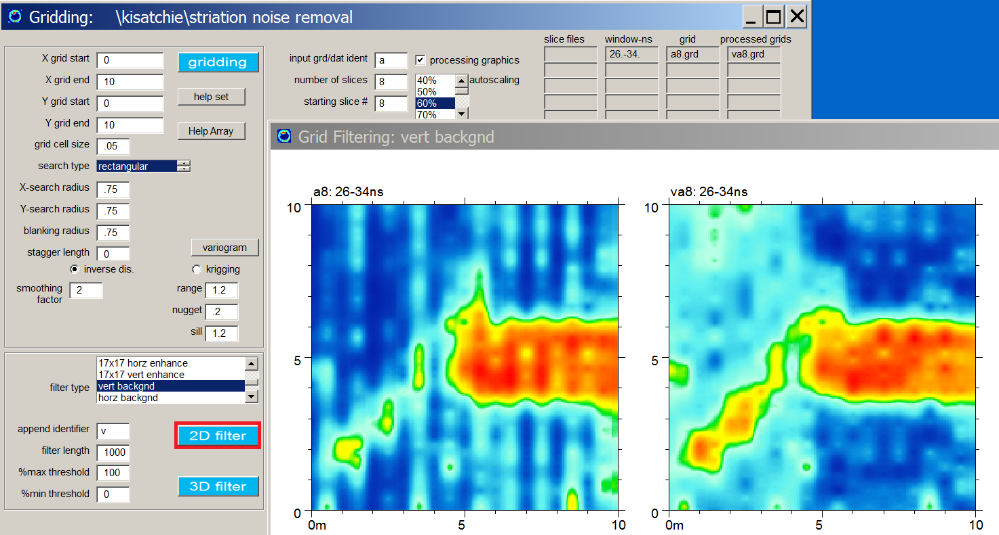
Figure 1. An example of applying a vertical background filter in the Grid menu to a time slice image with striation line noises

The %max/%min settings tell the software to only include values within this range percent of the max/min along the line. Adjusting the max value below 100% on the high end for example (say 90%), will only include values in the average below this. Likewise for the low min% setting. Normally, these setting can be left to 100 and 0 %.

In Figure 2, the same time slice image using a small filter length of 50 grid cells (in the vertical direction is used). This filter not only gets rid of the vertical line noises, it also acts similar to a high pass filter in the y direction – removing low frequency features greater than 50 grid cells.

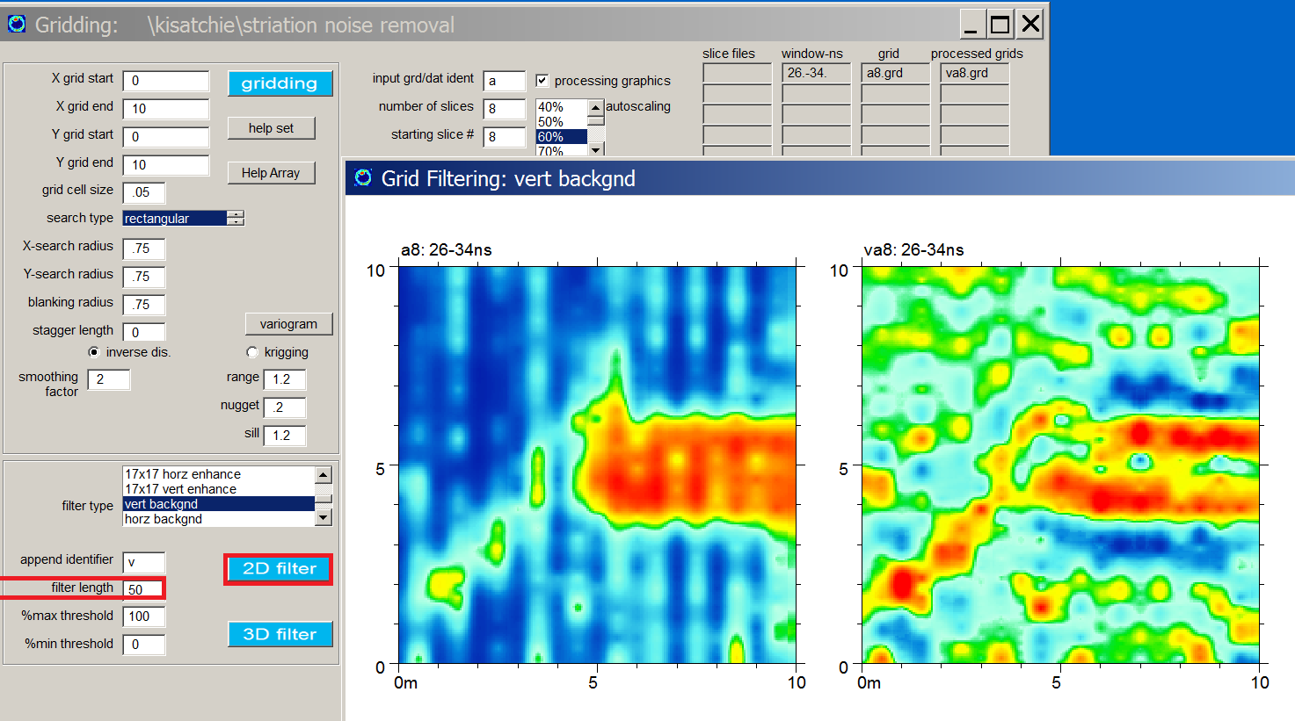

Figure 2. Example of the same time image in Figure 1 but with a filter length of 50 which is shorter than the total length of the grid (cells) in y - vertical direction.

Note: The user should be careful in using this filter with small filter lengths, as numerous small amplitude features can appear in the filter image which may or may not be what they want to achieve..

27) 2D FFT Grid Filtering

Project folder: \kisatchie\FFT 2D crop noise\

Purpose: To introduce the operations available in the Grid menu to filter grids using 2D Fast Fourier Transforms.

Basic Information: GPR-SLICE has filtering options in the Grid menu to remove a variety of noise from the time slice images. A common noise seen in archaeological surveys are noises do to agricultural crops (Figure 1). The field noises can sometimes completely mask subsurface features. A specialized filter to remove these spatially coherent noises is the 2 dimensional Fast Fourier Transform (FFT). In the filter spatially components that identify the crop noises can be easily identified on the 2D FFT transform image. The 2D FFT filter menu is accessed from the Grid menu. On top of the transform image, the user can blank out spatial components related to the noise. The user only needs to blank components in the first and second quadrant as these reflection of these filters are automatically placed in the 2D FFT transformed image with the negative wavenumbers for x and y axes.

For the example with crop noises in the time slice image that are about 45 degrees to the main x and y axis of the grid (a1.grd), the spatial components that are seen in the transformed image will indicate strong energy at nearly 90 degrees away from the this angle. Blanking these components and taking the Inverse FFT2d, a filtered time slice with the angular crop noise is removed. The developed filter can be stored and imported at a later time or to apply to other time slices in the grid set. For grids that are not square or binary lengths, they will be resampled so that FFT operations can be done. The resulting saved grids will have the identifier “resamp” appended to the names. So an completely resampled and FFT2D filtered image will be named “FFT-resamp-**N.grd” upon saving.

A second example shows crop noises that are slightly off the horizontal in grids lh1-4.grd (Figure 2). Blanking out these noises in the transformed image along with multiples, the inverse 2d FFT will have the horizontal crop noises removed. Comparison of 4 filtered and unfiltered grids for this dataset are shown in Figure 3 using comma delimited options in the Pixel Map menu.

Note: The spatial frequencies in the center of the transformed image significantly control the filtered time slice image. Over filtering the 2d spatial components can result in unrecognizable filtered imagery. If the image is over filtered one has the option to paint back these locations, or to reset the filter completely and start over.

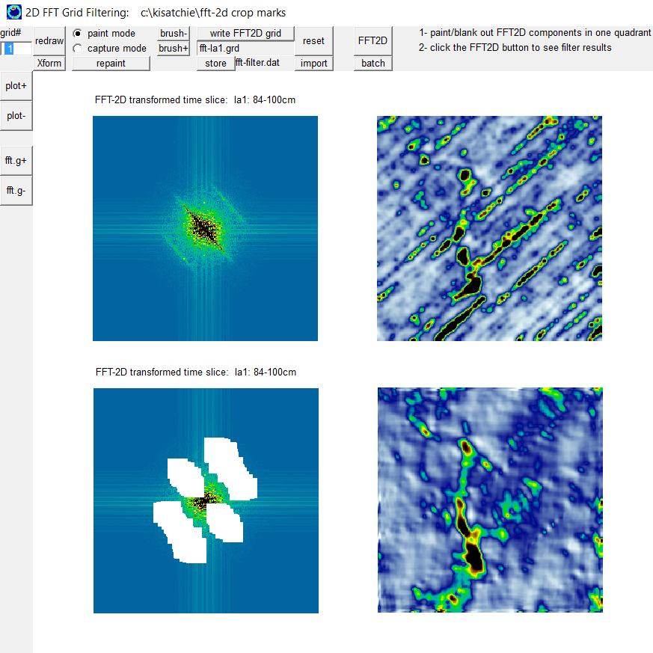

Figure 1 A time slice image with crop noises at nearly constant 45 degree angle to the main axis of the grid are seen (top right). The transformed 2D FFT image (top left) and a blanking the spatial components that are nearly perpendicular to those seen in the untransformed image (bottom left) helps create a filtered time slice image that has nearly all the 45 degree crop noise removed (bottom right).

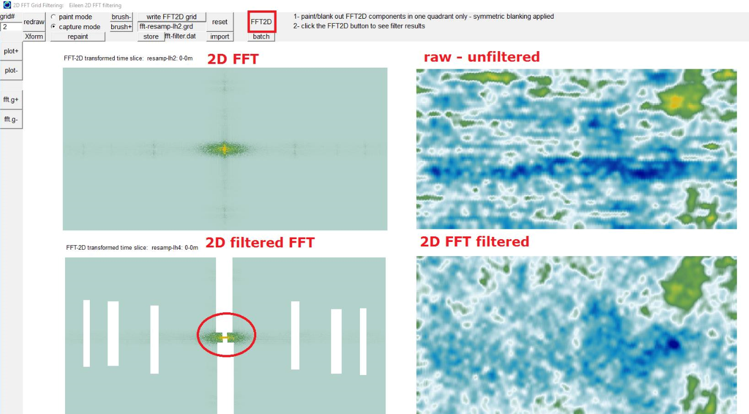

Figure 2 Another example of a dataset with some slightly off horizontal crop noises. 2D FFT filtering seen (bottom left) is used to remove this noise.

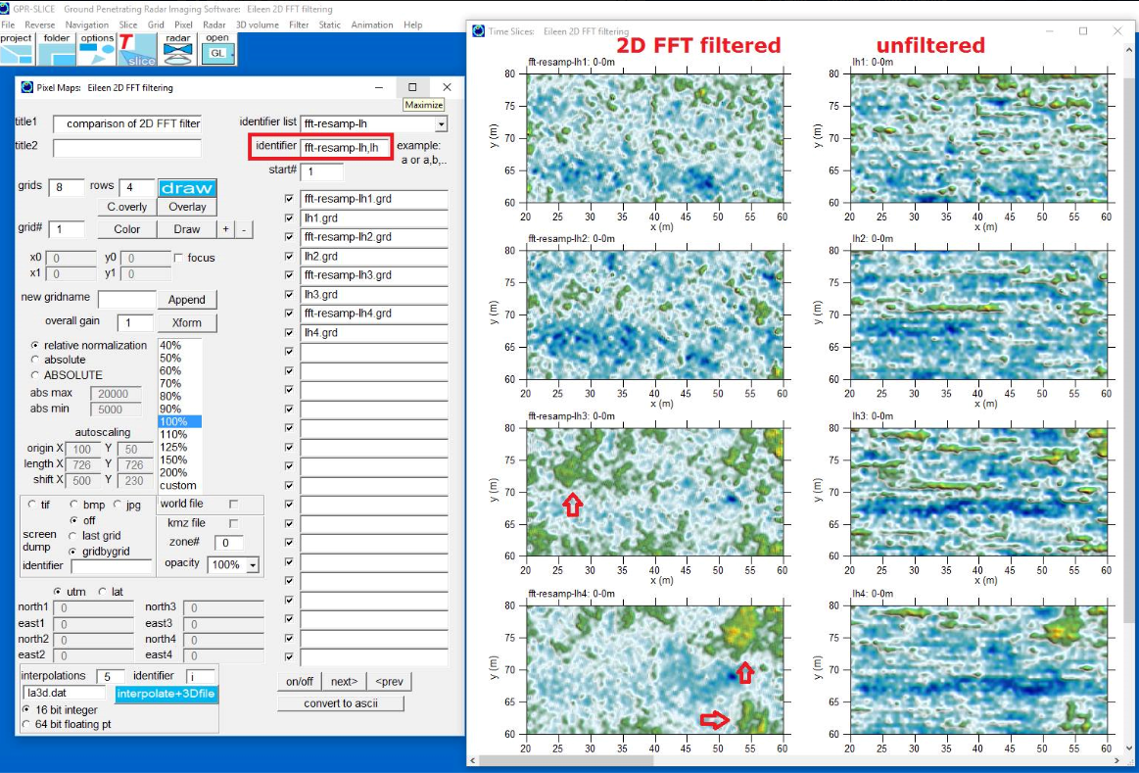
Figure 3. Four 2D FFT filter time slices are compared with original unfiltered time slices using comma delimited identifiers in the Pixel Map menu

28) FK Radargram Filtering

Project folder: \kisatchie\FKrad\

Purpose: To introduce the operations available in the Filter menu to perform frequency-wavenumber filtering of radargrams

Basic Information: GPR-SLICE has filtering options to transform radargrams into frequency-wavenumber (FK) space and to perform filtering operations on the transformed radargrams, followed by inverse transformation back into range and time space. The filtering process in FK space can allow great flexibility to remove some desired reflection features on raw radargrams which can not be easily remove in time domain space. Shown in Figure 1 is a simulation of a dipping layer along with the FK transformation. Blanking out the FK components in the upper right upper quadrant - which are FK components that are nearly perpendicular to the desired reflection features seen in the range-time raw radargrams - the inverse FK transformed radargram is shown to have these reflections removed.

Another example is show for a simulation with 2 dipping features in each direction (Figure 2). Generating an FK filtered radargram only the reflections that are dipping left to right can be removed.

In Figure 3 a real radargram is shown where dipping reflections from both sides of the radargram can be seen. Differential filtering of either of these reflections can be accomplished through FK filtering. In this example, the reflections dipping down from right to left are differential removed from FK filtering.

Note: Currently in GPR-SLICE, if the total number of scans are different between radargrams, batch operations can not be run as equivalent FK filters are not set. If one has radargrams that have all the same length on the ground, if one resamples the radargrams in the Slice/Resample menu to the same number of scans per radargram, then batch operations can be implemented.
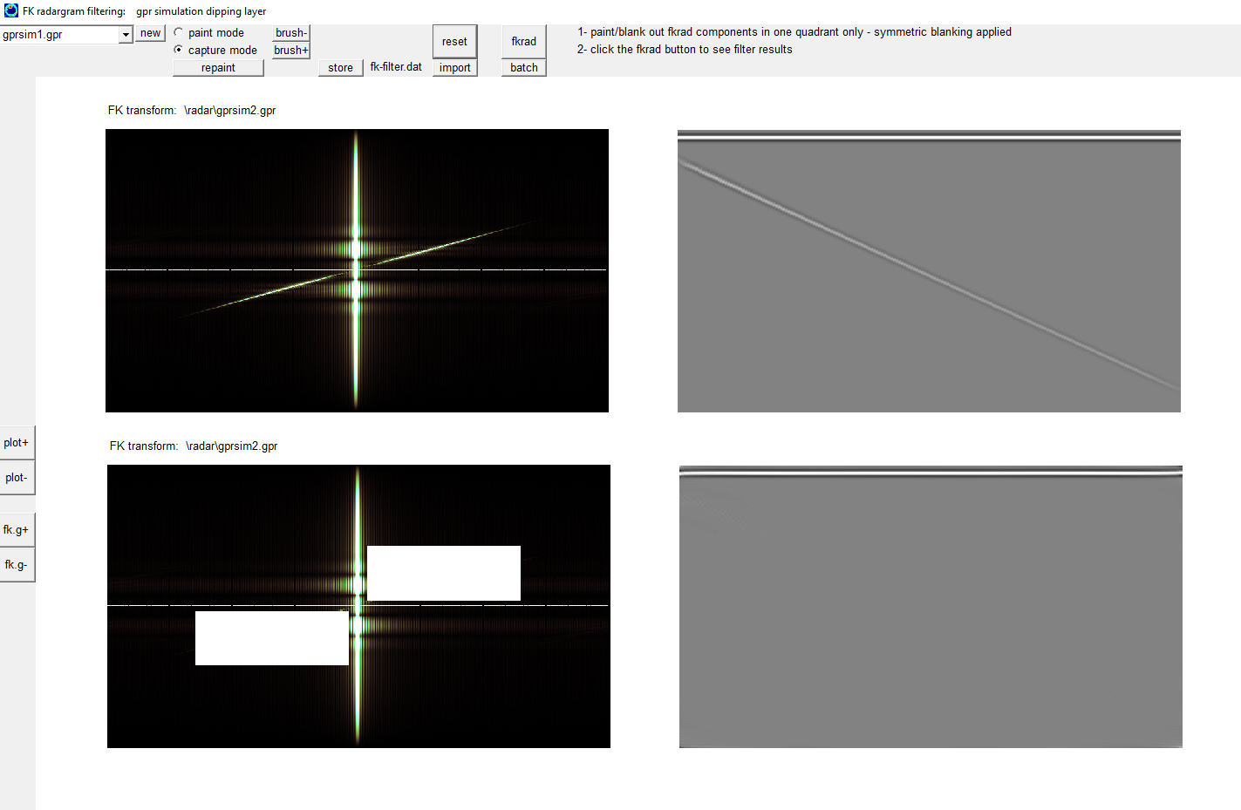
Figure 1. Removal of a dipping reflector see on a radargram is accomplish by filtering the FK transformed radargram

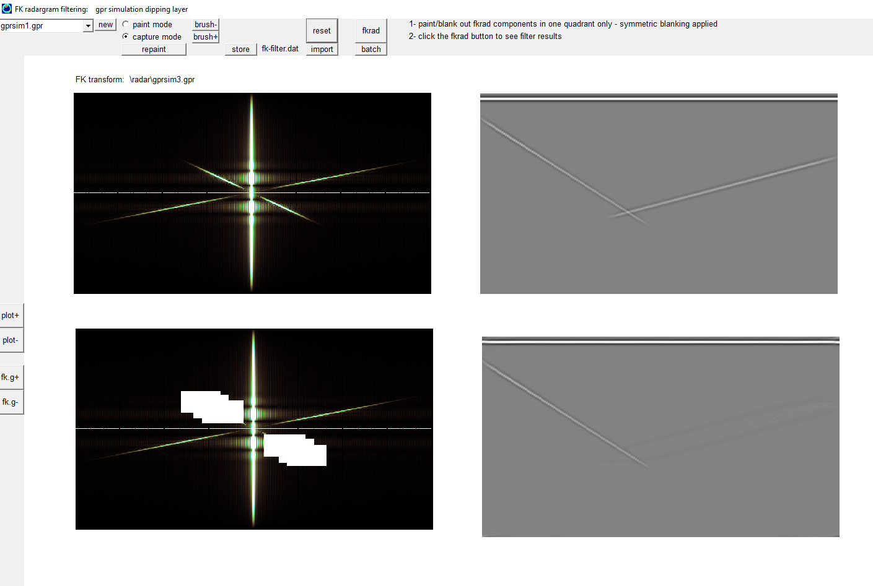
Figure 2. Removal of only one dipping direction for reflections seen on a radargram using FK filtering.

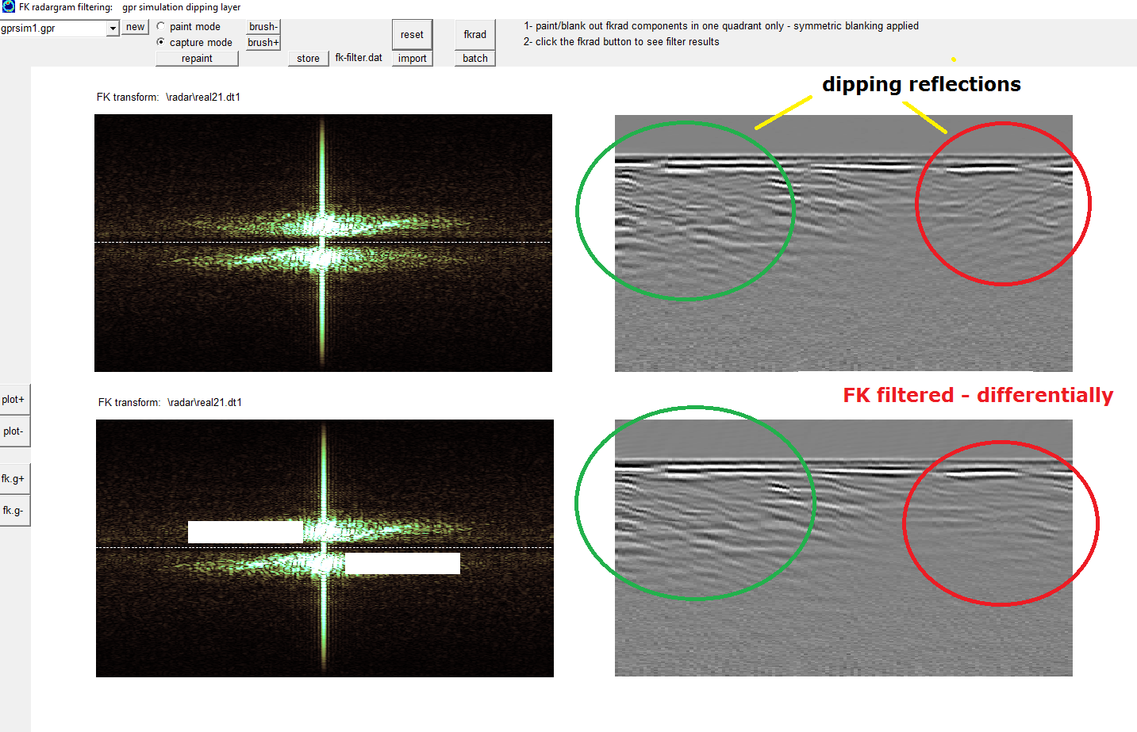
Figure 3. A real radargram showing some dipping reflection components in both directions starting from the sides along with differential FK filtering of reflection just that are dipping downward from right to left.

