GPR-SLICE Basic Processing Tutorial

PURPOSE
The intent of this work instruction is to provide an understanding of the basic processing steps that can be completed in the GPR Slice software. This tutorial does not cover the entire functions available in GPR-SLICE, just the basic steps that should work for the majority of GPR projects.

DEFINITION AND ACRONYMS
Dielectric Permittivity – The electrical susceptibility of a material. The range varies between 1 (Air) to 81 (Water). This range is also known as Relative Dielectric permittivity (RDP). Water has a greater RDP than air. Speeds of waves in air move faster in air than water.
Low Frequency – 12.5-200 MHz, long wavelengths, able to prospect deep (up to 45 meters). Used for geological and geophysical applications.
High Frequency – 800-2600 MHz, short wavelength, with shallow prospection (as little as 30cm). Used for concrete scanning and utility locating.
Two Way Travel Time (TWTT) – GPR records TWTT in nanoseconds (ns) and can convert this into depth based on parameters entered into the GPR unit or software.
DS2000 – Leica GPR, that was rebranded from IDS Opera Duo. This is a dual antenna GPR with 250 MHz and 700 MHz central frequencies. (This tutorial originally written for Leica equipment by Matt Allen at WSP Civils - but is easily transferrable to all GPR manufacturers)
Depth Penetration – The depth range of GPR is limited by the electrical conductivity of the ground, the transmitted center frequency and the radiated power. As conductivity increases, the penetration depth decreases. This is because the electromagnetic energy is more quickly dissipated into heat, causing a loss in signal strength at depth. Higher frequencies do not penetrate as far as lower frequencies, but give better resolution. Good penetration is achieved in dry sandy soils or massive dry materials such as granite, limestone, and concrete.
Time Zero Correction – A processing step that allows you to bring up the first reflection event (usually ground surface) to time zero. From this target depths can be accurately measured.
Background filter - A processing step that removes horizontal banding in profiles to make anomalies to aid in data clarity.
Bandpass filter – A processing step that allows a range to be set for high and low frequencies. This also aids in data clarity, by removing drift or noise in data.
Regain – A processing option that enhances targets of interest making data easier to interpret.
Hyperbola Matching – A processing option that measures wave velocity for accurate depth evaluations.
Wave Velocity – Higher RDP yields lower wave velocity and shorter wave lengths (Eg: wet clay soils, organics). Lower RDP yields higher wave velocities and longer wave lengths (Eg: dry sandy soil, asphalt).
Radargram – Sectional (profile) view of the subsurface.
Hilbert Transform – Processing option that creates an envelope of amplitudes while maintaining polarity. It takes the positives and negatives from your signal responses and collapses them into a total signal that shows the amplitude of that event.

Starting a New GPR Slice Project
- Open GPR Slice
- File Pulldown → Create New Project → Enter project name
- Select equipment type (For Leica DS2000 select IDS)
- Click New survey to start project and close dialogue window
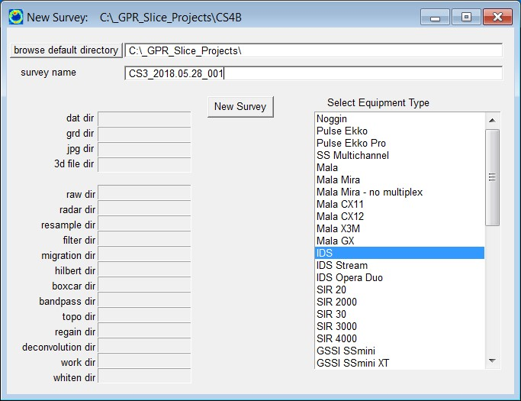

Transfer Data
Data needs to be converted using HD_DataConverter to put the Leica GPR data into a usable file format for GPR slice. (For all other manufacturers, GSSI, MALA, SS, Zond, Geoscanners, Impulse Radar, Radarteam etc, skip to the 3rd bullitt step)
- Open HD_DataConverter. Browse to project folder. This is where the raw project data was saved. Select the operaduo.xml file. Click Open.
- Select destination folder. This auto populates to within the project folder above, but creates all the converted data in GRED_HD folder. Click convert. Sometimes this process can take a few minutes depending on project area, and amount of transects completed in the field.
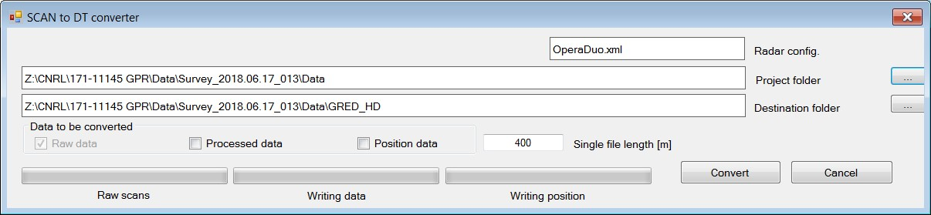
- File Pulldown → Transfer Data
- Browse to the GRED_HD data folder. Click search. Click import radargram data. Close import data window.
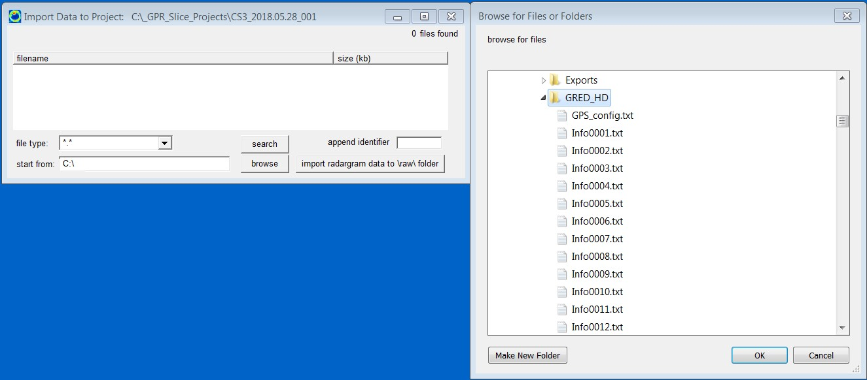
Data is now under the \raw\ folder. As each processing step is completed these folders get populated with additional processed data files.
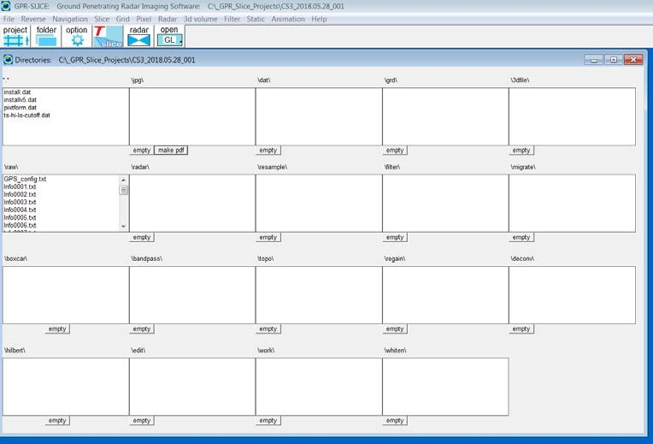

Creating and Editing Info File for Local GPR grid
- File pulldown Create New info. Below dialogue window pops up. This particular data set came from the Leica DS2000, so we have channel 1 and 2 data (250 MHz and 700 MHz). An information file for each channel of data is required for viewing each set of data.
- Under filename input a 1 after info. This will be for channel 1 data. Set file identifier to TA01.
- Select the grid type. For this project grids were run in a Y direction.
- Populate the X start/end, Y start/end fields. For this project the grids were spaced 2m apart. X end = 8m, and Y end = 12m. You can manually edit these values later if needed.
- Select radargram identifier + extension and select import – create info. The profile name, x0, x1, y0, y1 columns will be populated automatically.
- We can repeat the process above to create an info file for the channel 2 data.
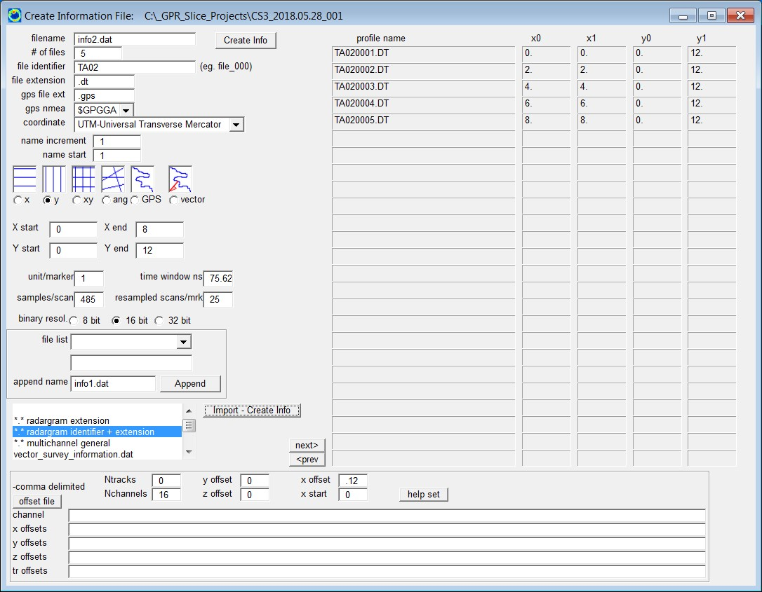

Edit Info File
- File pulldown → Edit info file
- Select IDS get ts for each info file. Extracts the time window and samples/scan for IDS equipment.
- Manually edit profile lengths if required. Click on save edits once completed.
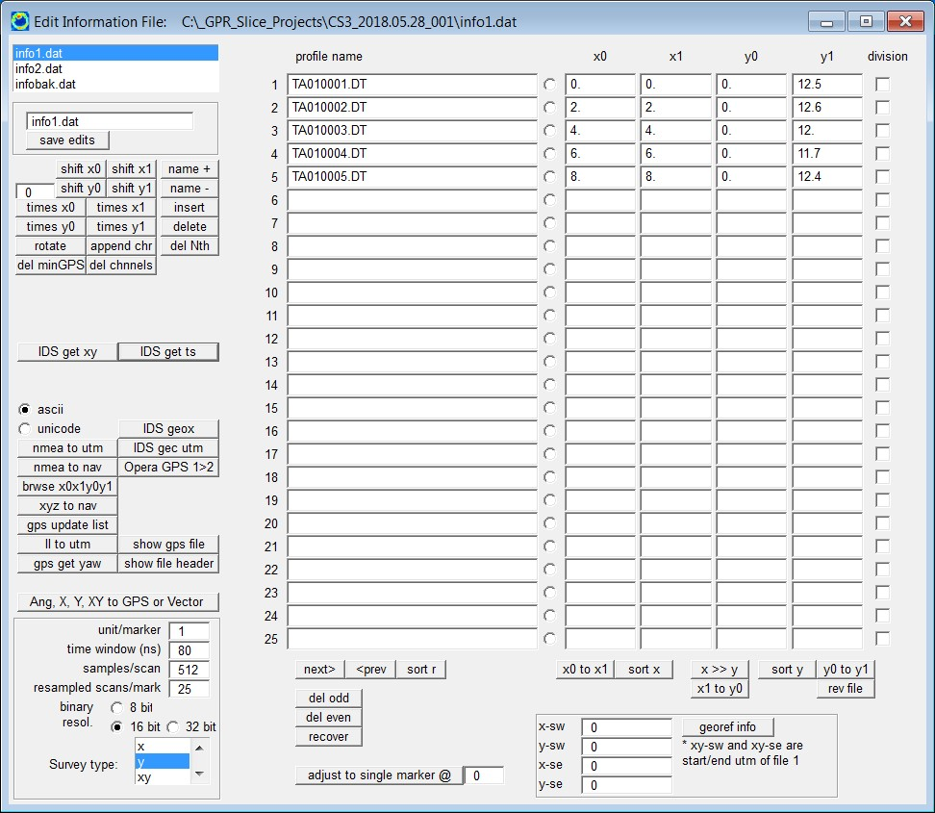

Convert Data
- File pulldown → Convert data
- Select IDS 16 to 16 bit. Converted data will go to the \radar\ folder.
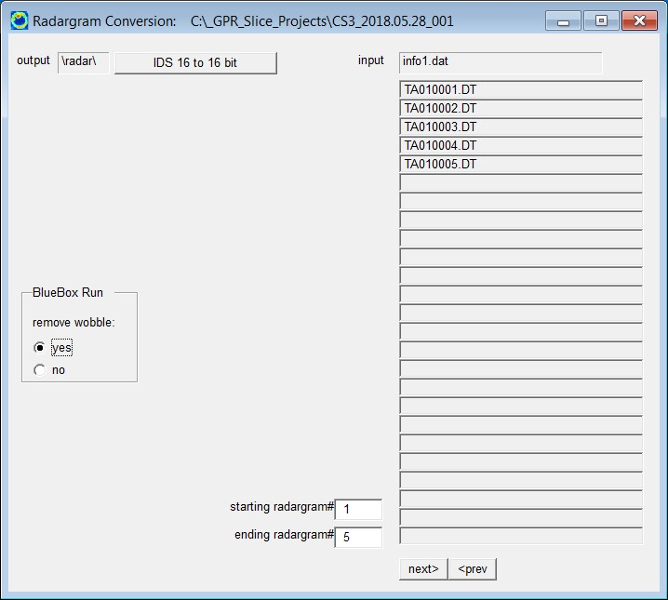
- The next window can be used to adjust the gain and wobble. Select batch gain-wobble, and close window when process has completed.
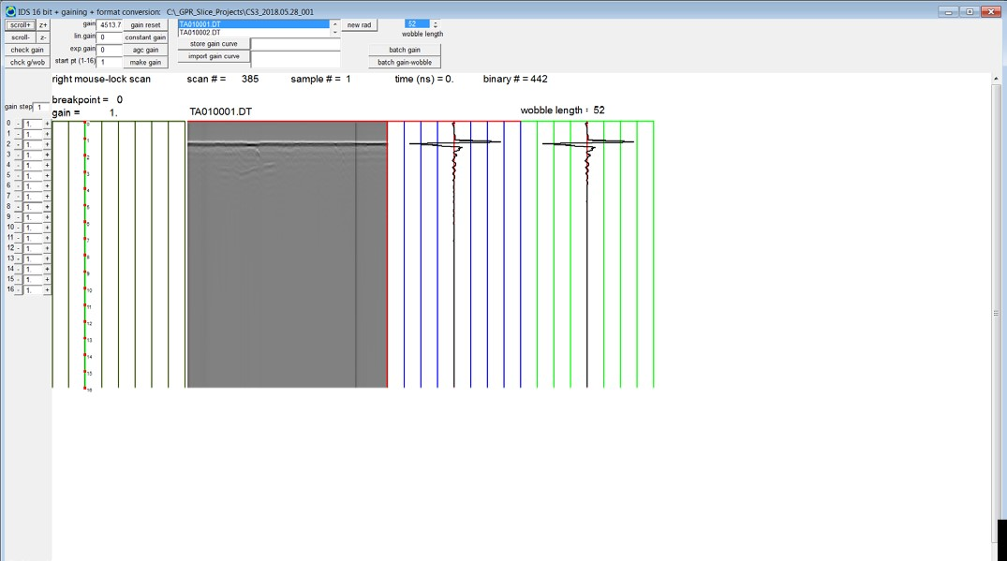

Reverse Radargrams
- Reverse pulldown → Reverse
- If the data was collected in a reverse or zig zag alternating pattern, the profiles will need to be reversed to account for this. The reverse menu allows you to adjust for this. There are a bunch of different options to choose from, or you can manually check off the profiles to reverse, and select start reversing.
- In this data set all profiles were taken starting at the y0 position, and reverse is not needed.
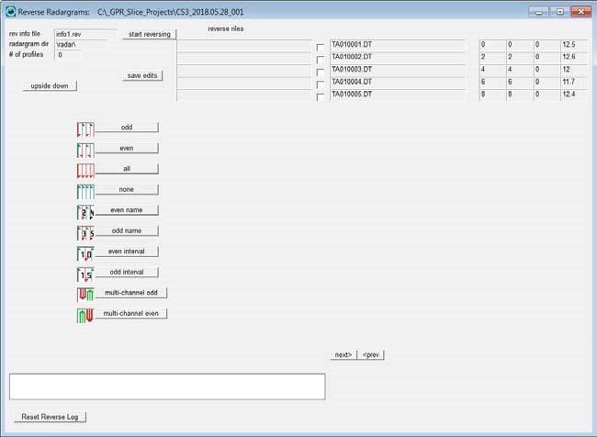
- When the reverse process is complete this dialogue can be closed, and you can view the reverse profile map (Reverse pulldown → Reverse map). Green dot = start position, red dot = end position.
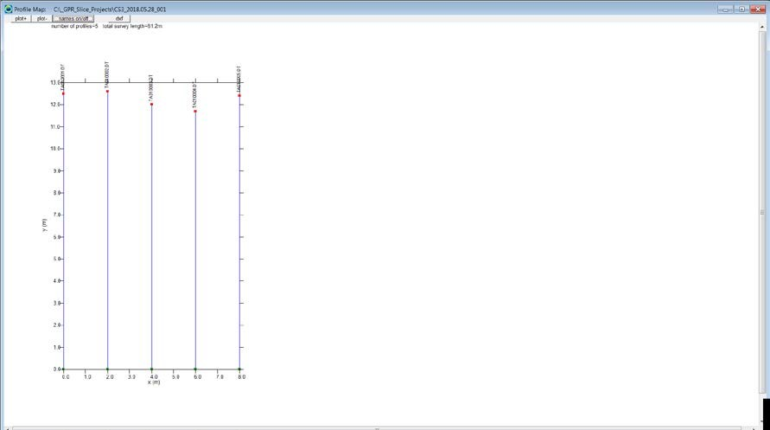

Navigation Markers
- Navigation pulldown → Markers
- With local data set, select artificial markers and close dialogue.
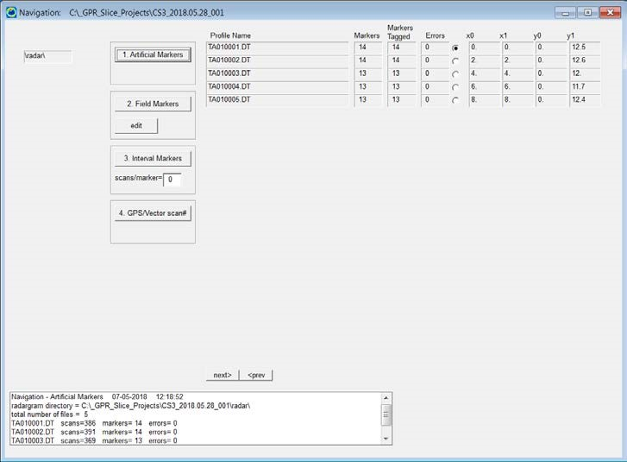
- Navigation pulldown → Show Markers
- This will show along your profile where the markers are created. (1m intervals)
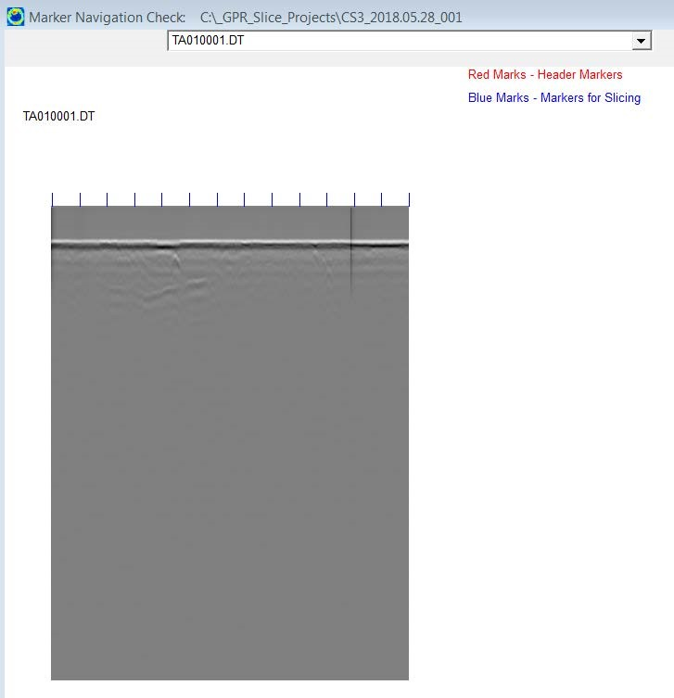

Time Zero Correction
- Radar pull down → Radargram Editing
- Under input directory select \radar\
- Select auto 0ns line-by-line + truncate
- A Truncate samples dialogue will pop up showing you what the time zero calculations were for profile 1. Select OK.
- The time zero correction will occur on each of the radargrams. You should see the tops getting cut off.
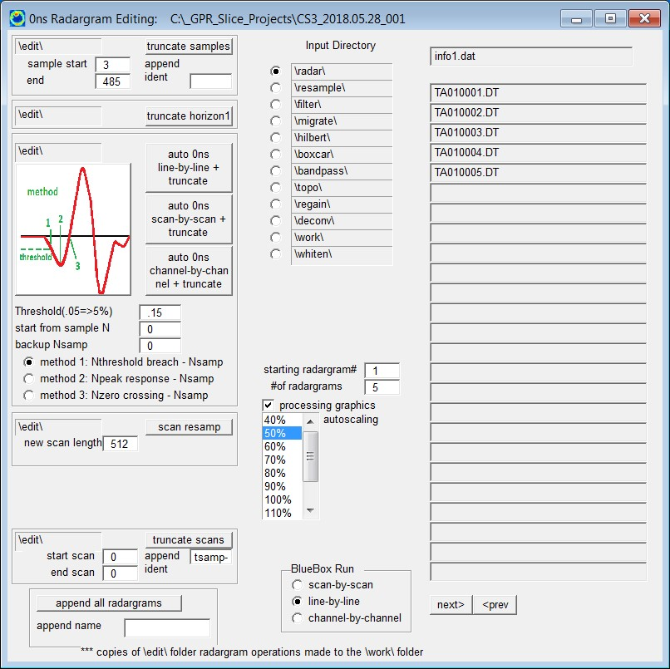
- Close the radar gram window that appeared. Another window will pop up as shown below to switch to the edited info file. Select yes, and close the radargram editing window.
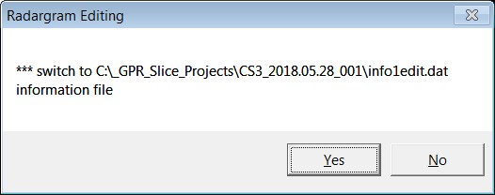

Filter Menu
- Select the filter pulldown → Filters
- The menu below will be used to do run the bandpass, background filter and Hilbert processing. • Under input directory select \edit\
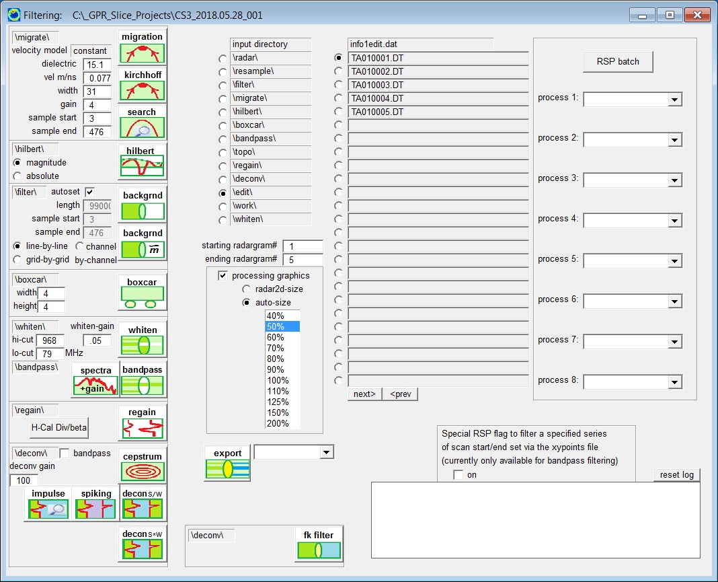

Bandpass Filter
- Select the spectra + gain button. This opens a new window where you can adjust the high and low frequency cutoff.
- Right mouse click under high cutoff to set the high cutoff frequency.
- Left mouse click around power spectra to set the low cutoff frequency
- Select helpset once the frequency range is determined.
- Select AGC gain. The profile will be gained to provide clarity.
- Close bandpass filter settings window.
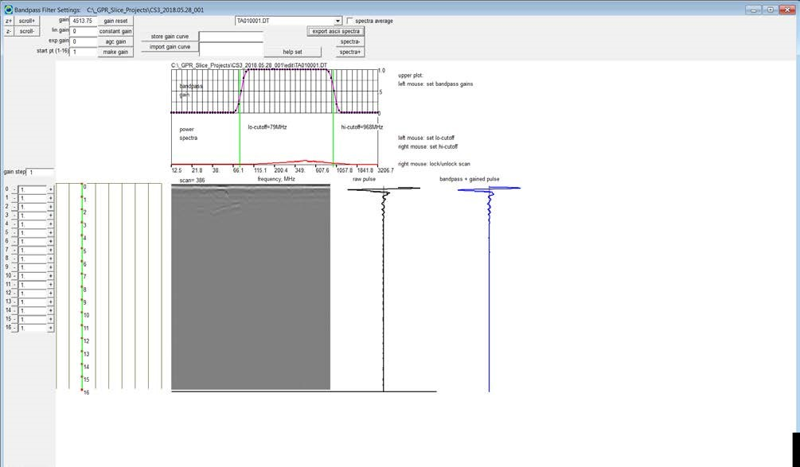
- To apply all of the bandpass settings selected in bandpass filter settings, select the bandpass button in the filter menu.
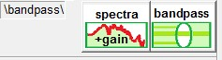
- Initiating the process above will open another radargram menu. This will take the radargrams from the edit folder, and apply the bandpass processing. You will see the process occur for each of the radargrams within your project. The updated radargrams will be under the bandpass folder. This window can be closed once the processing has completed.

Background Filter
- This filter removes horizontal banding that appears in the radargrams. Under input directory in the Filtering menu select bandpass.
- Select backgrnd, and you will see all the processing take place on the radargrams. You can close the background removal window once complete.
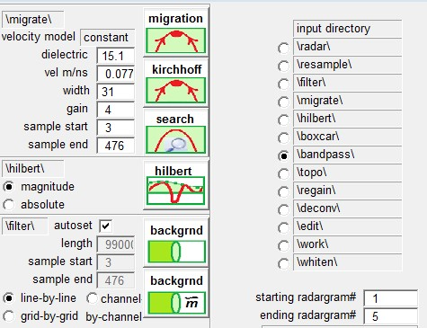

Hilbert Transform
- This filter creates an envelope of amplitudes based on signal responses while maintaining polarity. This can be a great way to visualize targets in a radargram.
- Select \filter\ under input directory. Select Hilbert, and you will see all the processing take place on the radargrams. You can close the Hilbert transform window once complete.
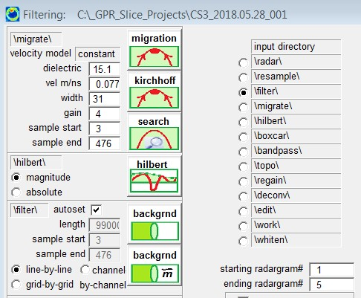

Hyperbola Search
- Within the filter menu select the search button above Hilbert as shown above. Under input directory ensure filter is selected.
- Hyperbola search window opens. The x pixels and y pixels can be edited to adjust the profile height and width.
- In the upper left you can toggle through profiles to search for hyperbolas. In the below image you can see one located at about x=4 and y = 0.6
- To complete the hyperbola match, the two vertical red lines need to be aligned to the edges of the hyperbola. This can be done by using the scroll bar highlighted below.
- To align and match the hyperbola left click to adjust to match the hyperbola. When the hyperbola matched left click to complete and select calculate. The menu above the radargram will populate the calculated dielectric and velocity.
- In data sets with multiple hyperbolic reactions at different depths this search method should be used to match multiple hyperbola at varying depths to check wave velocity and RDP. The RDP and wave velocity can differ at varying depths unless the soil is homogenous in terms of dielectric, and this may affect the depths of the targets depending on the RDP chosen. One option is to use the greater dielectric value to provide minimum possible depths of utilities to the client. Another option is to pick a hyperbola with a dielectric value in the mid-range of each the hyperbola matches completed. This is to some extent an average, but this can potentially cause depths to be inaccurate. The video link below gives an excellent in-depth explanation for this.

https://www.youtube.com/watch?v=1KNChZuFxLo&t=829s
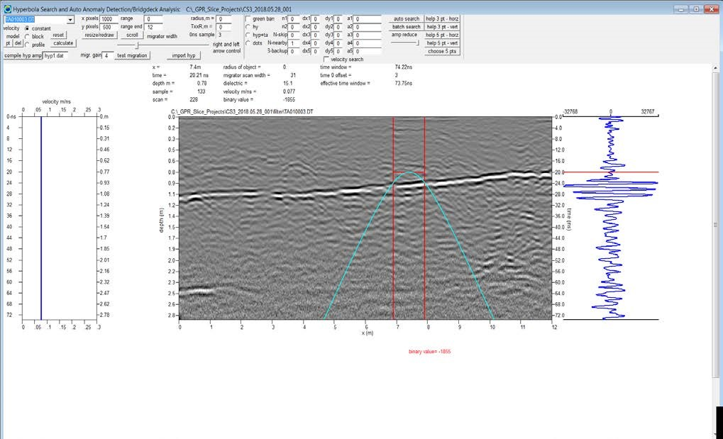

Creating Time Slices
- GPR Slice can create time slices from the radargram data. The example below time slicing is applied to the filter folder containing the radargrams with the background filter processing applied.
- Search 0ns, auto detect, close window. Select help thick to adjust time window and depths.
- Set the number of time slices, generally 20 is a good number. Set bins per mark and bin parameter. Start the slice process by selecting slice/xyz
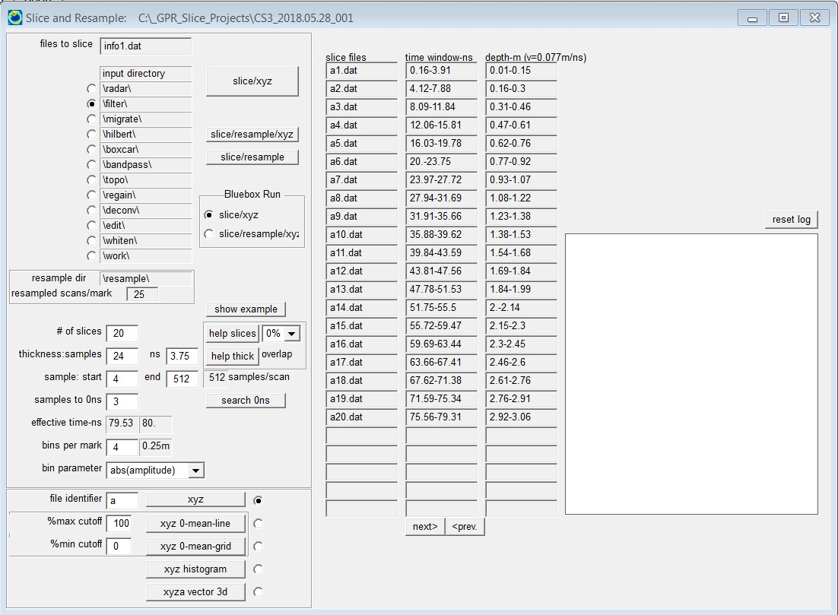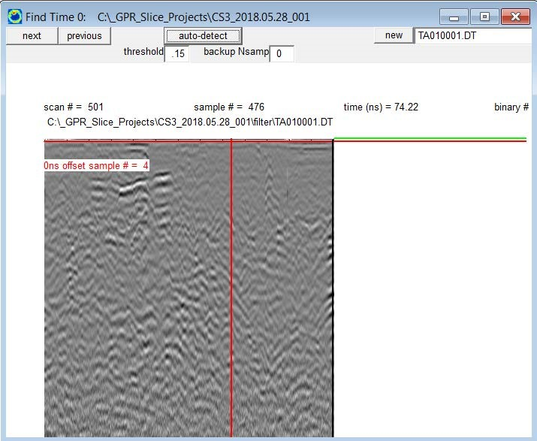

Gridding
- Gridding will create time slice pixel maps. Grid menu grid →Grid
- Select inverse distance with a smoothing factor of 2.
- Select help set (default option button) to automatically populate grid cell size and search radius.
- Select start gridding, and you will see each grid be created in a new window.
- When completed close window, and apply a 5x5 low pass filter to the pixel maps. This will remove any gridding noise. Note the append identifier ‘l’ is set to the smoothed grids. To apply filter select 5x5 low pass and select start 2D.
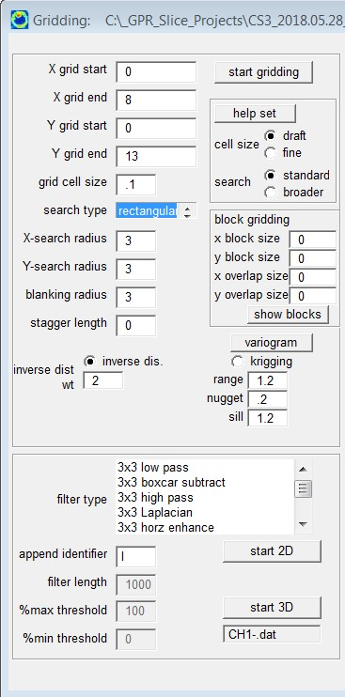

Display Time Slices and Build 3d File
- Accessed by clicking T-Slice button or from pixel pulldown menu → 2D Time slices
- Select identifier, ‘la’ (time slice data with 5x5 low pass applied)
- Set gridding to start at 1
- Set number of grids and rows to be displayed on screen. Example below has 20 grids shown in 4 rows
- Set auto scale size. Example below set is to 90% • Select draw button at the top of the window
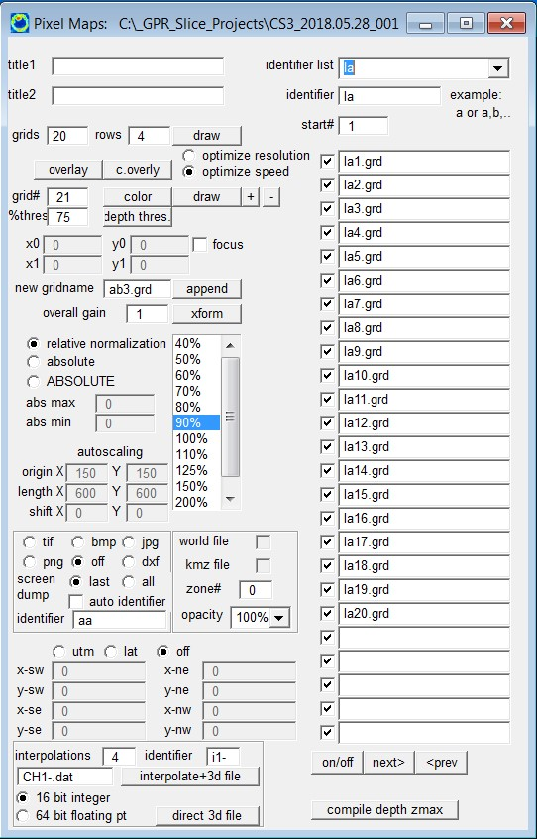

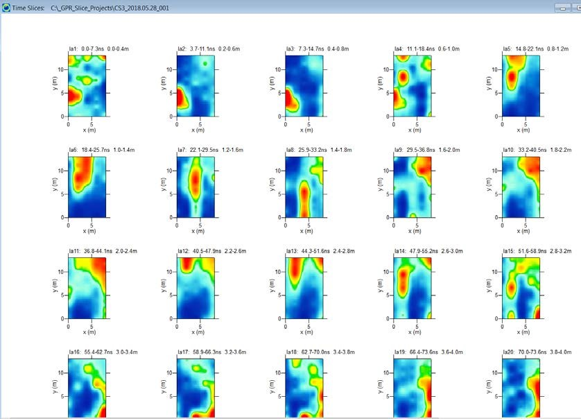

- Left click in the white area of the screen as shown above and the menu below will open. Gain the data by selecting auto gain all. Click redraw to see changes.
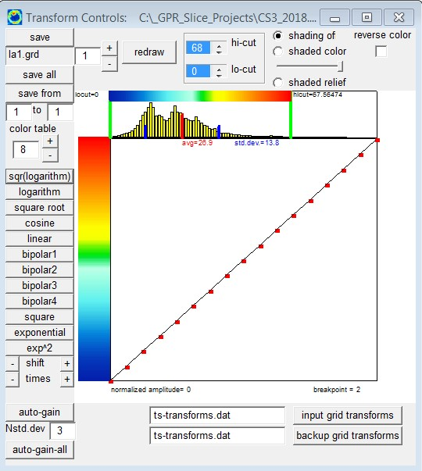
- Close window and select interpolate + 3d file from the T-Slice menu shown on previous page to generate the 3d volume files. Generally, 4-5 interpolations is a good number.

3D Volume Viewing
- Can be opened by clicking the Open GL button in GPR slice or from the pulldown menu 3d volume → Open GL volume. The Open GL Volume + draw allows the ability to add interpolations (points and line work).
- Volume cube can be rotated holding the left mouse button.
- Z slider bar toggles depth
- Selecting bounce you can rapidly view the time slices. Selecting store will store a time slice, or radargram on the screen.
- Step-/Step+ Toggles view backward and forward for time slices and radargrams.
